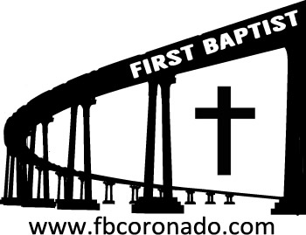

Reach Up, Reach Out, Reach Our World
445 C Avenue
Coronado, CA 92118
(619) 435-6588
fbcoronado.com
Jim W. Baize, Pastor
Julie Burkhart, Secretary, Childcare Coordinator
Patsy Lower, Treasurer
Laura Stecher, Children’s Ministry
David Preston, Youth Ministry
Dan Malcolm, Men’s Ministry/VIP Ministry
Cindy Wilson, Women’s Ministry
Monica Medina, Convalescent Ministry
Sheerah Haywood, Worship Ministry
Bobby Greer, Maintenance
Our mission is to produce fully devoted followers
of Jesus Christ. If we can be of any help to you,
feel free to give us a call.

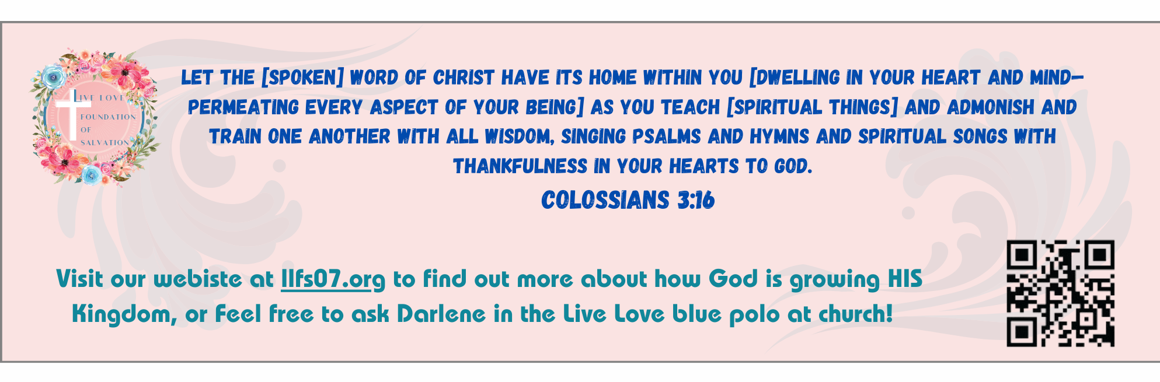

First Baptist Church
Of Coronado

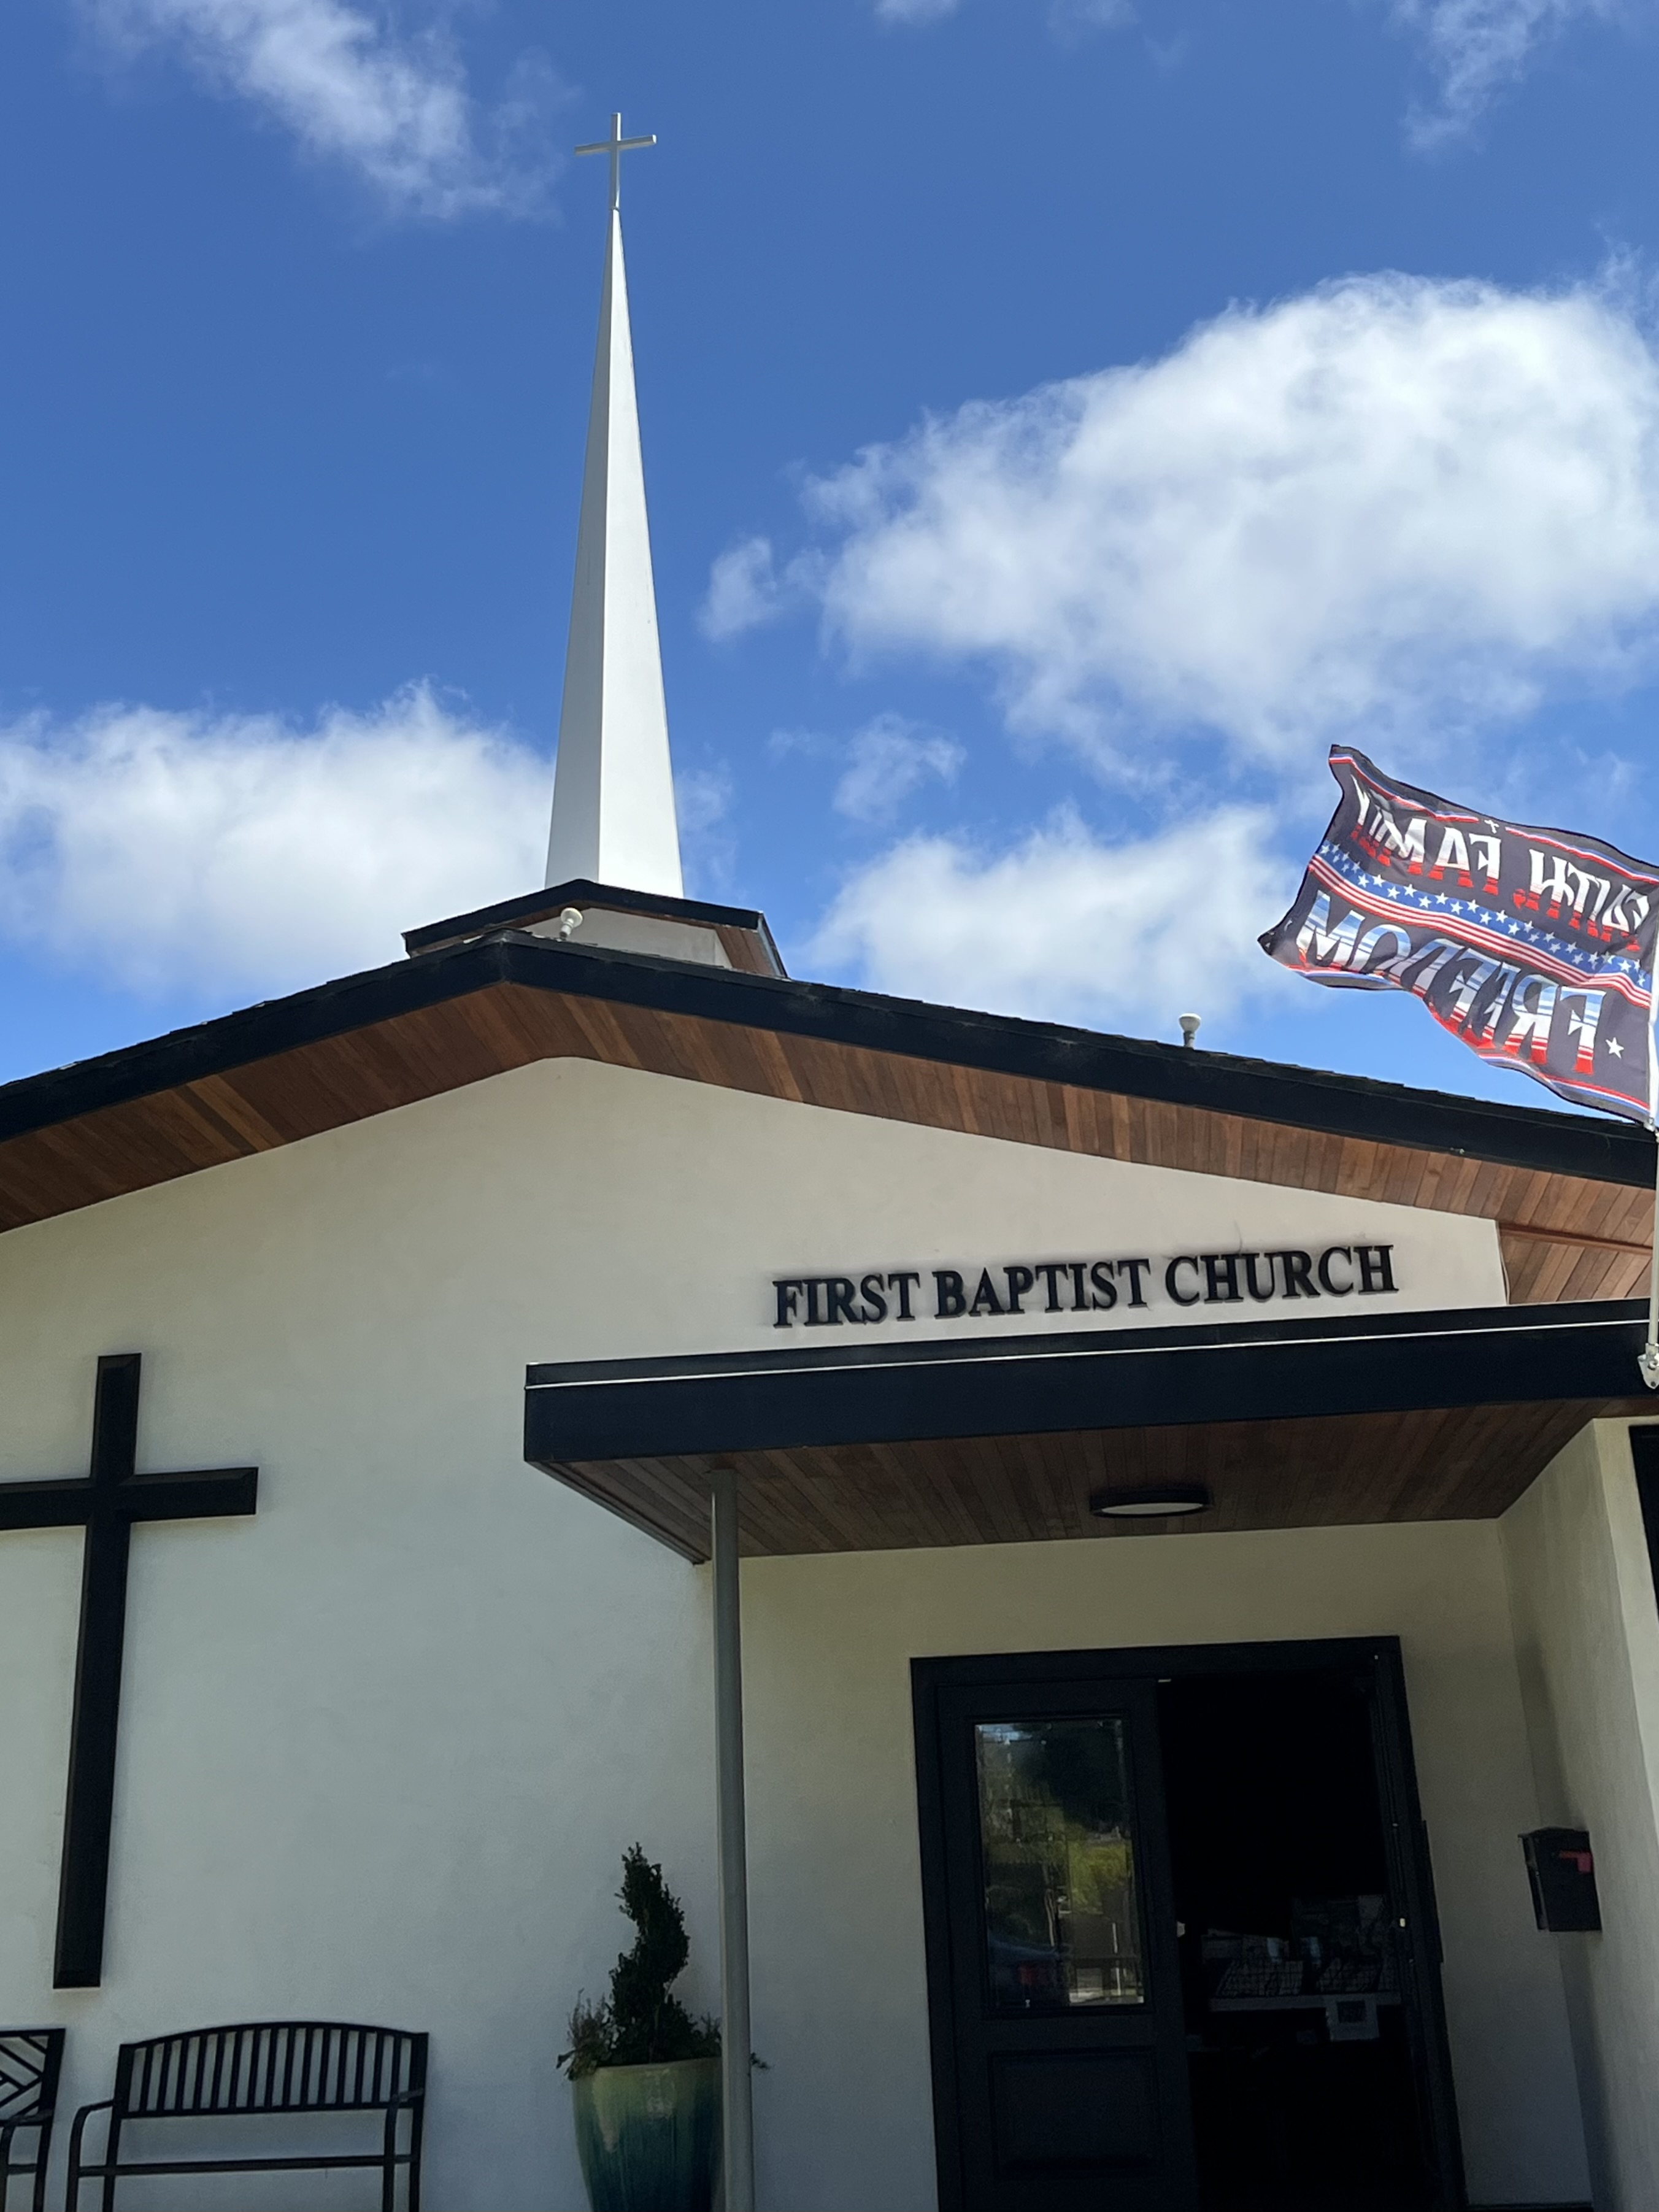

The Theology of Thanksgiving
Pastor Jim W. Baize
November 23, 2025

GEORGE WASHINGTON’S
THANKSGIVING DAY PROCLAMATION

We hear a lot about “separation of church and state” (so-called), but read the words of our first President:

Whereas it is the duty of all Nations to acknowledge the providence of Almighty God, to obey his will, to be grateful for his benefits, and humbly to implore his protection and favor—and whereas both Houses of Congress have by their joint Committee requested me “to recommend to the People of the United States a day of public thanksgiving and prayer to be observed by acknowledging with grateful hearts the many signal favors of Almighty God especially by affording them an opportunity peaceably to establish a form of government for their safety and happiness.”
Now therefore I do recommend and assign Thursday the 26th day of November next to be devoted by the People of these States to the service of that great and glorious Being, who is the beneficent Author of all the good that was, that is, or that will be—That we may then all unite in rendering unto him our sincere and humble thanks—for his kind care and protection of the People of this Country previous to their becoming a Nation—for the signal and manifold mercies, and the favorable interpositions of his Providence which we experienced in the course and conclusion of the late war—for the great degree of tranquility, union, and plenty, which we have since enjoyed—for the peaceable and rational manner, in which we have been enabled to establish constitutions of government for our safety and happiness, and particularly the national One now lately instituted—for the civil and religious liberty with which we are blessed; and the means we have of acquiring and diffusing useful knowledge; and in general for all the great and various favors which he hath been pleased to confer upon us.
And also that we may then unite in most humbly offering our prayers and supplications to the great Lord and Ruler of Nations and beseech him to pardon our national and other transgressions—to enable us all, whether in public or private stations, to perform our several and relative duties properly and punctually—to render our national government a blessing to all the people, by constantly being a Government of wise, just, and constitutional laws, discreetly and faithfully executed and obeyed—to protect and guide all Sovereigns and Nations (especially such as have shewn kindness unto us) and to bless them with good government, peace, and concord—To promote the knowledge and practice of true religion and virtue, and the increase of science among them and us—and generally to grant unto all Mankind such a degree of temporal prosperity as he alone knows to be best.
Given under my hand at the City of New-York the third day of October in the year of our Lord 1789.

Welcome to First Baptist Church of Coronado!

Adult Sunday School 8:45
Worship Service 10:00
Windsurfers Youth Group 10:00
Children’s Sunday School 10:15
Active-Duty Military Lunch 11:30

Bible Studies This Week

Tuesday
Oaks Int. Military Bible Study at FBCC
6-8 p.m.
Childcare provided

Wednesday
Ladies’ Bible Study Fellowship at FBCC 10:00
Childcare provided

Thursday
Ladies’ Bible Study at FBCC 10:30

Saturday
Men’s Coffee Club 8:00
Coffee, fellowship, and prayer

Christmas Eve/Christmas Sunday Service
Christmas is right around the corner! We have designed beautiful invitations for Christmas Sunday service on 12/21/25 and Christmas Eve Candlelight service on 12/24/25. These will be ready for you to take on Sunday, November 30th to distribute to family, friends and neighbors.

