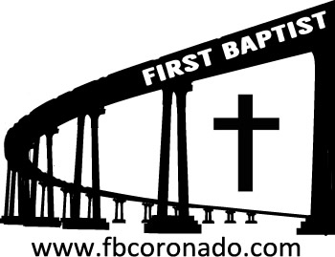

Reach Up, Reach Out, Reach Our World
445 C Avenue
Coronado, CA 92118
(619) 435-6588
fbcoronado.com
Jim W. Baize, Pastor
Julie Burkhart, Secretary, Childcare Coordinator
Patsy Lower, Treasurer
Laura Stecher, Children’s Ministry
David Preston, Youth Ministry
Dan Malcolm, Men’s Ministry/VIP Ministry
Cindy Wilson, Women’s Ministry
Monica Medina, Convalescent Ministry
Sheerah Haywood, Worship Ministry
Bobby Greer, Maintenance
Our mission is to produce fully devoted followers
of Jesus Christ. If we can be of any help to you,
feel free to give us a call.

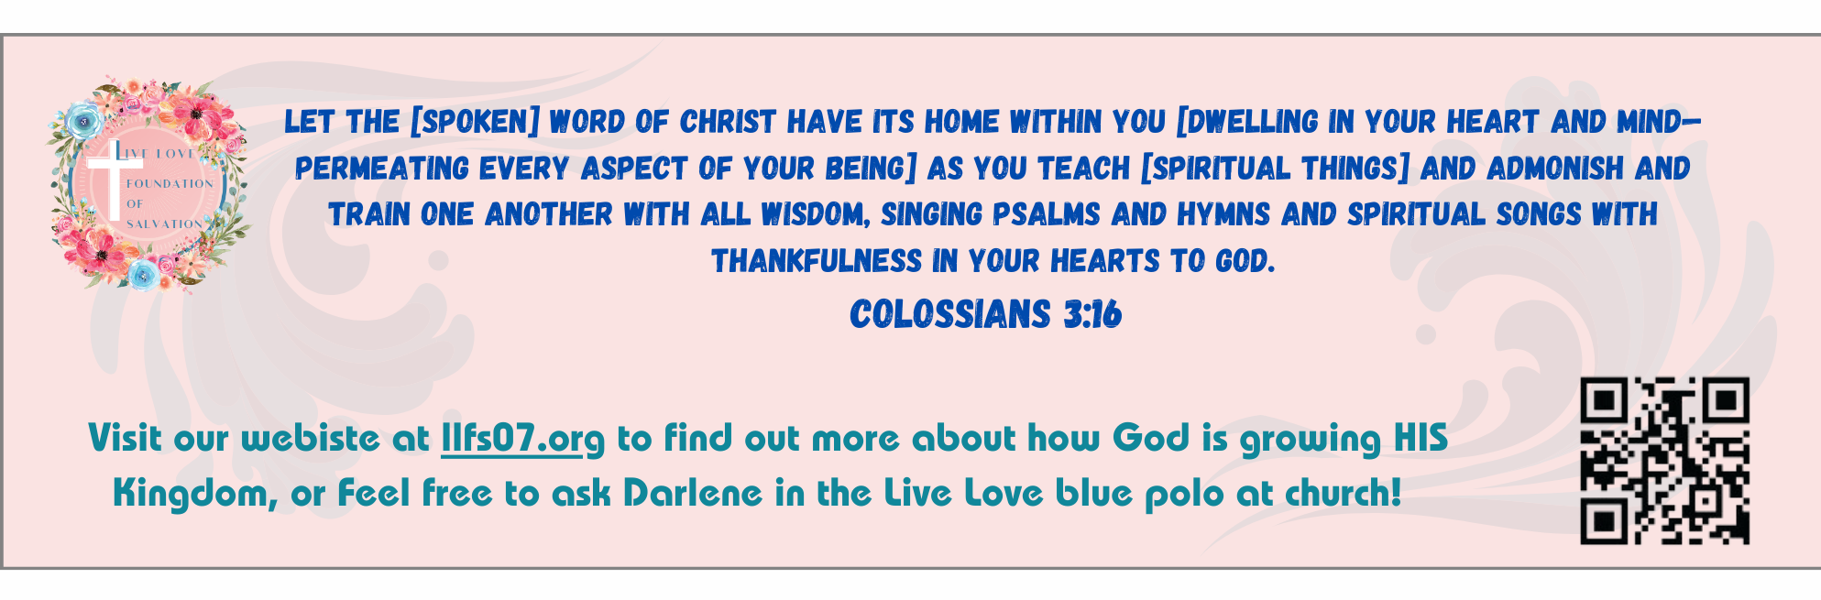
First Baptist Church of Coronado

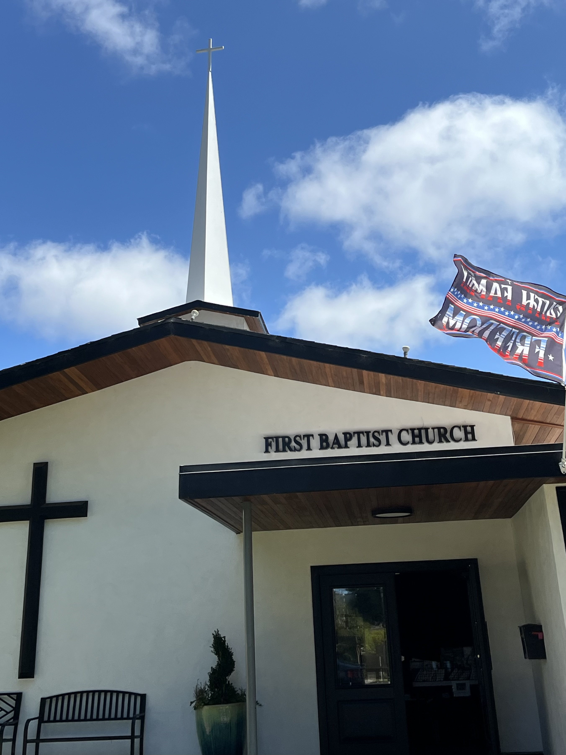

Beginning of the End
Pastor Jim W. Baize
November 2, 2025

THE SPIRIT OF ANTICHRIST
“And this is that spirit of antichrist, whereof ye have heard that it should come; and even now already is it in the world.” 1 John 4:3
The four passages in the New Testament that use this term are unique to the apostle John (1 John 2:18, 22; 4:3; 2 John 1:7). The term itself is a transliteration of the Greek compound word anti plus Christos, meaning one who is “against” Christ.
John distinguishes between “the” Antichrist (1 John 2:18) and the “many” antichrists against whom we are continually fighting today.
Although a sincere Christian should be aware of the Antichrist (the “man of sin” in 2 Thess 2:3-10), far more caution is urged to identify and fight the spirit of antichrist that is already here!
To begin with, it should be noted that there is no specific word for “spirit” in 1 John 4:3. The English word is supplied by the translators to clarify the obvious meaning of the text, that it is the attitude or character of antichrist of which we are to be wary. Those who have this spirit are liars (1 John 2:22), mainly because they refuse to accept the truth that Jesus is the Christ.
Further rejection of that truth centers around denial of the incarnation of Christ, that Jesus is the Creator God come in human flesh (1 John 4:3 and 2 John 1:7). Those who would deny that truth embrace the very core of all lies and become anti-Christ. Such persons are like the thief and the robber who harm the sheep (John 10:1), embrace another gospel (Galatians 1:6-9), and teach other doctrines (1 Timothy 1:3-7).
From such as these we are to turn away (2 Timothy 3:5). HMM III. ICR. 1.29.24

Welcome to First Baptist Church of Coronado!

Adult Sunday School 8:45
Worship Service & Communion 10:00
Children’s Sunday School 10:15
Baptisms 11:00
Active-Duty Military Lunch 11:30

Bible Studies This Week

Tuesday
Oaks Int. Military Bible Study at FBCC
6-8 p.m.
Childcare provided

Wednesday
Ladies’ Bible Study Fellowship at FBCC 10:00
Childcare provided

Thursday
Ladies’ Bible Study at FBCC 10:30

Saturday
Men’s Coffee Club 8:00
Coffee, fellowship, and prayer

Upcoming

FBCC’s Annual Ladies’ Christmas Tea Tickets on sale today!
Tickets are $20 each. There a few tickets left. Be thinking of family and friends you can invite for this wonderful evening of beautiful worship, a fabulous guest speaker, and delicious food and teas.

Samaritan’s Purse Operation Christmas Child is upon us!
Boxes are due NO LATER than Nov16th. Also, please DO NOT tape boxes shut because they have to be inspected. Boxes can be closed with rubber bands or yarn. If you would like another box text Monica Medina @ 619-547-5018.

