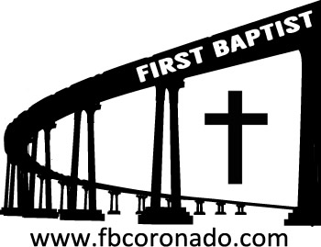

Reach Up, Reach Out, Reach Our World
445 C Avenue
Coronado, CA 92118
(619) 435-6588
fbcoronado.com
Jim W. Baize, Pastor
Julie Burkhart, Secretary, Childcare Coordinator
Patsy Lower, Treasurer
Laura Stecher, Children’s Ministry
David Preston, Youth Ministry
Dan Malcolm, Men’s Ministry/VIP Ministry
Cindy Wilson, Women’s Ministry
Monica Medina, Convalescent Ministry
Sheerah Haywood, Worship Ministry
Bobby Greer, Maintenance
Our mission is to produce fully devoted followers
of Jesus Christ. If we can be of any help to you,
feel free to give us a call.

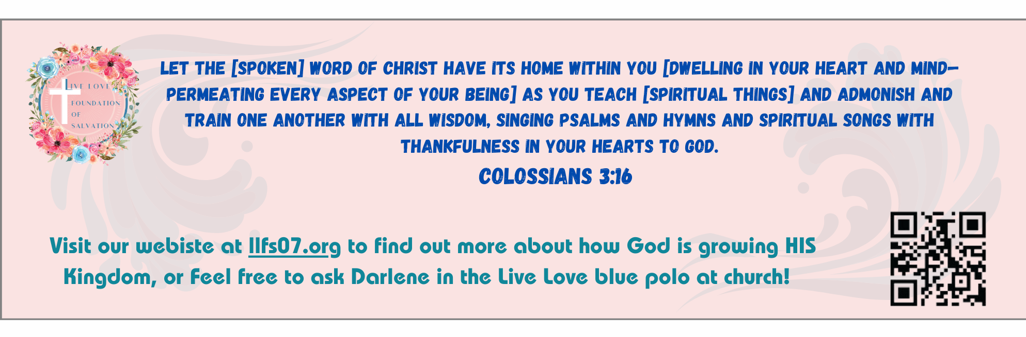

First Baptist Church
Of Coronado

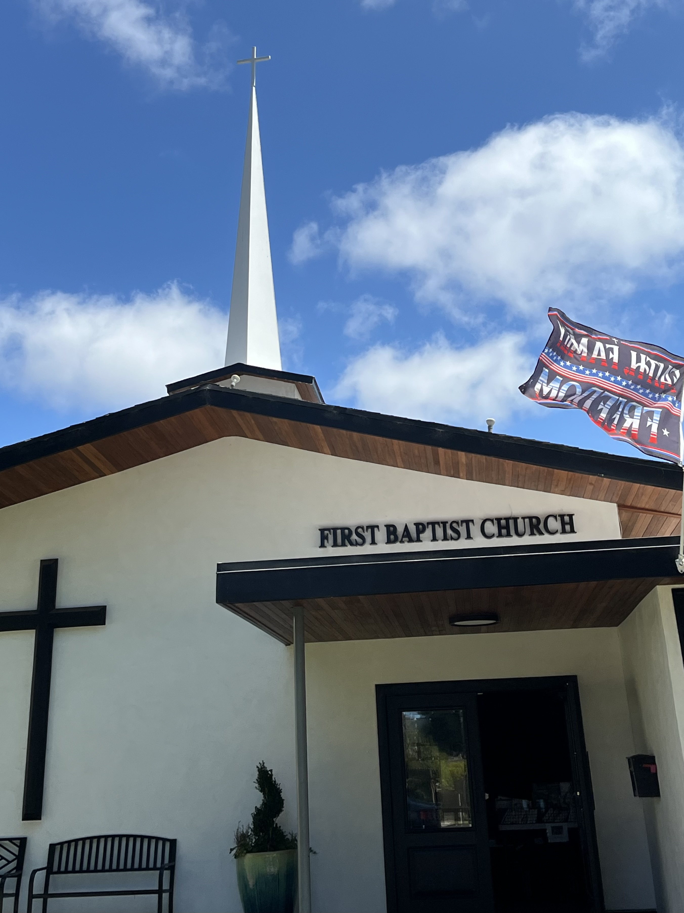

November 16, 2025
“In Jerusalem”
Pastor Jim Baize

IS ANYTHING TOO HARD FOR GOD?
“Is anything too hard for the LORD? At the time appointed I will return unto thee, according to the time of life, and Sarah shall have a son.” (Genesis 18:14)
This rhetorical question posed to Abraham by the Lord was in response to Sarah’s doubts concerning His promise that they would have a son. It would, indeed, require a biological miracle, for both were much too old for this to happen otherwise. With God, however, all things are possible, and He can, and will, fulfill every promise, even if a miracle is required.
This same rhetorical question was asked of the prophet Jeremiah. “Then came the word of the LORD unto Jeremiah, saying, Behold, I am the LORD, the God of all flesh: is there anything too hard for me?” (Jeremiah 32:26-27). The One who created all flesh, who raises up kings and puts them down, could surely fulfill His promise to restore Israel to its homeland when the set time had come.
But Jeremiah had already confessed his faith in God’s omnipotence. “Ah Lord GOD! behold, thou hast made the heaven and the earth by thy great power and stretched out arm, and there is nothing too hard for thee” (Jeremiah 32:17). The God who called the mighty universe into being would not fail to keep His promise and fulfill His will.
Actually, the word translated “hard” in these verses is more commonly rendered “wonderful,” or “marvelous,” or an equivalent adjective, referring usually to something miraculous that could only be accomplished by God. For example, “marvelous things did he...in the land of Egypt” (Psalm 78:12). “For thou art great, and doest wondrous things: thou art God alone” (Psalm 86:10).
The first occurrence of the word (Hebrew pala), however, is in our text for today. There is nothing—no thing—too hard for the Lord, and we should never doubt His word! HMM. ICR. 7.26.23

Welcome to First Baptist Church of Coronado!

Adult Sunday School 8:45
Worship Service 10:00
Children’s Sunday School 10:15
Active-Duty Military Lunch 11:30

Bible Studies This Week

Tuesday
Oaks Int. Military Bible Study at FBCC
6-8 p.m.
Childcare provided

Wednesday
Ladies’ Bible Study Fellowship at FBCC 10:00
Childcare provided

Thursday
Ladies’ Bible Study at FBCC 10:30

Saturday
Men’s Coffee Club 8:00
Coffee, fellowship, and prayer

