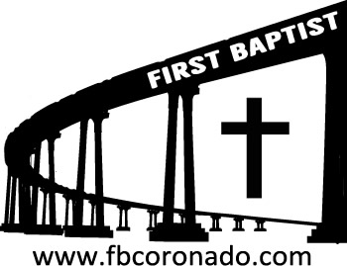

Reach Up, Reach Out, Reach Our World
445 C Avenue
Coronado, CA 92118
(619) 435-6588
fbcoronado.com
Jim W. Baize, Pastor
Julie Burkhart, Secretary, Childcare Coordinator
Patsy Lower, Treasurer
Laura Stecher, Children’s Ministry
Dan Malcolm, Men’s Ministry/VIP Ministry
Cindy Wilson, Women’s Ministry
Monica Medina, Convalescent Ministry
Sheerah Haywood, Worship Ministry
Bobby Greer, Maintenance
Our mission is to produce fully devoted followers
of Jesus Christ. If we can be of any help to you,
feel free to give us a call.

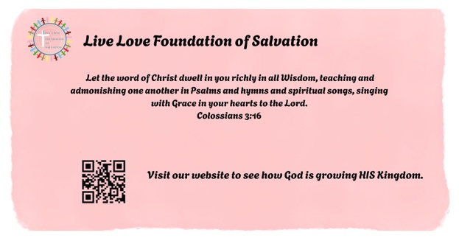

First Baptist Church
of Coronado

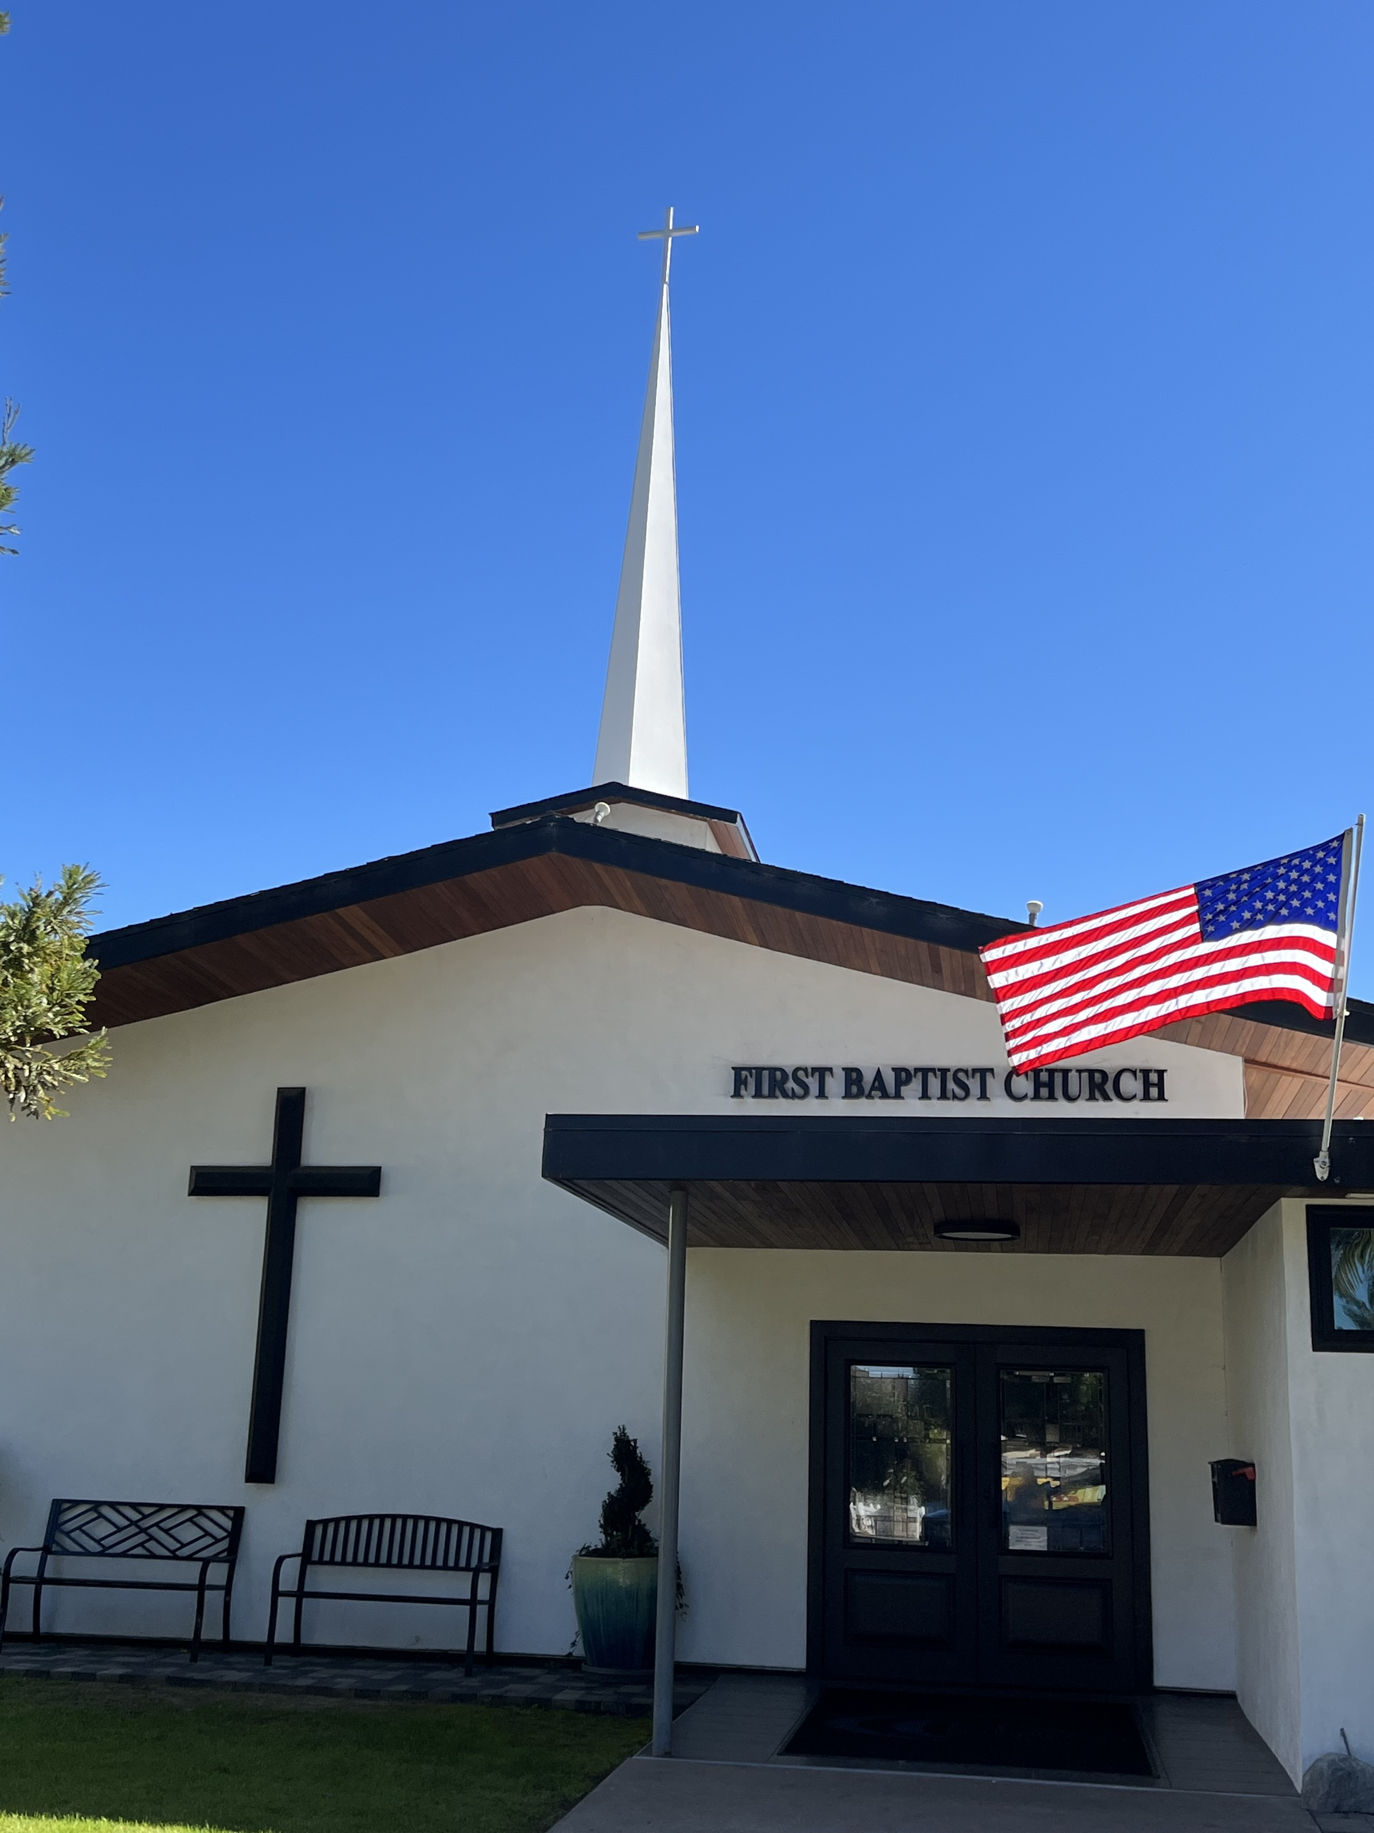

THE DOCTRINE OF SALVATION
Pastor Jim W. Baize
October 4, 2026

THE IMPORTANCE OF SPIRITUAL HERITAGE by Pat Baize

Last week in Dallas, a woman named Mavis celebrated her 100th birthday. I sent my love and eternal gratitude.
Why am I telling you about Mavis? Because without her, I might not be your pastor’s wife or maybe not even be a Christian. She is part of my spiritual heritage. Let me explain.
Our family moved to a new town when I was 6 years old. My father, a US Army Sergeant, was transferred to Ft. Riley, KS. My parents looked for a good church and found Calvary Baptist Church. It became an important part of our lives. I accepted Christ as my Savior the second Sunday we attended.
My mother had accepted Christ just a few months earlier at a Tent Meeting in Dallas. Our family was invited to that meeting by Mom’s brother, my uncle Luther.
Luther was a new Christian, himself. His wife Maggie invited him to go to church with her.
Maggie had recently become a Christian because her friend, Mavis, had invited her to church. Mavis was also a new Christian.
Mavis had been invited to church by yet another friend, Peggy, who had recently accepted Christ because her grandmother, Granny Creech, prayed for her.
In Heaven, I’ll look for Granny Creech and thank her for the part she had in my eternal salvation. I’ll ask who led her to the Lord; I’ll find them and thank them, and on and on.
How important is it to invite people to church with you? I’m thinking very important...family, friends, neighbors, perfect strangers...imperfect strangers, too.
I encourage you to remember those who had a part in your salvation and Christian growth and make it a point to thank them.
I don’t know how long Granny Creech prayed, but she didn’t give up. Keep praying!

Welcome to First Baptist Church of Coronado!

Adult Sunday School 8:45
Worship Service & Communion 10:00
Children’s Sunday School 10:15

Bible Studies This Week

Tuesday
Oaks Int. Military Bible Study
6-8 p.m. Childcare provided

Wednesday
Women’s BSF 10:00-11:30
Childcare provided

Thursday
Women’s Bible Study 10:30-Noon

Saturday
Men’s Coffee & Bible Study
Grounds & Grace
Brothers in the Word helping iron sharpen iron.
Invite a friend.

Candy Needed!
FBCC’s 8th Annual Fall Outreach is Halloween from 4-9 pm and we are collecting candy! Lots of candy! If you are able, please bring candy to the church office. If you are interested in volunteering your time for this event a sign-up sheet will be circulated Sunday mornings.





