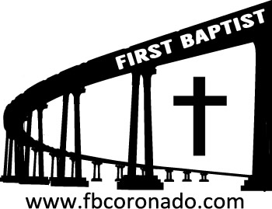

Reach Up, Reach Out, Reach Our World
445 C Avenue
Coronado, CA 92118
(619) 435-6588
fbcoronado.com
Jim W. Baize, Pastor
Julie Burkhart, Secretary, Childcare Coordinator
Patsy Lower, Treasurer
Laura Stecher, Children’s Ministry
David Preston, Youth Ministry
Dan Malcolm, Men’s Ministry/VIP Ministry
Cindy Wilson, Women’s Ministry
Monica Medina, Convalescent Ministry
Sheerah Haywood, Worship Ministry
Bobby Greer, Maintenance
Our mission is to produce fully devoted followers
of Jesus Christ. If we can be of any help to you,
feel free to give us a call.

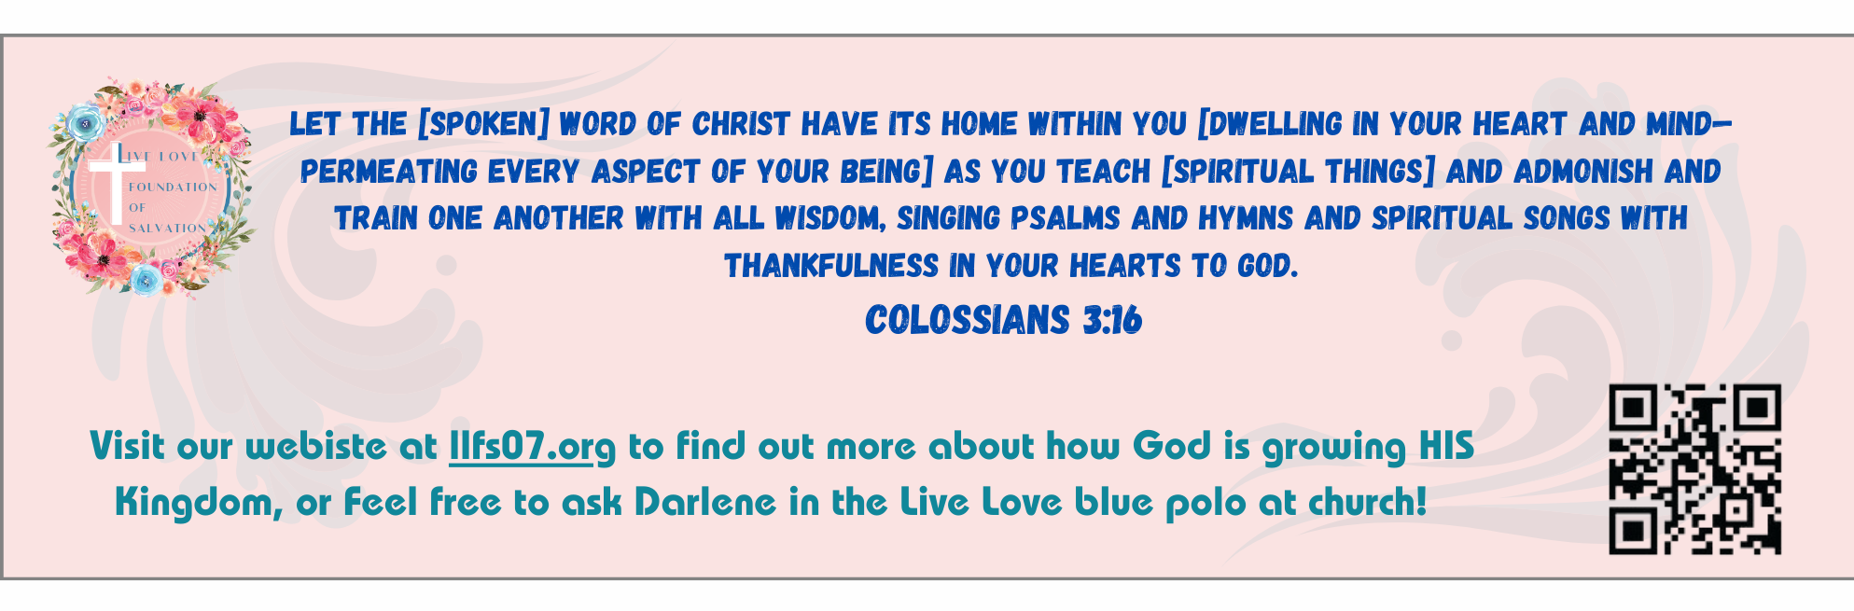
First Baptist Church of Coronado

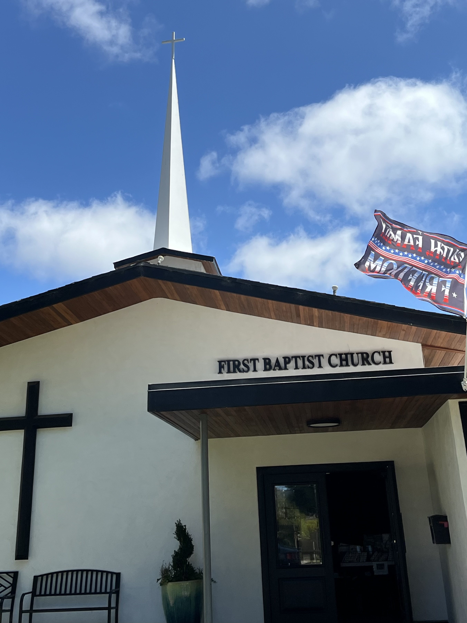

On The Road Again
Pastor Jim W. Baize
October 26, 2025
CREATOR

“For by him were all things created, that are in heaven, and that are in earth, visible and invisible, whether they be thrones, or dominions, or principalities, or powers: all things were created by Him, and for Him.” Col 1:16
The phrase “all things” is used throughout these verses to emphasize that everything has been brought into existence by the “dear Son” Col 1:13, 16-20
- All things were created through Him and for Him.
- All things consist (stand together) in Him.
- All things will give preeminence to Him.
- All things reside in His fullness.
- All things will be reconciled to Him.
The list of created things in v 16 is exhaustive: heaven, Earth, visible and invisible things, and the rulers in and of the universe—thrones, dominions, principalities, powers. Jesus Christ is “far above all principality, and power, and might, and dominion, and every name that is named, not only in this world, but also in that which is to come” Eph 1:21.
The Creator existed before all things and now “approves” all things. Solomon understood this as he spoke of wisdom: “The LORD possessed me in the beginning of his way, before his works of old. I was set up from everlasting, from the beginning, or ever the earth was” Pro 8:22-23, just as He chose us “before the foundation of the world” Eph 1:4.
When the Lord Jesus revealed Himself to John, He said, “I am Alpha and Omega, the beginning and the ending, saith the Lord, which is, and which was, and which is to come, the Almighty” Rev 1:8. These grand sweeps of eternity are anchors for our faith. But we must not lose sight that “the heavens and the earth, which are now, by the same word [the word of the Creator] are kept in store, reserved unto fire against the day of judgment and perdition of ungodly men” 2 Pet 3:7. HMM III. ICR. 10.13.25

Welcome to First Baptist Church of Coronado!

Adult Sunday School 8:45
Worship Service 10:00
Windsurfers Youth Group 10:00
Children’s Sunday School 10:15
Active-Duty Military Lunch 11:30

Bible Studies This Week

Tuesday
Oaks Int. Military Bible Study at FBCC
6-8 p.m.
Childcare provided

Wednesday
Ladies’ Bible Study Fellowship at FBCC 10:00
Childcare provided

Thursday
Ladies’ Bible Study at FBCC 10:30

Saturday
Men’s Coffee Club 8:00
Coffee, fellowship, and prayer

Upcoming

FBCC’s Annual Ladies’ Christmas Tea Tickets on sale today!
Tickets on sale today after the worship service. Tickets are $20 each. Be thinking of family and friends you can invite for this wonderful evening of beautiful worship, a fabulous guest speaker, and delicious food and teas.

Samaritan’s Purse Operation Christmas Child is upon us!
We will have an opportunity to pack a shoebox (provided by Samaritan’s Purse) with gifts for a boy or girl. All boxes must be filled and returned to FBCC by November 16th. Please be thinking about participating in this wonderful Christmas ministry!

Men’s Breakfast Saturday, November 1 8:00

Communion Observed Sunday, November 2

