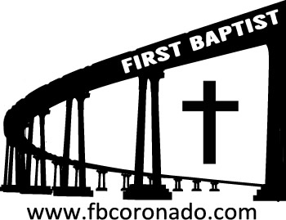

Reach Up, Reach Out, Reach Our World
445 C Avenue
Coronado, CA 92118
(619) 435-6588
fbcoronado.com
Jim W. Baize, Pastor
Julie Burkhart, Secretary, Childcare Coordinator
Patsy Lower, Treasurer
Laura Stecher, Children’s Ministry
David Preston, Youth Ministry
Dan Malcolm, Men’s Ministry/VIP Ministry
Cindy Wilson, Women’s Ministry
Monica Medina, Convalescent Ministry
Sheerah Haywood, Worship Ministry
Bobby Greer, Maintenance
Our mission is to produce fully devoted followers
of Jesus Christ. If we can be of any help to you,
feel free to give us a call.

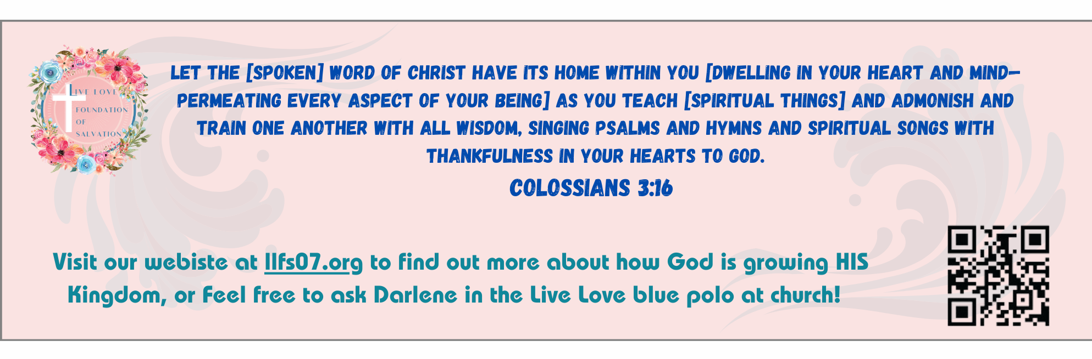
First Baptist Church of Coronado

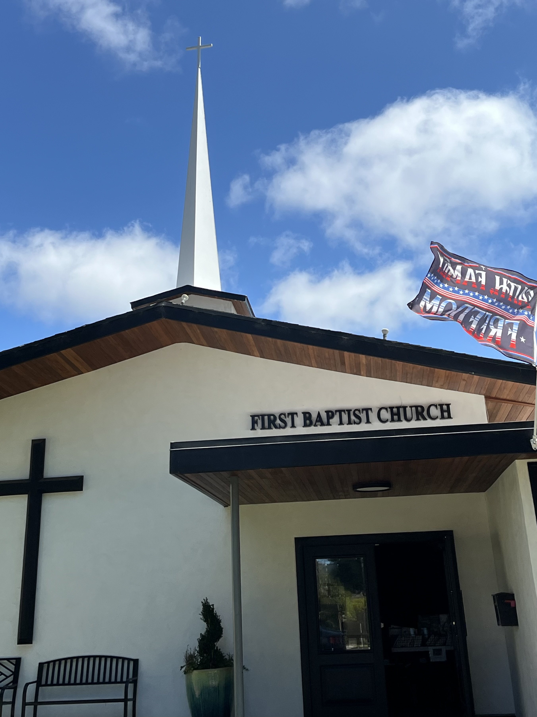

Ephesus and Diana
Pastor Jim W. Baize
October 19, 2025

WE LOVE FIRST BAPTIST CHURCH, CORONADO!

Every so often I hear about or read about a pastor being treated poorly by his flock. Granted, some preachers are not what they ought to be, but some love the Lord and their people, but are blindsided by one or more church members who are unhappy with him for some reason.

I empathize with them. I can’t imagine how that would feel. Pat and I have felt so loved and appreciated for most all of the 55 years we have been serving the Lord and His people!

I know it is the pure grace of God because I have not always been the best pastor! God knows I should have handled some things differently…but He is so good.

And YOU are so good! We sat down Sunday afternoon and read the beautiful cards that many of you got to sign for Pastor Appreciation Sunday. It is wonderful to feel all the love and acceptance. It makes me want to be a better pastor to you all!

Thank you for the greetings and thank you for the food gift cards! You sure know the way to our hearts! If it is God’s will, we hope to be here for quite a while longer!

May God richly bless you and our church family!

Welcome to First Baptist Church of Coronado!

Adult Sunday School 8:45
Worship Service 10:00
Children’s Sunday School 10:15
Active-Duty Military Lunch 11:30

Bible Studies This Week

Tuesday
Oaks Int. Military Bible Study at FBCC
6-8 p.m.
Childcare provided

Wednesday
Ladies’ Bible Study Fellowship at FBCC 10:00
Childcare provided

Thursday
Ladies’ Bible Study at FBCC 10:30

Saturday
Men’s Coffee Club 8:00
Coffee, fellowship, and prayer

Upcoming

FBCC’s Annual Ladies’ Christmas Tea Tickets on sale today!
Reserve your spot now ladies as there are just 64 tickets available. Tickets go on sale today after the worship service. Tickets are $20 each. Be thinking of family and friends you can invite for this wonderful evening of beautiful worship, a fabulous guest speaker, and delicious food and teas.

The Creation and Earth History Museum Church Tour
Saturday, October 25 Meet in the parking lot of the museum at 1:15. Tour is from 1:30-4 pm
10946 Woodside Ave. N Santee, CA 92071
See David Preston for more details.

Samaritan’s Purse Operation Christmas Child is upon us!
We will have an opportunity to pack a shoebox (provided by Samaritan’s Purse) with gifts for a boy or girl. Monica Medina is heading up this ministry and will give details today about this gift giving event. All boxes must be filled and returned to FBCC by November 16th. Please be thinking about participating in this wonderful Christmas ministry!

