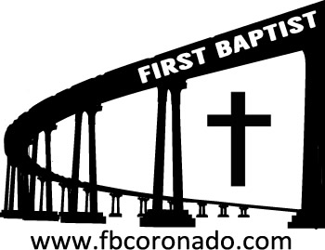

Reach Up, Reach Out, Reach Our World
445 C Avenue
Coronado, CA 92118
(619) 435-6588
fbcoronado.com
Jim W. Baize, Pastor
Julie Burkhart, Secretary, Childcare Coordinator
Patsy Lower, Treasurer
Laura Stecher, Children’s Ministry
David Preston, Youth Ministry
Dan Malcolm, Men’s Ministry/VIP Ministry
Cindy Wilson, Women’s Ministry
Monica Medina, Convalescent Ministry
Sheerah Haywood, Worship Ministry
Bobby Greer, Maintenance
Our mission is to produce fully devoted followers
of Jesus Christ. If we can be of any help to you,
feel free to give us a call.

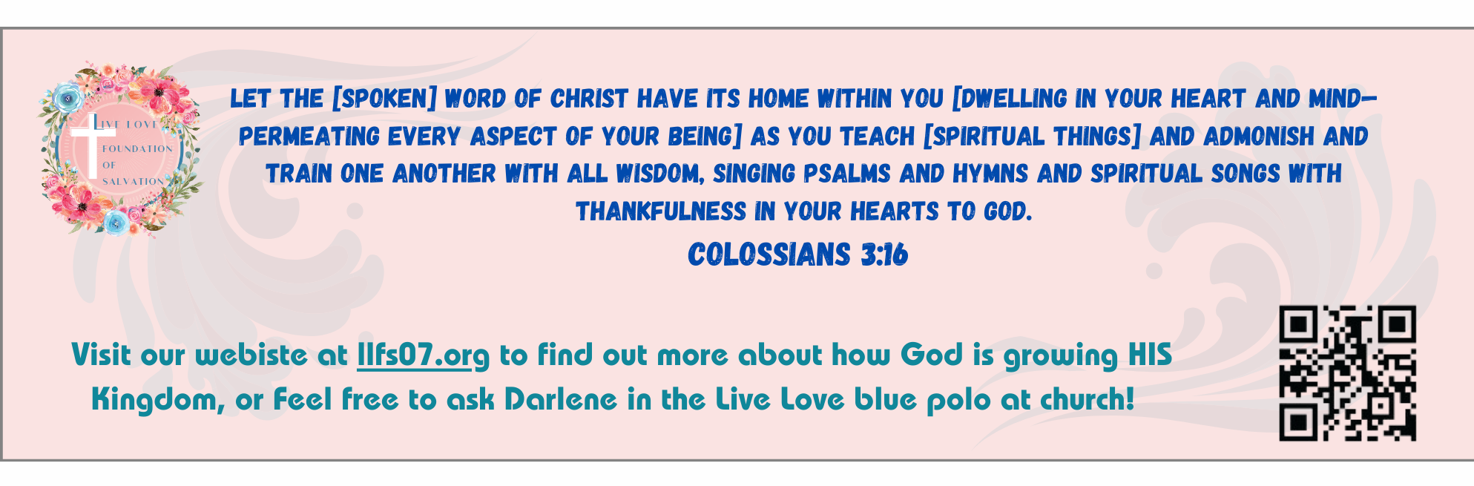
First Baptist Church of Coronado

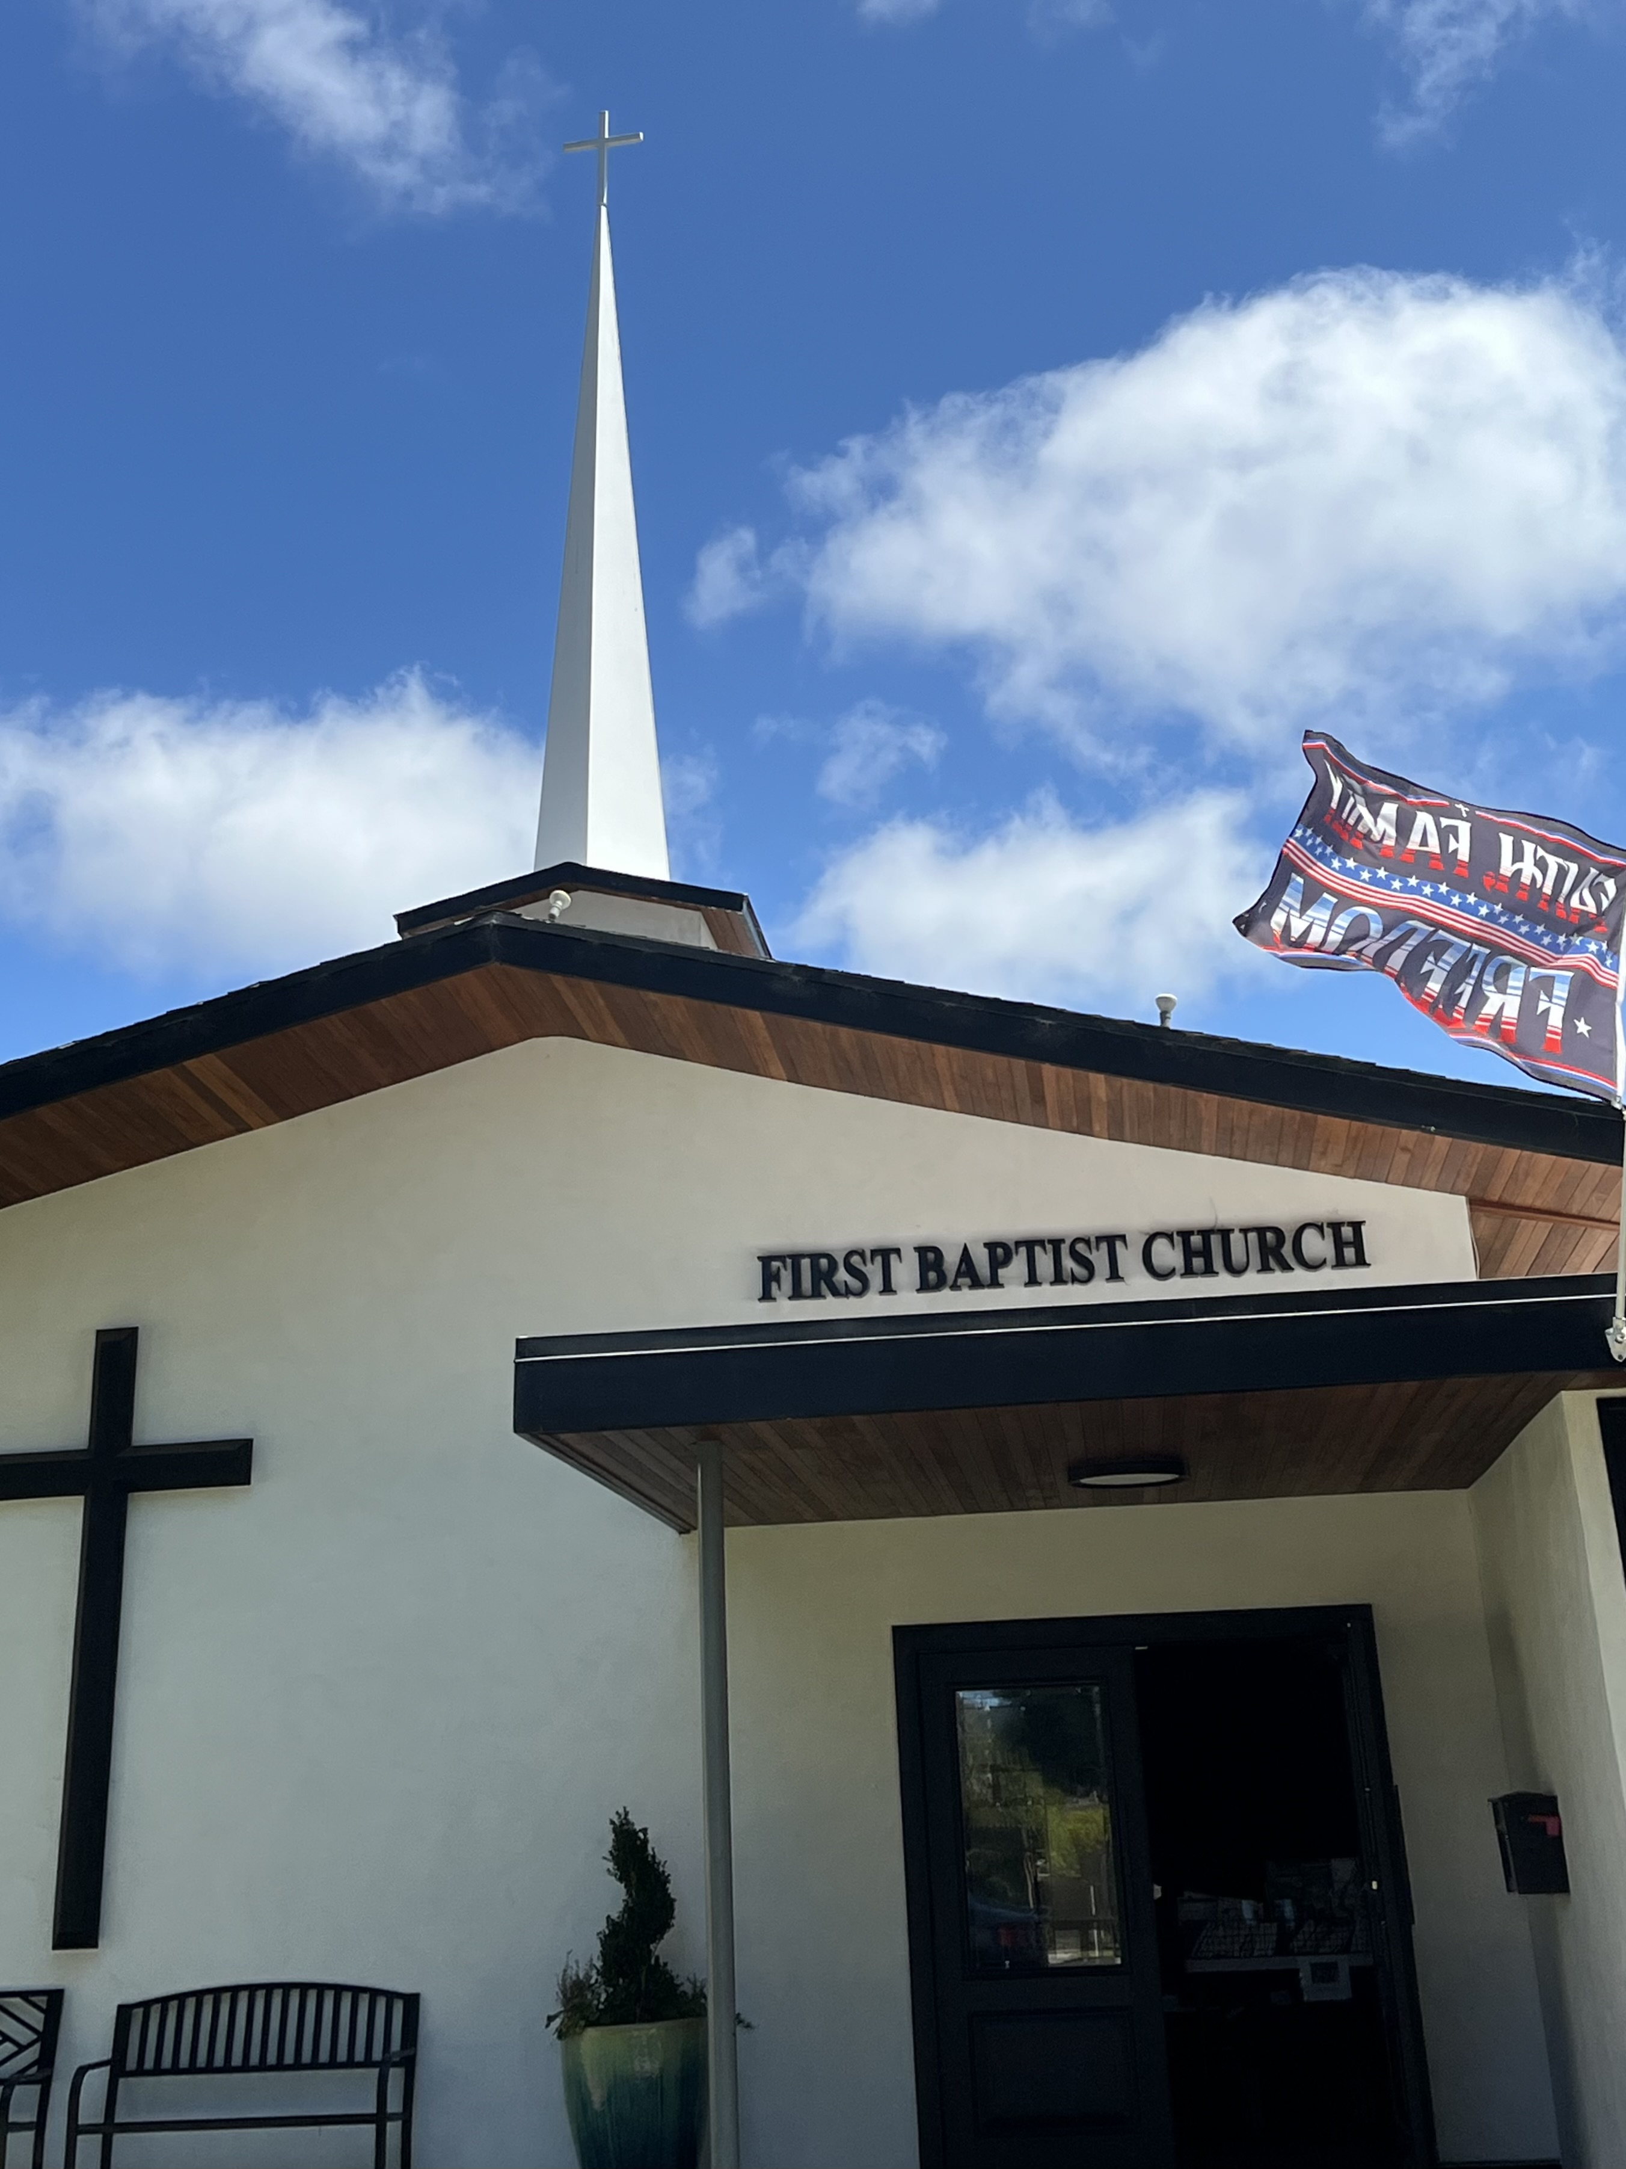

Meanwhile, in Ephesus
Pastor Jim W. Baize
October 12, 2025

CREATION, YOUNG EARTH, MALE & FEMALE

"And unto the angel of the church of the Laodiceans write; These things saith the Amen, the faithful and true witness, the beginning of the creation of God." Rev 3:14 This salutation in the last of the seven church epistles in Revelation contains the last of four occurrences of the distinctive phrase "the beginning of the creation." The glorified Christ here assumes this as one of His divine names. Note that even God's work of creation, long since completed (Genesis 2:1-3), had a beginning, and that beginning was Christ. "In the beginning was the Word....All things were made by him" John 1:1, 3.

The first two occurrences of this phrase also come from the lips of Christ. "From the beginning of the creation
God made them male and female" Mark 10:6. This assertion by the Creator, Jesus Christ (quoting Gen 1:27), makes it unambiguously certain that Adam and Eve were created at the beginning of creation, not after the earth had already existed for 4.5 billion years. God also wrote this plainly on the tables of the law (Exo 20:8-11). Those evangelicals who accept the geological ages evidently reject this clear statement of the creation's Creator!

Then Christ also referred to the end-times in the context of the beginning-times. "In those days shall be affliction, such as was not from the beginning of the creation which God created unto this time, neither shall be" Mark 13:19. The phrase is also used in Peter's very important prophecy concerning the scoffers of the end-times who will argue (in willful ignorance) that "all things continue as they were from the beginning of the creation" (2 Peter 3:3-4), thereby denying that there ever was a real creation or real Creator and thus rejecting Christ Himself. But He is also the "true witness" and the "Amen," and such denials will only be "unto their own destruction” (2 Peter 3:16).
HMM. ICR 6.18.22

Welcome to First Baptist Church of Coronado!

Adult Sunday School 8:45
Worship Service 10:00
Windsurfers Youth Group 10:00
Children’s Sunday School 10:15
Fellowship BBQ Potluck at Spreckles Park 11:30

Bible Studies This Week

Tuesday
Oaks Int. Military Bible Study at FBCC
6-8 p.m.
Childcare provided

Wednesday
Ladies’ Bible Study Fellowship at FBCC 10:00
Childcare provided

Thursday
Ladies’ Bible Study at FBCC 10:30

Saturday
Men’s Coffee Club 8:00
Coffee, fellowship, and prayer

Upcoming

FBCC’s Annual Ladies’ Christmas Tea Friday December 12th 5-8 pm
Reserve your spot now ladies as there are just 64 tickets available. Tickets go on sale October 19th after the worship service. Tickets are $20 each. Be thinking of family and friends you can invite for this wonderful evening of beautiful worship, a fabulous guest speaker, and delicious food and teas.

