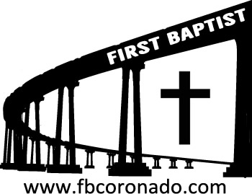

Reach Up, Reach Out, Reach Our World
445 C Avenue
Coronado, CA 92118
(619) 435-6588
fbcoronado.com
Jim W. Baize, Pastor
Julie Burkhart, Secretary, Childcare Coordinator
Patsy Lower, Treasurer
Laura Stecher, Children’s Ministry
Dan Malcolm, Men’s Ministry/VIP Ministry
Cindy Wilson, Women’s Ministry
Monica Medina, Convalescent Ministry
Sheerah Haywood, Worship Ministry
Bobby Greer, Maintenance
Our mission is to produce fully devoted followers
of Jesus Christ. If we can be of any help to you,
feel free to give us a call.

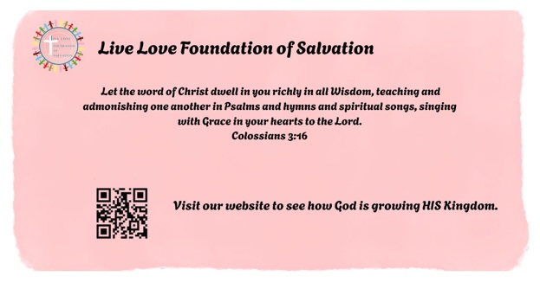

First Baptist Church
of Coronado

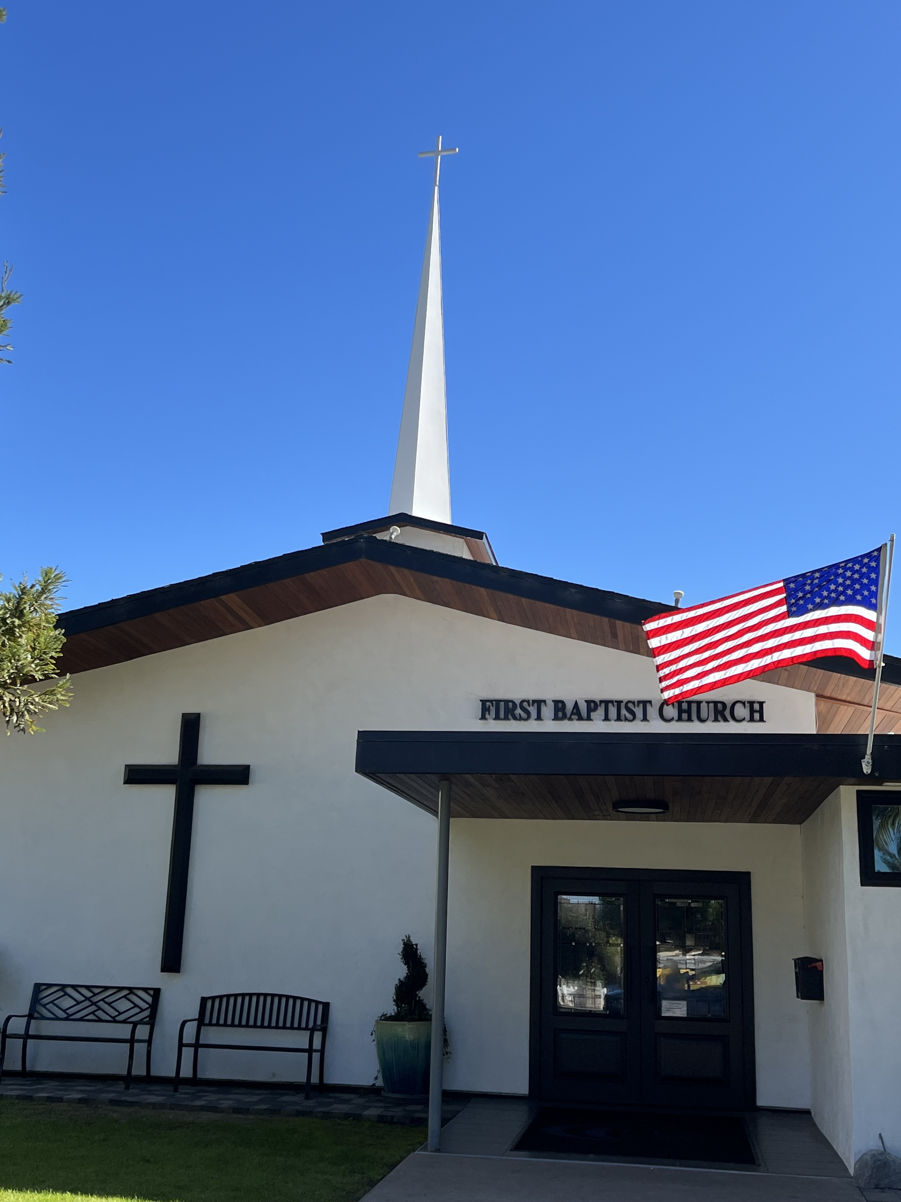

“I BELIEVE, HELP MY UNBELIEF”
Pastor Jim W. Baize
October 11, 2026

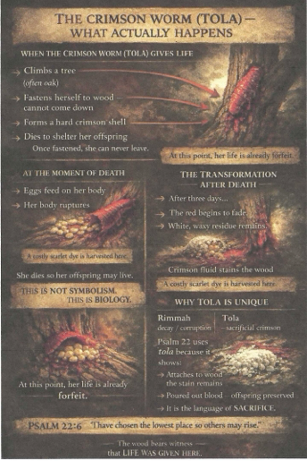

Welcome to First Baptist Church of Coronado!

Adult Sunday School 8:45
Worship Service 10:00
Children’s Sunday School 10:15

Bible Studies This Week

Tuesday
Oaks Int. Military Bible Study
6-8 p.m. Childcare provided

Wednesday
Women’s BSF 10:00-11:30
Childcare provided

Thursday
Women’s Bible Study 10:30-Noon

Saturday
Men’s Coffee & Bible Study
Grounds & Grace
Brothers in the Word helping iron sharpen iron.
Invite a friend.

Candy Needed!
FBCC’s 8th Annual Fall Outreach is Halloween from 4-9 pm and we are collecting candy! Lots of candy! If you are able, please bring candy to the church office. If you are interested in volunteering your time for this event a sign-up sheet will be circulated Sunday mornings.

