

Reach Up, Reach Out, Reach Our World
445 C Avenue
Coronado, CA 92118
(619) 435-6588
fbcoronado.com
Jim W. Baize, Pastor
Julie Burkhart, Secretary, Childcare Coordinator
Patsy Lower, Treasurer
Laura Stecher, Children’s Ministry
Dan Malcolm, Men’s Ministry/VIP Ministry
Cindy Wilson, Women’s Ministry
Monica Medina, Convalescent Ministry
Sheerah Haywood, Worship Ministry
Bobby Greer, Maintenance
Our mission is to produce fully devoted followers
of Jesus Christ. If we can be of any help to you,
feel free to give us a call.

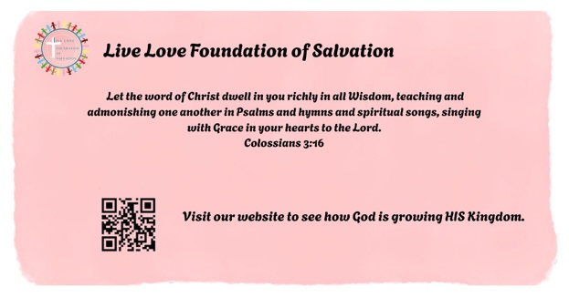

First Baptist Church
of Coronado

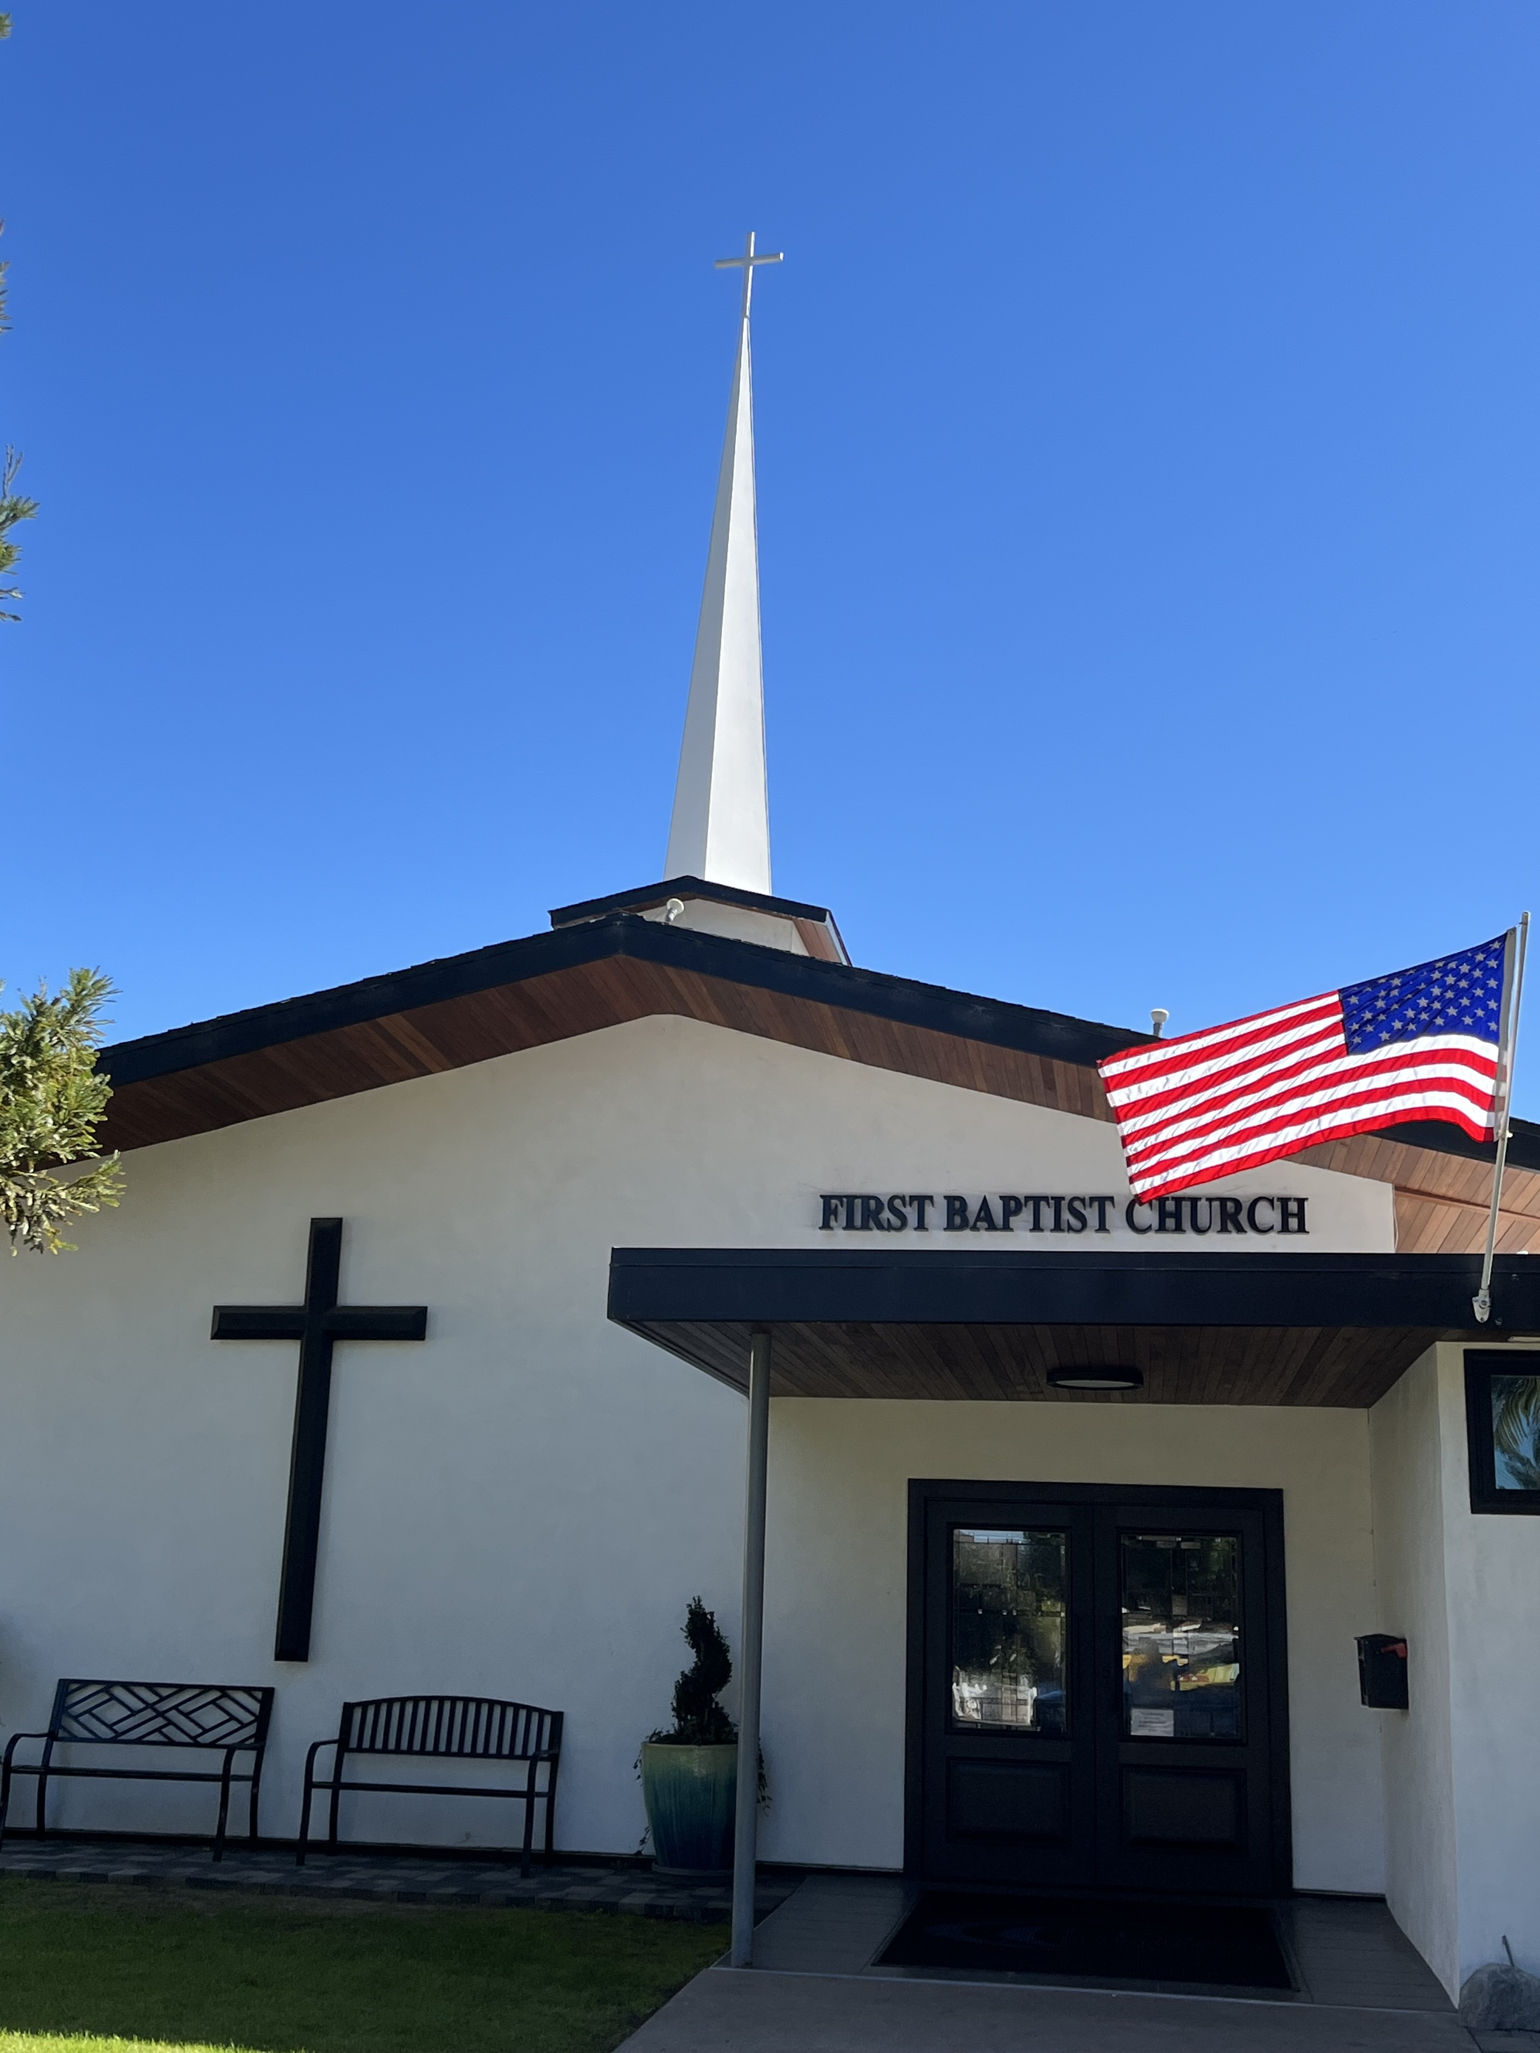

THE FALL OF MANKIND
Pastor Jim W. Baize
September 27, 2026

“THE SCARS OF SIN”

“But the Philistines took him (Samson), and put out his eyes, and brought him down to Gaza, and bound him with fetters of brass; and he did grind in the prison house.” (Judges 16:21)
The sad end of mighty Samson, who once had been so greatly energized and utilized by the Lord, is also an allegory and a grave warning to every Christian. “But every man is tempted, when he is drawn away of his own lust, and enticed. Then when lust hath conceived, it bringeth forth sin: and sin, when it is finished, bringeth forth death” (James 1:14-15).
Satan knows our individual weaknesses and tempts us accordingly. Many Christians have fallen into sin through
some Delilah, but probably many more have fallen into sin through pride, or covetousness, or compromise, or apathy.
First, sin blinds. We are commanded to grow in Christ,
adding to our initial faith the attributes of virtue, knowledge, temperance, patience, godliness, kindness, and love (2 Pet 1:5-7). Otherwise, “he that lacks these things is blind, and
cannot see afar off, and has forgotten that he was purged from his
old sins” (2 Peter 1:9).
Then, sin binds. It may not be with chains, as with Samson,
but unconfessed sin quickly enslaves its practitioners. “While they promise them liberty, they themselves are the servants of corruption: for of whom a man is overcome, of the same is he brought in bondage” (2 Peter 2:19).
Finally, sin grinds. Instead of the promised freedom from restraint, a sinful life soon becomes a “grind,” tedious and tasteless, like “the dog turned to his own vomit again” (2 Peter 2:22).
Samson did return to God again before his death, but he was still blind, and bound, and grinding. God forgives, but the effects of sin are not easily removed. How much better it
would be never to yield to the temptation at all. HMM. ICR.1.9.24

Welcome to First Baptist Church of Coronado!

Adult Sunday School 8:45
Worship Service 10:00
Children’s Sunday School 10:15

Bible Studies This Week

Tuesday
Oaks Int. Military Bible Study
6-8 p.m. Childcare provided

Wednesday
Women’s BSF 10:00-11:30
Childcare provided

Thursday
Women’s Bible Study 10:30-Noon

Saturday
Men’s Coffee & Bible Study
Grounds & Grace
Brothers in the Word helping iron sharpen iron.
Invite a friend.

Men’s Breakfast Saturday, October 3, 8:00









