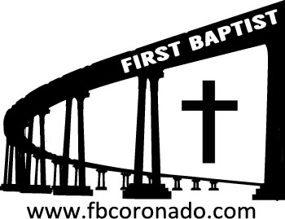

*Reach Up, Reach Out, Reach Our World*

445 C Avenue

Coronado, CA 92118

(619) 435-6588

fbcoronado.com

Jim W. Baize, Pastor

Julie Burkhart, Secretary, Childcare Coordinator

Patsy Lower, Treasurer

Laura Stecher, Children’s Ministry

David Preston, Youth Ministry

Dan Malcolm, Men’s Ministry/VIP Ministry

Cindy Wilson, Women’s Ministry

Monica Medina, Convalescent Ministry

Sheerah Haywood, Worship Ministry

Bobby Greer, Maintenance

Our mission is to produce fully devoted followers

of Jesus Christ. If we can be of any help to you,

feel free to give us a call.

***First Baptist Church of Coronado***

***FROM HERO TO ZERO***

***Pastor Jim W. Baize***

***August 24, 2025***

**IN THE SPOTLIGHT**

I think I am correct in assuming most of us like to have favorable recognition. If that were not the case, there would be no “participation trophies.” We like the kind things people say about us. We enjoy hearing others brag on us. But wrapped up in all that is a danger. *Will we accept praise and glory that rightfully belongs to another?*

If you are an officer and you have some hard-working, quality sailors under you, your superiors may think you are really doing an exceptional job, and it will be reflected in your fitness reports. You may receive high praise for the work others do. The same can happen in retail, industry, or (gasp!) ministry. Instead of accepting praise that belongs to others, deflect it to those who deserve it!

At Lystra, Paul and Barnabas found themselves the object of, not only amazement, but of worship! The priest of a pagan religion was going to offer animal sacrifices to them! How did they react? They tore their cloths as a sign of spiritual consternation and grief! They cried out, *“we are men of like passions…”* And they refused to accept praise that belonged to another. In this case, it belonged to God!

If we are ever tempted to accept praise as if we are “hot stuff,” I have two words for us: “*Remember Agrippa*!” He was hot…until he wasn’t!

*Proverbs 16:18 Pride goes before destruction,*

*And a haughty spirit before a fall.*

**Welcome to First Baptist Church of Coronado!**

Adult Sunday School 8:45

Worship Service 10:00

Windsurfers Youth Group 10:00

Children’s Sunday School 10:15

Active-Duty Military Lunch 11:30

**Bible Studies This Week**

**Tuesday**

**Oaks Int. Military Bible Study at FBCC**

6-8 p.m.

Childcare provided

**Thursday**

The Women’s Thursday morning Bible Study is on break for the summer.

The Thursday evening dinner/bible study is currently on break.

**Saturday**

**Men’s Coffee Club 8:00 a.m.**

(except the first Saturday of each month)

Coffee, conversation and The Word of God.

**Teachers/Aids Needed**

The Children’s Ministry needs teachers and assistants in the Sunday School classrooms. If you can volunteer once a month, please let us know! Contact Laura Stecher or Secretary Julie Burkhart. You may also fill out a Connection Card.

