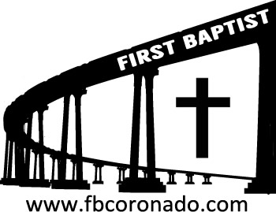

Reach Up, Reach Out, Reach Our World
445 C Avenue
Coronado, CA 92118
(619) 435-6588
fbcoronado.com
Jim W. Baize, Pastor
Julie Burkhart, Secretary, Childcare Coordinator
Patsy Lower, Treasurer
Laura Stecher, Children’s Ministry
Dan Malcolm, Men’s Ministry/VIP Ministry
Cindy Wilson, Women’s Ministry
Monica Medina, Convalescent Ministry
Sheerah Haywood, Worship Ministry
Bobby Greer, Maintenance
Our mission is to produce fully devoted followers
of Jesus Christ. If we can be of any help to you,
feel free to give us a call.



First Baptist Church
of Coronado

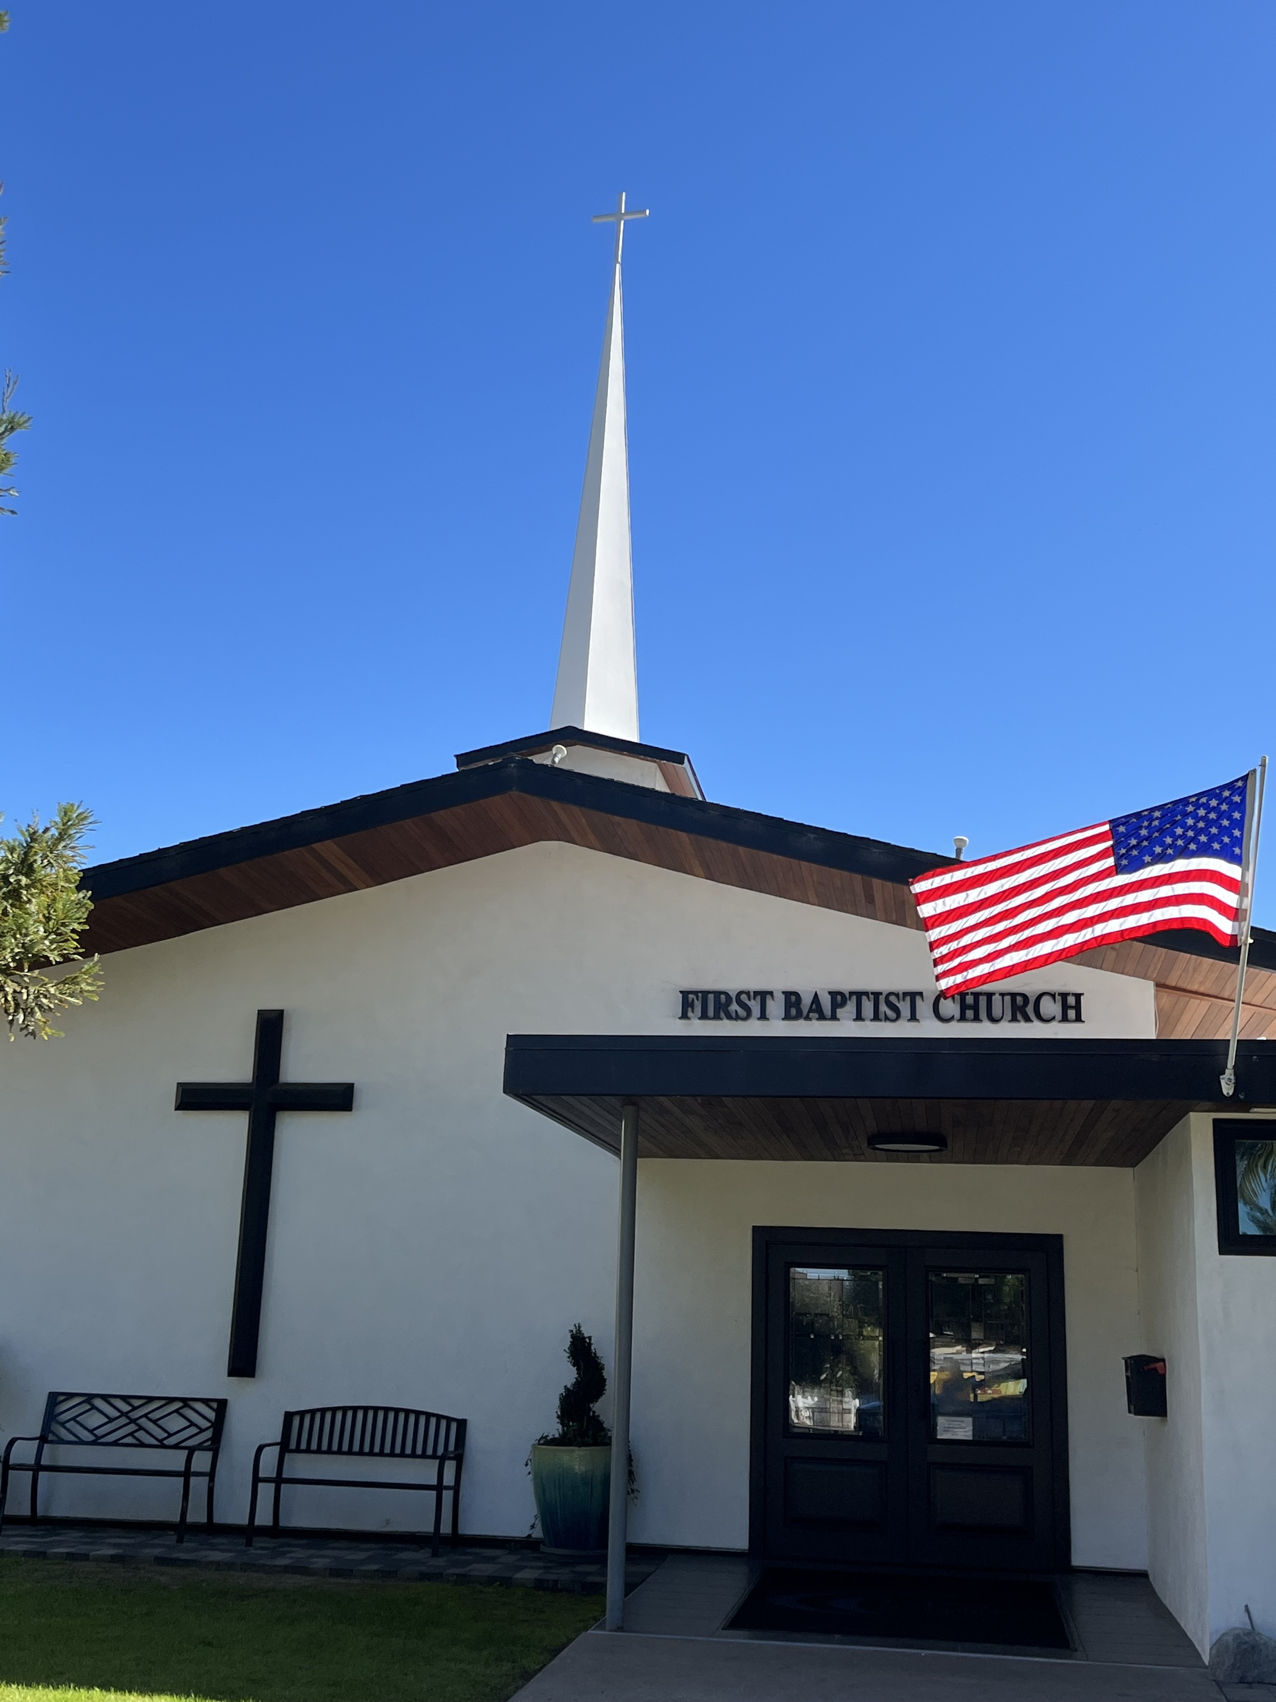

THE DEATH OF JESUS CHRIST
Pastor Jim W. Baize
August 23, 2026

A SERMONIC PREDICATMENT!

If you have been around First Baptist Church of Coronado very long you have probably heard me say that I try to keep 3-4 weeks ahead in my sermon studies, especially if I am in a sermon series. That way, I have a couple of weeks for fresh ideas and illustrations to “pop- up” for use in the sermons. (Pop-up is not an accurate term. I know that God often gives me ideas or helps me see things around me that are pertinent to the message. I don’t usually believe in coincidences. Rather, I believe in God incidences.)

For today’s message I had already planned weeks ago to use what is referred to as a “Physician’s Explanation of the Crucifixion of Jesus Christ.” It is graphic. It is brutal. For those not as familiar with what crucifixion entailed, it is raw and explicit.

The problem is, the last time I shared that, it triggered a couple of church attendees physically to the point that one was nauseous and the other passed out in the service!

I decided not to read that account in the service. I don’t want it to get around that my preaching makes people sick!!!

It is available online for those who are interested, but suffice it to say, all that Jesus endured on the cross was the worse Satan could inflict upon Him. He paid such a high price for you and for me!

Be thankful He did!

You don’t have to go to heaven;
You don’t have to go to hell;
But you can’t stay here!

Welcome to First Baptist Church of Coronado!

Adult Sunday School 8:45
Worship Service 10:00
Children’s Sunday School 10:15

Bible Studies This Week

Tuesday
Oaks Int. Military Bible Study at FBCC
6-8 p.m. Childcare provided

Saturday
Men’s Coffee & Bible Study at FBCC
Grounds & Grace
Brothers in the Word helping iron sharpen iron.
Invite a friend.

Women’s Bible Study Fellowship begins September 9th!
Class will meet 10:00-11:30. Childcare is provided.
To register online go to bsfinternational.org, class 1134.

Children’s Books Needed
We are collecting books for our Little Children’s Library. If you have any appropriate children’s books at home that you no longer need, please bring them to the church. Thank you!

