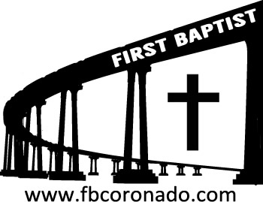

Reach Up, Reach Out, Reach Our World
445 C Avenue
Coronado, CA 92118
(619) 435-6588
fbcoronado.com
Jim W. Baize, Pastor
Julie Burkhart, Secretary, Childcare Coordinator
Patsy Lower, Treasurer
Laura Stecher, Children’s Ministry
Dan Malcolm, Men’s Ministry/VIP Ministry
Cindy Wilson, Women’s Ministry
Monica Medina, Convalescent Ministry
Sheerah Haywood, Worship Ministry
Bobby Greer, Maintenance
Our mission is to produce fully devoted followers
of Jesus Christ. If we can be of any help to you,
feel free to give us a call.

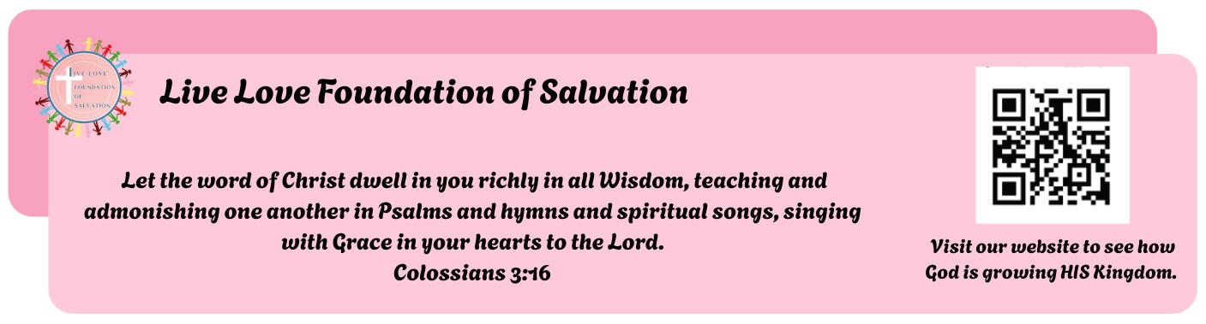

First Baptist Church
of Coronado

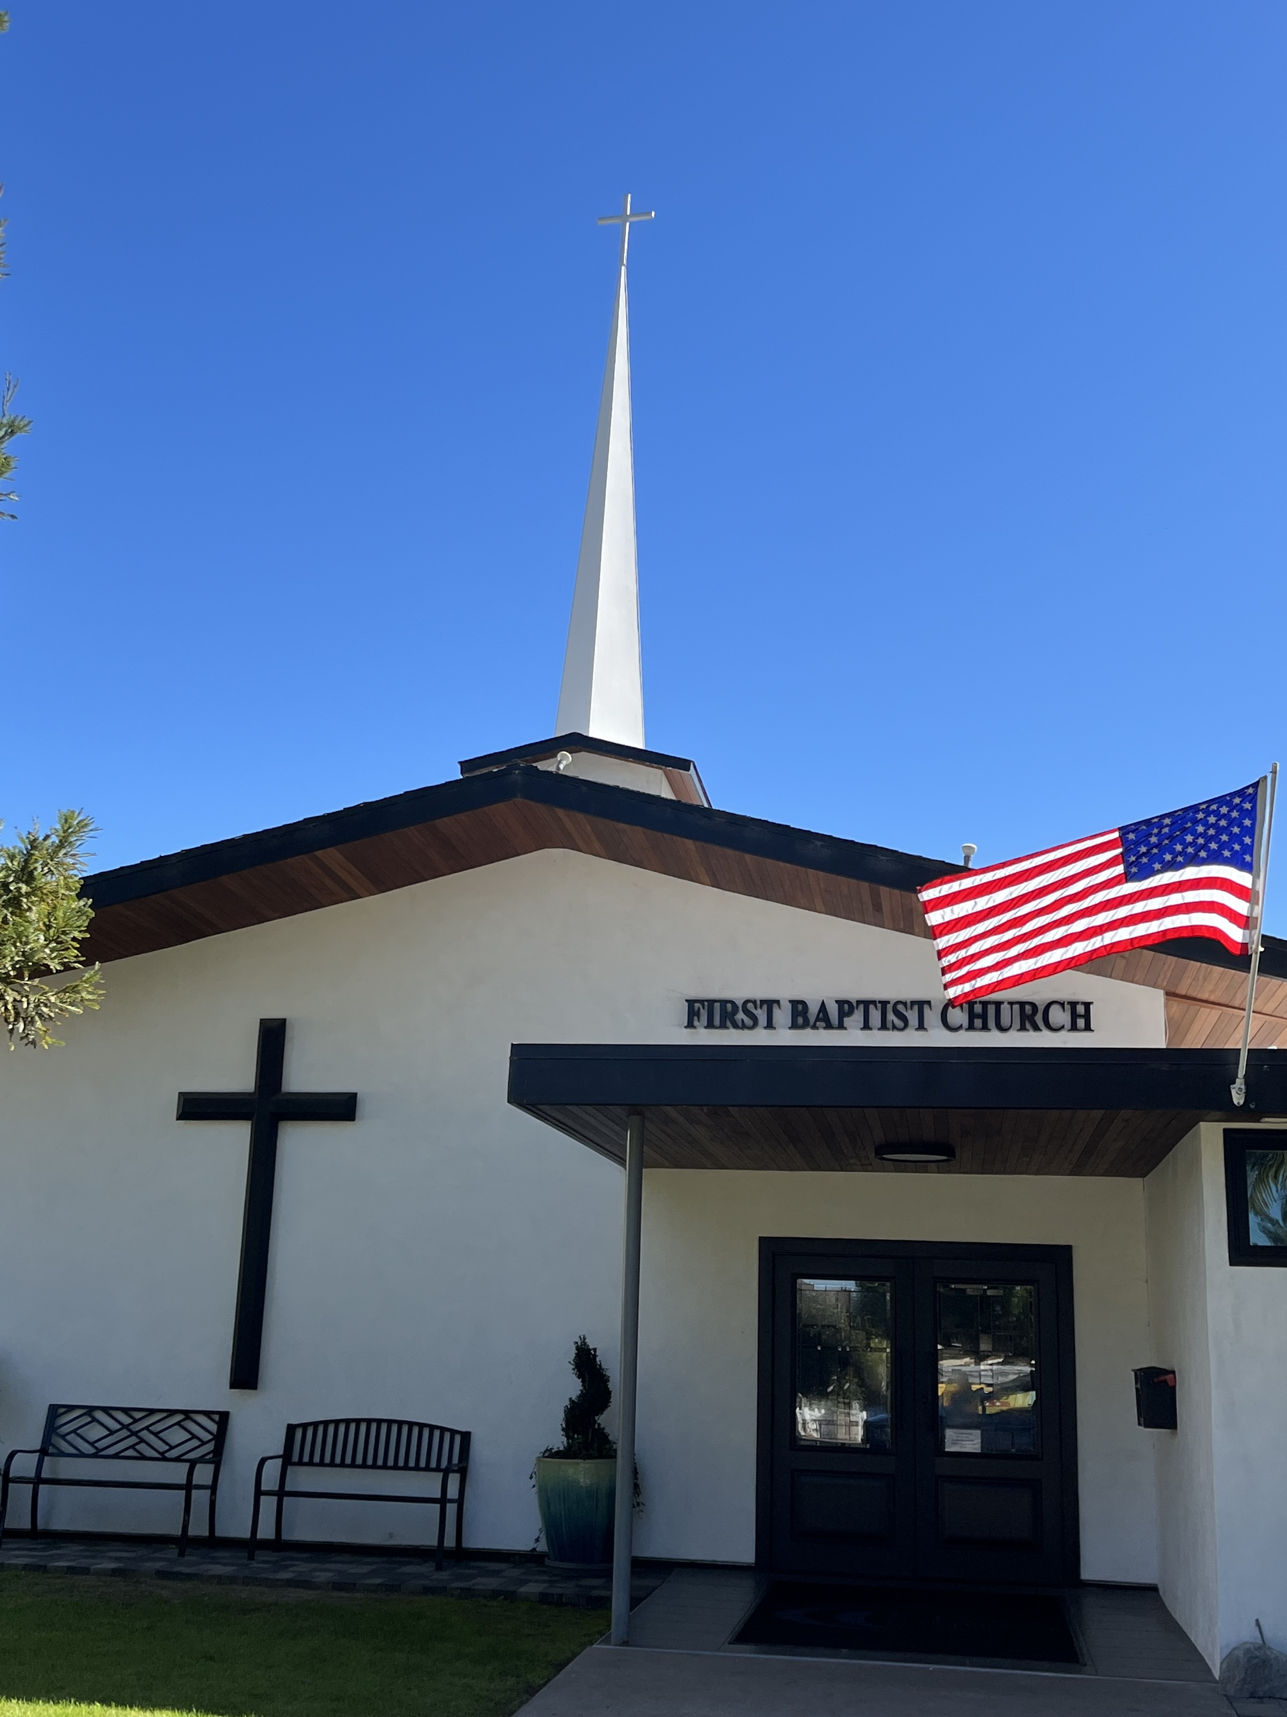

THE HUMANITY OF
JESUS CHRIST
Pastor Jim W. Baize
August 16, 2026

“A SERMON WITHIN A SERMON”
Key Biblical Uses and Meanings of Hyssop.

Have you ever connected the hyssop in the Passover to the hyssop used at Calvary. This is a potential sermon...very interesting.

- Protection and Redemption (The Passover): In Exodus 12:22, Israelites used a bunch of hyssop to paint the blood of the Passover lamb on their doorframes. This acted as a sign for the destroyer to pass over and symbolizing protection from death and deliverance from slavery.

- Purification from Impurity (The Law of Moses): Under Mosaic law, priests used hyssop combined with cedar wood, scarlet yarn, and water or blood to cleanse people healed of skin diseases (leprosy”) and those contaminated by touching a corpse (Lev 14:4, Num 19:6). Here it symbolizes ceremonial and moral cleansing.

- Repentance and Forgiveness (King David's Plea): In Psalm 51:7, after committing adultery and murder, King David cried out, "Cleanse me with hyssop, and I will be clean; wash me, and I will be whiter than snow." He used hyssop to symbolize an inner, spiritual washing and renewal of the soul that only God can provide.

- The Ultimate Sacrifice (Crucifixion):
In John 19:29, soldiers lifted a sour wine-soaked sponge to Jesus on a hyssop branch just before His death. This final act ties the entire biblical narrative together, visually identifying Jesus as the ultimate Passover Lamb whose blood provides permanent salvation and cleansing from sin.

Welcome to First Baptist Church of Coronado!

Adult Sunday School 8:45
Worship Service 10:00
Children’s Sunday School 10:15

Bible Studies This Week

Tuesday
Oaks Int. Military Bible Study at FBCC
6-8 p.m. Childcare provided

Saturday
Men’s Coffee & Bible Study at FBCC
Grounds & Grace
Brothers in the Word helping iron sharpen iron.
Invite a friend.

Women’s Bible Study Fellowship begins September 9th!
Class will meet 10:00-11:30. Childcare is provided.
To register online go to bsfinternational.org, class 1134.

