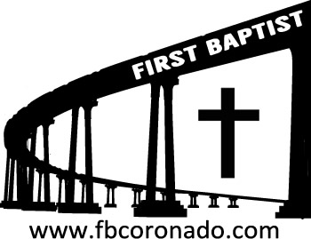

Reach Up, Reach Out, Reach Our World
445 C Avenue
Coronado, CA 92118
(619) 435-6588
fbcoronado.com
Jim W. Baize, Pastor
Julie Burkhart, Secretary, Childcare Coordinator
Patsy Lower, Treasurer
Laura Stecher, Children’s Ministry
Dan Malcolm, Men’s Ministry/VIP Ministry
Cindy Wilson, Women’s Ministry
Monica Medina, Convalescent Ministry
Sheerah Haywood, Worship Ministry
Bobby Greer, Maintenance
Our mission is to produce fully devoted followers
of Jesus Christ. If we can be of any help to you,
feel free to give us a call.



First Baptist Church
of Coronado

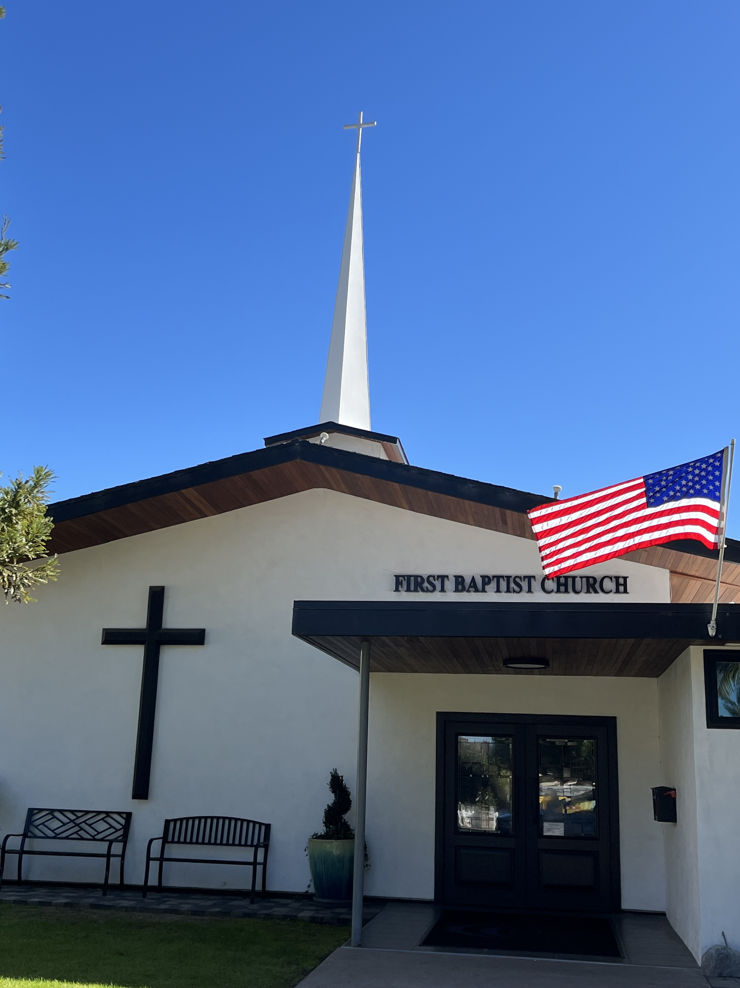

THE DEITY OF GOD
Pastor Jim W. Baize
August 9, 2026

CAROLYN JOYCE MOOREHOUSE

CAROLYN JOYCE MOOREHOUSE

1933-2026

(The following article was written by Carolyn’s son, Jim Moorhouse. We honor Carolyn as the last remaining charter member of our First Baptist Church of Coronado.)

The remarkable, 93-year life and journey of Carolyn Joyce Moorhouse, in which she survived polio as a young girl, became the first Miss Coronado in her home of more than 80 years, and left a lasting impact as a volunteer and friend to everyone she met, ended quietly on August 2, 2026, with her family and beloved dog Archie all together in support.

Carolyn leaves behind five children, seven grandchildren and 10 great-grandchildren, and joins her beloved husband of 62 years, John, who preceded her in death in 2015.

Carolyn spent most of her adult life servicing the Coronado community, first as an employee at the Coronado Post Office and then for 19 years in various capacities at the Coronado Elementary School. After retiring from the school, she spent her time volunteering as an ambassador for the Coronado Historical Association at the Coronado Hospital as a greeter for more than 15 years, and perhaps most rewardingly for two decades as a baby cuddler in the neonatal unit at UCSD.

It was at the post office in 1951, the year she graduated from Coronado High School, where she met her husband, John. They were married a year later and worked together side-by-side for six years before starting a family in 1958.

It was also in 1951 that she served as the very first Miss Coronado, representing the city in the Miss San Diego pageant as part of the Miss California contest (connecting all the way to the 1952 Miss USA pageant). The Miss San Diego pageant was staged in May of that year, and Carolyn represented Coronado in a number of different functions that month, including more than one local TV appearance showcasing her talent -- twirling the baton as a four-year majorette at Coronado High.

Born in Seattle, Washington on April 29, 1933, Carolyn moved to California with her family (including her parents and younger brother William) in 1939 and to Coronado in 1944. William died from hepatitis at age 12 in May of 1951, ten years after contracting polio when he was just two years old. In 1941, as an 8-year-old, Carolyn was also afflicted with polio, surviving the disease but battling affects from the illness her entire life.

As part of her busy lifestyle in Coronado, she spent many active years involved with a number of different civic minded organizations, including the 20-30 Club and Job's Daughters, and also spent many nights with her own long-term group of friends, who for years met monthly as the iconically named: Dignified Ladies Club.

Away from Coronado, her and John traveled the world, visiting countless countries, continents and regions through the years, including China, Africa, Scandinavia, and more. But nothing made her happier than camping under the stars near a river, especially in Yosemite, a favorite destination as both a child and as an adult.

Carolyn passed away peacefully at Sharp Parkview Hospice Home surrounded by her family, who took comfort in remembering her sharp wit, hilarious opinions, and the life of service she lived.

Services are scheduled for Tuesday, August 18 at 10 a.m. in the “Garden of Hope” at Greenwood Memorial Park (4300 Imperial Ave., San Diego). In lieu of flowers, donations can be made to the Yosemite Rivers Alliance in the name of Carolyn Moorhouse at https://www.yosemiterivers.org.

Welcome to First Baptist Church of Coronado!

Adult Sunday School 8:45
Worship Service & Communion 10:00
Children’s Sunday School 10:15

Bible Studies This Week

Tuesday
Oaks Int. Military Bible Study at FBCC
6-8 p.m. Childcare provided

Saturday
Men’s Coffee & Bible Study at FBCC
Grounds & Grace
Brothers in the Word helping iron sharpen iron.
Invite a friend.

