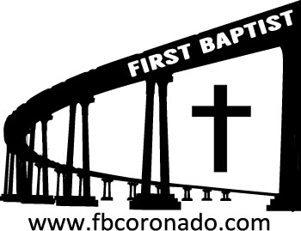

*Reach Up, Reach Out, Reach Our World*

445 C Avenue

Coronado, CA 92118

(619) 435-6588

fbcoronado.com

Jim W. Baize, Pastor

Julie Burkhart, Secretary, Childcare Coordinator

Patsy Lower, Treasurer

Laura Stecher, Children’s Ministry

Jason & Jennifer Griffith, Youth Ministry

Dan Malcolm, Men’s Ministry/VIP Ministry

Cindy Wilson, Women’s Ministry

Monica Medina, Convalescent Ministry

Sheerah Haywood, Worship Ministry

Bobby Greer, Maintenance

Our mission is to produce fully devoted followers

of Jesus Christ. If we can be of any help to you,

feel free to give us a call.

***First Baptist Church of Coronado***

***“REBUILDING HOME”***

***Pastor Logan Mabe***

***July 13, 2025***

**WELCOME THE MABE FAMILY!**

Logan and Brittany Mabe have spent the past 15 years in San Diego, where they’ve been dedicated to serving in several different ministries. Logan served as a Bible teacher, PE teacher, and coach at my former church school, OVCA. He became our Youth Pastor, Associate Pastor, and finally Lead Campus Pastor at OVC Chula Vista. They have five amazing kids ranging from 12 to 1 year old. Their family has been uniquely connected to both foster care and adoption as they began fostering kiddos in 2013 and since that time have cared for 12 different kids including their 3 oldest children who are their forever family. They have a deep love for the community, foster care, education, and the local church. Logan now serves as the Deputy Executive Director of Restoration225, an organization that equips churches, agencies, and volunteers to support families impacted by foster care. Together, Logan and Brittany are also leading the launch of New Story Church in Chula Vista in 2026.

**Welcome to First Baptist Church of Coronado!**

Adult Sunday School 8:45

Worship Service 10:00

Windsurfers Youth Group 10:00

Children’s Sunday School 10:15

**Bible Studies This Week**

**Tuesday**

**Oaks Int. Military Bible Study at FBCC**

6-8 p.m.

Childcare provided

**Thursday**

10:30 a.m.

**Evening Bible Study 5:30-7:30 at FBCC (Men & Women)**

Potluck meal at 5:30

**Saturday**

**Men’s Coffee Club 8:00 a.m.**

(except the first Saturday of each month)

Coffee, conversation and The Word of God.

**Upcoming Events**

Israel 13 Day Inspirational Tour

October 23 thru November 4, 2026

For more information contact Lori Blumenthal

@ 619-990-2586

There are informational pamphlets on the table near the front entry way.

