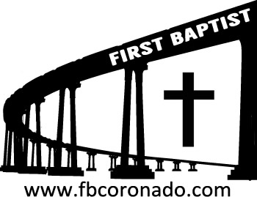

Reach Up, Reach Out, Reach Our World
445 C Avenue
Coronado, CA 92118
(619) 435-6588
fbcoronado.com
Jim W. Baize, Pastor
Julie Burkhart, Secretary, Childcare Coordinator
Patsy Lower, Treasurer
Laura Stecher, Children’s Ministry
Dan Malcolm, Men’s Ministry/VIP Ministry
Cindy Wilson, Women’s Ministry
Monica Medina, Convalescent Ministry
Sheerah Haywood, Worship Ministry
Bobby Greer, Maintenance
Our mission is to produce fully devoted followers
of Jesus Christ. If we can be of any help to you,
feel free to give us a call.

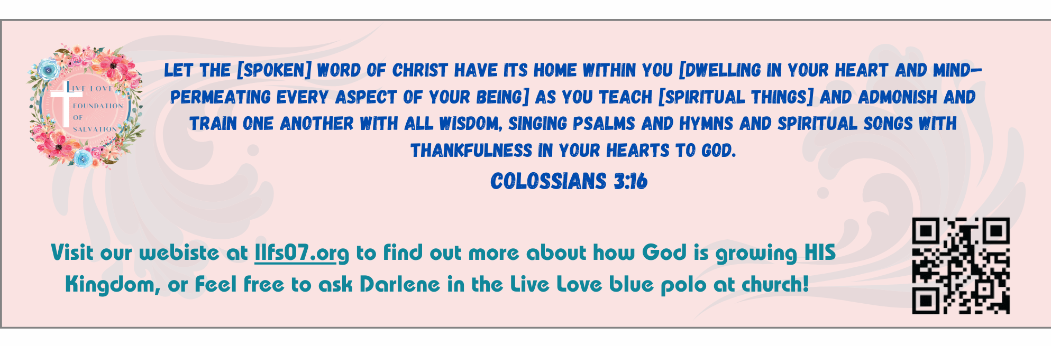
First Baptist Church
of Coronado

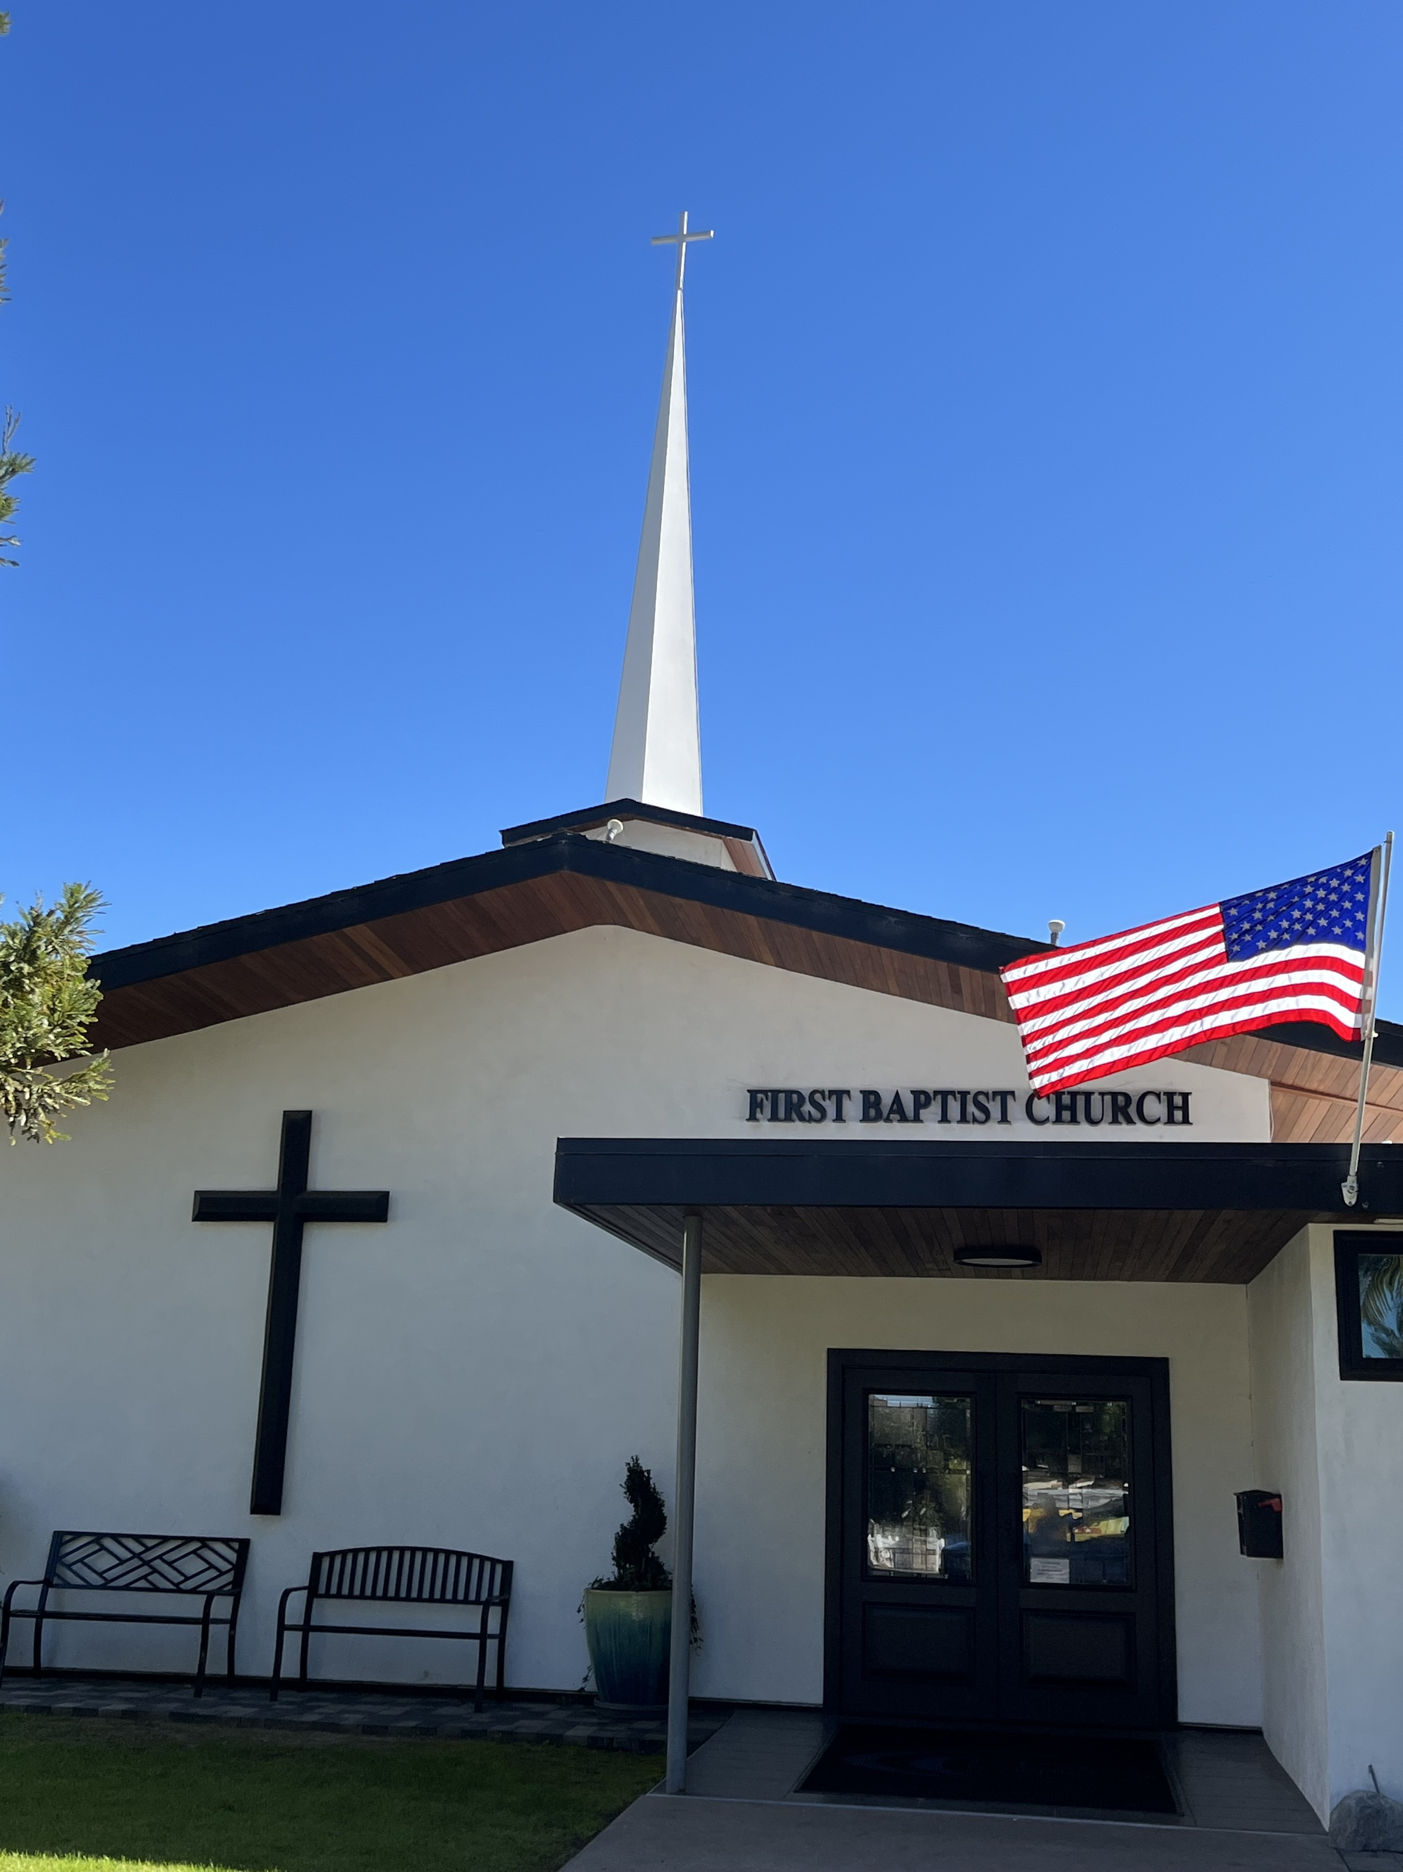

The Holiness of God
Pastor Jim W. Baize
July 12, 2026

DON’T CALL ME REVEREND!
“He sent redemption unto his people: he has commanded his covenant forever: holy and reverend is his name.” (Psa 111:9)
It is most interesting that the adjective “reverend” is used only this once in the entire King James Bible. And there it applies to God, not to any man!
However, the Hebrew word so translated in this verse (yare) occurs therein frequently, usually being translated (some 30 times) as “terrible.” The first time it is applied to God was by Moses. “Thou shalt not be affrighted at them: for the LORD thy God is among you, a mighty God and terrible” Deuteronomy 7:21. Note also Moses’ testimony in Deuteronomy 10:17: “For the LORD your God is God of gods, and Lord of lords, a great God, a mighty, and a terrible, who regards not persons, nor takes reward.”
For those who would deny or oppose Him, “it is a fearful thing to fall into the hands of the living God” Hebrews 10:31. But God is also uniquely a God of love. He is a merciful and forgiving God; He is “the God of all grace” 1 Peter 5:10 and of many other wonderful attributes.
“He looks upon all the inhabitants of the earth” (God is thus omnipresent). “He fashions their hearts alike” (He is omnipotent). “He considers all their works” (He is omniscient) Psalm 33:14-15.
“In the beginning God created the heaven and the earth” Genesis 1:1. If a person truly believes the first verse of the Bible, he should be able to believe all other verses in the Bible, no matter what men or devils can say to the contrary. Our God, who has also become our Redeemer and Savior, is “eternal, immortal, invisible, the only wise God” 1 Timothy 1:17.
He is indeed a God of many attributes. HMM. ICR. 7.1.26

Welcome to First Baptist Church of Coronado!

Adult Sunday School 8:45
Worship Service 10:00
Children’s Sunday School 10:15
Active-Duty Military Luncheon 11:30

Bible Studies This Week

Tuesday
Oaks Int. Military Bible Study at FBCC
6-8 p.m. Childcare provided

Saturday
Men’s Coffee & Bible Study at FBCC
Grounds & Grace
Brothers in the Word helping iron sharpen iron.
Invite a friend.

Community Prayer
Monday July 13th 6:30
Living Waters Christian Fellowship
1224 Tenth Street, Coronado
Several churches are participating, joining together
to pray for the Coronado community and its leaders.

