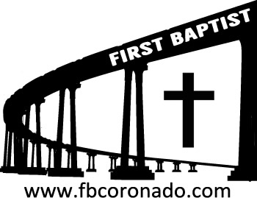

Reach Up, Reach Out, Reach Our World
445 C Avenue
Coronado, CA 92118
(619) 435-6588
fbcoronado.com
Jim W. Baize, Pastor
Julie Burkhart, Secretary, Childcare Coordinator
Patsy Lower, Treasurer
Laura Stecher, Children’s Ministry
Dan Malcolm, Men’s Ministry/VIP Ministry
Cindy Wilson, Women’s Ministry
Monica Medina, Convalescent Ministry
Sheerah Haywood, Worship Ministry
Bobby Greer, Maintenance
Our mission is to produce fully devoted followers
of Jesus Christ. If we can be of any help to you,
feel free to give us a call.

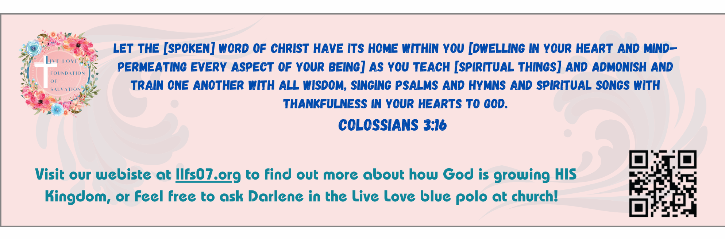

BEING A DAD IS A SPECIAL CALLING

I became a dad for the first time on December 17, 1970. Pat did all the hard work – the labor – and I got to have a daughter, whom we named Shannon Noelle. Back in those days I couldn’t be in the delivery room, I had to pace in a waiting area, all by myself. The situation hadn’t changed a whole lot on July 21, 1975, when I became the father of a second daughter, Misty Dawn. When we found out we were going to have our third child, we made plans to attend a class where you can be certified to be in the delivery room. (Well, where I could be certified. Pat was going to be in the room whether I was or not!)

I heard you had to take pillows to the class, sit on the floor, and learn how to breathe together. Since we both had been breathing together for several years already, I didn’t really think I needed this class. I made the mistake of offering to pay the instructor full price, in advance, if she would just sign the card and certify me right then and there, at the first class. She was mortified. I think she yelled at me. Under no circumstances would she do such a thing! So, I attended classes designed to teach me how to inhale and exhale. It also taught me a new vocabulary. They weren’t birth pangs, they were contractions. OK. Pat didn’t like me reminding her of that!

Then, on January 19, 1978, I was able to be in the delivery room to see our son Benjamin James enter this world. Wow! It was one of the most emotional experiences I have ever had. Pat was amazing. So was my son.

Our children are grown now. But I remember each one the way they were when we were still at the hospital. They changed our lives in every way imaginable. Being a dad is right up there with being a husband. If God has called you to that role, be the best one you can be. Oh, and you only have one shot at doing that. Give it your all.

DAVID AND GOLIATH
Pastor Terry Miller
June 21, 2026

Welcome to First Baptist Church of Coronado!
Today we honor all Fathers!

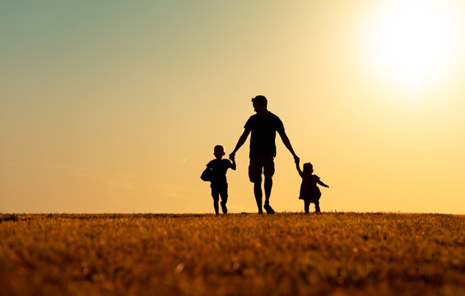

Adult Sunday School 8:45
Worship Service 10:00
Children’s Sunday School 10:15
Active-Duty Military Meal 11:30

Bible Studies This Week

Tuesday
Oaks Int. Military Bible Study at FBCC
6-8 p.m. Childcare provided

Saturday
Men’s Coffee & Bible Study at FBCC
Grounds & Grace
Brothers in the Word helping iron sharpen iron.
Invite a friend.

Church Luncheon 6/28/26
It’s time to share a meal together!
FBCC will provide grilled hamburgers and hot dogs. If you are able, please bring a side dish to share.





