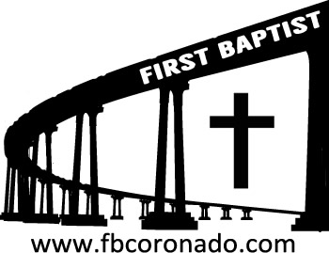

Reach Up, Reach Out, Reach Our World
445 C Avenue
Coronado, CA 92118
(619) 435-6588
fbcoronado.com
Jim W. Baize, Pastor
Julie Burkhart, Secretary, Childcare Coordinator
Patsy Lower, Treasurer
Laura Stecher, Children’s Ministry
Dan Malcolm, Men’s Ministry/VIP Ministry
Cindy Wilson, Women’s Ministry
Monica Medina, Convalescent Ministry
Sheerah Haywood, Worship Ministry
Bobby Greer, Maintenance
Our mission is to produce fully devoted followers
of Jesus Christ. If we can be of any help to you,
feel free to give us a call.

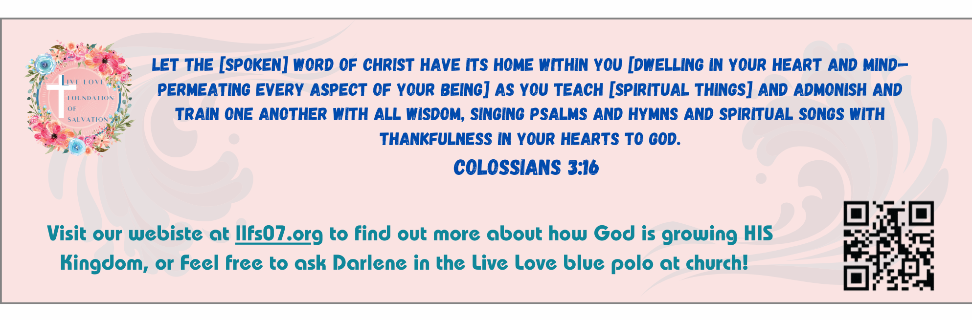
First Baptist Church
of Coronado

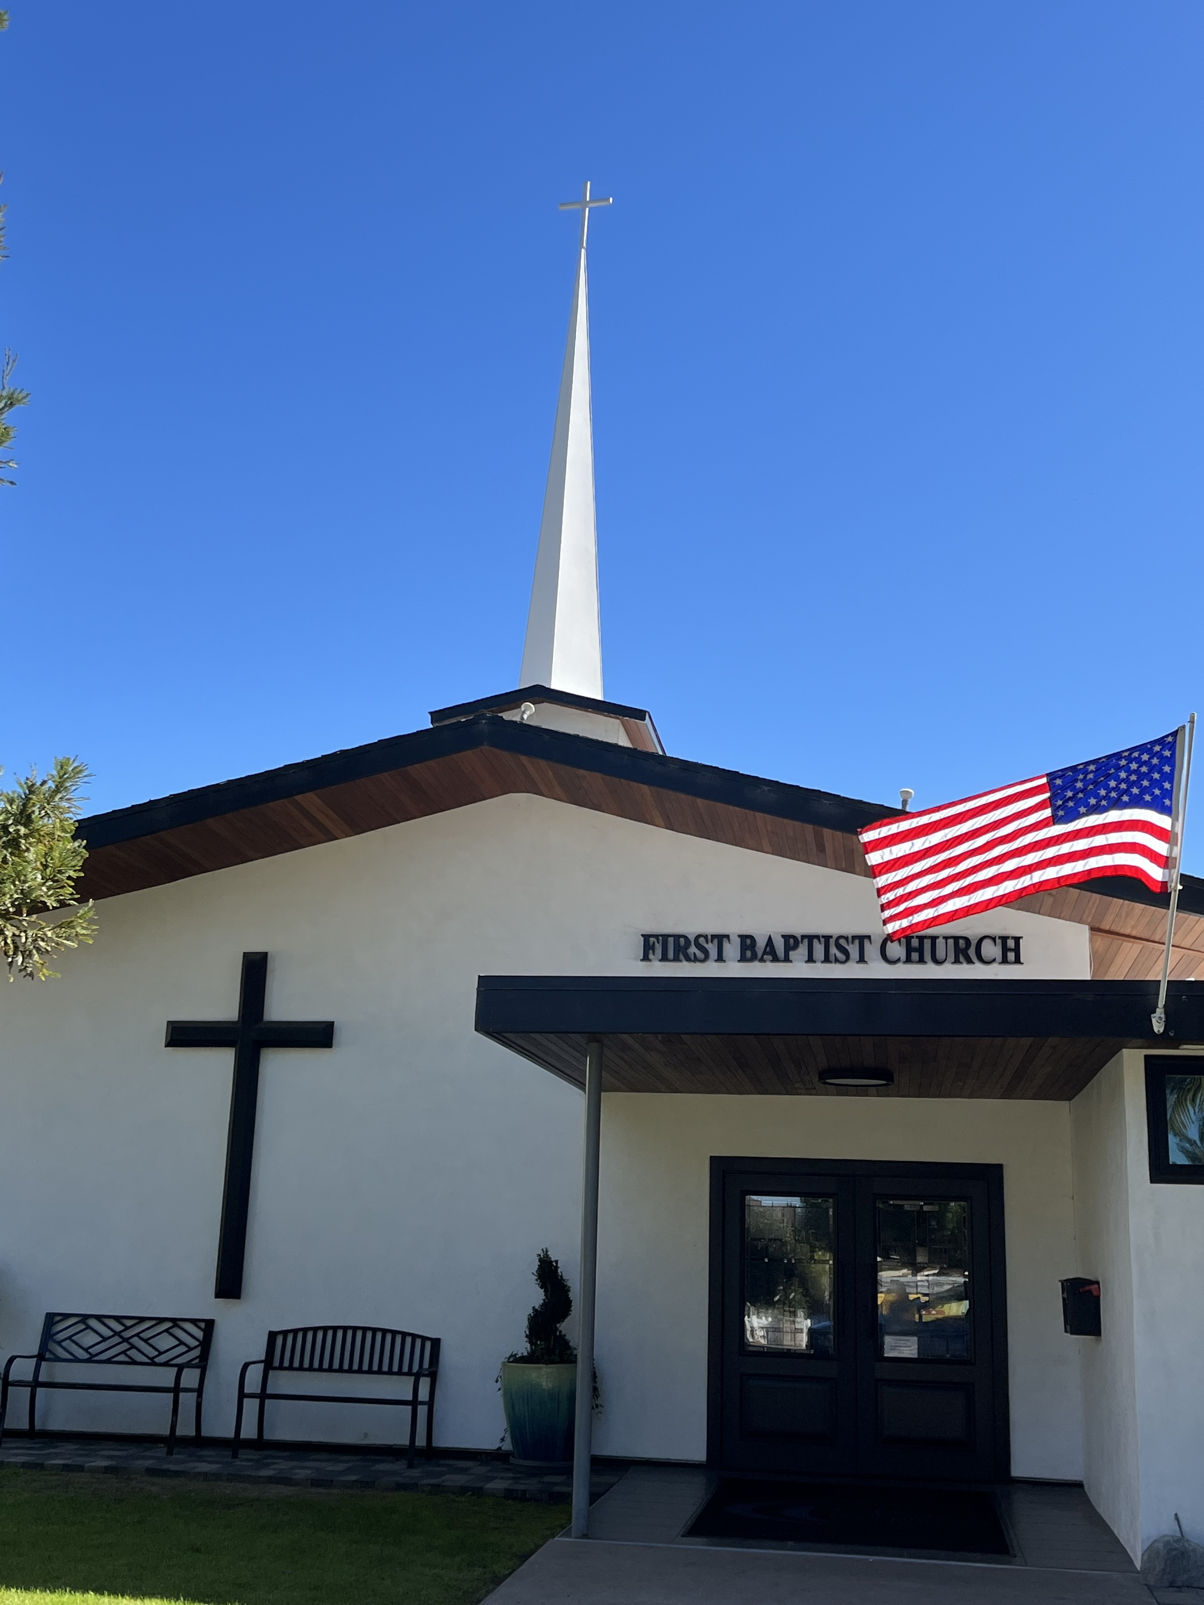

The Omnipresence of God
Pastor Jim W. Baize
May 31, 2026

GOD IS ALWAYS AROUND!

Did you have a big brother or big sister when you were growing up? Were they able to come to your rescue when the school bully decided to pick on YOU? If they did, I’ll bet it was a relief to see them take care of business on your behalf! But even if you had a big brother or sister to watch out for you, were they always around? Probably not!

I WAS the big brother! I didn’t have one around to protect me. (As it turned out, I made friends with the bullies in elementary and high school! That was MUCH better than getting beat up by them!)

Wouldn’t it be great to have a big brother around today? Even better if he could be around every day and all through every night?

Guess what? We have someone better than that! We have a God Who is everywhere all the time! He is omnipresent. He is in our homes, at work or school, at play, in church, in the hospital, in the jail cell, on that ship, in the foxhole – well, you get the idea! He is always there, right where you need Him!

Today we will try to get a better understanding of this phenomenal attribute of God called His omnipresence! May God bless us as we do!

Welcome to First Baptist Church of Coronado!

Adult Sunday School 8:45
Sunday Worship Service 10:00
Children’s Sunday School 10:15
Active-Duty Military Meal 11:30

Bible Studies This Week

Tuesday
Oaks Int. Military Bible Study at FBCC
6-8 p.m. Childcare provided

Thursday
Ladies’ Bible Study at FBCC 10:30

Saturday
Men’s Breakfast 8:00 Sunday June 6th
Enjoy a delicious breakfast and great fellowship!
Invite a friend.

Classical Conversations Homeschool Meetings:
Interested in homeschooling your children? Classical Conversations is forming a homeschool group that will meet right here at FBCC one day a week.

- Informative meeting to be held at Spreckles Park May 29th at 11:00 a.m.

- Parent Practicum to be held at FBCC June 3rd 9am – 4 pm.
Parent Practicums are events hosted to inspire and equip parents to become better “everyday educators,” combining the encouragement of community, integration of ideas, and practice with the classical skills. Parent Practicum is a once-a-year parent investment.

Communion will be observed Sunday June 7th

