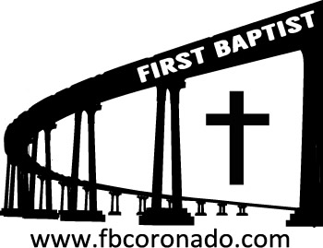

Reach Up, Reach Out, Reach Our World
445 C Avenue
Coronado, CA 92118
(619) 435-6588
fbcoronado.com
Jim W. Baize, Pastor
Julie Burkhart, Secretary, Childcare Coordinator
Patsy Lower, Treasurer
Laura Stecher, Children’s Ministry
David Preston, Youth Ministry
Dan Malcolm, Men’s Ministry/VIP Ministry
Cindy Wilson, Women’s Ministry
Monica Medina, Convalescent Ministry
Sheerah Haywood, Worship Ministry
Bobby Greer, Maintenance
Our mission is to produce fully devoted followers
of Jesus Christ. If we can be of any help to you,
feel free to give us a call.

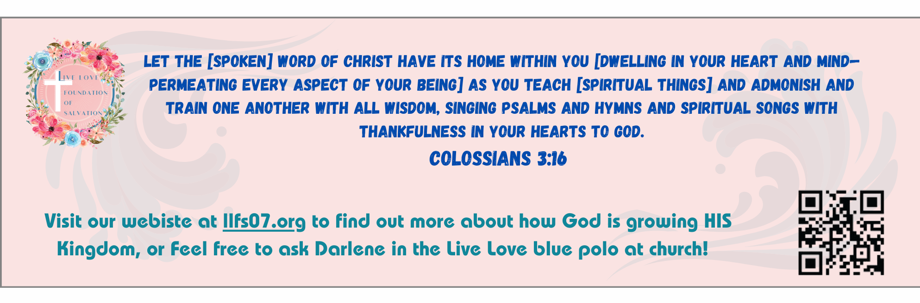
First Baptist Church
of Coronado

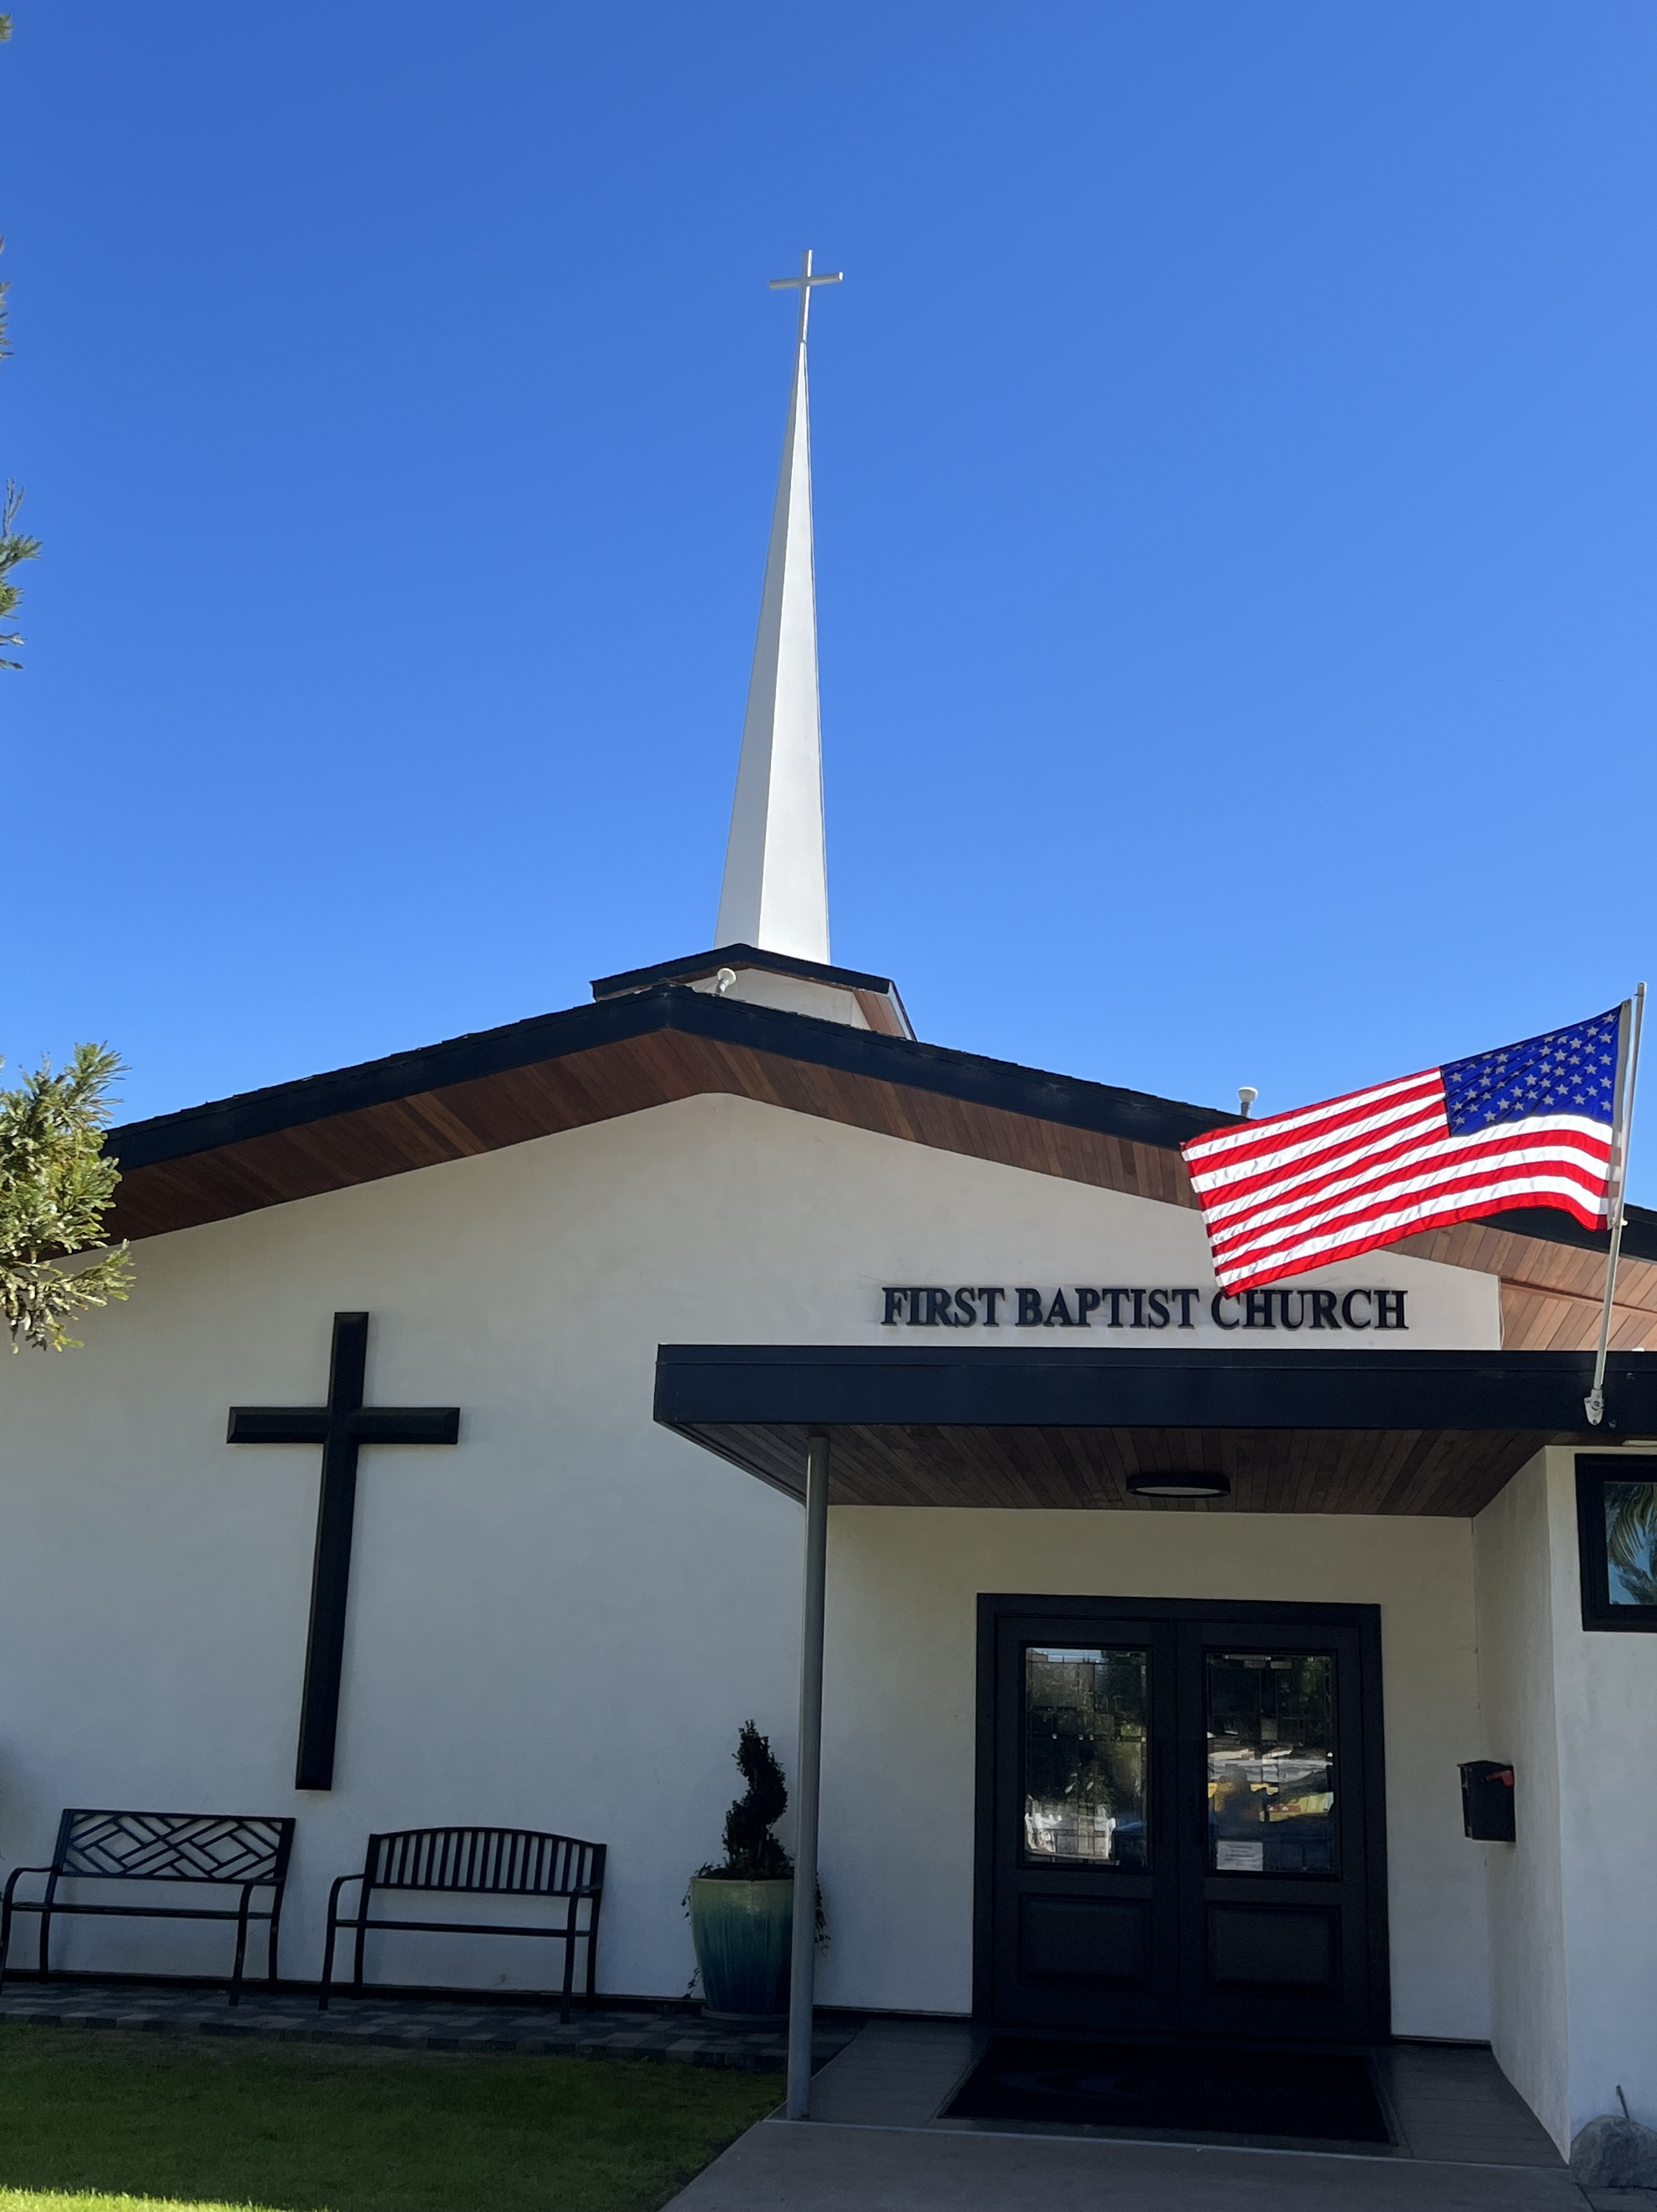

The Omniscience of God
Pastor Jim Baize
May 3, 2026

HE KNOWS EVERYTHING!
“I know your works, and charity, and service, and faith, and thy patience, and your works; and the last to be more than the first.” (Revelation 2:19)
Seven times in the letters to His seven representative churches in Revelation 2 and 3 the Lord Jesus says, “I know your works” (Revelation 2:2, 9, 13, 19; 3:1, 8, 15). Whatever we are doing – or not doing – He knows!
Sometimes such knowledge can bring – or at least should bring – great consternation. He knows, for example, all our hypocrisies: “I know . . . that you have a name that you live, and aet dead” (3:1). He also knows when our outward display of religious activity masks a real heart-attitude of compromising self-interest. “I know your works, that you are neither cold nor hot” (v.15).
Yet, He also knows when our service is genuine and our testimony is God-glorifying and faithful. “I know . . . your labor, and your patience...I know...you hold fast my name, and have not denied my faith” (2:2, 13).
Of these seven testimonies of His knowledge, the central one is in our text. He knows when we really love Him, for the “charity” mentioned is nothing less than agape, or unselfish love. He knows all about our sincere “service” and true “faith” in His Word as well as our “patience” of hope.
Perhaps the most precious of His assurances, however, is that to the suffering church at Smyrna. “I know your... tribulation, and poverty” (2:9). When He says that He knows, the sense is that He understands, because He has been through it all Himself. Therefore, “we have not a high priest who cannot be touched with the feeling of our infirmities; but was in all points tempted like as we are, yet without sin. Let us therefore come boldly unto the throne of grace, that we may obtain mercy, and find grace to help in time of need” (Hebrews 4:15-16). HMM. ICR. 4.24.26

Welcome to First Baptist Church of Coronado!

Adult Sunday School 8:45
Sunday Worship Service, Communion & Baptisms 10:00
Children’s Sunday School 10:15
Active-Duty Military Meal 11:30

Bible Studies This Week

Tuesday
Oaks Int. Military Bible Study at FBCC
6-8 p.m. Childcare provided

Wednesday
Ladies’ Bible Study Fellowship at FBCC 10:00

Thursday
Ladies’ Bible Study at FBCC 10:30

Saturday
Men’s Bible Study – Grounds & Grace 8:00
Brothers in the Word helping iron sharpen iron

