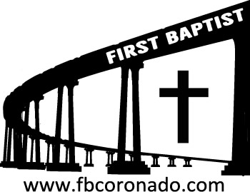

Reach Up, Reach Out, Reach Our World
445 C Avenue
Coronado, CA 92118
(619) 435-6588
fbcoronado.com
Jim W. Baize, Pastor
Julie Burkhart, Secretary, Childcare Coordinator
Patsy Lower, Treasurer
Laura Stecher, Children’s Ministry
Dan Malcolm, Men’s Ministry/VIP Ministry
Cindy Wilson, Women’s Ministry
Monica Medina, Convalescent Ministry
Sheerah Haywood, Worship Ministry
Bobby Greer, Maintenance
Our mission is to produce fully devoted followers
of Jesus Christ. If we can be of any help to you,
feel free to give us a call.

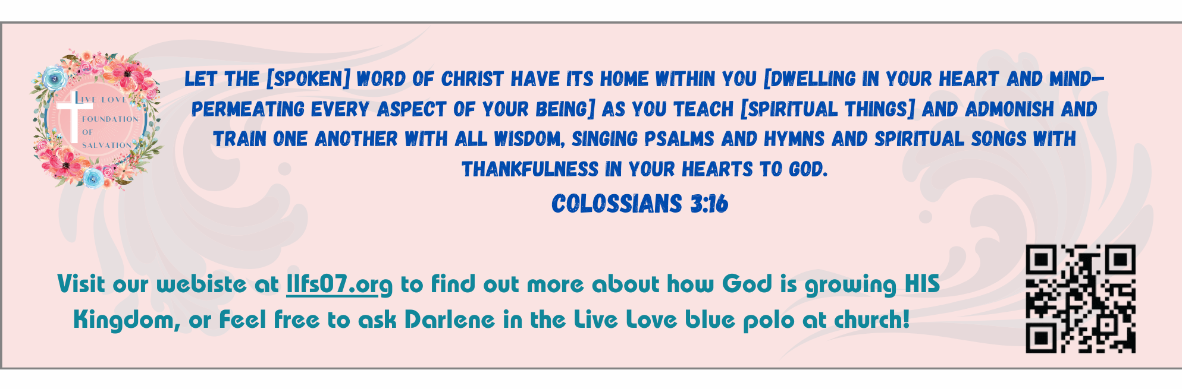
We Remember and We Honor Those Who Gave All

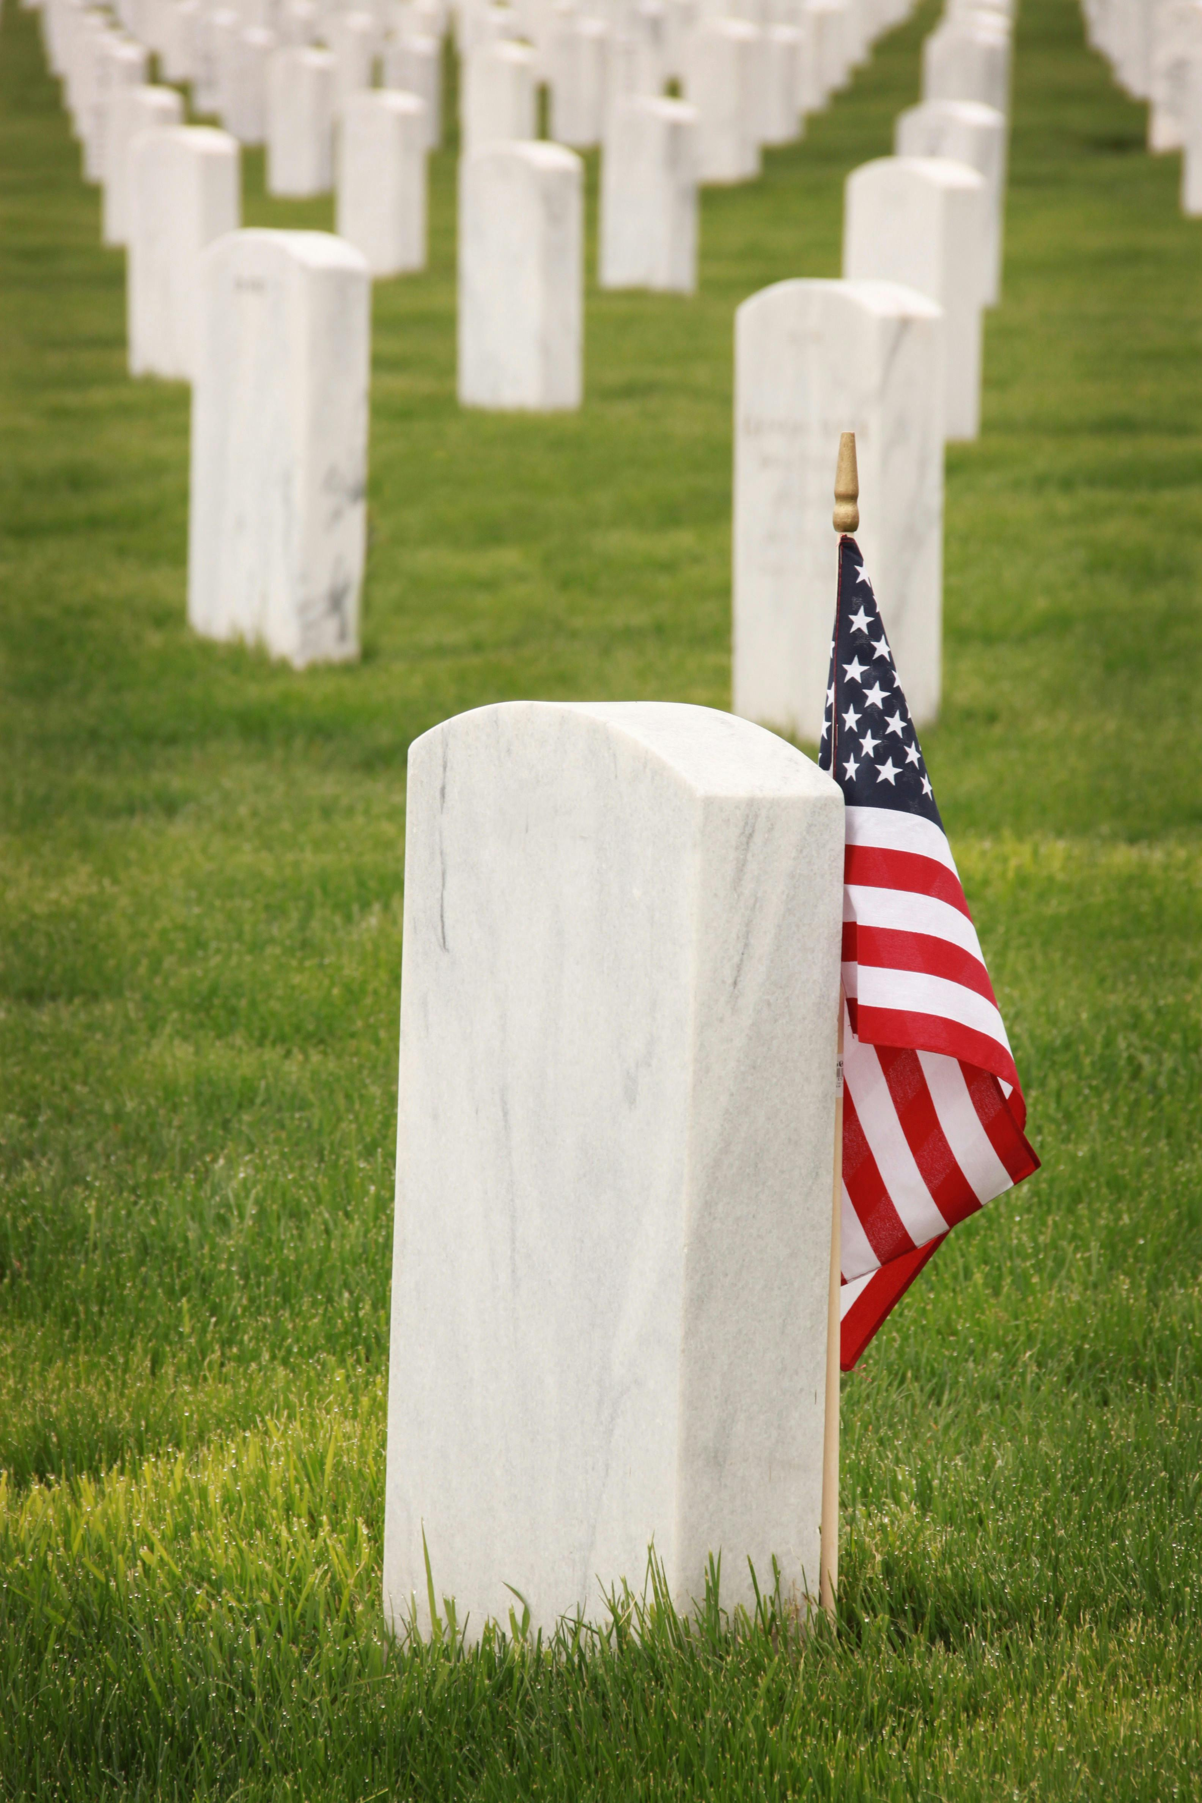

The Cost of Freedom
Pastor Jim W. Baize
May 24, 2026

“ME AND BOBBY McGEE”

"Me and Bobby McGee," is a song famously sung by Janis Joplin around 1969, written by Kris Kristofferson, and is a story about the bittersweet tension between freedom and love. It tells the story of two drifters traveling across America, exploring the emotional highs of shared companionship and the inevitable loneliness that comes with having "nothin' left to lose".

It’s a catchy tune but an awful philosophy of life. It contains an even worse definition – that of the word freedom. The chorus says,

Freedom’s just another word for nothin’ left to lose
Nothin’ don’t mean nothin’ hon, if it ain’t free, no no
And feelin’ good was easy...when he sang the blues
You know, feelin’ good was good enough for me
Good enough for me and my Bobby McGee.

Real freedom is worth dying for! Freedom is the dying word on the lips of William Wallace in Braveheart. Freedom is what the statue stands for in New York Harbor. Freedom has been the battle cry of the United States since 1776, and before. Freedom has cost the lives of over 1.3 million Americans over the last 250 years! Freedom is fought for and bled over, even today.

But there is a freedom that is more precious than political freedom...there is a freedom that liberates more than the body...it liberates the soul – for eternity.

"Now the Lord is the Spirit, and where the Spirit of the Lord is, there is liberty" (2 Corinthians 3:17). And John 15:13 says, "Greater love hath no man than this, that a man lay down his life for his friends."

Let us give thanks for both freedoms we enjoy and cherish because of the death of Christ and so many others. That was the cost of Memorial Day.

Welcome to First Baptist Church of Coronado!

Adult Sunday School 8:45
Sunday Worship Service 10:00
Children’s Sunday School 10:15
Active-Duty Military Meal 11:30

Bible Studies This Week

Tuesday
Oaks Int. Military Bible Study at FBCC
6-8 p.m. Childcare provided

Thursday
Ladies’ Bible Study at FBCC 10:30

Saturday
Men’s Bible Study at FBCC – Grounds & Grace 8:00
Brothers in the Word helping iron sharpen iron

Coronado Prayer Walk
Saturday May 30 2026, 9:30 at FBCC
Meet here at FBCC as we pray for the churches, community, schools, children and youth of Coronado. The intention is for God to continue moving this community through the effects of the local church and para-church organizations.
One of the goals is to raise a team to share the Gospel and teach God’s Word through a Good News Club, an after-school program here on Coronado Island. Join us as we pray to raise up the right people and for God to open doors.

Classical Conversations Homeschool Meetings:
Interested in homeschooling your children? Classical Conversations is forming a homeschool group that will meet right here at FBCC one day a week.

- Informative meeting to be held at Spreckles Park May 29th at 11:00 a.m.

- Parent Practicum to be held at FBCC June 3rd 9am – 4 pm.
Parent Practicum are events hosted to inspire and equip parents to become better “everyday educators,” combining the encouragement of community, integration of ideas, and practice with the classical skills. Parent Practicum is a once-a-year parent investment.

