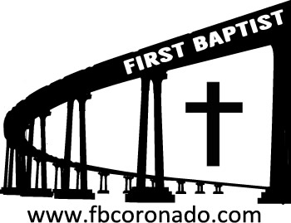

Reach Up, Reach Out, Reach Our World
445 C Avenue
Coronado, CA 92118
(619) 435-6588
fbcoronado.com
Jim W. Baize, Pastor
Julie Burkhart, Secretary, Childcare Coordinator
Patsy Lower, Treasurer
Laura Stecher, Children’s Ministry
David Preston, Youth Ministry
Dan Malcolm, Men’s Ministry/VIP Ministry
Cindy Wilson, Women’s Ministry
Monica Medina, Convalescent Ministry
Sheerah Haywood, Worship Ministry
Bobby Greer, Maintenance
Our mission is to produce fully devoted followers
of Jesus Christ. If we can be of any help to you,
feel free to give us a call.

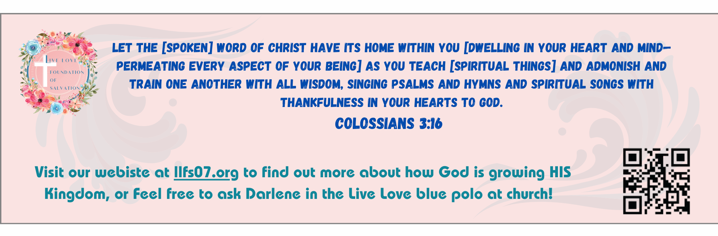

First Baptist Church of Coronado

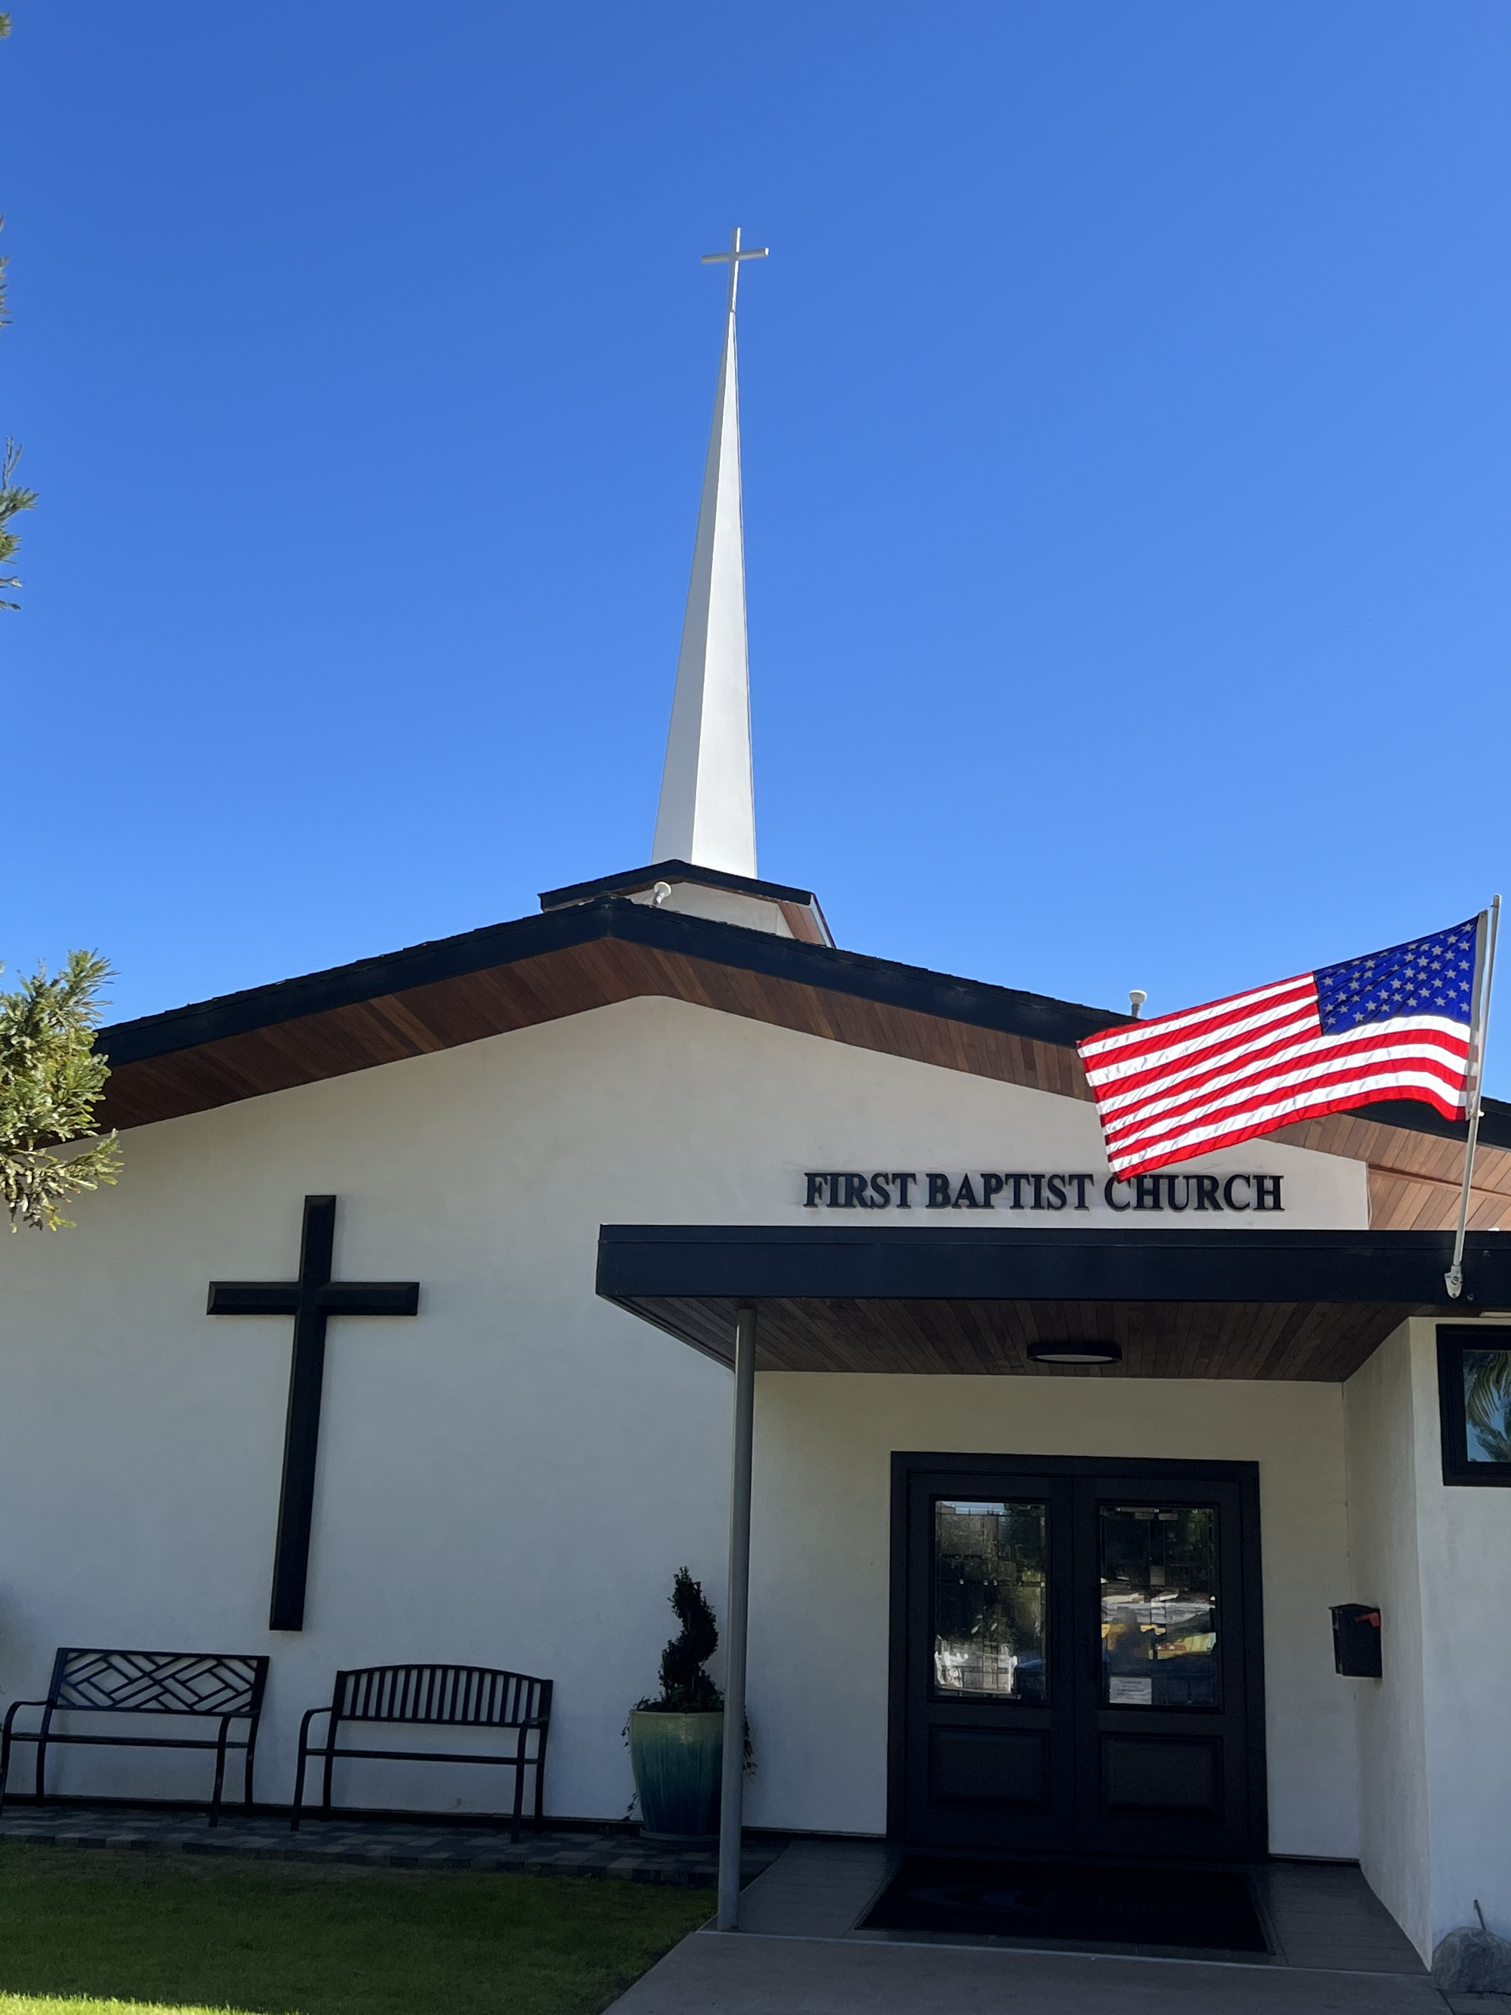

The Omnipotence of God
Pastor Jim W. Baize
May 17, 2026

GOD IS OMNIPOTENT
“Ah Lord GOD! behold, thou hast made the heaven and the earth by thy great power and stretched out arm, and there is nothing too hard for thee.” (Jeremiah 32:17)
The Genesis record of creation generates more hostility among men than any other message. Even secular atheists claim to respect the humanitarian teachings of Jesus, but they bristle irrationally when the Lord Jesus is identified as the Creator. Perhaps this is because the evidence for God’s omnipotence is displayed so openly and vividly by the “greatness of his might” (Isaiah 40:26).
The God who can speak the billions of galaxies into existence with the “breath of his mouth” (Psalm 33:6) is a God who can cast ungodly men into eternal hell for their defiance and rebellion against “the only Lord God, and our Lord Jesus Christ” (Jude 1:4). Conversely, the God who “stretcheth out the north over the empty place, and hangeth the earth upon nothing” (Job 26:7) is able to “save them to the uttermost that come unto God by him” (Hebrews 7:25).
No wonder the psalmist expresses the praise that all men should declare: “Great is the LORD, and greatly to be praised; and his greatness is unsearchable. One generation shall praise thy works to another, and shall declare thy mighty acts. I will speak of the glorious honour of thy majesty, and of thy wondrous works. And men shall speak of the might of thy terrible acts: and I will declare thy greatness” (Psalm 145:3-6).
When the Lord Jesus was formally invested at the great assembly around the throne, the entire throng burst into the song “Thou art worthy, O Lord, to receive glory and honour and power: for thou hast created all things, and for thy pleasure they are and were created” (Revelation 4:11). Each of us would do well to carry that song in our hearts every day. HMM III. ICR. 4.25.26

Welcome to First Baptist Church of Coronado!

Adult Sunday School 8:45
Sunday Worship Service 10:00
Children’s Sunday School 10:15
Active-Duty Military Meal 11:30

Bible Studies This Week

Tuesday
Oaks Int. Military Bible Study at FBCC
6-8 p.m. Childcare provided

Thursday
Ladies’ Bible Study at FBCC 10:30

Saturday
Men’s Bible Study at FBCC – Grounds & Grace 8:00
Brothers in the Word helping iron sharpen iron







