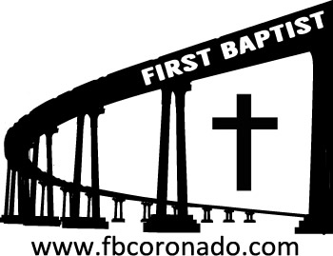

Reach Up, Reach Out, Reach Our World
445 C Avenue
Coronado, CA 92118
(619) 435-6588
fbcoronado.com
Jim W. Baize, Pastor
Julie Burkhart, Secretary, Childcare Coordinator
Patsy Lower, Treasurer
Laura Stecher, Children’s Ministry
David Preston, Youth Ministry
Dan Malcolm, Men’s Ministry/VIP Ministry
Cindy Wilson, Women’s Ministry
Monica Medina, Convalescent Ministry
Sheerah Haywood, Worship Ministry
Bobby Greer, Maintenance
Our mission is to produce fully devoted followers
of Jesus Christ. If we can be of any help to you,
feel free to give us a call.

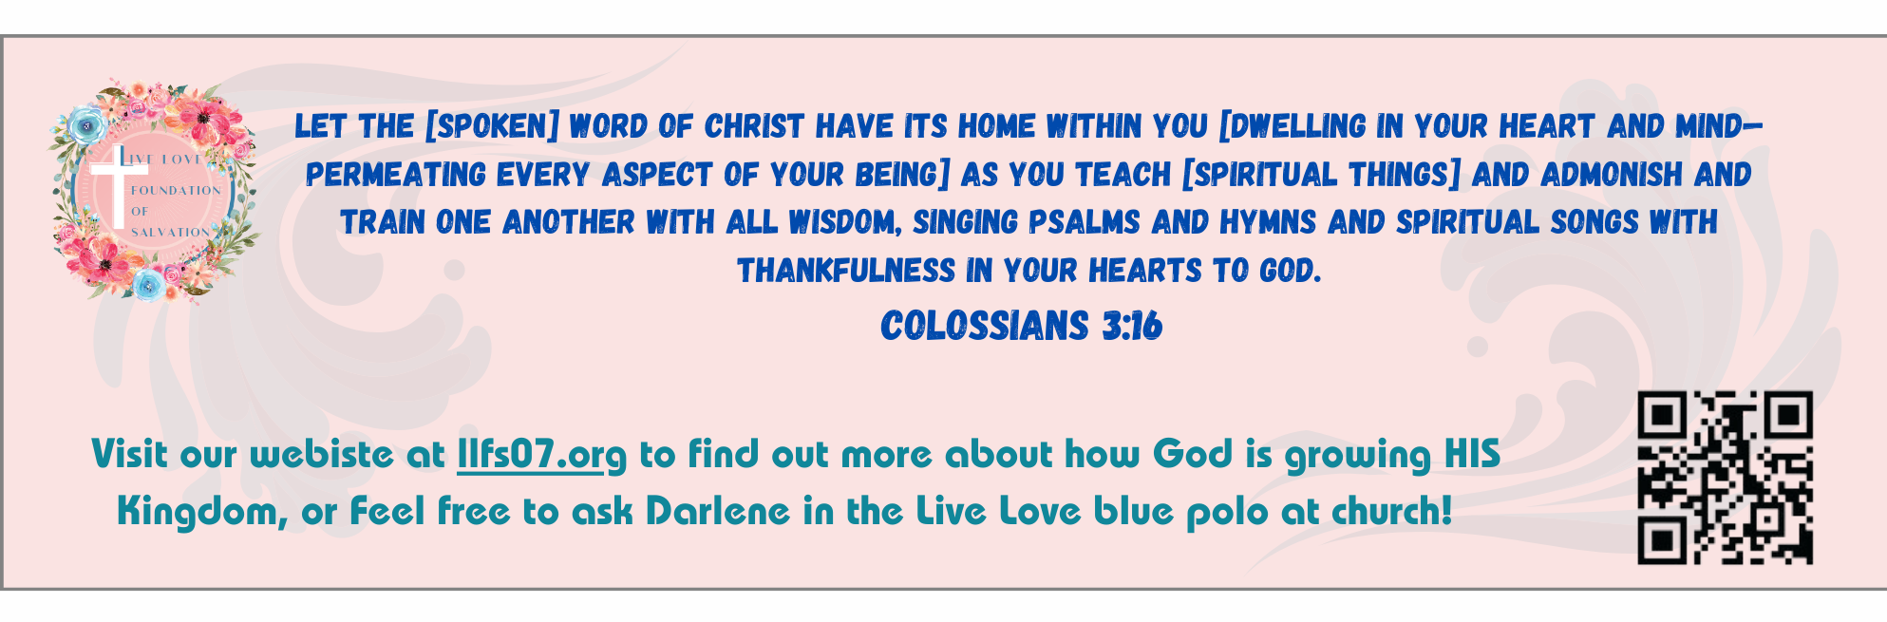

A TRIBUTE TO MOMS
Mother’s Day, 2026

To those who are expecting, we anticipate with you.
To those who experienced loss through miscarriage, failed adoptions, or runaways, we hurt for you.
To those of you who are single moms, we stand by you.
To those who gave birth this year, we celebrate you.
To those who lost a child, we mourn with you.
To those who battle infertility, we pray for you.
To those who foster, adopt, or mentor, we salute you.
To those with close relationships with your kids, we are happy for you.
To those with difficult, distant relationships, we weep with you.
To those of you who are in the trenches with little ones every single day, we appreciate you.
To those who endured driver’s tests, doctor visits, and many a sleepless night, we are glad for you.
To those who lost a mom, we grieve with you.
To those who were abused by your mom, we forgive them with you.
To those who have aborted a child, we remember them and you. Let God forgive you. He can!
To those who are stepmoms, we pray for smooth relationships.
To those who face empty nests, we both weep and rejoice with you.

Motherhood is not for the faint of heart! There are some real warriors in our midst. We lift you up and thank God for you all!

Church would not be church without moms! The Bible tells us of many wonderful mothers who made a difference in the world. We have moms like that right here at First Baptist Church! And we love you!

Your Pastor & Pat

Seven Ways to Love Your Mom
Pastor Jim W. Baize
May 10, 2026

Adult Sunday School 8:45
Sunday Worship Service 10:00
Children’s Sunday School 10:15
Active-Duty Military Meal 11:30

Bible Studies This Week

Tuesday
Oaks Int. Military Bible Study at FBCC
6-8 p.m. Childcare provided

Thursday
Ladies’ Bible Study at FBCC 10:30

Saturday
Men’s Bible Study at FBCC – Grounds & Grace 8:00
Brothers in the Word helping iron sharpen iron







