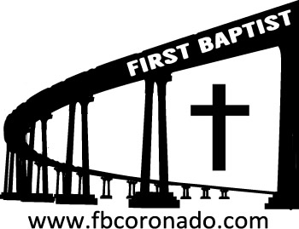

Reach Up, Reach Out, Reach Our World
445 C Avenue
Coronado, CA 92118
(619) 435-6588
fbcoronado.com
Jim W. Baize, Pastor
Julie Burkhart, Secretary, Childcare Coordinator
Patsy Lower, Treasurer
Laura Stecher, Children’s Ministry
David Preston, Youth Ministry
Dan Malcolm, Men’s Ministry/VIP Ministry
Cindy Wilson, Women’s Ministry
Monica Medina, Convalescent Ministry
Sheerah Haywood, Worship Ministry
Bobby Greer, Maintenance
Our mission is to produce fully devoted followers
of Jesus Christ. If we can be of any help to you,
feel free to give us a call.

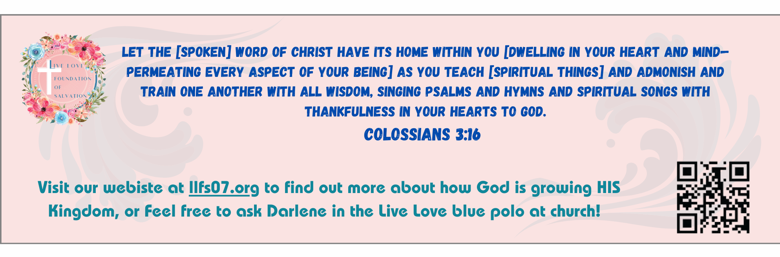
First Baptist Church
of Coronado

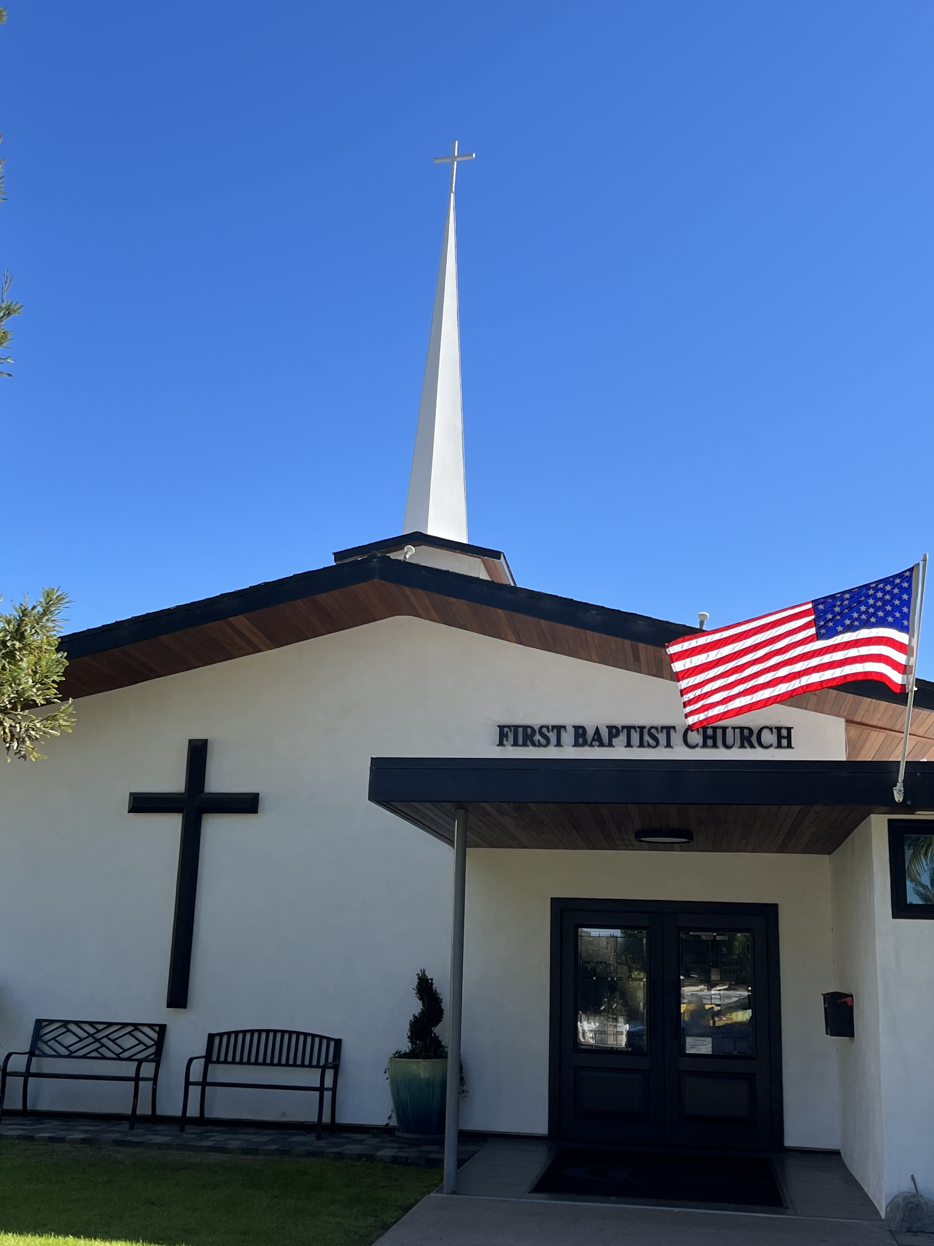

The Return of Jesus With His Saints
Pastor Jim Baize
April 26, 2026

THE RETURN OF JESUS WITH HIS SAINTS...

Well, I have done it again! I have definitely bitten off more than I can chew with today’s sermon subject. Whole books have been written about several subjects found in the teaching about this amazing event! After studying this message for the last 3 weeks or so, I feel like I am trying to preach a whole set of Bible encyclopedias in one sermon!

I shouldn’t be surprised at this point in my ministry. Preaching eternal truths as revealed by a Holy, infinite God, by its very nature, is inexhaustible!

Please forgive me for trying to present too much for one spiritual meal!

Last week we preached the return of Jesus FOR His saints. That is the first phase of the Second Coming of Jesus Christ and is called the Rapture. Today I will preach on the return of Jesus WITH His saints. That is called the Revelation.

After being with Jesus in heaven for a little over 7 years, we will come back to earth with Him as He wins the Battle of Armageddon, chains Satan, and judges sin in the world. After that, He will establish His 1000 years of righteous reign. Finally, a King in Whom is no corruption or graft! There will be no resignations over wrongdoing. No one will take bribes. His reign will be the biggest and best reign ever. No one has ever seen anything like it. (Sorry!)

One thing is certain, you WANT to be part of the rapture; but you do NOT want to be on earth for the revelation, unless you are returning to earth with Jesus!

Are you ready, my friend?!

Welcome to First Baptist Church of Coronado!

Adult Sunday School 8:45
Sunday Worship Service 10:00
Children’s Sunday School 10:15
Active-Duty Military Meal 11:30

Bible Studies This Week

Tuesday
Oaks Int. Military Bible Study at FBCC
6-8 p.m. Childcare provided

Wednesday
Ladies’ Bible Study Fellowship at FBCC 10:00

Thursday
Ladies’ Bible Study at FBCC 10:30

Saturday
Men’s Breakfast 8:00
Great food & fellowship


We will be baptizing again on Sunday, May 3rd. If you have accepted Jesus as your Savior and have not been baptized by immersion and would like to, let us know! Fill out a connection card and drop it in the offering box or email Julie – secretary@fbcoronado.com.

