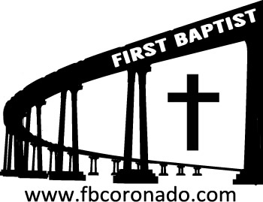

Reach Up, Reach Out, Reach Our World
445 C Avenue
Coronado, CA 92118
(619) 435-6588
fbcoronado.com
Jim W. Baize, Pastor
Julie Burkhart, Secretary, Childcare Coordinator
Patsy Lower, Treasurer
Laura Stecher, Children’s Ministry
David Preston, Youth Ministry
Dan Malcolm, Men’s Ministry/VIP Ministry
Cindy Wilson, Women’s Ministry
Monica Medina, Convalescent Ministry
Sheerah Haywood, Worship Ministry
Bobby Greer, Maintenance
Our mission is to produce fully devoted followers
of Jesus Christ. If we can be of any help to you,
feel free to give us a call.

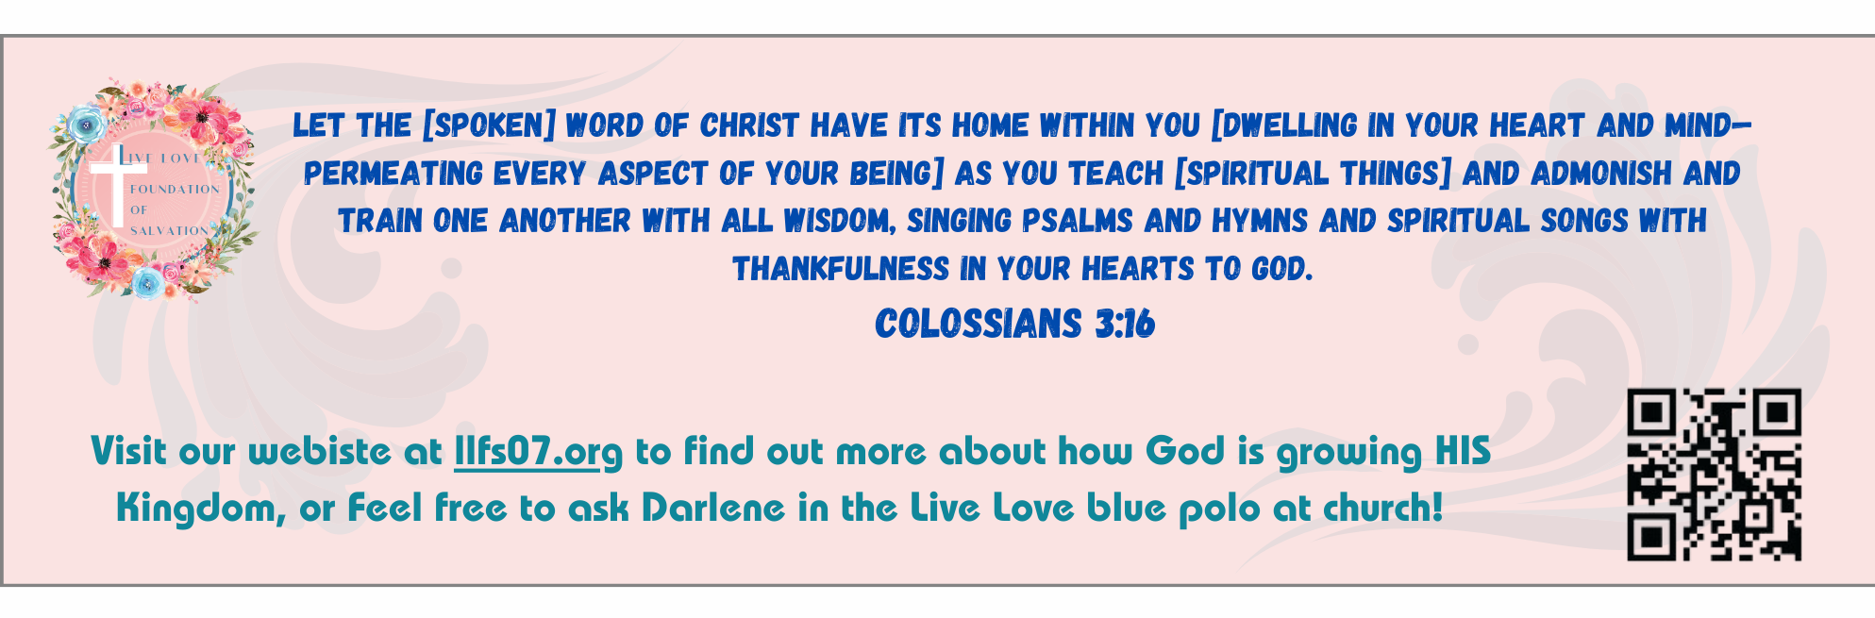
First Baptist Church
of Coronado

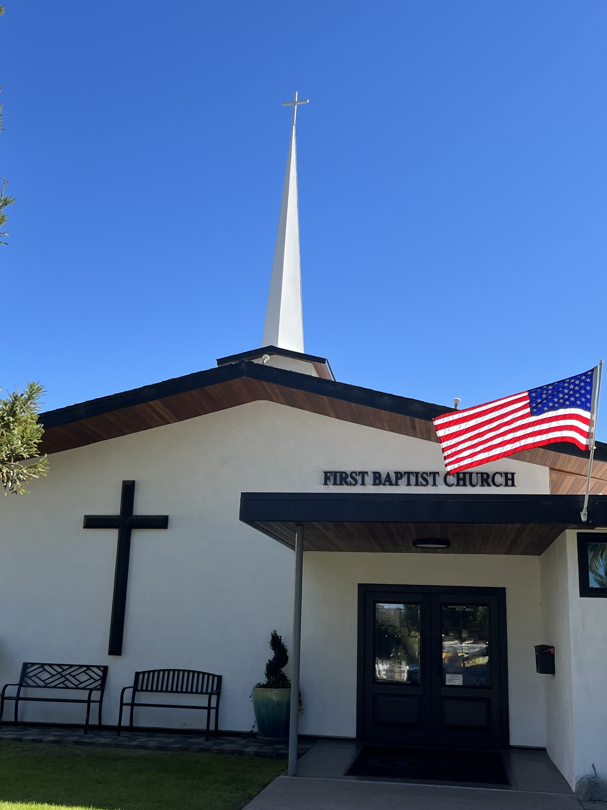

The Return of Jesus!
Pastor Jim Baize
April 19, 2026
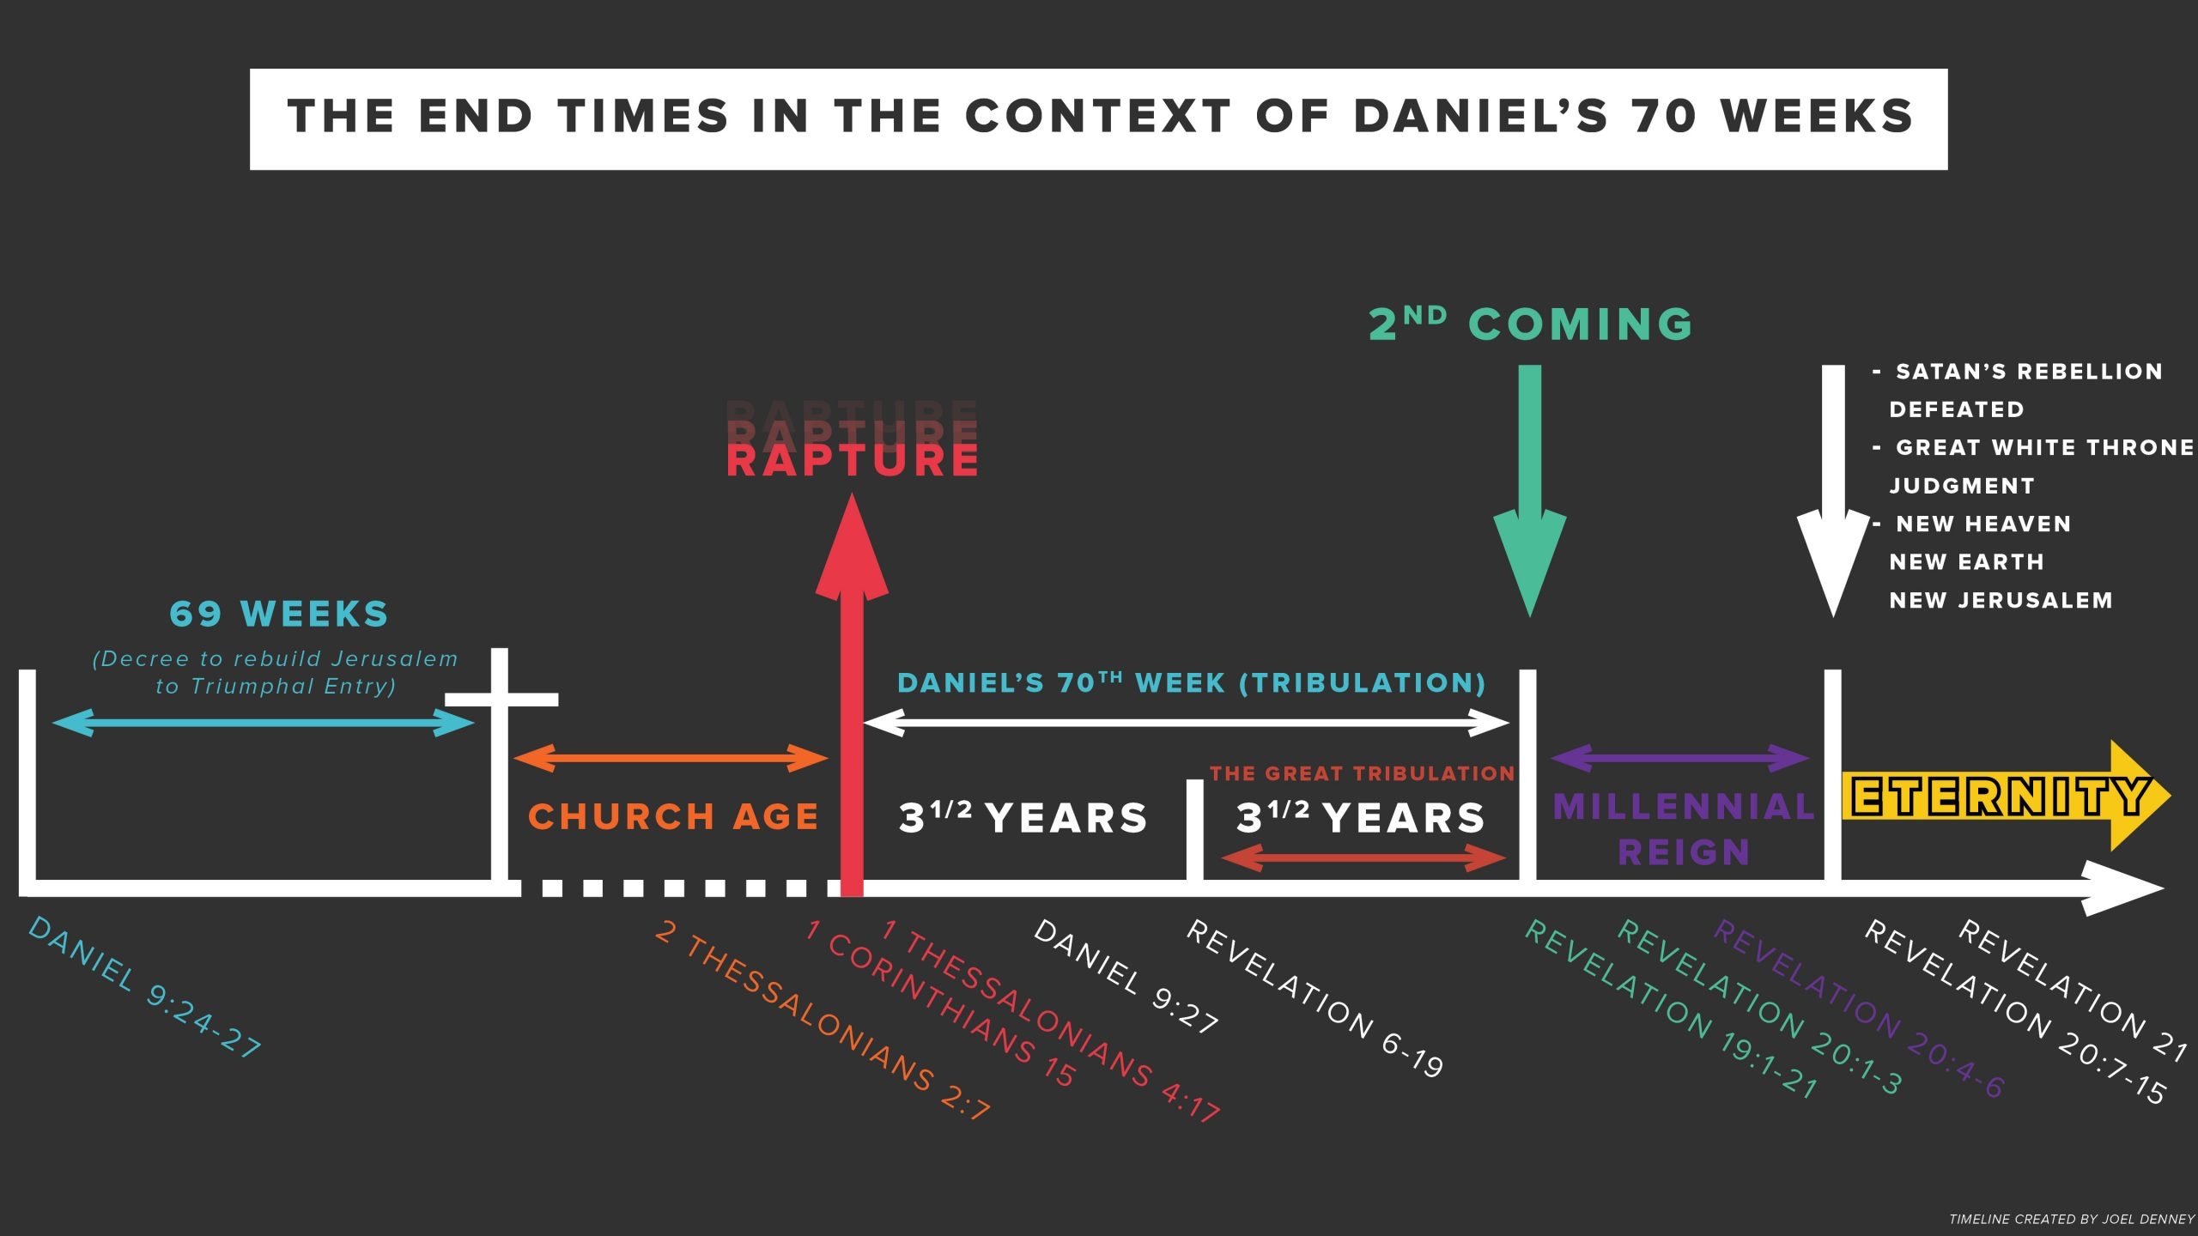

Welcome to First Baptist Church of Coronado!

Adult Sunday School 8:45
Sunday Worship Service 10:00
Children’s Sunday School 10:15
Active-Duty Military Meal 11:30

Bible Studies This Week

Tuesday
Oaks Int. Military Bible Study at FBCC
6-8 p.m. Childcare provided

Wednesday
Ladies’ Bible Study Fellowship at FBCC 10:00

Thursday
Ladies’ Bible Study at FBCC 10:30

Saturday
Men’s Coffee Club 8:00
Coffee, fellowship, and prayer

We will be baptizing again on Sunday, May 3rd. If you have accepted Jesus as your Savior and have not been baptized by immersion and would like to, let us know! Fill out a connection card and drop it in the offering box or email Julie – secretary@fbcoronado.com.

