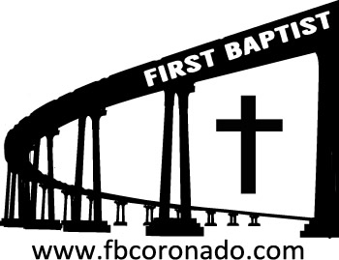

Reach Up, Reach Out, Reach Our World
445 C Avenue
Coronado, CA 92118
(619) 435-6588
fbcoronado.com
Jim W. Baize, Pastor
Julie Burkhart, Secretary, Childcare Coordinator
Patsy Lower, Treasurer
Laura Stecher, Children’s Ministry
David Preston, Youth Ministry
Dan Malcolm, Men’s Ministry/VIP Ministry
Cindy Wilson, Women’s Ministry
Monica Medina, Convalescent Ministry
Sheerah Haywood, Worship Ministry
Bobby Greer, Maintenance
Our mission is to produce fully devoted followers
of Jesus Christ. If we can be of any help to you,
feel free to give us a call.

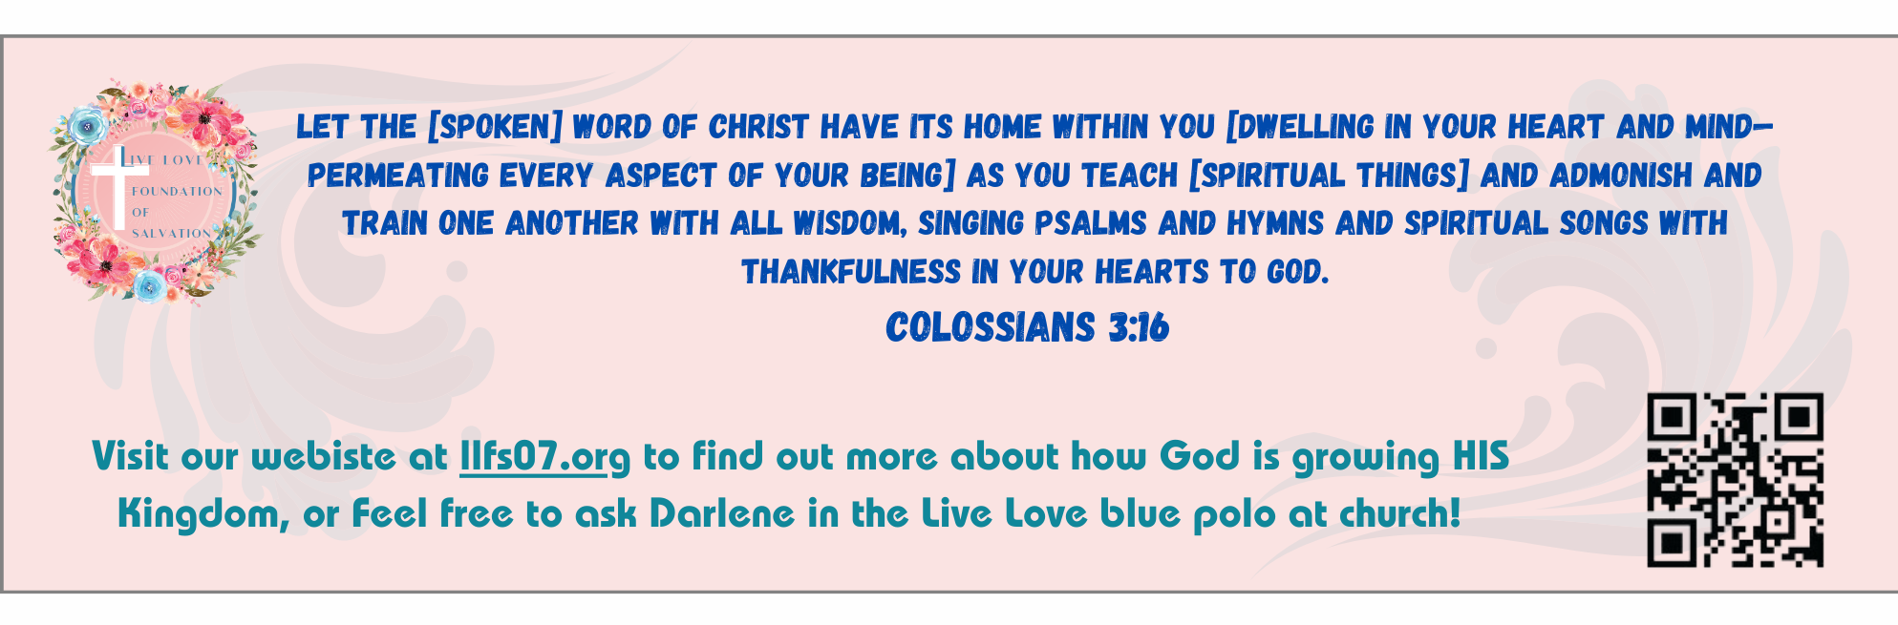
First Baptist Church
of Coronado

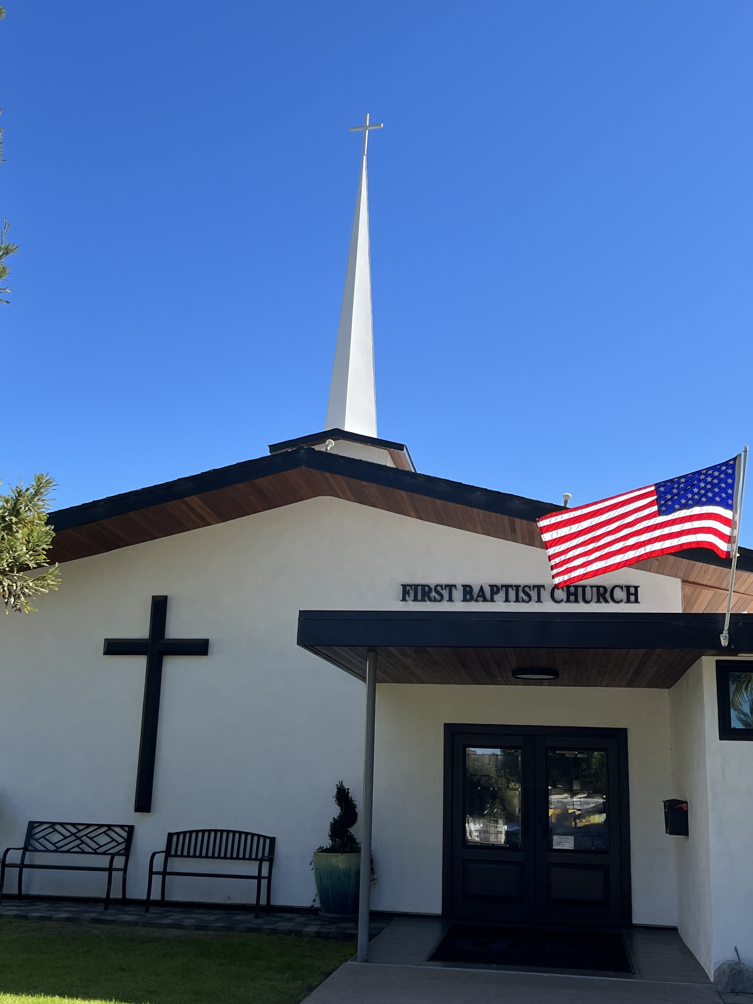

The Trinity
Pastor Jim Baize
April 12, 2026

WHAT ABOUT SATURDAY?

Over a week ago we celebrated Good Friday. That day gives us good reason to celebrate because it reminds us all that Jesus loves us so much that He endured the rejection of His people and the brutalization of crucifixion on our behalf! By His stripes we are healed!

Then last Sunday we celebrated Resurrection Day! We serve a LIVING Savior; He’s in the world today... I thank God for the price Jesus paid on Friday and the power He displayed on Sunday!

But what about Saturday? Have you ever thought about that? Think of what Mary endured. She saw her firstborn Son, savagely treated and tormented. She heard Him gasping through parched lips, while hanging from a cross like a common criminal! Her heart broke! All of the joys He had brought her...all of the good things He taught... all of the miracles He performed...and now He would die!

And what about the disciples. They all fled, except for John who stood at the foot of the cross...and the denying Peter as he warmed himself by the enemies’ fire...and Judas, who had hanged himself. What were His followers thinking? There had been so much promise, and now it was for nothing. All hope was gone!

Have you ever endured something like that “Saturday?” Of course you have. The heavens seem like cold brass. God is silent. And you wonder, what now? Remember this, Weeping may endure for the night, but joy comes in the morning! Before you know it, we will be with Jesus, and everything will be OK – no, not OK – MORE than OK!

If you are going through a spiritually dry spell right now, hang on! Jesus has you! Saturday will not last forever.

Welcome to First Baptist Church of Coronado!

Adult Sunday School 8:45
Sunday Worship Service 10:00
Children’s Sunday School 10:15
Active-Duty Military Meal 11:30

Bible Studies This Week

Tuesday
Oaks Int. Military Bible Study at FBCC
6-8 p.m. Childcare provided

Wednesday
Ladies’ Bible Study Fellowship at FBCC 10:00

Thursday
Ladies’ Bible Study at FBCC 10:30

Saturday
Men’s Coffee Club 8:00
Coffee, fellowship, and prayer

