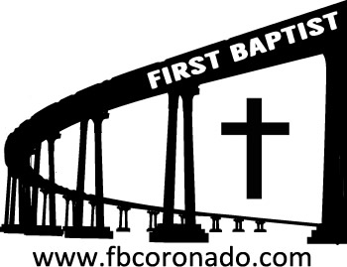

Reach Up, Reach Out, Reach Our World
445 C Avenue
Coronado, CA 92118
(619) 435-6588
fbcoronado.com
Jim W. Baize, Pastor
Julie Burkhart, Secretary, Childcare Coordinator
Patsy Lower, Treasurer
Laura Stecher, Children’s Ministry
David Preston, Youth Ministry
Dan Malcolm, Men’s Ministry/VIP Ministry
Cindy Wilson, Women’s Ministry
Monica Medina, Convalescent Ministry
Sheerah Haywood, Worship Ministry
Bobby Greer, Maintenance
Our mission is to produce fully devoted followers
of Jesus Christ. If we can be of any help to you,
feel free to give us a call.

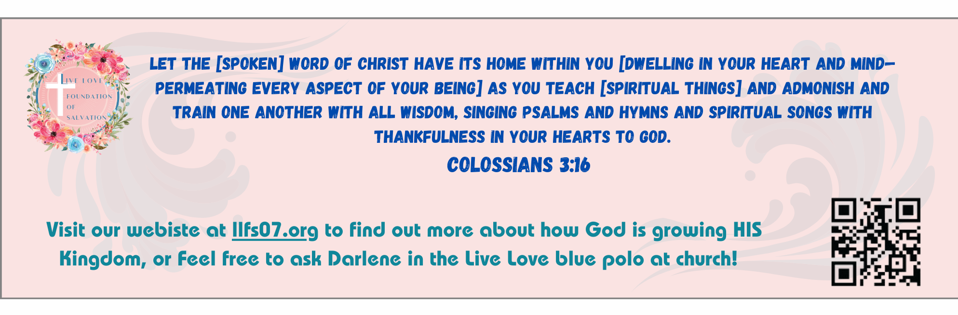
First Baptist Church
of Coronado

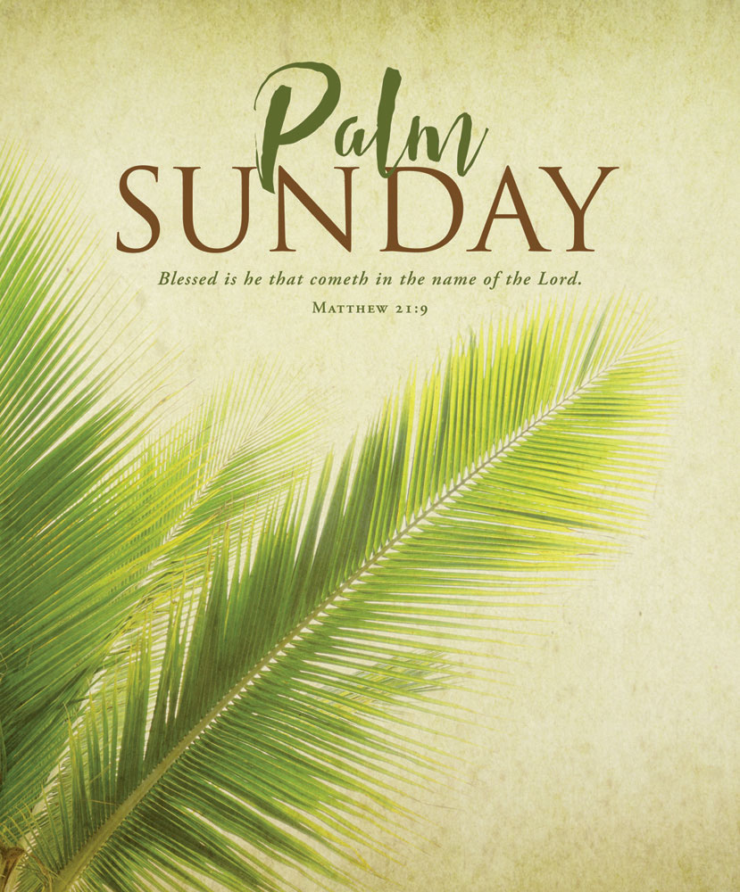

Why Did Jesus Have to Die?
Pastor Jim Baize
March 29, 2026

PALM SUNDAY

Palm Sunday is the first day of the high, Holy Week, preceding Easter. It begins with the people receiving Jesus as the Messiah and King; and it ends with Him being betrayed, unjustly condemned, dying, and rising again from the dead! What a week it was!

Riding into Jerusalem on a donkey was the fulfillment of prophecy. It was also a type of a King who enters a city in victory and peace! Jesus was offering to be their Messiah! How did they react? Many of them cried out, “Crucify Him! Crucify Him!”

Jesus didn’t force the matter. He did not demand to be their king. The choice was theirs to make.

Jesus does not force His way into our minds or hearts. He stands patiently on the outside, knocking on our heart’s door, longing to be invited in...

Behold, I stand at the door, and knock: if any man hear my voice, and open the door, I will come in to him, and will sup with him, and he with me. Rev 3:20

Today we celebrate His triumphant entry and His crucifixion. We do so with Holy Communion. Next week we celebrate His resurrection from the dead!

Because He lives, we can live, too!

Welcome to First Baptist Church of Coronado!

Adult Sunday School 8:45
Worship Service & Communion 10:00
Children’s Sunday School 10:15
All Church Fellowship Dinner 11:30

Bible Studies This Week

Tuesday
Oaks Int. Military Bible Study at FBCC
6-8 p.m. Childcare provided

Wednesday
Ladies’ Bible Study Fellowship at FBCC 10:00

Thursday
Ladies’ Bible Study at FBCC 10:30

Saturday
Men’s Coffee Club 8:00
Coffee, fellowship, and prayer

Upcoming Events

Walk The Cross
Walk The Cross takes place on Good Friday. Meet at Coronado Southern Baptist Church at 3:00 (111 Orange Avenue). From there 5 other churches will be walked to with bible readings and prayer held at each church. Join other Christians from various churches in Coronado for this special event!

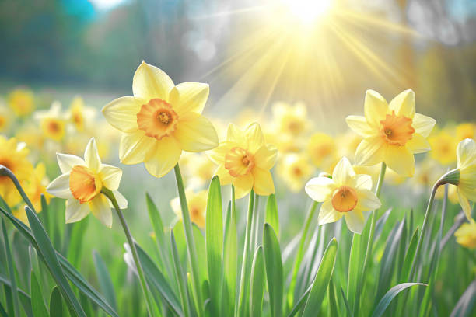

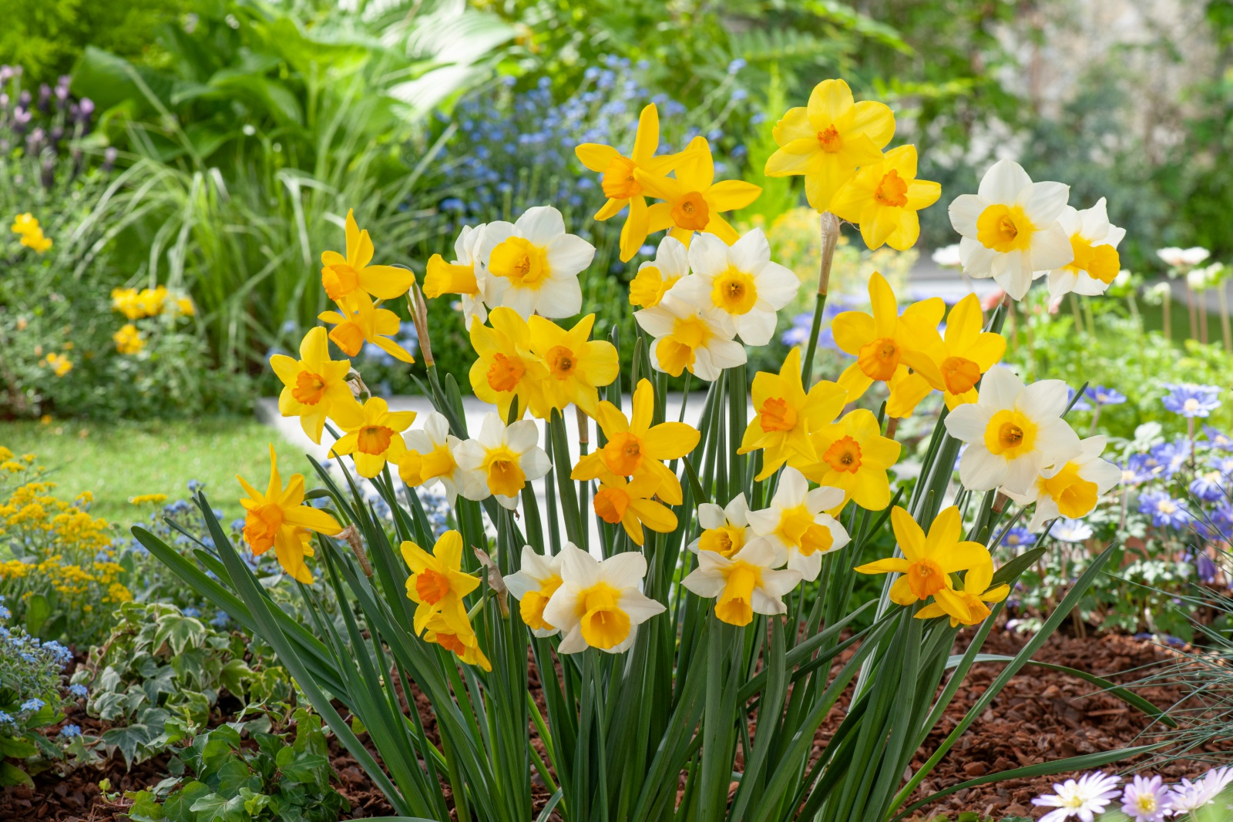Easter Sunday is next Sunday! FBCC will hold two services for Easter Sunday, 8:30 & 10:15. Children’s Sunday School will take place during the 10:15 service only. Childcare will be provided for both services and each child will receive an Easter gift!

