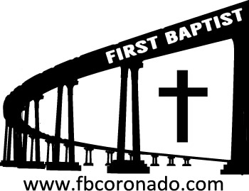

Reach Up, Reach Out, Reach Our World
445 C Avenue
Coronado, CA 92118
(619) 435-6588
fbcoronado.com
Jim W. Baize, Pastor
Julie Burkhart, Secretary, Childcare Coordinator
Patsy Lower, Treasurer
Laura Stecher, Children’s Ministry
David Preston, Youth Ministry
Dan Malcolm, Men’s Ministry/VIP Ministry
Cindy Wilson, Women’s Ministry
Monica Medina, Convalescent Ministry
Sheerah Haywood, Worship Ministry
Bobby Greer, Maintenance
Our mission is to produce fully devoted followers
of Jesus Christ. If we can be of any help to you,
feel free to give us a call.

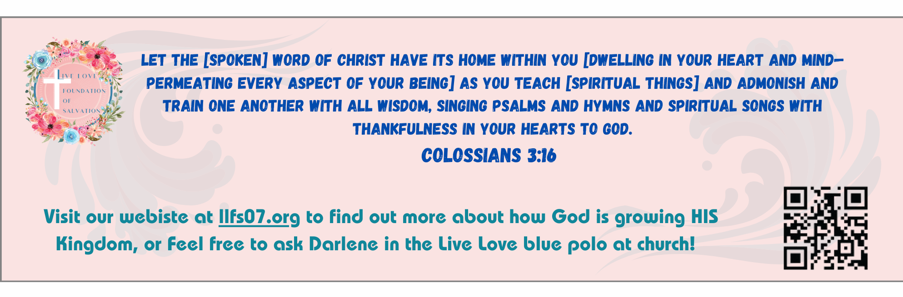
First Baptist Church
of Coronado

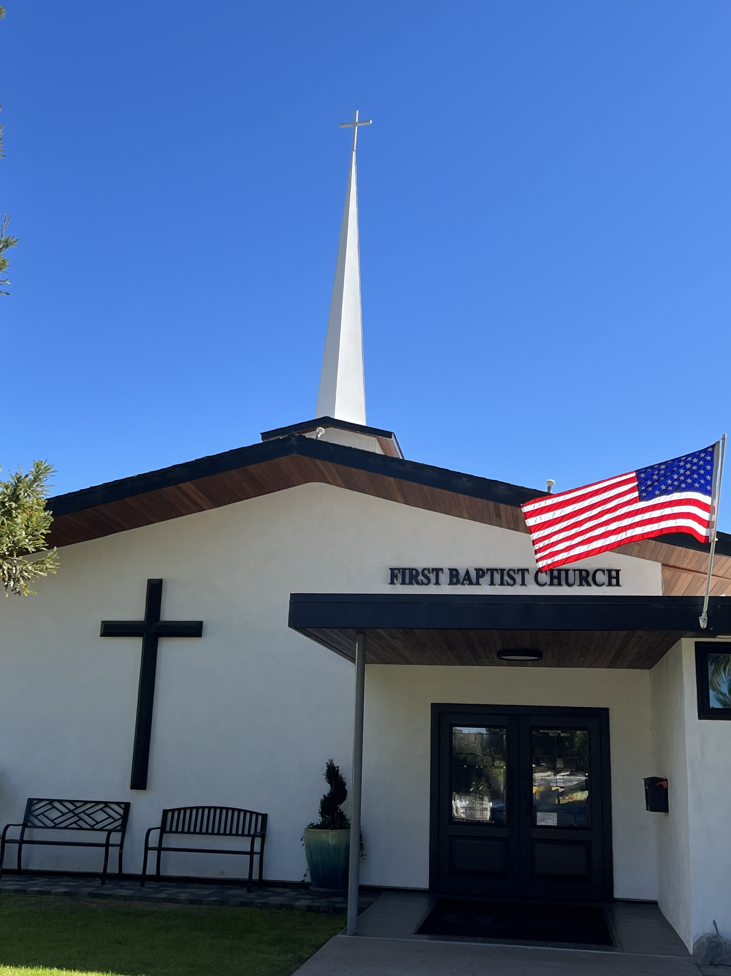

Are Allah and Jehovah The Same?
Pastor Jim Baize
March 22, 2026

JESUS OR MUHAMMAD?

- Nature and Divinity: Christians believe Jesus is God incarnate. In Islam, Jesus is a revered prophet (Issa), but not divine, and Muhammad is considered the final human messenger of Allah.
- Life and Mission:
Jesus' ministry focused on spiritual reform, love, nonviolence, and preaching the kingdom of God. Muhammad was both a religious leader and a political/military head of state, leading armies and establishing a legal system.
- Death and Resurrection: Christianity centers on Jesus' crucifixion and resurrection for salvation. Islamic tradition holds that Jesus was not crucified but raised to heaven, and he will return. Muhammad died in Medina after completing his mission.
- Sinlessness: The Bible portrays Jesus as sinless. The Quran indicates that Muhammad was tasked to ask for forgiveness for his sins.
- Approach to Power: Jesus renounced worldly power, refusing to use force to defend himself. Muhammad exercised power through both preaching and military leadership.
- Miracles: While both are associated with miracles, Islamic tradition emphasizes that Jesus performed miracles only by Allah's permission.
Key Shared Beliefs (within Islam):

- Both were born to the Virgin Mary (Maryam).
- Both are considered messengers of God.
- Both are expected to play a role in the end times (Jesus' Second Coming).
Only Jesus is the Way, the Truth, and the Life! John 14:6

Welcome to First Baptist Church of Coronado!

Adult Sunday School 8:45
Worship Service 10:00
Children’s Sunday School 10:15
ACTIVE-DUTY Military Lunch 11:30

Bible Studies This Week

Tuesday
Oaks Int. Military Bible Study at FBCC
6-8 p.m. Childcare provided

Wednesday
Ladies’ Bible Study Fellowship at FBCC 10:00

Thursday
Ladies’ Bible Study at FBCC 10:30

Saturday
Men’s Coffee Club 8:00
Coffee, fellowship, and prayer

Upcoming Events

Church Fellowship Potluck Sunday
Join us as we enjoy a meal and fellowship together on Sunday, March 29th immediately following the worship service. Be thinking about what main dish, side dish, salad or dessert you’d like to share!



Easter Sunday is April 5th. FBCC will hold two services for Easter Sunday, 8:30 & 10:15. Children’s Sunday School will take place during the 10:15 service only. Childcare will be provided for both services and each child will receive an Easter gift! Beautiful invitations are available to give to family, friends, and neighbors. Please take some!

