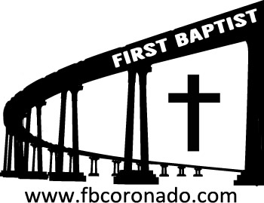

Reach Up, Reach Out, Reach Our World
445 C Avenue
Coronado, CA 92118
(619) 435-6588
fbcoronado.com
Jim W. Baize, Pastor
Julie Burkhart, Secretary, Childcare Coordinator
Patsy Lower, Treasurer
Laura Stecher, Children’s Ministry
David Preston, Youth Ministry
Dan Malcolm, Men’s Ministry/VIP Ministry
Cindy Wilson, Women’s Ministry
Monica Medina, Convalescent Ministry
Sheerah Haywood, Worship Ministry
Bobby Greer, Maintenance
Our mission is to produce fully devoted followers
of Jesus Christ. If we can be of any help to you,
feel free to give us a call.

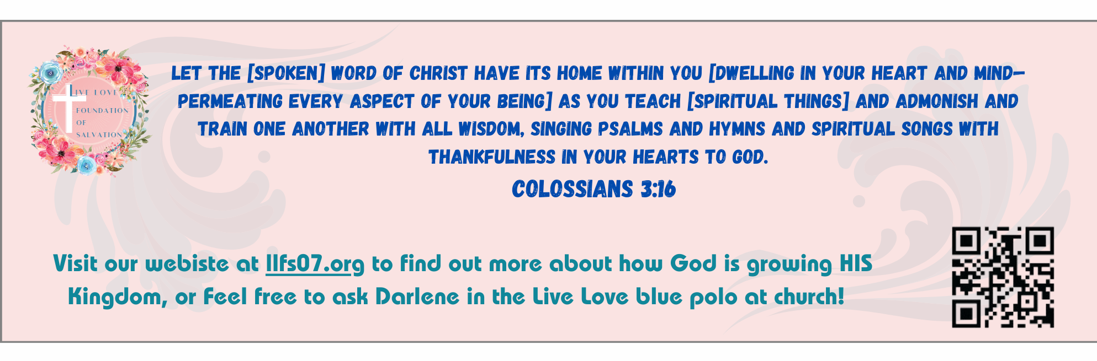
First Baptist Church
of Coronado

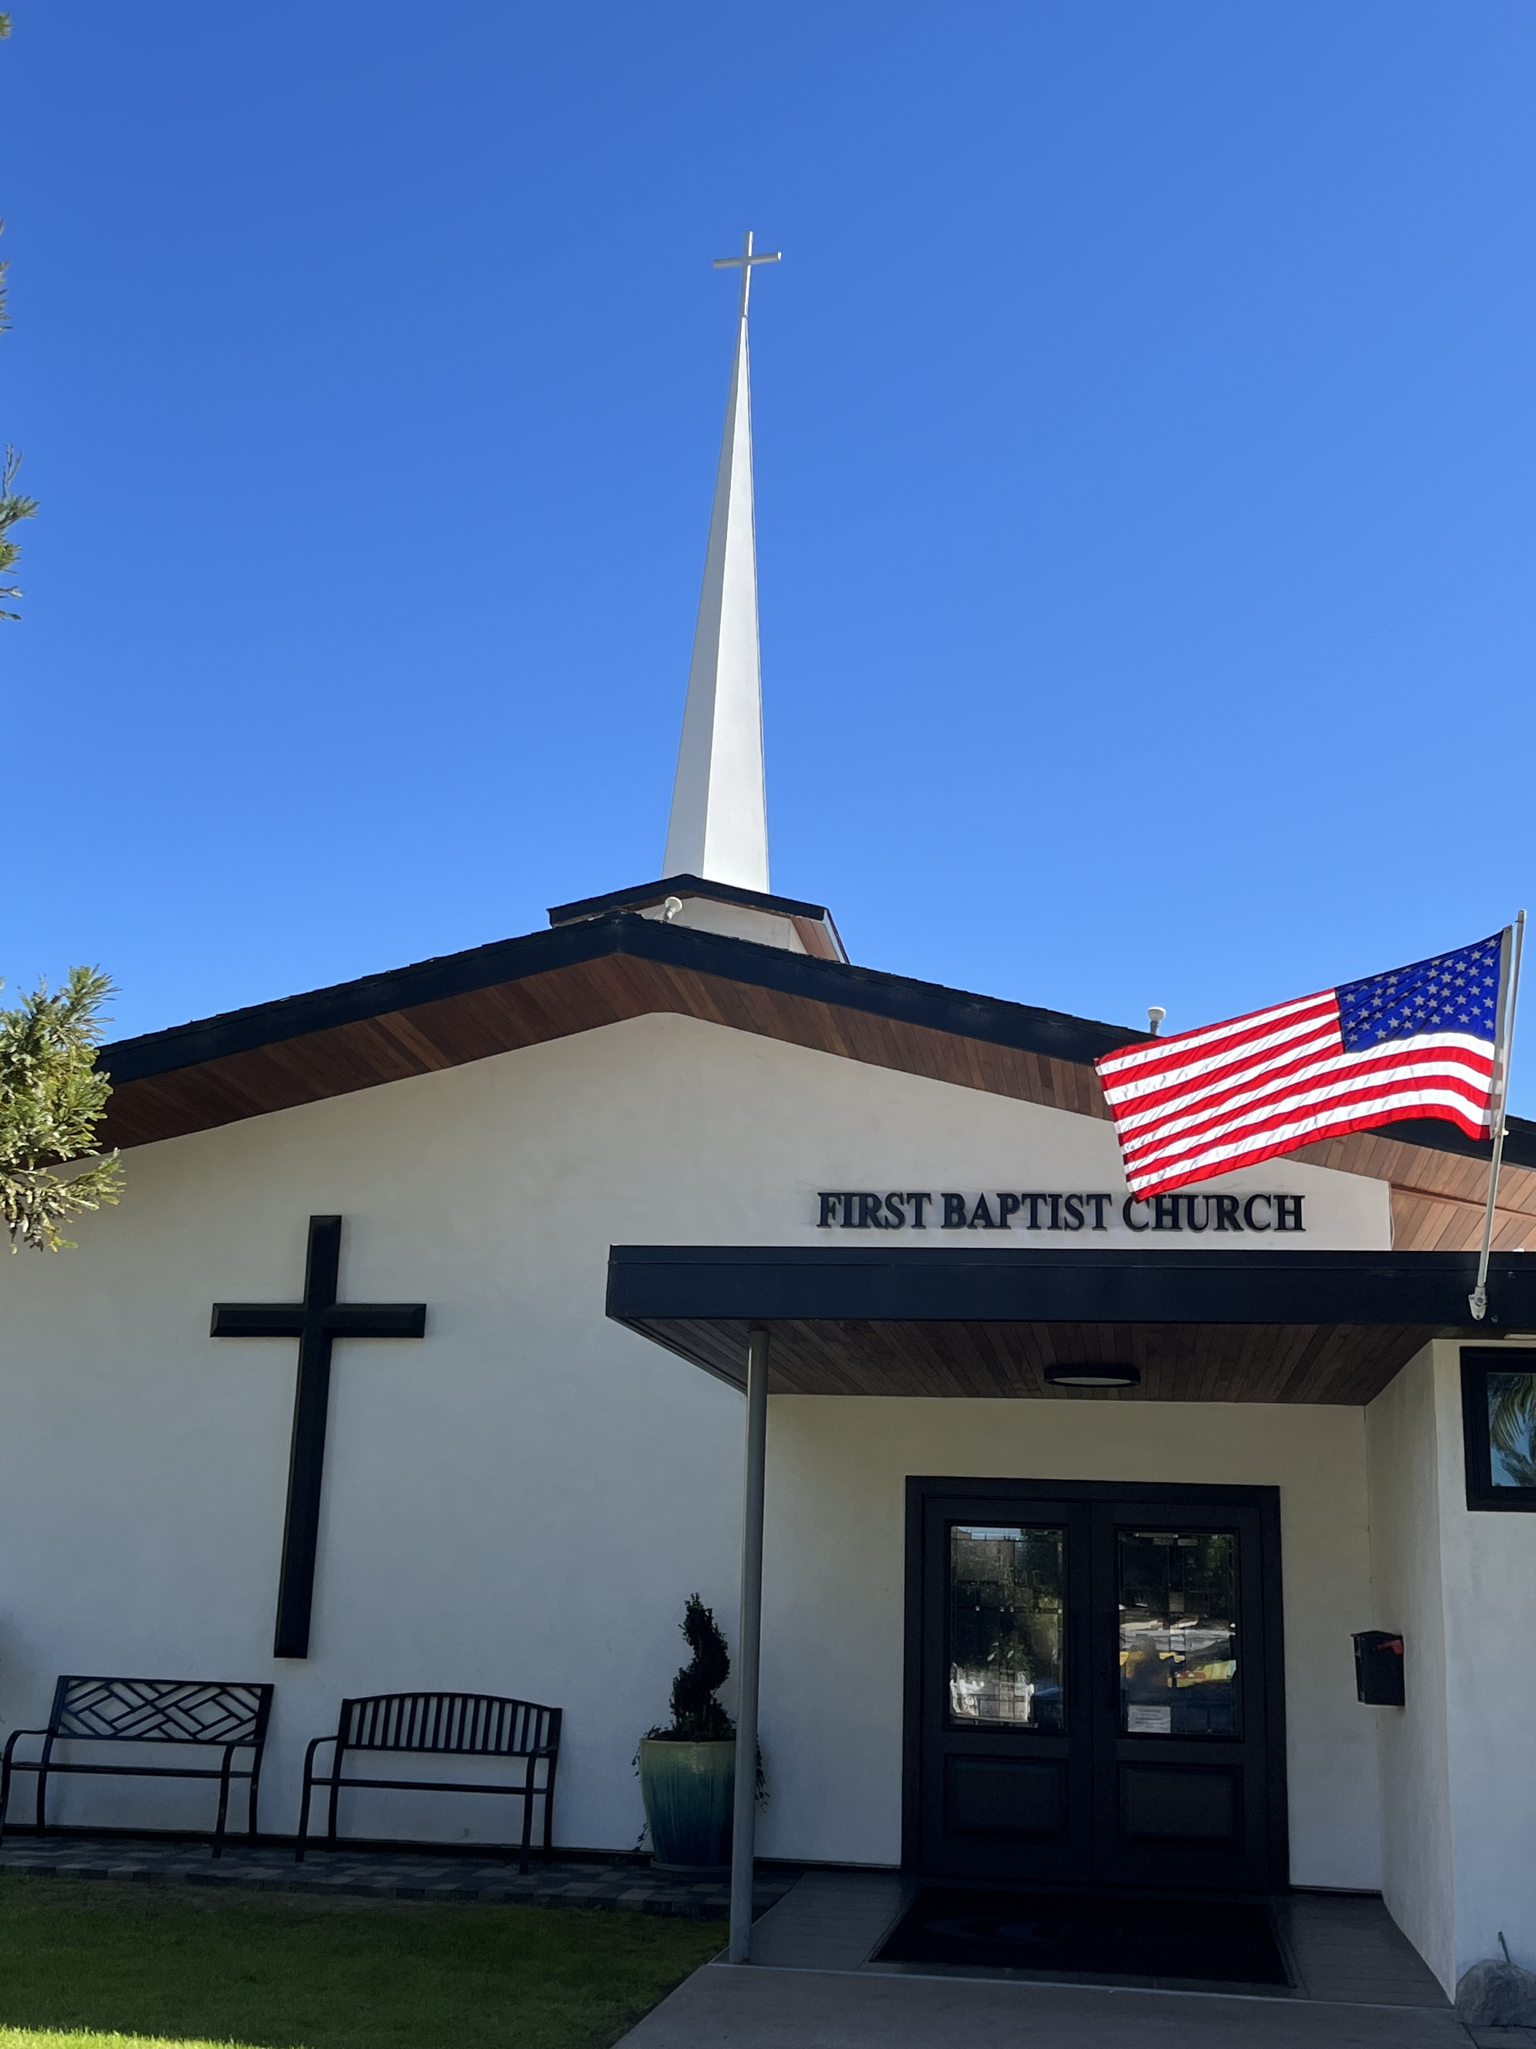

Seventeen Mistakes: Errors, No.
Mistakes, Yes. Part 2
Pastor Jim Baize
March 15, 2026

THE GOD WHO PROVIDES...

“Now the God of hope fill you with all joy and peace in believing, that ye may abound in hope, through the power of the Holy Ghost.” (Rom 15:13)
God provides for more than believers’ physical needs. This is indicated by seven titles given Him in the New Testament.
The God of love. We need love, and “God is love” (1 John 4:8). Then “the fruit of the Spirit is love” in our lives (Gal 5:22) because He Himself is “the God of love and peace” (2 Cor 13:11.)
The God of all grace. God saves us by His grace, and then we need to “grow in grace” (2 Pet 3:18). We can do this because “the God of all grace...hath called us unto his eternal glory” (1 Pet 5:10).
The God of peace. He satisfies the believer’s need for peace of soul, and He is called “the God of peace” five times in the New Testament (Rom 15:33; 16:20; Phil 4:9; 1 Thess 5:23; Heb 13:20).
The God of all comfort. Our God is called “the Father of mercies, and the God of all comfort” because He “comforts us in all our tribulation,” enabling us to provide comfort to others “by the comfort wherewith we ourselves are comforted of God” (2 Cor 1:3-4).
The God of patience. We do “have need of patience” (Hebrews 10:36), which is also supplied by “the God of patience and consolation” (Romans 15:5).
The God of glory. It was “the God of glory” who first called Abraham (Acts 7:2), and through the Word we also “are changed into the same image from glory to glory, even as by the Spirit of the Lord” (2 Cor 3:18).
The God of hope. By His Spirit He fills us with joy, peace, power, and abundant hope—blessing us “with all spiritual blessings . . . in Christ” (Eph 1:3). HMM. ICR. 1.25.26

Welcome to First Baptist Church of Coronado!

Adult Sunday School 8:45
Worship Service 10:00
Children’s Sunday School 10:15
ACTIVE-DUTY Military Lunch 11:30

Bible Studies This Week

Tuesday
Oaks Int. Military Bible Study at FBCC
6-8 p.m. Childcare provided

Wednesday
Ladies’ Bible Study Fellowship at FBCC 10:00

Thursday
Ladies’ Bible Study at FBCC 10:30

Saturday
Men’s Coffee Club 8:00
Coffee, fellowship, and prayer

Upcoming Events

Church Fellowship Potluck Sunday
Join us as we enjoy a meal and fellowship together on Sunday, May 29th immediately following the worship service. A sign-up sheet will be distributed this Sunday; be thinking about what main dish, side dish, salad or dessert you’d like to share!



Easter Sunday is April 5th. FBCC will hold two services for Easter Sunday, 8:30 & 10:15. Children’s Sunday School will take place during the 10:15 service only. Childcare will be provided for both services and each child will receive an Easter gift! Beautiful invitations are available to give to family, friends, and neighbors. Please take some!



