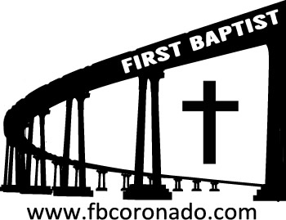

Reach Up, Reach Out, Reach Our World
445 C Avenue
Coronado, CA 92118
(619) 435-6588
fbcoronado.com
Jim W. Baize, Pastor
Julie Burkhart, Secretary, Childcare Coordinator
Patsy Lower, Treasurer
Laura Stecher, Children’s Ministry
David Preston, Youth Ministry
Dan Malcolm, Men’s Ministry/VIP Ministry
Cindy Wilson, Women’s Ministry
Monica Medina, Convalescent Ministry
Sheerah Haywood, Worship Ministry
Bobby Greer, Maintenance
Our mission is to produce fully devoted followers
of Jesus Christ. If we can be of any help to you,
feel free to give us a call.

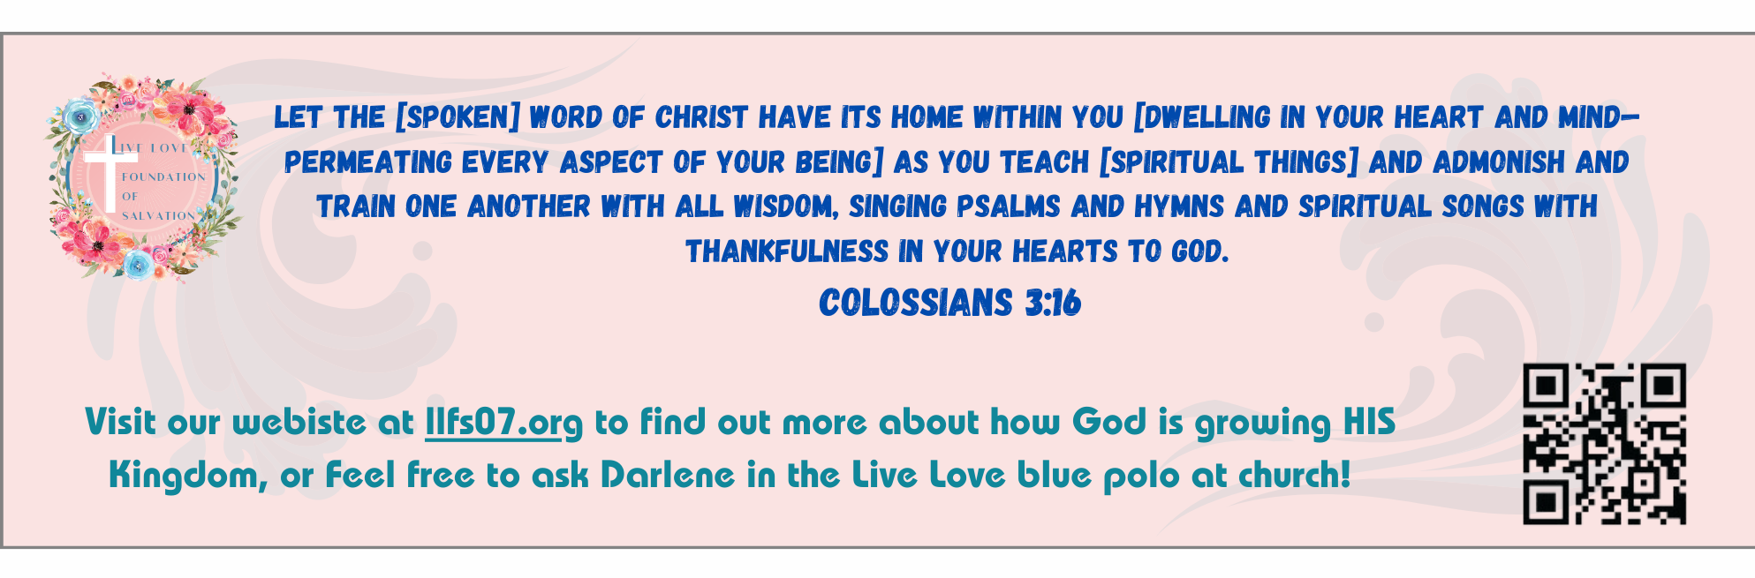
First Baptist Church
of Coronado

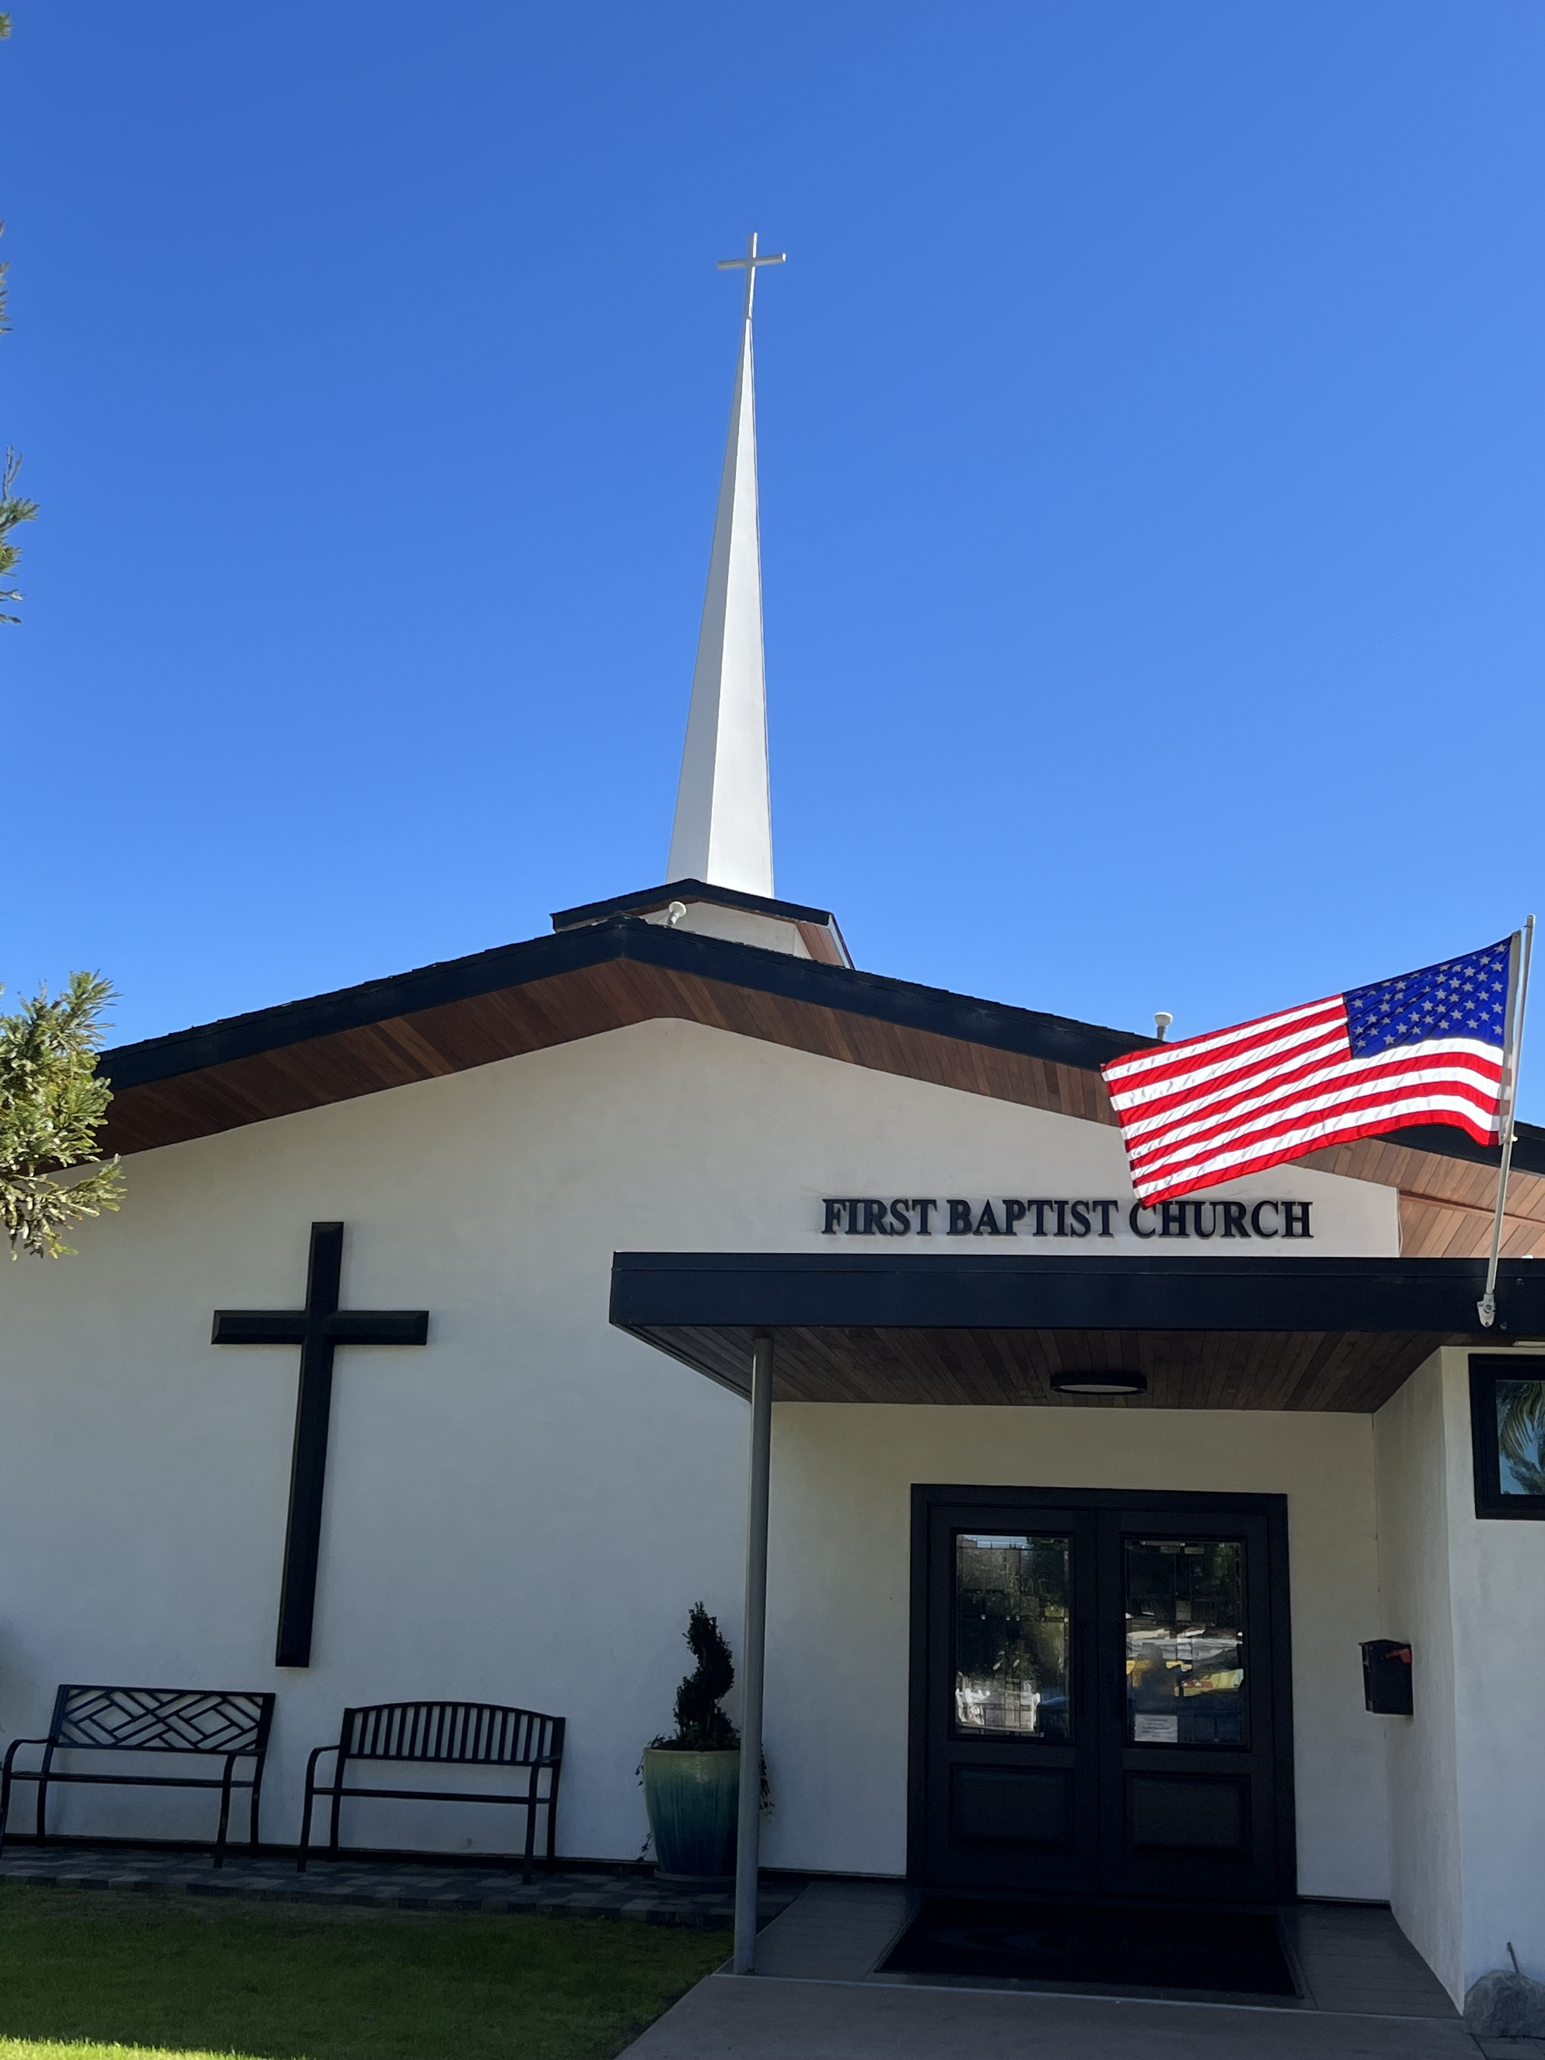

Seventeen Mistakes: Errors, No.
Mistakes, Yes.
Pastor Jim Baize
March 8, 2026

I WILL CARRY YOU

“Hearken unto me, O house of Jacob, and all the remnant of the house of Israel, which are borne by me from the belly, which are carried from the womb: and even to your old age I am he; and even to hoar hairs will I carry you: I have made, and I will bear; even I will carry, and will deliver you.” (Isaiah 46:3–4)
When we are young, concern for the future may be the furthest thing from our thoughts, but as we age we become more cognizant of our diminishing strength and declining health. While these changes become our new reality and may occupy our thoughts and discourage us, they come as no surprise to the God who made us and sustains us.
In Psalm 71, the author begins by proclaiming God as his “rock,” “hope,” and “refuge:” “For thou art my hope, O Lord GOD: thou art my trust from my youth” (v. 5). However, along with these declarations of trust, he then lifts prayers to the Lord expressing many of the same aging concerns we experience today: “Cast me not off in the time of old age; forsake me not when my strength faileth” (v. 9); “now also when I am old and grayheaded, O God, forsake me not” (v. 18).
These cares are nothing to be ashamed of but are just the kind of concerns that God wants us to lift up to Him: “Casting all your care upon him; for he careth for you” (1 Peter 5:7); “cast thy burden upon the LORD, and he shall sustain thee” (Psalm 55:22). If you find similar worries crowding your mind, hold fast to God’s assurance of His faithfulness to His beloved children (37:28). All the way from the womb to the tomb, He will carry you! DWR. ICR. 2.6.26

This devotion has a lot more meaning for me now than it would have 40 or 50 years ago. I had a funeral last Tuesday and another tomorrow! I often come face to face with the reality of the brevity of our lives on earth!

I can’t tell you how comforting God’s promises are now that I am “gray-headed.” Do you know Jesus? If not, today can be the day you meet Him!

Welcome to First Baptist Church of Coronado!

Adult Sunday School 8:45
Worship Service 10:00
Children’s Sunday School 10:15
ACTIVE-DUTY Military Lunch 11:30

Bible Studies This Week

Tuesday
Oaks Int. Military Bible Study at FBCC
6-8 p.m. Childcare provided

Wednesday
Ladies’ Bible Study Fellowship at FBCC 10:00

Thursday
Ladies’ Bible Study at FBCC 10:30

Saturday
Men’s Coffee Club 8:00
Coffee, fellowship, and prayer

Upcoming Events



Easter Sunday is April 5th. FBCC will hold two services for Easter Sunday, 8:30 & 10:15. Childcare will be provided for both services and each child will receive an Easter gift. Beautiful invitations are available to give to family, friends, and neighbors. Please take some!



