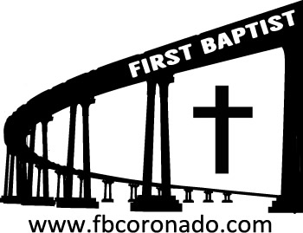

Reach Up, Reach Out, Reach Our World
445 C Avenue
Coronado, CA 92118
(619) 435-6588
fbcoronado.com
Jim W. Baize, Pastor
Julie Burkhart, Secretary, Childcare Coordinator
Patsy Lower, Treasurer
Laura Stecher, Children’s Ministry
David Preston, Youth Ministry
Dan Malcolm, Men’s Ministry/VIP Ministry
Cindy Wilson, Women’s Ministry
Monica Medina, Convalescent Ministry
Sheerah Haywood, Worship Ministry
Bobby Greer, Maintenance
Our mission is to produce fully devoted followers
of Jesus Christ. If we can be of any help to you,
feel free to give us a call.

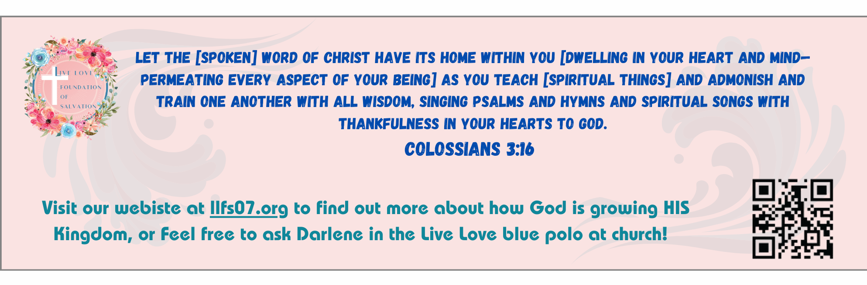
First Baptist Church
of Coronado



The Bible-Inspired Word of God
Pastor Jim Baize
March 1, 2026

“INSPIRED WORDS”

“Heaven and earth shall pass away: but my words shall not pass away.” (Luke 21:33)
The doctrine of plenary verbal inspiration, wrongly considered antiquated by many modern neo-evangelicals, is essential to the Christian faith. “All scripture [that is every word written down or inscribed] is given by inspiration [literally “breathed out] of God,” not man (2 Tim 3:16)!
We acknowledge, of course, that problems of transmission and translation exist, but these are relatively trivial in the entire context. We also acknowledge that the process of inspiration may have varied, but the end result is as if the entire Bible had been dictated and transcribed word by word.
This is the way Jesus Christ – the Creator, the Living Word, the Author of Scripture – viewed the Scriptures. “The scripture cannot be broken,” He said (John 10:35). “Till heaven and earth pass, one jot or one tittle shall in no wise pass from the law, till all be fulfilled” (Mat 5:18). “Then he said unto them, O fools, and slow of heart to believe all that the prophets have spoken....And beginning at Moses and all the prophets, he expounded unto them in all the scriptures the things concerning himself” (Luke 24:25, 27). The Bible, every word of it, is divinely inspired without error, is infallibly true, and has absolute authority in every area of our lives. The words of Christ, who taught these truths, are forever “settled in heaven” (Psalm 119:89) and “shall not pass away.”
It is mortally dangerous, therefore, “unto every man that heareth the words of the prophecy of this book” to “add unto these things” as cultists do or to “take away from the words of the book of this prophecy” as liberals do (Rev 22:18-19). Would it not be much better to say with the psalmist, “Thy testimonies also are my delight and my counsellors” (Psalm 119:24)? HMM. ICR. 1.29.25

Welcome to First Baptist Church of Coronado!

Adult Sunday School 8:45
Worship Service & Communion 10:00
Children’s Sunday School 10:15
ACTIVE-DUTY Military Lunch & Volleyball
Meet at Noon at Central Beach near Lifeguard tower

Bible Studies This Week

Tuesday
Oaks Int. Military Bible Study at FBCC
6-8 p.m. Childcare provided

Wednesday
Ladies’ Bible Study Fellowship at FBCC 10:00

Thursday
Ladies’ Bible Study at FBCC 10:30

Saturday
Men’s Coffee Club 8:00
Coffee, fellowship, and prayer

Upcoming Events



Easter Sunday is April 5th. FBCC will hold two services for Easter Sunday, 8:30 & 10:15. Childcare will be provided for both services and each child will receive an Easter gift. Beautiful invitations will be available soon. Please take some and hand them out to family, friends, and neighbors!



