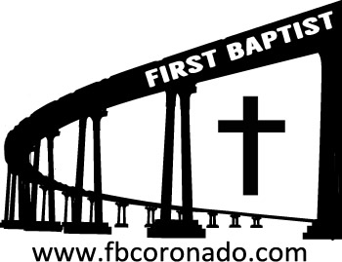

Reach Up, Reach Out, Reach Our World
445 C Avenue
Coronado, CA 92118
(619) 435-6588
fbcoronado.com
Jim W. Baize, Pastor
Julie Burkhart, Secretary, Childcare Coordinator
Patsy Lower, Treasurer
Laura Stecher, Children’s Ministry
David Preston, Youth Ministry
Dan Malcolm, Men’s Ministry/VIP Ministry
Cindy Wilson, Women’s Ministry
Monica Medina, Convalescent Ministry
Sheerah Haywood, Worship Ministry
Bobby Greer, Maintenance
Our mission is to produce fully devoted followers
of Jesus Christ. If we can be of any help to you,
feel free to give us a call.

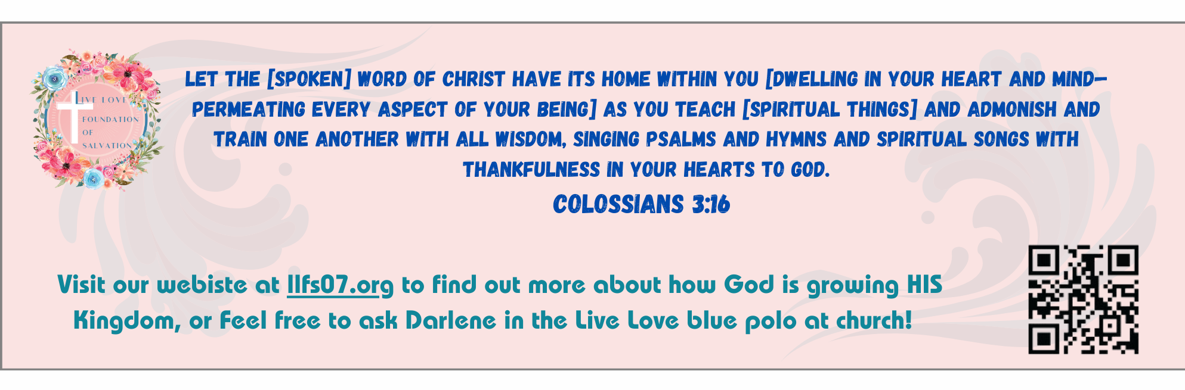
First Baptist Church
of Coronado

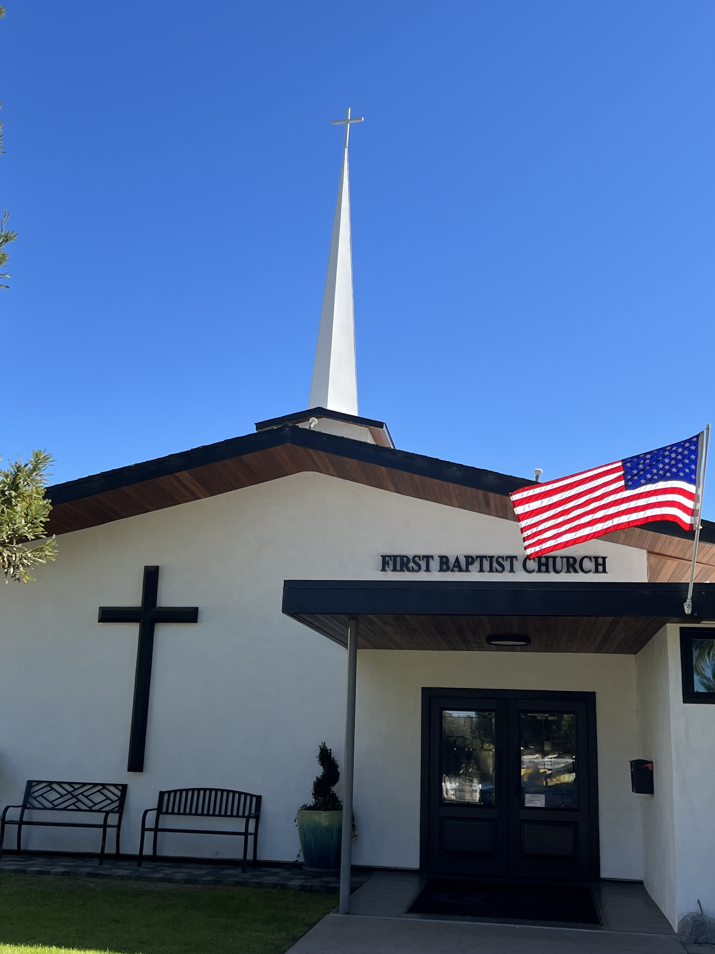

Eight Ways to Authentic Experience with God
Pastor Chris Ducas
February 22, 2026

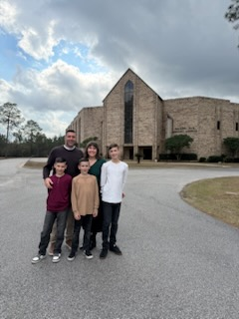

WELCOME CHRIS & STEPHANY DUCAS & FAMILY

Chris is a follower of Jesus and a former addict who has been sober for 17 years. He has served at two megachurches in San Diego, The Rock Church and Eastlake Church. I was blessed to be able to hire him to work at my former church, Ocean View Baptist Church, where he met and married Stephany. He now leads as Senior Pastor of Wilson Avenue Baptist Church in Mobile, Alabama. He also serves as lead pastor of a youth camp that reaches at-risk, unchurched teens and is leveraged by God to bring entire families to faith in Christ. God has blessed the Ducas family with three boys. Welcome Chris as he comes to preach for us this morning.

Welcome to First Baptist Church of Coronado!

Adult Sunday School 8:45
Worship Service 10:00
Children’s Sunday School 10:15
ACTIVE-DUTY Military Lunch 11:15

Bible Studies This Week

Tuesday
Oaks Int. Military Bible Study at FBCC
6-8 p.m. Childcare provided

Wednesday
Ladies’ Bible Study Fellowship at FBCC 10:00

Thursday
Ladies’ Bible Study at FBCC 10:30

Saturday
Men’s Coffee Club 8:00
Coffee, fellowship, and prayer

Upcoming Events

New Member Class Sunday 3/1/26 immediately following the worship service. Lunch and childcare provided. Please contact Julie for more information and to sign up @ secretary@fbcoronado.com

