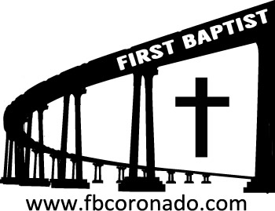

Reach Up, Reach Out, Reach Our World
445 C Avenue
Coronado, CA 92118
(619) 435-6588
fbcoronado.com
Jim W. Baize, Pastor
Julie Burkhart, Secretary, Childcare Coordinator
Patsy Lower, Treasurer
Laura Stecher, Children’s Ministry
David Preston, Youth Ministry
Dan Malcolm, Men’s Ministry/VIP Ministry
Cindy Wilson, Women’s Ministry
Monica Medina, Convalescent Ministry
Sheerah Haywood, Worship Ministry
Bobby Greer, Maintenance
Our mission is to produce fully devoted followers
of Jesus Christ. If we can be of any help to you,
feel free to give us a call.

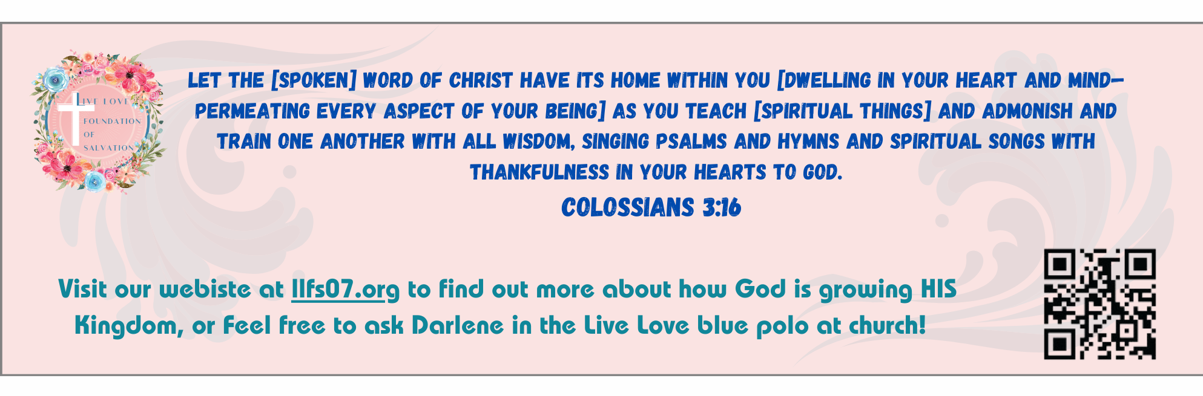
First Baptist Church
of Coronado

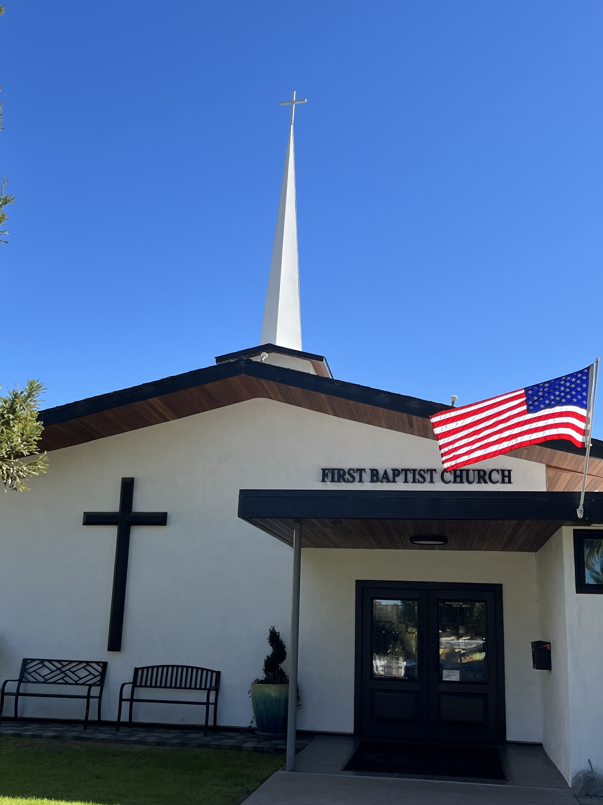

The Bible: The Word of God
Pastor Jim W. Baize
February 15, 2026

THE SETTLED WORD

“Forever, O LORD, thy word is settled in heaven.” (Psalm 119:89)
Most who read the Bible regularly are probably familiar with these sweeping statements from the Scriptures.
“So shall my word be that goes forth out of my mouth: it shall not return unto me void, but it shall accomplish that which I please, and it shall prosper in the thing whereto I sent it” (Isaiah 55:11).
- “For verily I say unto you, Till heaven and earth pass, one jot or one tittle shall in no wise pass from the law, till all be fulfilled” (Matthew 5:18).
- “Heaven and earth shall pass away, but my words shall not pass away” (Matthew 24:35).
- “But the word of the Lord endures forever. And this is the word which by the gospel is preached unto you” (1 Peter 1:25).
On this foundation, the psalmist made additional promises to his Lord in this stanza (Psalm 119:89–96). He noted the affliction that almost took his life (v. 92) and the wicked who tried to destroy him (v. 95), which are common enough occurrences among the godly. But in spite of the troubles in life, this godly man knew that the evidence abounds for God’s faithfulness throughout the earth (vv. 90–91).
God’s 77 rhetorical questions to Job (Job 38–41) centered on the evidence of His control and care for the universe. This sovereignty of God prompted the psalmist to reiterate his commitment to a firm familiarity with God’s precepts and a continual effort to seek them (Psalm 119:93–94).
He knew that the wicked would continue trying to destroy and that human affairs limit the possibility of perfection. But the godly man would understand God’s testimonies, since they are sufficient to apply to all situations (v. 96). HMM III. ICR. 12.2.25

Welcome to First Baptist Church of Coronado!

Adult Sunday School 8:45
Worship Service 10:00
Children’s Sunday School 10:15
ACTIVE-DUTY Military Lunch 11:15

Bible Studies This Week

Tuesday
Oaks Int. Military Bible Study at FBCC
6-8 p.m. Childcare provided

Wednesday
Ladies’ Bible Study Fellowship at FBCC 10:00

Thursday
Ladies’ Bible Study at FBCC 10:30

Saturday
Men’s Coffee Club 8:00
Coffee, fellowship, and prayer

Upcoming Events

Baptism Sunday 2/22/26 – If you’ve accepted Jesus as your personal Savior and not been baptized by immersion, now is your opportunity! Let Pastor Baize know if you’d like to be baptized.

New Member Class Sunday 3/1/26 immediately following the worship service. Lunch and childcare provided. Please contact Julie for more information and to sign up @ secretary@fbcoronado.com

