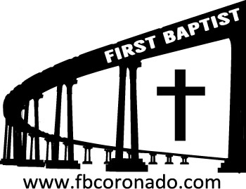

Reach Up, Reach Out, Reach Our World
445 C Avenue
Coronado, CA 92118
(619) 435-6588
fbcoronado.com
Jim W. Baize, Pastor
Julie Burkhart, Secretary, Childcare Coordinator
Patsy Lower, Treasurer
Laura Stecher, Children’s Ministry
David Preston, Youth Ministry
Dan Malcolm, Men’s Ministry/VIP Ministry
Cindy Wilson, Women’s Ministry
Monica Medina, Convalescent Ministry
Sheerah Haywood, Worship Ministry
Bobby Greer, Maintenance
Our mission is to produce fully devoted followers
of Jesus Christ. If we can be of any help to you,
feel free to give us a call.

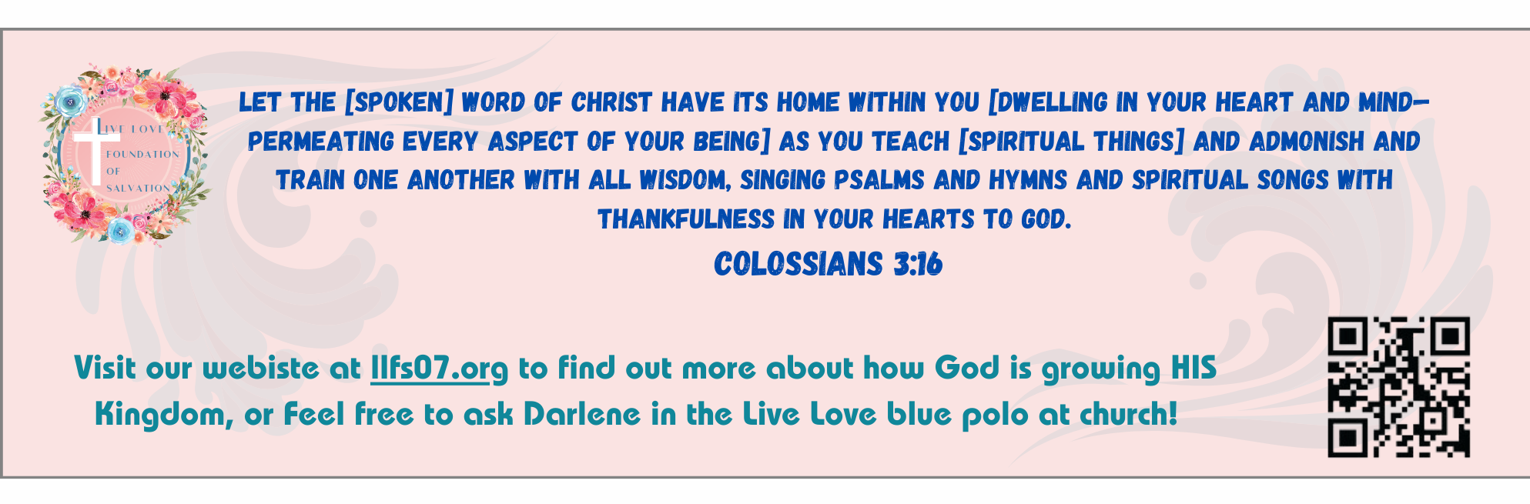
First Baptist Church
of Coronado

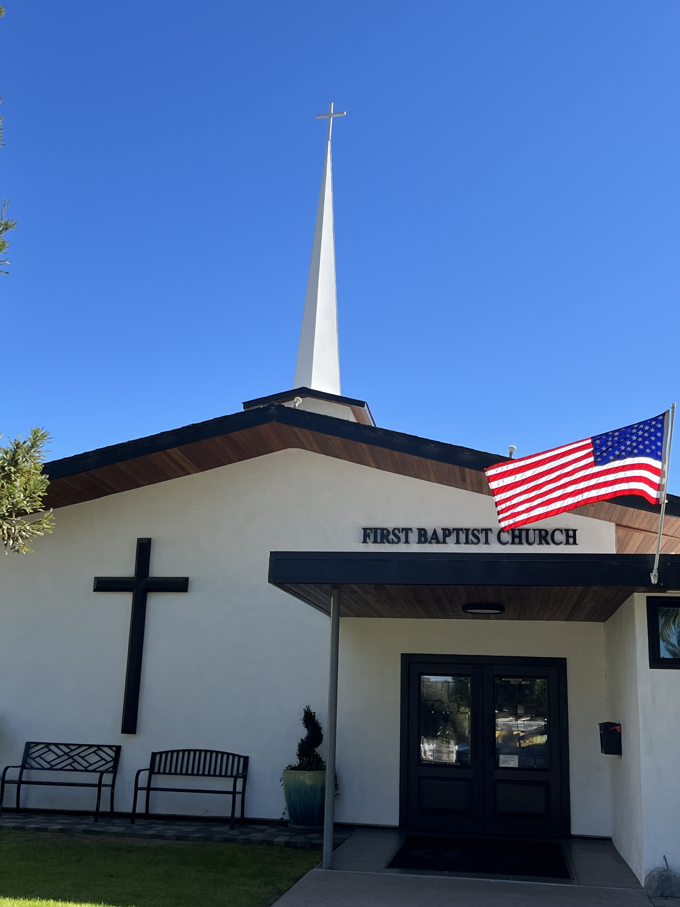

One Christian’s Perspective
On Immigration
Pastor Jim W. Baize
February 8, 2026

IT ALWAYS FEELS GOOD TO BE HOME!

There is a specific kind of relief that washes over you when you finally walk through your front door after a long trip. The unfamiliar beds, the busy schedules, and the noise of the outside world are left behind. You take a deep breath, kick off your shoes, and settle into the place where you truly belong. It’s a feeling of safety, familiarity, and deep rest. No matter how exciting the journey was, or how exhausting the day has been, it always feels good to go home.

This physical sense of relief is a beautiful shadow of a greater spiritual truth. Just as our bodies crave the comfort of our earthly homes, our souls crave the true home we find in God’s presence. We often spend our days wandering – chasing approval, striving for success, or simply trying to survive the chaos of life. We can easily drift away, feeling spiritually tired and relationally distant.

Yet, God is the Father who is always waiting on the porch, watching for our return. He is our refuge and our dwelling place. Returning to Him doesn’t require a complicated explanation or a perfect track record; it simply requires turning your heart back toward Him. Whether you have been away for a moment or a lifetime, His arms are open.

In His presence, you don’t have to perform or pretend. You can simply be. You can unload the burdens you’ve been carrying and find the refreshment your soul desperately needs. If you are feeling weary or lost today, remember that you have a place where you belong. Turn your heart toward God. – Joe Pettigrew

(Pat and I love being home! I thought you might like this devotion as much as I do.)

Welcome to First Baptist Church of Coronado!

Adult Sunday School 8:45
Worship Service 10:00
Children’s Sunday School 10:15
ACTIVE-DUTY Military Lunch 11:15

Bible Studies This Week

Tuesday
Oaks Int. Military Bible Study at FBCC
6-8 p.m. Childcare provided

Wednesday
Ladies’ Bible Study Fellowship at FBCC 10:00

Thursday
Ladies’ Bible Study at FBCC 10:30

Saturday
Men’s Coffee Club 8:00
Coffee, fellowship, and prayer

Upcoming Events

Baptism Sunday 2/22/26 – If you’ve accepted Jesus as your personal Savior and not been baptized by immersion, now is your opportunity! Let Pastor Baize know if you’d like to be baptized.

New Member Class Sunday 3/1/26 immediately following the worship service. Lunch and childcare provided. Please contact Julie for more information and to sign up @ secretary@fbcoronado.com

