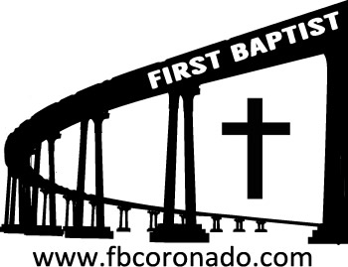

Reach Up, Reach Out, Reach Our World
445 C Avenue
Coronado, CA 92118
(619) 435-6588
fbcoronado.com
Jim W. Baize, Pastor
Julie Burkhart, Secretary, Childcare Coordinator
Patsy Lower, Treasurer
Laura Stecher, Children’s Ministry
David Preston, Youth Ministry
Dan Malcolm, Men’s Ministry/VIP Ministry
Cindy Wilson, Women’s Ministry
Monica Medina, Convalescent Ministry
Sheerah Haywood, Worship Ministry
Bobby Greer, Maintenance
Our mission is to produce fully devoted followers
of Jesus Christ. If we can be of any help to you,
feel free to give us a call.

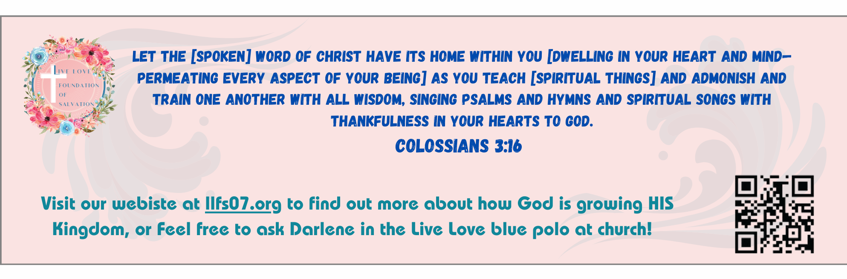
First Baptist Church
of Coronado

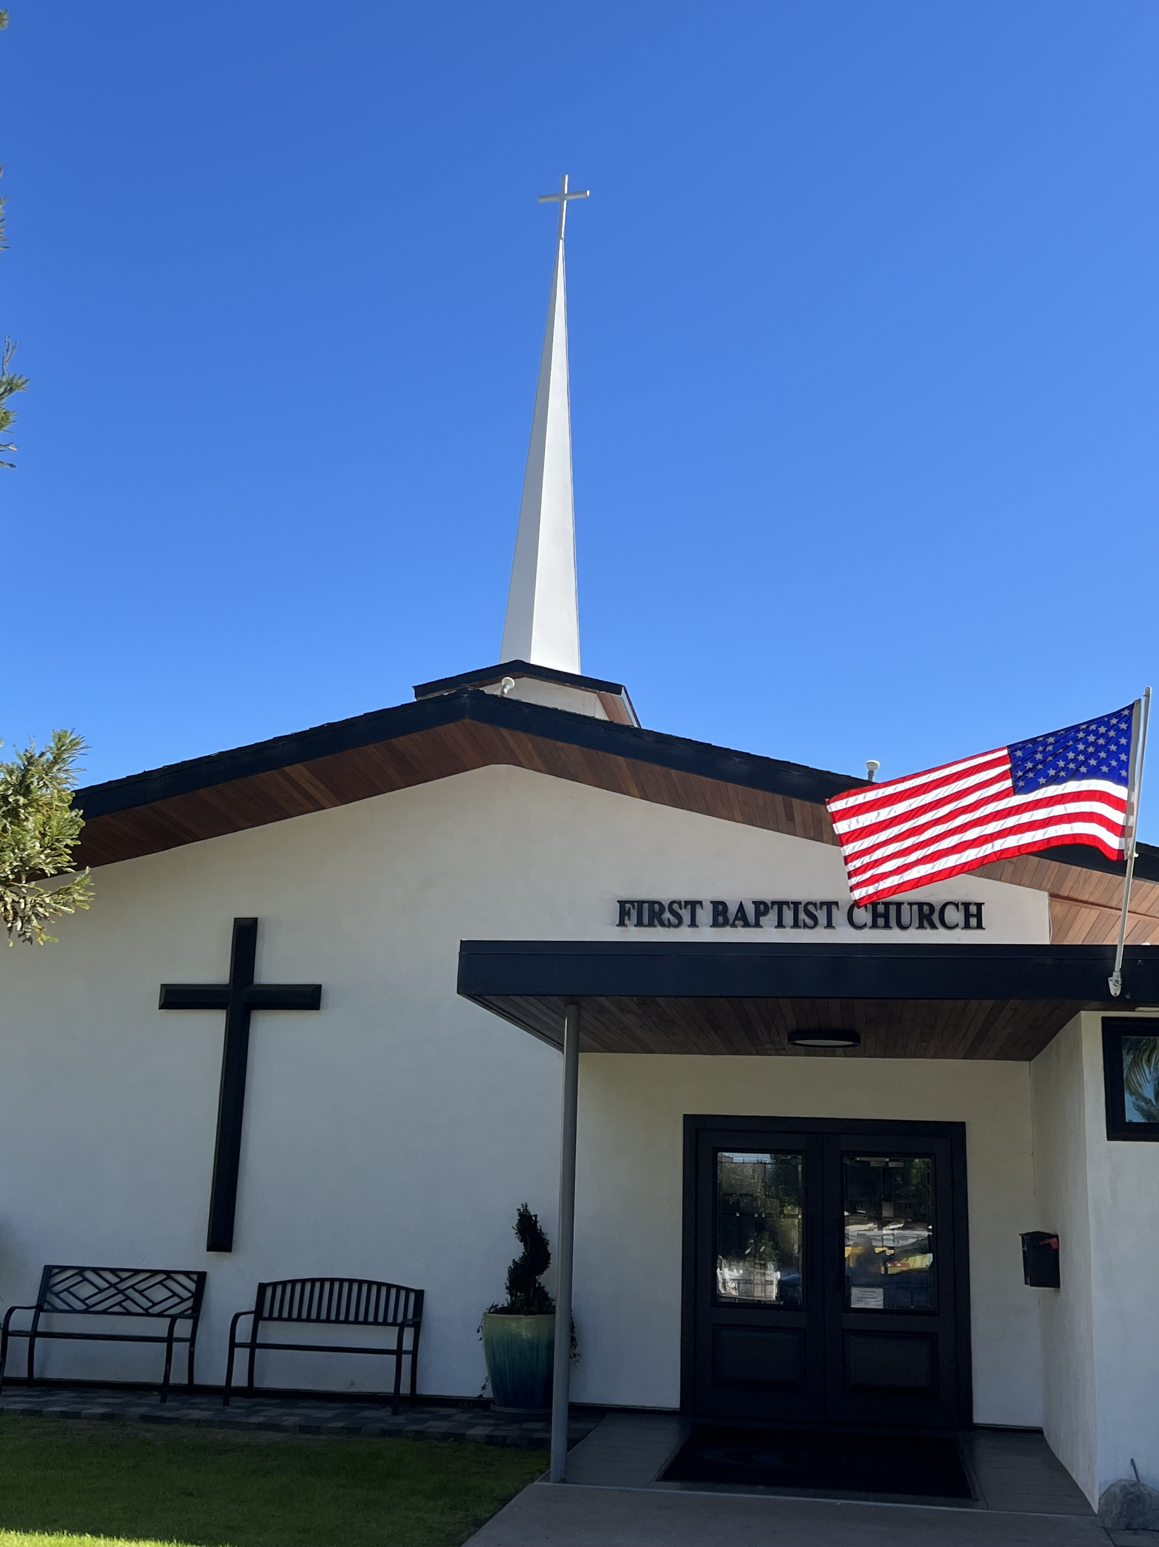

Commitment Sunday
Pastor Jim W. Baize
February 1, 2026

COMMITMENT SUNDAY – 2026

“Talking a good talk” is one thing; “walking a good walk” is another. This month we have studied how to diagnostically inspect how we use our time, talents, and finances. Today, Commitment Sunday, gives us the opportunity to “walk the talk.”

The US Navy has transferred many of our former members to their next duty station. (You’ve heard me say, “The Lord giveth and Uncle Sam taketh away!) That’s not entirely accurate, the Lord also moves people, but it seems that way sometimes. What I am asking you to do is not just talk about serving God, but to be willing to commit to doing just that.

Would you consider being a teacher in our children’s ministry? Or how about being a helper. We would schedule you no more than once or twice a month. Our kids are amazing and want someone to whom they can look up…someone who will teach them, pray for them, and make a difference in their lives. Maybe you could be part of our Praise Team. Or perhaps you could train to work in our sound booth. Would you consider heading up our military meal ministry? Your gift might be in cleaning or repairing the facilities. There is always something that needs done!

I would like to ask those who are not attending our services in person to please stop by the church during the week and pick up your Commitment Card. Then, I would ask you to drop your card off at the office. Put it in the mailbox, if no one is at the office.

Let’s prepare to pick up where we left off last year! The question is: Can God count on us in 2026? The answer lies with each one of us.

Commitment makes the difference!

Welcome to First Baptist Church of Coronado!

Adult Sunday School 8:45
Worship Service & Communion 10:00
Children’s Sunday School 10:15
ACTIVE-DUTY Military Lunch 11:15

Bible Studies This Week

Tuesday
Oaks Int. Military Bible Study at FBCC
6-8 p.m. Childcare provided

Wednesday
Ladies’ Bible Study Fellowship at FBCC 10:00

Thursday
Ladies’ Bible Study at FBCC 10:30

Saturday
Men’s Coffee Club 8:00
Coffee, fellowship, and prayer

Upcoming Events

Baptism Sunday 2/22/26 – If you’ve accepted Jesus as your personal Savior and not been baptized by immersion, now is your opportunity! Let Pastor Baize know if you’d like to be baptized.

New Member Class Sunday 3/1/26 immediately following the worship service. Lunch and childcare provided. Please contact Julie for more information and to sign up @ secretary@fbcoronado.com

