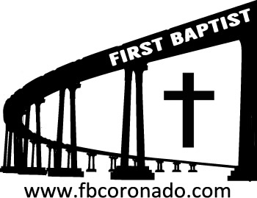

Reach Up, Reach Out, Reach Our World
445 C Avenue
Coronado, CA 92118
(619) 435-6588
fbcoronado.com
Jim W. Baize, Pastor
Julie Burkhart, Secretary, Childcare Coordinator
Patsy Lower, Treasurer
Laura Stecher, Children’s Ministry
David Preston, Youth Ministry
Dan Malcolm, Men’s Ministry/VIP Ministry
Cindy Wilson, Women’s Ministry
Monica Medina, Convalescent Ministry
Sheerah Haywood, Worship Ministry
Bobby Greer, Maintenance
Our mission is to produce fully devoted followers
of Jesus Christ. If we can be of any help to you,
feel free to give us a call.

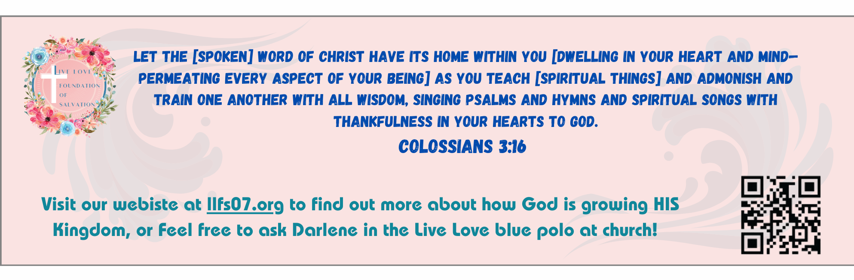
First Baptist Church
of Coronado

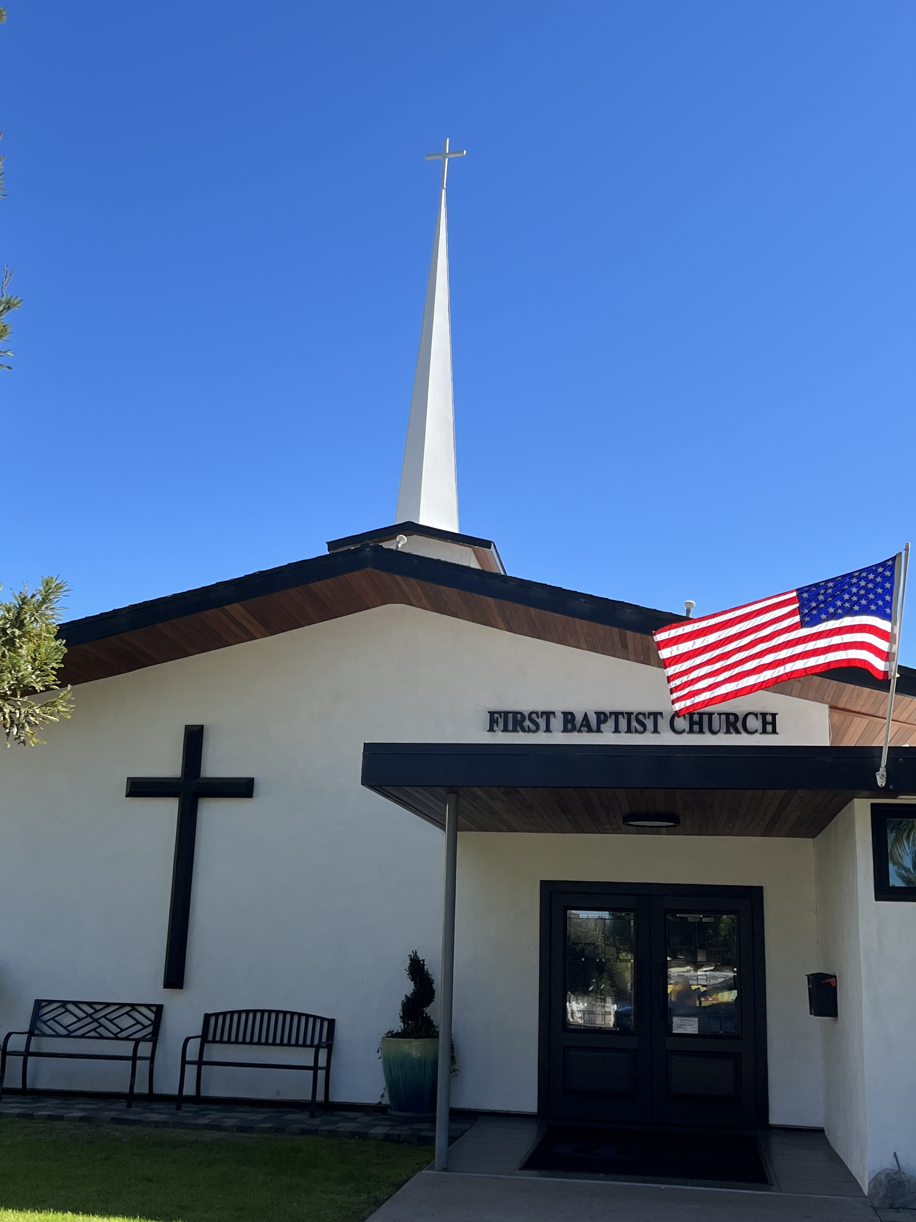

The Debt Trap
Pastor Jim W. Baize
January 25, 2026

THINGS ON WHICH TO WASTE MONEY

Are you looking for ways to waste money? Here are a few ideas I had:

1. Spend big bucks on a cup of mediocre or worse coffee.

2. Pay credit card interest each month (money spent for the privilege of continuing to have debt!)

3. Buy “quality” goods from China on some unknown website.

4. Purchase expensive appetizers to kill your appetite for dinner!

5. Pay ATM fees to be able to get to your own money!

6. Write checks that bounce and require overdraft fees.

7. Pay extra for “speedy shipping” on things you don’t really need in the first place!

8. Buy lots of baby and children’s designer clothes.

9. Pay for unused gym memberships.

10. Buy premium cable packages to get movie channels that are immoral and vulgar.

11. Alcohol is always a great thing on which to waste money.

12. Always spend whatever you must in order to have the latest phone, computer, car, or whatever.

I’m sure there are a lot more things we can waste money on. Give me some of your ideas!

GET OUT AND STAY OUT OF DEBT

Welcome to First Baptist Church of Coronado!

Adult Sunday School 8:45
Worship Service 10:00
Children’s Sunday School 10:15
Annual Business Meeting 11:00

Bible Studies This Week

Tuesday
Oaks Int. Military Bible Study at FBCC
6-8 p.m. Childcare provided

Wednesday
Ladies’ Bible Study Fellowship at FBCC 10:00

Thursday
Ladies’ Bible Study at FBCC 10:30

Saturday
Men’s Coffee Club 8:00
Coffee, fellowship, and prayer

Upcoming Events

Communion will be observed Sunday 2/1/26

Men’s Breakfast Saturday 2/7/26 8:00

Baptism Sunday 2/22/26 – If you’ve accepted Jesus as your personal Savior and not been baptized by immersion, now is your opportunity! Let Pastor Baize know if you’d like to be baptized.

New Member Class Sunday 3/1/26 immediately following the worship service. Lunch and childcare provided. Please contact Julie for more information and to sign up @ secretary@fbcoronado.com

