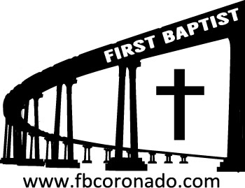

Reach Up, Reach Out, Reach Our World
445 C Avenue
Coronado, CA 92118
(619) 435-6588
fbcoronado.com
Jim W. Baize, Pastor
Julie Burkhart, Secretary, Childcare Coordinator
Patsy Lower, Treasurer
Laura Stecher, Children’s Ministry
David Preston, Youth Ministry
Dan Malcolm, Men’s Ministry/VIP Ministry
Cindy Wilson, Women’s Ministry
Monica Medina, Convalescent Ministry
Sheerah Haywood, Worship Ministry
Bobby Greer, Maintenance
Our mission is to produce fully devoted followers
of Jesus Christ. If we can be of any help to you,
feel free to give us a call.

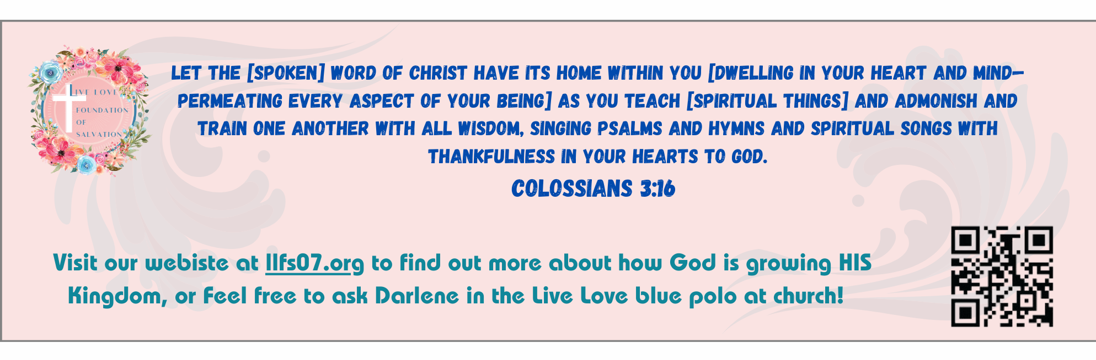
First Baptist Church
of Coronado

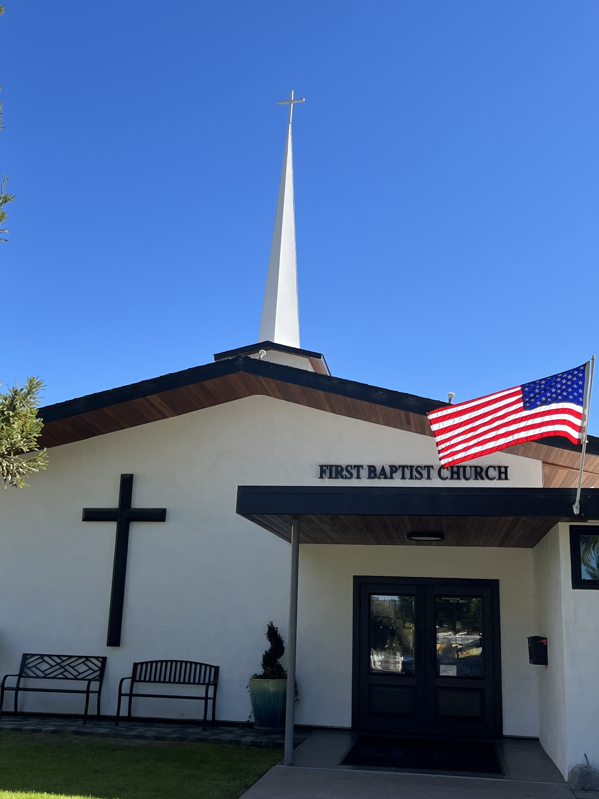

“A Spiritual Diagnostic-Money”
Pastor Jim W. Baize
January 18, 2026

BASIC PRINCIPLES CONCERNING YOUR MONEY

1. Money is not sinful in and of itself. Money is not “the root of all evil” – “the LOVE of money is the root of all evil.” Luke 16:6. Money is not moral, amoral, or immoral. Rom 14:14

2. Spirituality is not determined by one’s material riches. There are Biblical examples of believers who are rich and believers who are poor. 2 Cor 8:9; 1 Chron 29:12-14; Jesus had no place to lay His head and possessed not much more than a robe without seam.

3. Money is a tool to be used, not a master to obey. Mat 6:24. It is a dangerous thing when money or the lack of it begins to control our attitudes and actions.

4. Money can be a hindrance to the purposes of God. In Mat 19:23-26 it kept a rich young ruler from following Jesus. Mat 6:19-20 tells us it can become more important to us than the treasure of heaven! Luke 12:16-21 teaches that it can give a rich person a false sense of security.

5. The love of money can cause many other problems – a lack of contentment, foolish and harmful desires, a wandering away from the faith, and many sorrows. 1 Tim 6:6-11, 17-19; Phil 4:11-13

6. The basic purposes of money are: to provide for our material needs and to provide for others in their times of need. 1 Tim 5:8; 6:8; 1 Cor 9:13-14; Rom 10:15; Eph 4:28; James 2:15-16; 1 John 3:17-18

7. It is God Who gives us the ability to have and earn money. Deut 8:18 But thou shalt remember the Lord thy God; for it is He that giveth thee power to get wealth, that He may establish His covenant which He swore unto thy fathers, as it is this day. Every good gift is from above. James 1:17

Welcome to First Baptist Church of Coronado!

Adult Sunday School 8:45
Worship Service 10:00
Children’s Sunday School 10:15

Bible Studies This Week

Tuesday
Oaks Int. Military Bible Study at FBCC
6-8 p.m. Childcare provided

Wednesday
Ladies’ Bible Study Fellowship at FBCC 10:00

Thursday
Ladies’ Bible Study at FBCC 10:30

Saturday
Men’s Coffee Club 8:00
Coffee, fellowship, and prayer

Annual Church Business Meeting
Our annual business meeting will be held on Sunday, 1/25/26 immediately following the worship service. Clerk Report, Treasurer Report, Children’s Ministry Report and Trustee Report will be read, and the 2026 budget proposal will be voted on. The printed budget proposal for 2026 is available for review. They are located on the table near the Sound Booth door.

Ladies Pine Valley Retreat – Sign up today!
March 13-15 Cost $100 per person
$50 non-refundable deposit due upon registration.
Balance due no later than February 15, 2026.
See Cindy Wilson for more information & registration.



