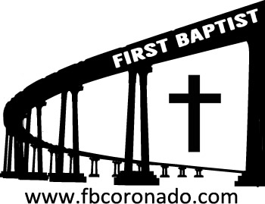

Reach Up, Reach Out, Reach Our World
445 C Avenue
Coronado, CA 92118
(619) 435-6588
fbcoronado.com
Jim W. Baize, Pastor
Julie Burkhart, Secretary, Childcare Coordinator
Patsy Lower, Treasurer
Laura Stecher, Children’s Ministry
David Preston, Youth Ministry
Dan Malcolm, Men’s Ministry/VIP Ministry
Cindy Wilson, Women’s Ministry
Monica Medina, Convalescent Ministry
Sheerah Haywood, Worship Ministry
Bobby Greer, Maintenance
Our mission is to produce fully devoted followers
of Jesus Christ. If we can be of any help to you,
feel free to give us a call.

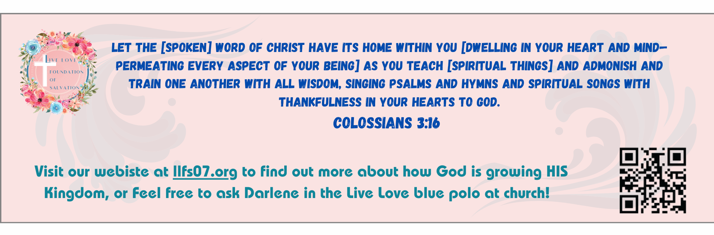
First Baptist Church
of Coronado

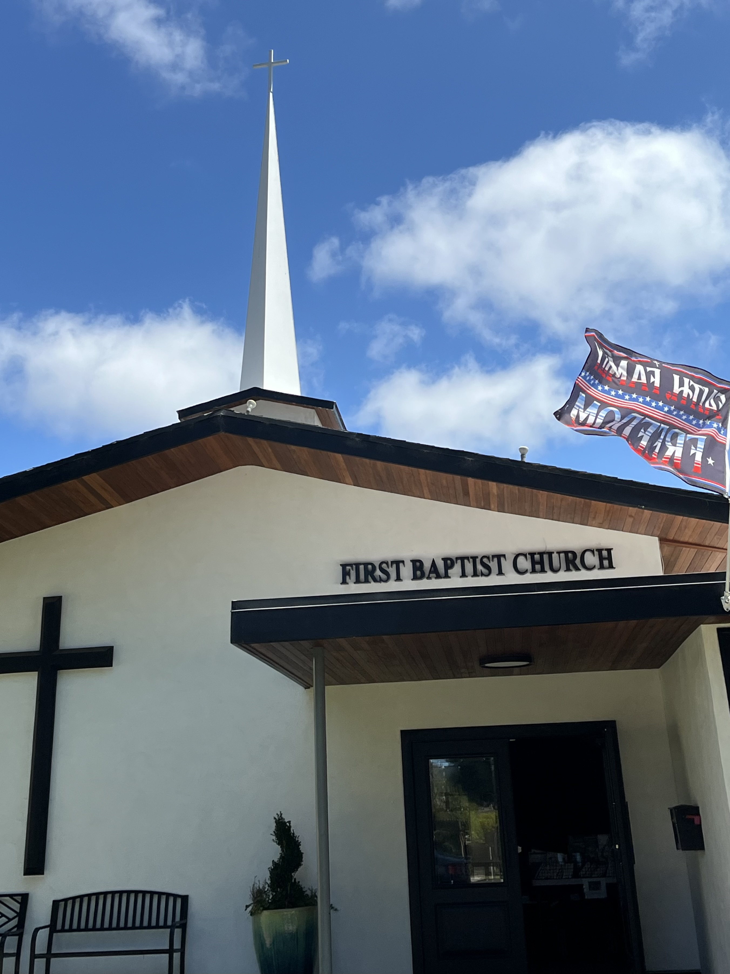

“A Spiritual Diagnostic”
Pastor Jim W. Baize
January 11, 2026

HAVE YOU HEARD THIS ONE?

“I've sure gotten old! I've had two bypass surgeries, a hip replacement, new knees, fought prostate cancer, and diabetes. I'm half blind, can't hear anything quieter than a jet engine, I take 40 different medications that make me dizzy, winded, and subject to blackouts. I have bouts with dementia, poor circulation, and can hardly feel my hands and feet anymore. I can't remember if I'm 85 or 92. Oh, and I have lost all my friends, but, thank God, I still have my California driver's license!”

We laugh to keep from crying, as my Mom used to say! Getting old is not for the timid!

I have known too many people who, when they got to a certain age, they decided they didn’t want to live any longer. “Why has God left me on earth…my family and friends are gone…I am ready to join them.”

It might be a trite answer, but if God has left you here, it is for a good reason (or many reasons.) He still has some things for you to do!

I have tried to find something good about every age I have been! (Wouldn’t it have been great to start our lives with the knowledge we now have?) But we can’t. We have one life to live here on earth…and another one for eternity with the Lord!

How are you spending your time?

Welcome to First Baptist Church of Coronado!

Adult Sunday School 8:45
Worship Service 10:00
Children’s Sunday School 10:15

Bible Studies This Week

Tuesday
Oaks Int. Military Bible Study at FBCC
6-8 p.m.
On break until January 13th, 2026

Wednesday
Ladies’ Bible Study Fellowship at FBCC 10:00
On break until January 14th, 2026

Thursday
Ladies’ Bible Study at FBCC 10:30

Saturday
Men’s Coffee Club 8:00
Coffee, fellowship, and prayer

Ladies Pine Valley Retreat – Sign up today!
March 13-15 Cost $100 per person
$50 non-refundable deposit due upon registration
Balance due no later than February 15, 2026
Cindy Wilson will have a registration table outside immediately following the worship service.
