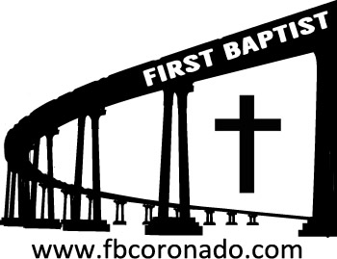

Reach Up, Reach Out, Reach Our World
445 C Avenue
Coronado, CA 92118
(619) 435-6588
fbcoronado.com
Jim W. Baize, Pastor
Julie Burkhart, Secretary, Childcare Coordinator
Patsy Lower, Treasurer
Laura Stecher, Children’s Ministry
David Preston, Youth Ministry
Dan Malcolm, Men’s Ministry/VIP Ministry
Cindy Wilson, Women’s Ministry
Monica Medina, Convalescent Ministry
Sheerah Haywood, Worship Ministry
Bobby Greer, Maintenance
Our mission is to produce fully devoted followers
of Jesus Christ. If we can be of any help to you,
feel free to give us a call.

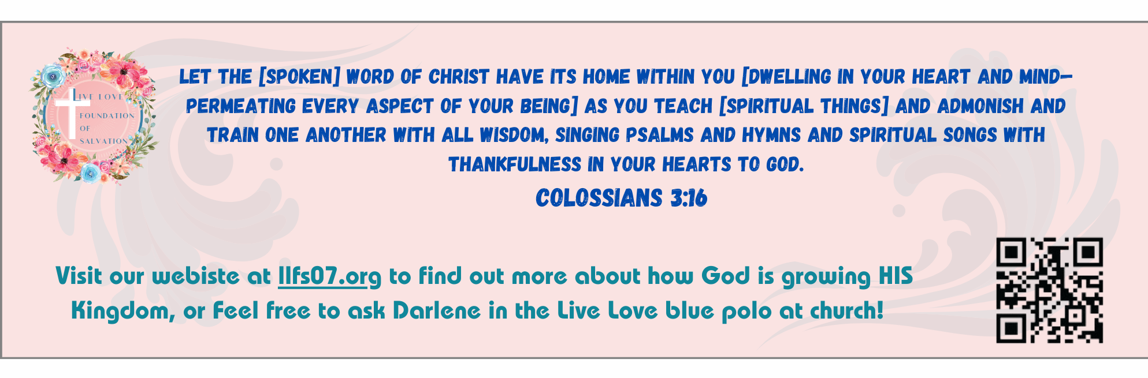
First Baptist Church
of Coronado

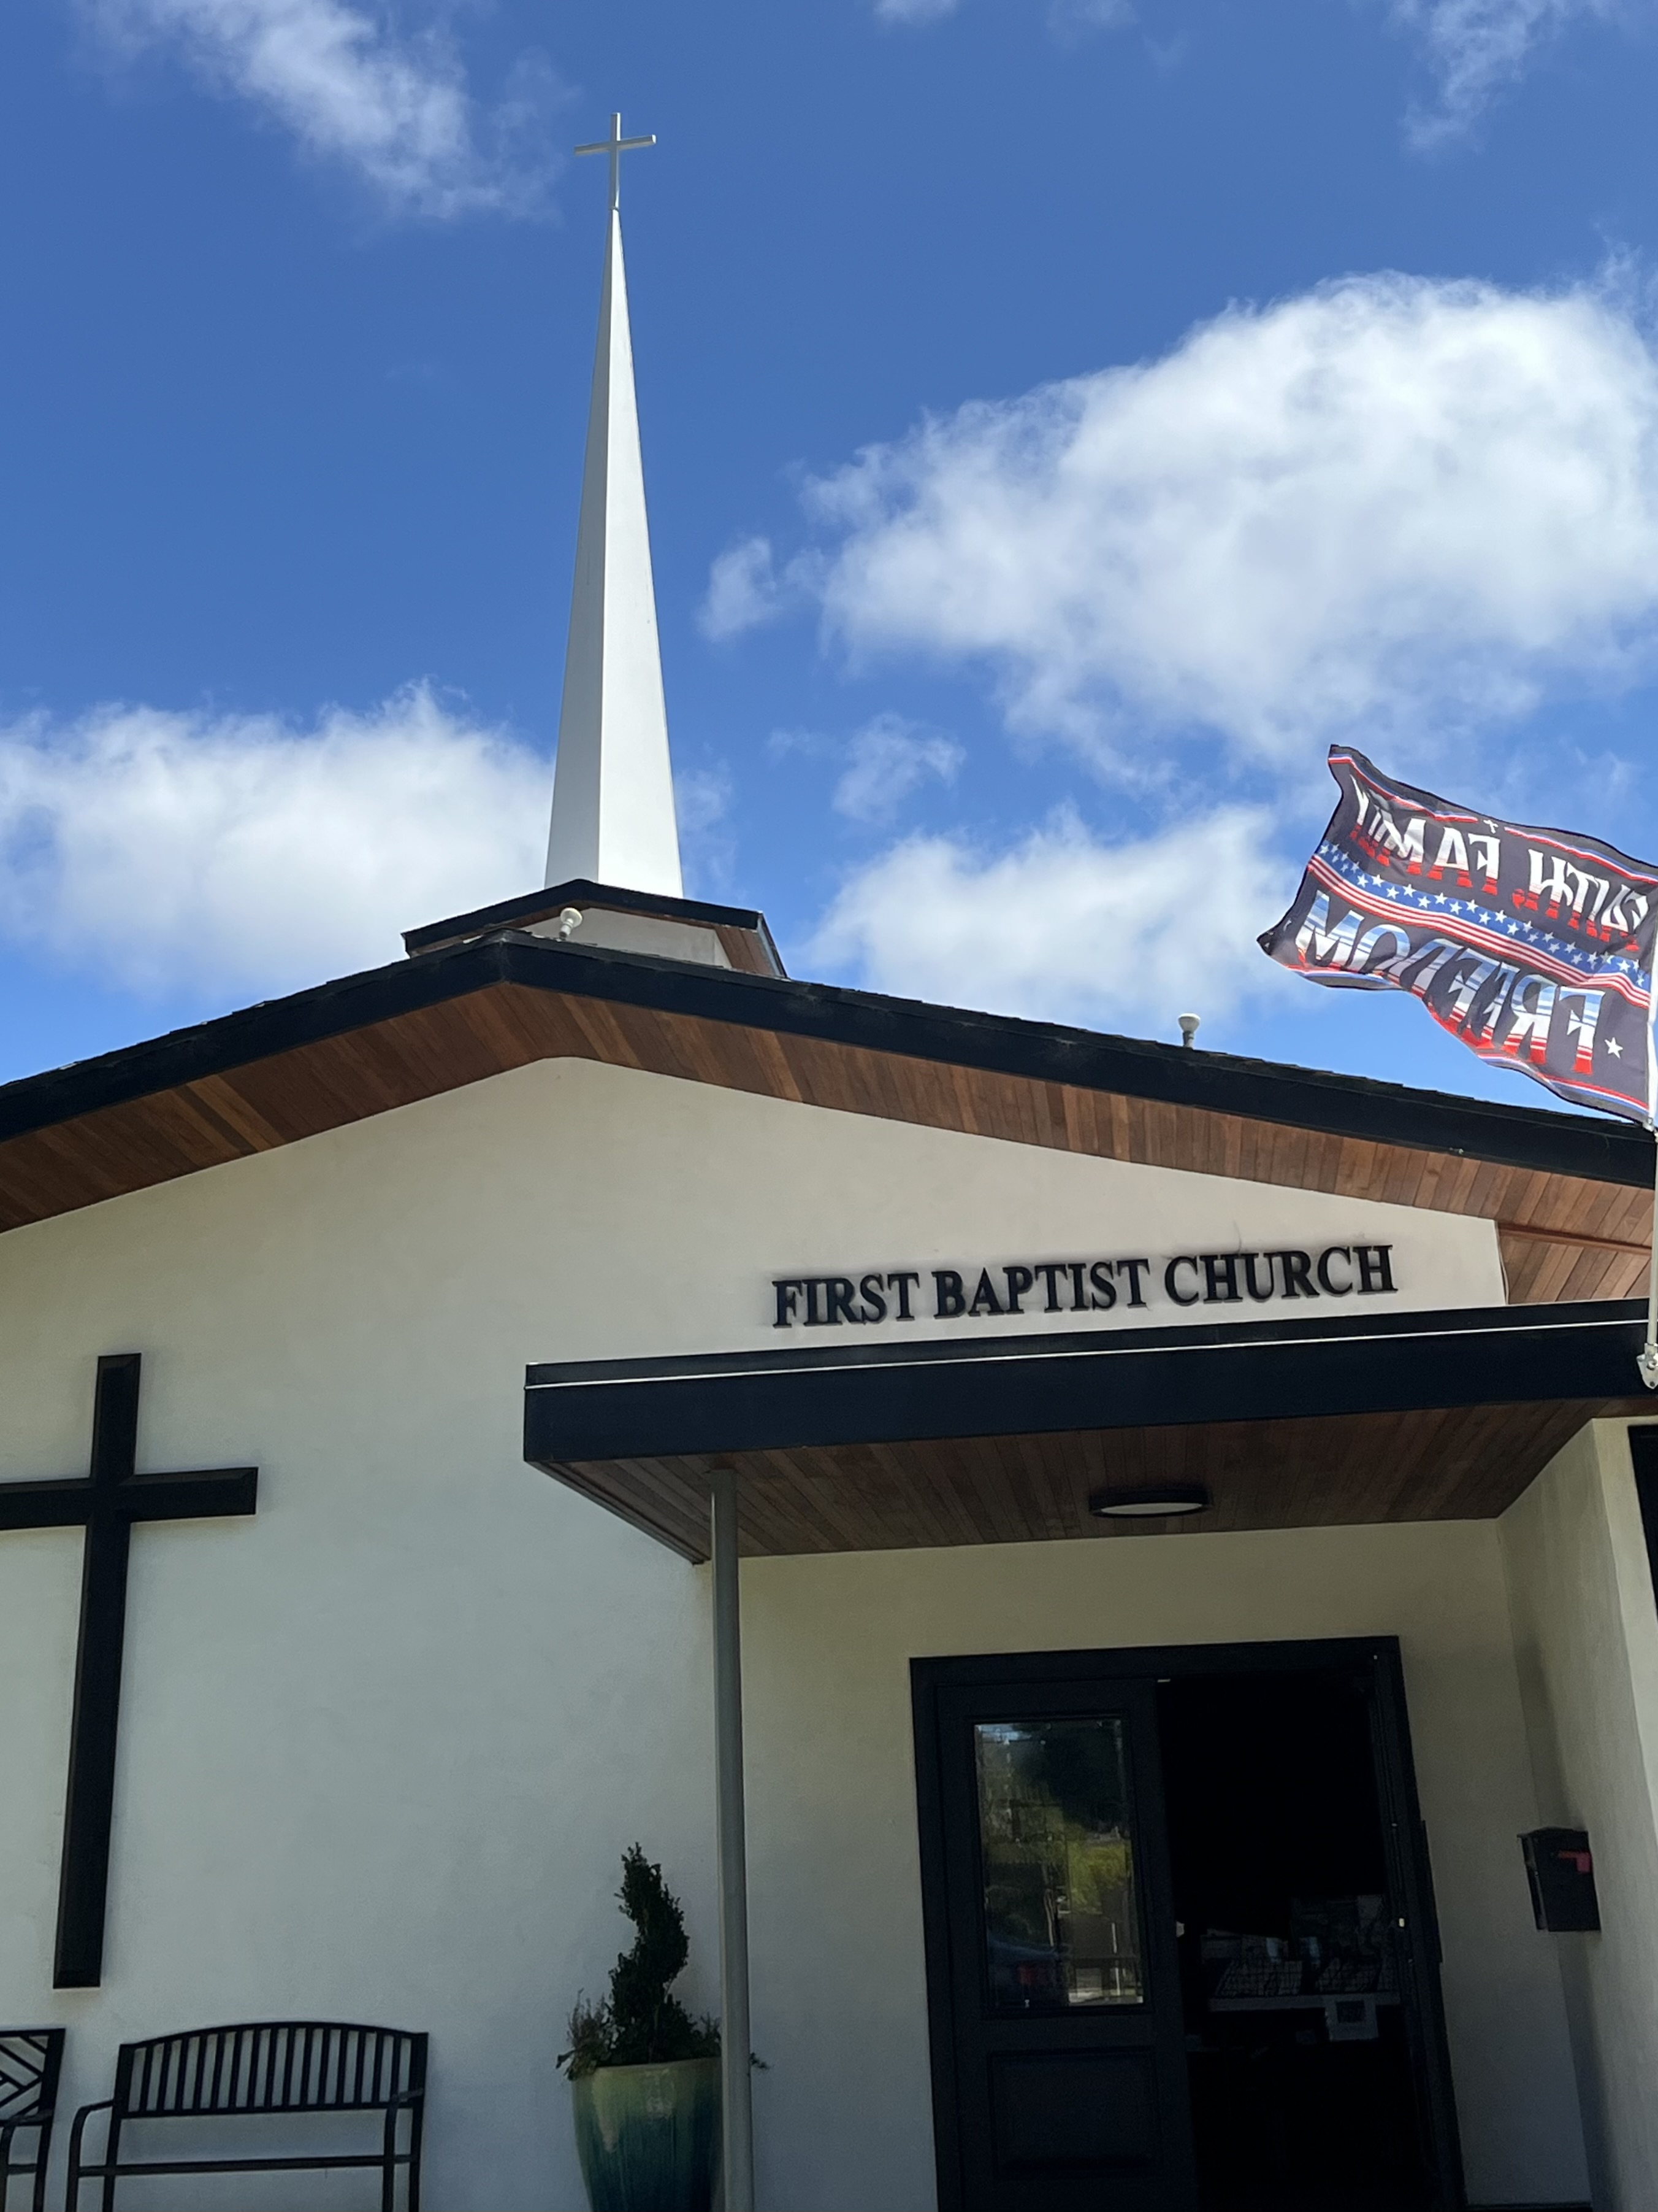

“The Storms of Life”
Pastor Jim W. Baize
January 4, 2026

NO DARK VALLIES – William O. Cushing, 1823–1902
He will wipe every tear from their eyes. There will be no more death or mourning or crying or pain, for the old order of things has passed away. (Revelation 21:4)
There is a land of pure delight, where saints immortal reign;
Eternal day excludes the night, and pleasures banish pain. – Isaac Watts
In every life there will be some “dark valleys.” Difficult days cannot be avoided. In fact, the lives of some believers seem to be filled with affliction and suffering. But for the child of God, there is glorious relief just ahead … the return of Christ and the promise of a land of endless delight. The prospect of Gods’ tomorrow also means a time of joyous reunion with loved ones who have preceded us. Truly “there’ll be songs of greeting when Jesus comes …”
William Orcutt Cushing knew the meaning of “dark valleys” in his life. After more than 20 years of successfully pastoring Disciples of Christ churches in the state of New York, he suddenly lost the ability to speak. Then his wife died at the age of 47. During this “valley period” Cushing became interested in hymn writing and wrote more than 300 hymn texts, including such other favorites as: “Under His Wings,” “When He Cometh,” and “Hiding in Thee.”
Ira David Sankey, the hymn’s composer, worked as a soloist and song leader with evangelist D. L. Moody for nearly 30 years in campaigns throughout the United States and the British Isles. “There’ll Be No Dark Valley” was widely used by Sankey in many of these meetings. The hymn’s simple repetitive message and singable melody still provide encouragement and comfort to God’s people.
There’ll be no dark valley when Jesus comes; there’ll be no dark valley when Jesus comes; there’ll be no dark valley when Jesus comes to gather His loved ones home.
There’ll be no more sorrow when Jesus comes; there’ll be no more sorrow when Jesus comes; but a glorious morrow when Jesus comes to gather His loved ones home.
There’ll be songs of greeting when Jesus comes; there’ll be songs of greeting when Jesus comes; and a joyful meeting when Jesus comes to gather His loved ones home.
Refrain: To gather His loved ones home, to gather His loved ones home; there’ll be no dark valley when Jesus comes to gather His loved ones home.

Are you looking forward to that day!

Welcome to First Baptist Church of Coronado!

Adult Sunday School 8:45
Worship Service & Communion 10:00
Children’s Sunday School 10:15

Bible Studies This Week

Tuesday
Oaks Int. Military Bible Study at FBCC
6-8 p.m.
On break until January 13th, 2026

Wednesday
Ladies’ Bible Study Fellowship at FBCC 10:00
On break until January 14th, 2026

Thursday
Ladies’ Bible Study at FBCC 10:30

Saturday
Men’s Coffee Club 8:00
Coffee, fellowship, and prayer



