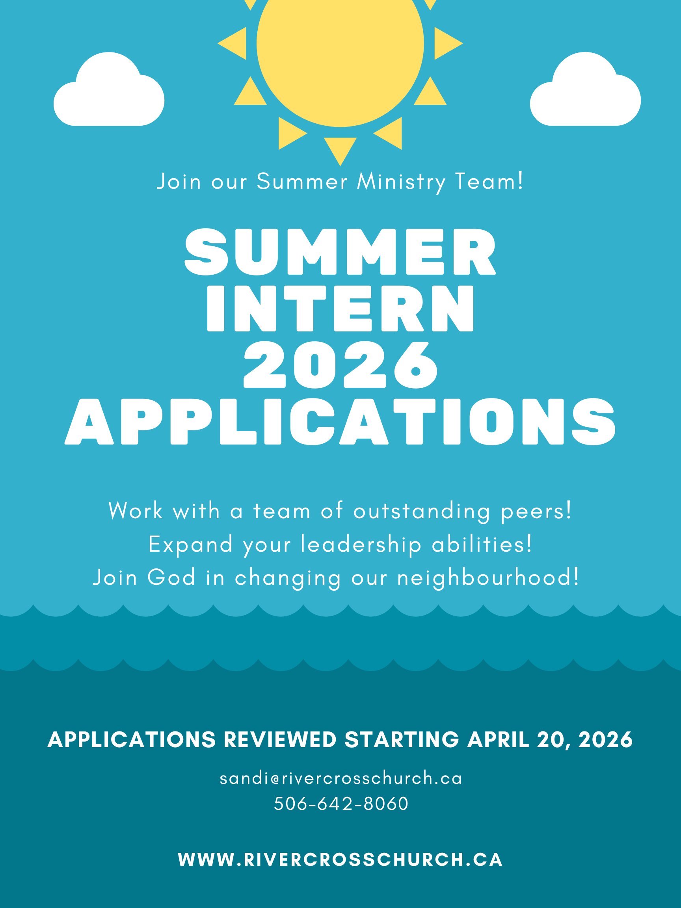

Pastors: Rob Nylen, Sandi Killeen, James Yang, Joe Page, John Knight
61 Forbes Drive, Saint John, NB E2K 0H7
www.rivercrosschurch.ca; 506-642-8060

Summer 2026 Ministry Opportunities:

Summer Ministry Intern Coordinator; Summer Outreach Ministry Intern; Summer Ministry Interns; Summer Facilities Manager Intern; Media Specialist Intern. The number of positions available will depend on the number of Federal and/or Provincial grants received. Full job descriptions can be found at the end of this application package.

Job Requirements/Qualifications of Summer Ministry Interns:
Please refer to the enclosed job descriptions for required qualifications and skills. For Intern positions, funds come from government grants which have further requirements mentioned here.

For the Federal grants, an eligible person:
- is between 15 and 30 years of age (inclusive) at the start of employment;
- is a Canadian Citizen, permanent resident, or person on whom refugee protection has been conferred under the Immigration and Refugee Protection Act* and;
- is legally entitled to work according to the relevant provincial/territorial legislation and regulations.

For the Provincial NB SEED grants, an eligible person:
- is a resident of New Brunswick or a First Nation community in New Brunswick
- is eligible to work in Canada;
- is a student in the current academic year and;
- is entering grade 11, grade 12, or attending a post-secondary institution full-time in the fall.

Dates, Hours and Wages:
Official start dates and wages for all positions depend on the number of grants received.

Please fill in the attached application form and return it to the RiverCross Church office or to the email below. We will begin reviewing applications on April 20, 2026.

Questions? Contact Sandi Killeen, sandi@rivercrosschurch.ca; 506-642-8060

RIVERCROSS CHURCH SUMMER INTERN APPLICATION

Complete and return these applications to the RiverCross Church office, Attention: Sandi Killeen 61 Forbes Drive, Saint John NB, E2K 0H7 OR by email: sandikilleen@gmail.com. Please type or write clearly in dark ink.

Personal Information

Name:
Address:
City:
Province: |  |  | Postal Code:
Phone (Home): |  |  | Cell:
Email:
Age: |  | Birth Date:
School or University |  |  |  | Most recently completed grade or year:
I am applying for: (list all positions that apply)

Church Information

Home Church:
How regularly of you attend church?
Briefly Describe any areas of service you have been involved in at your church (i.e. mission tour, teaching, Sunday school, etc.)

Help us get to know you:
What are three of your strengths, and how will they add to RiverCross summer ministries?
How do you expect to be challenged this summer?
Briefly describe when and how you came to faith in Jesus.
Describe your current relationship with God.
Why do you want to be a leader at RiverCross Church this summer?
What one thing would you like to see happen in the area of ministry you are applying for?
Have you worked in this area of ministry before? If so, what is your favourite thing about it? If not, what are you most excited for?
What do you think makes a great team member?

Education

 | Institution | # of years completed | Date of graduation | Degree/Major
High School
College or University
Other

Employment
Please list up to 3 of your most recent employments

Employer | Position | Supervisor | Phone # | Dates

Certifications

Please list and describe any certifications you have that are relevant to the position(s) you are applying for, and when these were earned:
Do you have valid First Aid and CPR training? If so, what level of certification do you have? (This is not a job requirement)

Skills
Please check off anything on this list that you would feel qualified to do, organize, or teach. Feel free to add your own!

 | Bible study |  | Team Building |  | Lights/Sound
 | Playing Instruments |  | Conversation Starting |  | Volunteer Recruitment
 | Song Leading |  | Parent Follow Up |  | Yardwork
 | Singing |  | Administration |  | Maintenance
 | Story Telling |  | Scheduling |  | Painting (upkeep)
 | Painting (art) |  | Conflict Resolution |  | Other:
 | Group Games |  | First Aid |  | Other:
 | Crafts |  | Video Editing |  | Other:
 | Sports |  | Photography |  | Other:

References (Required)

1 | Name: |  | Phone #:
1 | Relationship:
2 | Name: |  | Phone #:
2 | Relationship:
3 | Name: |  | Phone #:
3 | Relationship:

Anything else you’d like us to know?

_________________________________________ __________________________
Signature of Applicant Date
Thank you for your application! We will be in contact with each applicant by May 1, 2024.

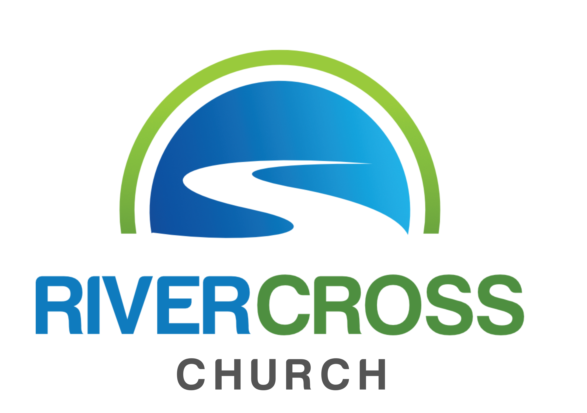
RiverCross Church
Summer Ministry Coordinator 2026
(Canada Summer Jobs Title: Child Care Programs Planning Officer)
Job Description:

The Summer Ministry Coordinator will be responsible for planning, in collaboration with our Next Generation ministry staff and community partners, opportunities that provide free childcare options for working families. This will include planning and implementing day-camps, as well as making families aware of opportunities that are offered through our community partners with the goal of resourcing families well. The Child-care Programs Planning Officer will identify gaps when there are no child care options available during the summer months for families in our community, and will plan and implement opportunities to meet those needs.

This role will involve recruiting and resourcing volunteers, planning and implementing programs, providing support to other local not-for-profits, and researching and advertising effectively.

This role will also take leadership of our Sunday morning children's program, and make participating families aware of mid-week opportunities.

Please note that this position may be dependent on grant funding.

Term of position: Up to 12 weeks.

RiverCross Church
Summer Ministry Intern 2026
(Canada Summer Jobs Title: Child Care Worker Assistant)
Job Description:

The Summer Ministry Intern(s) will work in collaboration with the Summer Ministry Coordinator to implement opportunities that provide free childcare options for working families. This will include planning and implementing day-camps to take place at our facility, as well as making families aware of opportunities that are offered through our community partners with the goal of resourcing families well.

Additionally, the Child Care Worker Assistant will take an active role in the planning and implementing of our Sunday morning children's program
Please note that this position may be dependent on grant funding.

Term of position: Up to 12 weeks.

RiverCross Church
Summer Facilities Manager 2026
Job Description:

The Summer Facilities Manager will have the following responsibilities:

- Spring and Summer maintenance of property on Forbes Drive.
- Maintain gardens, lawns and property, regular trash pick-up on property and adjacent forest owned by RiverCross Church.
- Beautification of property.
- Maintenance at our 211 Main Street site in the Old North End.
- Garbage pick-up and beautification of the site and gardens as well as front sidewalk.
- Weed and maintain garden areas under the direction of the trustees.
- Site preparation at our Mission facility for activities and programs, as well as Hope Mission summer activities and outings with both youth and adults.
- Site preparation for Children’s and Youth programs throughout the summer, including set up and tear down.
- Work with the summer ministry team to create sets for selected programs
- Inside work such as painting and light renovations on rainy days
Please note that this position may be dependent on grant funding.

Term of position: Up to 14 weeks

RiverCross Church
Summer Outreach Ministry Intern 2023
(Canada Summer Jobs Title: Community Programs Director)
Job Description:

The Summer Outreach Ministry Intern will be responsible for:

• Plan, organize, and coordinate all aspects of RiverCross Mission’s twice-weekly community meal program during July. This program provides programming for adults, children, and families experiencing food insecurity and financial poverty in the Old North End and Crescent Valley communities in Saint John.

• Coordinate RiverCross Mission’s special summer outings

• Work with the RiverKids Director and Summer Ministry Intern Coordinator to ensure that families from the Old North End, Crescent Valley and Anglin Drive neighbourhoods can access summer programs and resources led by Summer Ministry Interns. These programs serve as child care support for many low income parents during the summer months.

• Tech Support: provide broad creative input to the RiverCross Mission Facebook Group in order to create a virtual community space for people to connect

• Support our community partners in the Old North End and Crescent Valley: (The Nick Nicolle Community Centre, ONE Change, The North End Food Bank, and Chuck's Convenience) by participating in programs and events, offering shared community services, and serving in the food bank each Tuesday.

• Project Support – depending on time and availability, work on identified projects to support RiverCross Mission’s regular programs and activities.

Please note that the successful applicant must be eligible for a New Brunswick SEED grant
Term of position: Up to 12 weeks

RiverCross Church
Media Specialist 2023
Job Description:

The Media Specialist Intern will have the following responsibilities:

- Film, photograph, edit, finalize, and share all video-based projects for all relevant events at RiverCross church, including but not limited to:
  - Weekly Children’s teaching times
  - Multi-Day Summer camps for children throughout July and August
  - Community Outreach events for the Old North End and Cresent Valley
  - Video content for Broadcast or Livestream
  - Other events as required
- Contact, schedule, gather, and follow up with volunteers who might create their own videos as part of compilations to the projects this intern will be producing
- Work with staff members in drafting and planning out media and digital components to the various projects
- Further discussion and details will be arranged based on the qualifications, interests, education and training of the hired person(s).

Please note that this position is dependent on grant funding.

Term of position: Up to 12 weeks

