

LIFE GROUPS | LEADERS GUIDE
March 9-15, 2025 | Winter Week 8

ANNOUNCEMENTS

Well leaders, have you ever had it where you look back on the time and wondered where it all went? Given that we’ve arrived now in week 8, you and your groups might feel a little of that, as we get very near the end of this semester. As you’re able, look back at the road you’ve all travelled, and be grateful for how the Lord has led you all through the studies, conversations, and times of prayer and support.

- YOUR EIGHTH MEETING:
- You’re almost there - only one more week of studies after this! Have you considered the idea yet of planning a week 10 – a time where you can gather your group together, and wrap up the season with some lighthearted fun and fellowship? If not, we invite you to do that!
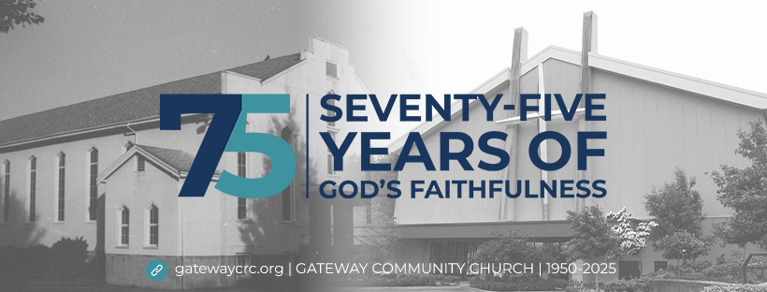
- Next week, be on the lookout for the Feedback Forms, that we will be asking your help to remind your groups to complete, as we begin to look forward to the Fall 2025 season of Life Groups.
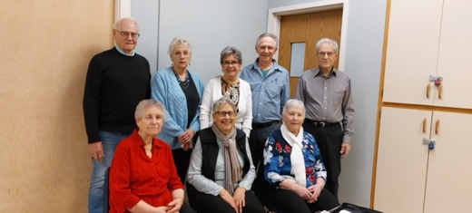

- Gateway’s 75th anniversary:
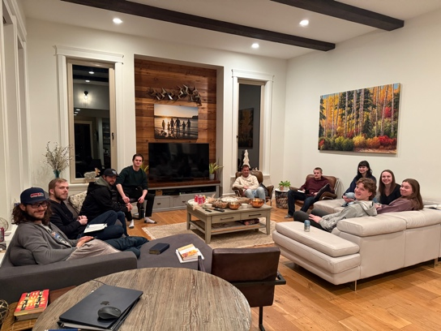
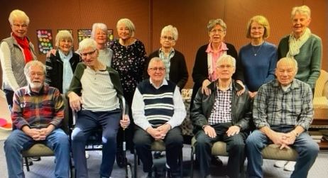
- As it’s our 75th anniversary this year as a church family, Betty Beukema and her planning team want to fill up a time capsule with memories of who we are now, in 2025.

- Can you all make a concerted effort to get group pictures to me this season!? I would love to have each of our groups represented! Can you all please submit a group shot back to me before February 23rd? I’ll keep track and bug you all (nicely of course) as our weeks carry on!
- As of this writing, I have now received FIVE! We have 11 more to go – and we only have THREE more scheduled gatherings of groups.
- I will be texting and emailing leaders directly to ask for these – please beat me to that!

GETTING TO KNOW YOU

LEADER NOTE: These are the lowest risk questions and are great ways to get everyone in your group talking – from those who love sharing stories, to those who feel a little uncomfortable in this new space. Low risk questions have their way of breaking the ice and getting everyone a little more comfortable sharing. It also gives a chance for everyone to share in an easy, approachable way.

- Who would win in an arm wrestle, you or the person to your left?

LEADER NOTE: Of course, your members won’t be able to prepare for this in advance – unless everyone always shows up and always sits in the exact same spots. Enjoy the spontaneity of this moment as you lead your group.

- If you had to switch careers or change paths, what would you like to do next?

LEADER NOTE: This question is one of those “what if” type questions that actually can be really hard to answer, but is always a neat exercise to consider an alternative path in life – perhaps it’s exploring making a hobby a profession, maybe it’s the earliest dreams to be a pro-athlete that will re-emerge, maybe it’s a fascination that has never seen the light of day. Questions like this will give you a deeper insight into your members the dreams and aspirations they have.

QUICK REVIEW

LEADER NOTE: These following two questions aim to have your group reflect upon last Sunday’s message. The first question will always be the same, and the second one is provided from our teaching pastor from the service.

1. Looking back at your notes from this week’s teaching, was there anything that particularly caught your attention, challenged, or confused you?

LEADER NOTE: Be sure to grab a sermon guide on Sunday morning, or bring your own way to take notes, and jot down your own questions!

2. Pastor Marcel said this weekend, “When we focus on God first, and who He is, we come to grips with the reality that He has the power, authority, love, and compassion to take our pain and turn it around for His good and for His glory.” Share a time when you have experienced this in your life.

LEADER NOTE: n/a

SCRIPTURE REVIEW

LEADER NOTE: This is a critical moment in your group’s meeting, as we’re moving away from discussing the message, and turning our hearts towards the scripture passage and themes we’re exploring. While our groups are “sermon-based groups,” they’re not meant to be evaluations or examinations of only the message. Our goals are to get into the themes that come up in the message, from the passage of Scripture we’re rooted in. As you seen the need to change up the pattern of these questions, feel free to more simply ask after reading the portion of scripture, “What stands out to you about this passage?”

READ Acts 4:23-31.
1. What does this passage say about the character of God?

2. What does this passage say about fallen humanity and the world we are in?

3. Where does this passage specifically expose sin or unbelief in my own life? How does it specifically call me to change my thinking, redirect my affections, replace behaviors, and trust in my Savior?

DIGGING DEEPER

LEADERS NOTE: These discussion questions generally start simple and gradually become deeper and more complex. This progression follows natural discussion patterns, but as leaders, you know your group best. Use this guide flexibly; it is not necessary to cover every question. Focus on ensuring everyone is heard and has the opportunity to contribute and ask their questions.

1. READ Acts 4:24. The prayer opens addressing God as “Sovereign Lord.” What are they saying about their place in their relationship with God? Why is this significant?

LEADER NOTE: The Greek word used here for “sovereign” (Despotes, δεσπότηςª), means “the one who holds complete power or authority over another.” The one with this power or authority can be a master, a ruler, a lord, or God. We wouldn’t call our bosses and superiors at work, our “sovereign leaders” as they do not have complete power and authority over our lives, they might have authority while we’re serving in our shifts and completing our workplace tasks. We wouldn’t call our parents our “sovereign leaders” either, because while they retain authority over our lives, they do not have complete control. As these people are praying, they are quick to submit themselves to God’s “complete power and authority.”

Suggesting to us that in everything that they say and do, they are fully accountable before God. There’s not a square inch of their lives, that is their own. There’s not a dot or iota in their writing or speech that is apart from God’s influence. The opposite of master, ruler, and lord – would be a slave or servant – one who would be seeking to fulfill the bidding and desires of the ones who have power and authority over them.

This is how the ones praying here, visualize themselves – not necessarily as we might picture slaves (as slaves in the 19th and 20th centuries were treated vastly different than how they were in the 1st century), but as ones who were honored to serve their master and to contribute to their objectives.

Paul writes to Timothy, his protégé-pastor, “All who are under the yoke of slavery should consider their masters worthy of full respect, so that God’s name and our teaching may not be slandered” (1 Timothy 6:1 | NIV). The word “master” here, is the same as “sovereign” in the Acts 4 text, and Paul tells Timothy, that he must help those who are slaves and servants to respect and honor their masters, so that God’s name may increase.

It's of utmost importance for us today, to continually recognize that God is God, and that we are not. Which in the 21st century, where we’re told more often than we might admit or even realize, that we are our own gods in and of ourselves, and that there is none as great as we are, and there are none more capable than we are.

- How do you address the Lord in your prayers? How does that affect what you pray?

LEADER NOTE: This question gets a little more personal in nature, as it’s asking your members to share some intimate details about their prayer life, and about their relationships with God the Father. However, we are now in our 8th week of meeting, so it’s more than okay if there are some longer awkward pauses as you share this question. Typically, people are thinking about their own answers, even if they’re not sharing them.

As normally encouraged, when you experience these pauses, leaders, it’s on you to lead by example. Share some of your own practices, and how it affects the way you see your own prayers flow. While also, you can share too what you have heard in other people’s prayers, from those lead from the stage in our church services, or those lead by our parents at our dinner tables growing up.

2. READ Acts 4:26-28, Revelation 17:14. The theological concept of “already and not yet,” refers to the tension between God’s kingdom being already present, but not yet fully realized. This means that today, we’ll still experience evil and opposition. How can we stay strong through today’s troubles?

LEADER NOTE: In this portion of Acts 4, we see once again the fruit of the study of these early followers of Jesus, as they’ve searched the scriptures looking for answers to their questions of what has all happened in and around them. Here they come across upon Psalm 2, and see that David wrote about times in his life, and through the Holy Spirit, about times that will yet come, that there is opposition for those who are trying to live for the Lord.

These current Acts 4 followers have seen these things play out firsthand in their last couple of days. They experienced the kings and rulers arrest and interrogate them; they’ve seen the gentiles poke fun at the impact of the Spirit. However, a little while ago, Jesus told them, “In the world you will have tribulation. But take heart; I have overcome the world” (John 16:33 | ESV). Jesus here is touching on this “already and not yet” theological reality. Jesus has defeated all that is broken and sinful, salvation has been won, victory has been achieved – however, the world is still very much broken and distant from Him. It’s still very much sinful and selfish. Therefore, we can quickly understand that our present realities will be affected by the evils of this world, all the while we know, that God has won.

Isaiah articulates that while there will be devastating floods, rivers rising past their banks, and destructive fires – all things that represent the evils of this world – that God “will be with you … they shall not overwhelm you … you shall not be burned” (Isaiah 43:1b-2 | ESV). Isaiah sees that there will be troubles, but that they won’t be our end, they won’t signify our death and separation from God, but that in those tough moments, God will be present – leading and guiding. Psalm 23:4 emphasises this too, “Even though I walk through the valley of the shadow of death, I will fear no evil, for you are with me.” Notice the word “through”? David, recognizes that it is God who is holding him, guiding him, and assisting him through the hardest points of his life.

Today, we can recognize much of the same thing, that while life can be rather tumultuous – whether it be financial burdens, health concerns, broken relationships, persecution in our workplaces, etc., we can see God’s hand carrying us through today’s troubles.

- READ John 16:33. Commentator Ajith Fernando writes, “When we gaze at our Sovereign God, we need only to glance at our problems.” Why do we so easily gaze at ourselves, and only glance at God?

LEADER NOTE: This is a fantastic quote to reflect upon at the best of times in the Christian life, but here in the context of this prayer, and our further study of prayer, it’s helpful to see the difference in weight and focus we include in our prayers. Now, that part of the topic will be explored a little later on, in the closing Taking it Home question, so be sure to keep the ‘weight’ and ‘focus’ part of the conversation until then, for now – the emphasis is upon the direction of our gaze.

As we are still in the “not yet” portion of the “already and not yet” concept, we must see that the world we live in, is sinful. And we are too. As Romans 3:23 says, “for all have sinned and fall short of the glory of God,” we’re told ourselves, that we too, are within the fallen world, and do not exist outside the brokenness. Therefore, it’s often said, that we can hardly see past our own noses – we can’t see past our own lives. While we must be careful to not dimmish or invalidate the troubles we (or others) face, we must be aware, that we often make troubling things in our lives, our everything, our entire focus. Which leaves us only looking at, and to, ourselves for the help that we need. We find ourselves fulling ‘gazing’ upon ourselves and only ‘glancing’ at God, rather than what Fernando here is encouraging us to do – to gaze fully upon God, and only glance back at ourselves.

Gazing upon God and acknowledging His role of Master and Lord over our lives helps us see better, just how much He is striving to help us overcome the troubles we face, granting us strength to endure, wisdom to discern, and patient in timing.

- How can we help each other keep our gaze upon God?

LEADER NOTE: This is the beauty and the goal of being a part of the “communion of saints,” a community of people whom the Lord has called and equipped to share life together. In moments of hardship, fellow believers have the opportunity to communicate the Lord’s love and mercy, through their own expressions of care and presence. The strong get to help the weak, and the weak get to lean on the strong. This can take a few different looks,

- In Actions. We can tangibly help our neighbors gaze upon the Lord in acts of service, dropping off a meal, providing a ride, helping with financial burdens, etc.

- Through Words. We can tangibly help our neighbors gaze upon the Lord with our words, helping discern and understand circumstances, providing encouragement through prayer and in God’s Word, asking good questions, etc.

- In Silence. We can tangibly help our neighbors gaze upon the Lord by being silent, and giving a hug, entering the moments of sadness and brokenness, acknowledging and affirming hurts, etc.

But all this does take both courage and humility, key traits of a growing disciple of Jesus, as it takes both traits to ask for help, and both to graciously point another to Christ.

3. READ Acts 4:24-30. Through the whole prayer, their focus on Jesus is unwavering; they are also not asking for wisdom, protection, or favor with authorities. What are they asking for?

LEADER NOTE: So often, when prayer has been taught about, it’s followed the ACTS acronym. Adoration is giving God praise, Confession is acknowledging our sin, Thanksgiving is expressing our gratitude for what we do have, and Supplication is our requests left at God’s throne. While this Acts 4 prayer doesn’t include the middle two aspects of prayer, it puts much weight and focus upon adoration and concludes with supplication.

In this prayer, it’s key to take note that the words in vs. 24-25, are them recognizing their place in front of God, that it is He who is their Lord and Master, and that it is He who put all the earth in its place. Vs 25-28 take a little different direction, as they see their place not only within God’s creation, but now also within His overarching story. These verses comprise 106 words (in the ESV) – roughly 70% of the prayer.

Then, only as the prayer is wrapping up, they appeal to the Lord, their requests. But their requests are not for what we might suspect they’d be asking for. As the question indicates, we might suspect that they would be asking for wisdom to discern how they’re to proceed, or protection from their enemies, or maybe even favour with the Jewish leaders. Instead, they ask the Lord for the ability to have more opportunities to speak on His behalf, and that God would continue to do His good work. In their supplication, they’re not thinking about themselves and their own agendas and desires but asking for more opportunity to experience the Lord and His leading. These verses comprise 43 words (in the ESV), roughly 30% of the prayer.

- READ Philippians 4:6. How might your week ahead look different if you prayed for the same things?

LEADER NOTE: Remember the patterns of life that we are seeing evident in the lives of the people in this early church. They’ve been focused on prayer, studying scriptures, to fellowship, and to breaking of bread together – all with a focus centered on Jesus. From what we can tell in these chapters, their lives all took some extraordinary changes in their paths. Consider the lame man, now with strong legs! Consider Peter, who not long ago denied Christ, now is preaching His Name to the Jewish Leaders. Think of the now 5000 people who make up this church, as they’ve witnessed many of these things take place.

As they devote themselves to their focus on Jesus, they’re making more and more sense of all that is happening around them. Before, the crowds scattered as Jesus was arrested, now here in the temple courts, masses of people are praising God for this good work He has done.

When we see these realities take shape in the ancient texts, we can be assured that as God has lead people in those ways before, surely, He will lead people today, in very similar ways. While we might not see lame people walk again (who knows – maybe we will?!), we can certainly join the masses in looking for God’s miraculous hand.

TAKING IT HOME

READ Matthew 6:7-8, John 15:7. In the Acts 4 prayer, there is a considerable difference between the number of words focused upon the Lord and upon their own needs and requests. How are we left challenged to grow in our prayer life?

LEADER NOTE: We saw the difference in weight (70% upon God, and 30% upon requests) in the previous questions, which isn’t prescribing how our prayers must look, but is describing where the focus of our prayers need to be. In the Matthew text, Jesus tells us that we shouldn’t fill our prayers with hollow and empty thoughts and statements – where we are seeking to be seen as spiritually superior to those around us. It’s even quite intriguing to read what Jesus says here too, “your Father knows what you need before you ask Him” (Matthew 6:8 | ESV). As we open up ourselves as individuals and as groups, the Lord already knows what is on our hearts. While He asks that we still tell Him what’s on our hearts, we don’t have to give Him all the details. His invitation here, is for us, to like this prayer in Acts 4, to recognize more who He is, and where we are at in our relationship with Him, remembering that He is God, and that we are not.
Then in the John passage, Jesus is teaching us that in our prayers, that we should be able to ask Him for anything, “and it will be done for you” (John 15:7 | ESV). It might be tempting here to misunderstand Jesus’ invitation, that while He means what He says, that we can ask Him anything, the implication of the context is that the person praying abides in Him; they are the branch that is attached to the vine that is Jesus Christ. Meaning that any fruit that is produced, is sought for, or even is possible – is what Jesus would ordain. A grape vine can only produce grapes, and those grapes can only produce what can be made from grapes. Wine, juice, raisins, and jams. A grape can want to produce peanut butter all day long, but it’ll never happen, because it’s a grape. When a follower of Jesus, is fully abiding within Him, the prayers that are prayed seek to grow themselves in the fruit that Jesus ordains – and that will all be done for us.

PERSONAL REFLECTION

LEADER NOTE: This following question is completely optional and is intended for the participants’ personal reflection. But do feel free to explore using the question within your groups meeting.

READ Luke 18:9-14. Luke records Jesus telling a parable that considers two rather different approaches to prayer. What do you notice about the differences between the prayers prayed? between the characters praying? and between their postures? Why is one man justified, and the other not? What do you notice about Jesus’ comments about the prayers? How might you be challenged to make your prayer life less difficult?

