

LIFE GROUPS | LEADERS GUIDE
November 23-29, 2025 | Fall Week 9

ANNOUNCEMENTS

Well, hey there Life Group Leaders!! Welcome to this week’s leadership guide for Gateway’s Life Groups. We’re in week #9 of our Fall 2025 season.

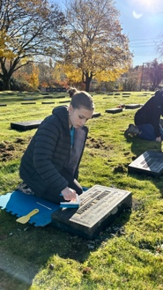
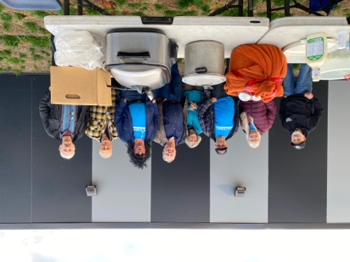
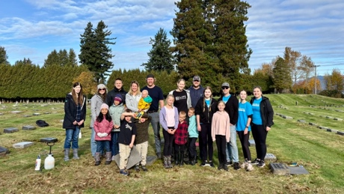


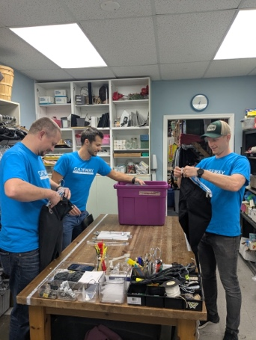
- YOUR NINTH MEETING:
- Sometime next week, we’ll be sending out our feedback forms out to all our group members, as a way to hear about how the season went for your group! It’s very helpful tool for us to plan for the coming seasons, to gauge the spiritual health and activity of our church family, and to assess our leadership needs going into the next season.
- When those come out, if you all would encourage your members to complete them, that would be super helpful!
- Also, consider planning a TENTH meeting – to celebrate the journey your group has been on! Make it a Christmas party, a fun night, a social time to build upon the relationships you’ve been investing in!

- PICTURES AT SERVE SITES?
- A number of your groups have gone out into our city serving in fantastic ways – at the food bank, at the Life Recovery Store – did you snap some pictures? Email or text them to pastor Adam.
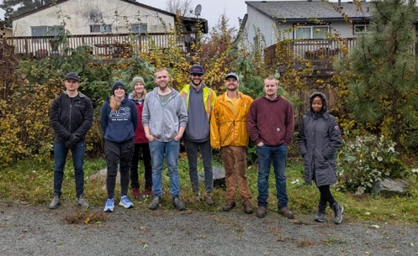
- Pictured on the top right, is the UNRAU group, the upper middle two are the GORTER/LUYMES group – both serving at Life Recovery Thrift Store. The bottom middle is the VAANDRAGER/VANDOP group at Hazelwood Cemetery cleaning gravestones, and the bottom right is the ROOS group serving a meal at 5and2 Ministries. Bottom left is our newest group this season, the DRAAISTRA/BRUEKELMAN group pulling blackberry bushes from a local park.
- Thanks everyone for sending in your pictures, it’s been GREAT to see you all in action, serving the Lord and our city, shoulder to shoulder!
- If you still have more, send them in!
GETTING TO KNOW YOU

LEADER NOTE: These are the lowest risk questions and are great ways to get everyone in your group talking – from those who love sharing stories, to those who feel a little uncomfortable in this new space. Low risk questions have their way of breaking the ice and getting everyone a little more comfortable sharing. It also gives a chance for everyone to share in an easy, approachable way.

- As Life Groups wraps up for the season, what is your fondest memory you have this season of gathering with your group?

LEADER NOTE: It’s always a good practice to reflect on the journey that we’ve been on, and this question will hopefully inspire a sense of fun reflection of times of laughter, and maybe even those times when you all got up to go home, but the conversation by the door, just kept going!

- What is one thing that you have discovered about your faith, or about the Lord, in this exploration of our Modern Problems, while seeking Ancient Solutions?

LEADER NOTE: This series, which we started back in the early summer, has been a neat series to explore. In our modern lives, we face all kinds of complexities, which while they’re quite different than those complexities of the early Israelites, they’re really – not different at all. We still live our lives with ourselves and the center of our sites, all the while pushing God to the peripheries of our lives. We talked about our identity in God, certainty, our need to surrender, about anxiety, injustice, sex and relationships, voices we hear, parenting, making wise decisions, being generous – and now about success and suffering. The reality, is that the overarching message of this whole series, is that ancient wisdom holds lasting practical answers, and that looking back at how God guiding the nation of Israel through their challenges, we will, ourselves, today in the 21st century, be also – guided forward. Because, in the face of Modern Problems, we can trust, Ancient Solutions.

QUICK REVIEW

LEADER NOTE: These following two questions aim to have your group reflect upon Sunday’s message. The first question will always be the same, and the second one is provided from our teaching pastor from the service.

1. Looking back at your notes from this week’s teaching, was there anything that particularly caught your attention, challenged, or confused you?

LEADER NOTE: Leaders, “lead by example” in your own use of these resources. Ahead of Sunday services, be sure to grab a guide in the lobby, fill it out during the message, scratch down extra thoughts and notes you might have, and bring it with you to your Life Group meetings.

2. In seasons of success, where are you most tempted to “take credit” rather than draw near to God? Why do you think that is?

LEADER NOTE: n/a

SCRIPTURE REVIEW

LEADER NOTE: Reading scripture together is one of the most important practices in our Life Groups, so never shirk away from reading the following passage, always making time to interact with the Word of God and its message for us. As leaders, you can read the passage yourselves, invite others to read the whole text, or go around the room from paragraph to paragraph. Over time, as you lead, you’ll see what works best. Always say “thank-you” to those who read out loud – it’s not everyone’s favourite thing to do.

These questions that follow, will be the same throughout the semester. And if you’re familiar with the “Triad Questions” from over the years, these are changed up a bit – simplified, and with slightly different emphases.

READ Proverbs 30:7-9
- How does this passage highlight God’s presence in our world?

- What does this passage say about our broken human condition?

- How does this passage call me to make change in my life?

Another option with these questions, is to even more simply ask, once you’ve read the passage together, as in a general way, “What strikes us about this passage?”

DIGGING DEEPER

LEADERS NOTE: These discussion questions generally start simple and gradually become deeper and more complex. This progression follows natural discussion patterns, but as leaders, you know your group best. Use this guide flexibly; it is not necessary to cover every question. Focus on ensuring everyone is heard and has the opportunity to contribute and ask their questions.

1. READ Proverbs 10:16, John 10:7-10. Jesus wasn’t talking about giving us full wallets or bursting bank accounts; what is Solomon’s “life” from “righteousness,” and Jesus’ “abundance” (NIV, “full”) that comes from being “saved”? Do you think they are talking about the same thing?

LEADER NOTE: On the surface, these two realities of “life” and “abundance” (ESV) or “fullness of life” (NIV) can be seen as the same thing, they’re close – but not identical.

Solomon’s emphasis throughout the book of Proverbs was about expounding a wisdom that would point to a life in God, one that would exude positive and good fruit from righteous living, and that living a good and wise life would lead to a flourishing and secure life in God.

Christ’s words communicate all the above, but they go a little deeper and point to the greatest truth that the abundance and full life that we have access to, doesn’t come just from our choice to live wisely, but comes from our salvation in Christ. We must remember, that outside of God, and outside of Christ’s death and resurrection, all things we do – are selfish and self-serving. But in Christ, and living into the fullness of life, or the abundance that He promises, we will be able to fully enjoy all that He has to offer – because our joy, our hope, our peace, our everything – will be found in Him. We could experience all kinds of suffering, and all kinds of success – and we’ll still have everything we need, in Him and in Him only!

So, while both Solomon and Jesus are both talking about living a spiritually rich life, Solomon is highlighting the outcome and results, but Jesus reveals the source. It’s Him. The fullness of life, the depth of His grace, the robust nature of His forgiveness – can only be experienced in the complete work of the Cross.

2. READ Proverbs 10:25. We can never be the same once a storm of life passes over. How have you seen both suffering and success make you more aware of God in your life?

LEADER NOTE: Any storm in our lives – a trouble that we experience – a hardship that we face will leave us either closer or farther from the Lord – as we’re never left the same after a difficult experience. As we’ll later read, in Proverbs 30 – that if we get too much in this life, we’ll be left taking credit; and if we don’t get much, we’ll be left desiring to take what isn’t ours – we’ll take note that God desires to give us just what we need, and at times, those hard experiences – while not caused by the Lord, will be used by Him to help us understand where we are at in our relationship with Him.

In our suffering, we’ll see our need for His grace and mercy.
In our success, we’ll see our need to give back to God all that He’s given to us.

And in both ways, we’ll be left in a posture of worship, giving Him glory, honor, and praise – all the while sensing that there’s still more work that we have to do, in order to have a better and fuller relationship with Him.

- READ Exodus 23:29-30 (in context of v.20-32), Deuteronomy 31:1-6. As Joshua was to take over Israelite leadership after Moses, and as they are about to move into the Promised Land, there would be a lot of work to do. Talk about the realities, that you might be aware of, when it comes to their suffering and success in that endeavor?

LEADER NOTE: As the story of the Israelites continued after Joseph saved them in Egypt, through his leadership in providing stored food through the years of famine, the nation stayed put there in Egypt. They grew in number, but as they grew, the new Pharoah’s forgot who Joseph was, and why this nation was there in the first place, and they were enslaved for hundreds of years. Yet, they continued to grow. As Moses was called to lead them away from their bondage, the Lord made these promises in Exodus 23, that they would be delivered, and that they would regain their own identity as a nation – but all under the Lord – who will lead them to the Promised Land, and come alongside them, when they had to chase other nations away.

But that process never came easy, while God promised their success – which is actually His success – it wouldn’t come without a challenge.

Joshua 3-4 talks about their first success in how the Lord stopped the Jordan River for them to cross.
Joshua 6 tells of another success as the Lord helped them defeat the city of Jericho.
Joshua 7-8 describes the suffering and success when it came to the victory over Ai, which didn’t start well.
Joshua 13, 15, 17, & 18 all tells of how after some major moments of success, the army of Israel didn’t finish the job by driving out all the Canaanites, Philistines, and Jebusites – who all would become deep burdens, highlighting more of their suffering.

But in this all, the Lord promised to never leave them, to never forsake them, to always be a source of provision for them. And here we see the modern problem that we face – while we’re not ridding the land of our enemies, we’re facing all kinds of distractions, temptations, and enemies of the Lord who seek to lead us down the “gradual road to hell.” The ancient solution, is to be reminded of the Lord’s same promise for us, which Paul communicates in Romans 8:31, “If God is for us, who can be against us?” and then in the very famous and familiar verses of Romans 8:38-39, “For I am sure that neither death nor life, nor angels nor rulers, nor things present nor things to come, nor powers, nor height nor depth, nor anything else in all creation, will be able to separate us from the love of God in Christ Jesus our Lord.”

3. READ Proverbs 24:10-12. As Solomon continues to record his wisdom for his son, what do you understand this text to mean?

LEADER NOTE: Sometimes we need to take a step back and look again at the text we’re reading to make sure we capture what the author meant for us to understand. Here is one of those texts that it would be good to slowly read, even read in a few translations to get a good sense of all that is happening. Know this going into that practice, just to name a few:

- The ESV (English Standard Version) prides itself on the closest word for word translation of original language to English. So it’s a little disjointed at times in its readability, but the combined words capture the theme and communicate it accurately.
- The NIV (New International Version) prides itself on capturing the theme from original languages, but then makes it accessible in modern English usage, to communicate the themes.
- The NLT (New Living Translation) prides itself on the simplification of the themes and text, but doesn’t sacrifice its meaning and original intent.
- The MESSAGE is not a translation, but a paraphrase – meaning that the author sought to capture the essence of the passage, but to share it in very approachable and understandable ways.

As you interact with this text, read it verse by verse, and capture the differences of each translation, and discover through those different words what Solomon is trying to communicate.

The long and short of it all, is that Solomon is highlighting that there are times when we face a hard moment – “adversity” (ESV), “trouble” (NIV), “pressure” (NLT), or “crisis” (MSG) – and we shirk back from doing anything for the one in need, because we say something like, “we didn’t know what was happening” or “we know nothing about that,” but we really do – then we’re in trouble, and have not fulfilled our obligation to “love our neighbor as ourselves.”

When we have the knowledge, and the resources to do something – the Lord requires us to consider just how we can lean in and do something valuable for God’s kingdom.

- READ Matthew 5:43-44, 7:13-14, 18:21-22. Disciples of Jesus are called to come alongside people who are facing hard moments in life. What are some of those adverse and troubling parts of life that you see people (maybe even yourself) having to navigate?

LEADER NOTE: After we’ve heard the invitation and really, the requirement to do something about other people’s burdens and misfortunes, the book of Matthew records the most practical solutions and approaches to coming alongside people and when facing life head on.

Matthew 5:43-44 encourages us to start in prayer – even praying for those who are enacting the harm.
Matthew 7:13-14 invites us to consider the pathway towards the Lord, in His kingdom, is not the easiest one to take, and therefore, we will face challenges.
Matthew 18:21-22 tells us that while persecution and hardships will be our reality, that we’re required to fully forgive those who have hurt us.

So, what are some of those challenges? The list will be long and extensive, but leaders, be careful to not draw out details and longwinded stories here – but simply name the hardships we face in life, just to grow in awareness where the suffering may lie.

There are all kinds of relational challenges (family conflict, spousal troubles, friendship betrayals, etc.). There are all kinds of emotional and mental health challenges (anxiety, depression, etc.)
There are all kinds of spiritual struggles (doubt, security, peace, etc.)
There are all kinds of physical challenges (illness, disability, death, living conditions, etc.)
There are all kinds of societal pressures (discrimination, exclusion, disagreements over values, etc.)

In every case, the Lord invites us to share in the burdens of our neighbors, to come to their aid – with love and respect – modelling to all the others in our lives, His grace and His mercy.

- READ Proverbs 24:13-14, James 1:2-8. Both Solomon and James are speaking to God’s people about their posture when it comes to navigating complexities in life. What is their combined advice for helping others? For finding peace yourself?

LEADER NOTE: Solomon writes to his son, “eat honey.” While it’s not likely that Solomon was teaching Rehoboam about good dietary practices, we can understand that Solomon was inviting his son to pursue a different aspect of wisdom – that it’s not just a life principle to pursue, it’s actually joyful, it’s nurturing, and sustaining. Then James takes this concept another step forward – that we should consider it joy, when hardships do come, because that means that our depth of wisdom, and strength in the Lord will be tested – and we’ll come out ahead. It means that there is actually a wisdom in our lives, that there is strength in the Lord – there is something to be tested!! And remember what we talked about earlier when Joshua was taking over leadership of the nation of Israel – they were told in Deuteronomy 31:6, “Be strong and courageous. Do not fear or be in dread of [your enemies, your challenges, your hardships] for it is the Lord your God who goes with you. He will not leave you or forsake you.”

So, we’re to be in constant pursuit of wisdom, taking on trials and hardships as opportunities to grow in the Lord, all the while relying on God’s mighty right hand of guidance.

TAKING IT HOME

READ Proverbs 30:7-9, Hebrews 13:1-6. What shift in life and in the posture of your heart, might you have to make to steer yourself away from pursuing “excess” or being unhappy in “lacking” – but being content in what the Lord has provided?

LEADER NOTE: The baseline of this conversation needs to start with our recognition that we’re in constant need of change, and in constant need of self-checks – to see what we’re really in pursuit of. Perhaps a great place to start here is not just in Proverbs and Hebrews, but in David’s prayer at the end Psalm 139:23-24, “Search me, O God, and know my heart, try me and know my thoughts! And see if there be any grievous way in me and lead me in the way everlasting!” Then from there, develop some discussion around our human posture and state of our hearts and lives.

When we’re greedy – we’re to shift to trust in the Lord’s provision.
When we’re discontent – we’re to shift to a posture of gratitude, being grateful for what we do have.
When we’re anxious – we’re to steer away from fear and uncertainty, striving to look for peace.
When we’re focusing just on ourselves and making our own plans – we’re to see the Lord at the beginning of everything and how’s He’s paving the way forward.

PERSONAL REFLECTION

LEADER NOTE: This following question is completely optional and is intended for the participants’ personal reflection. But do feel free to explore using the question within your groups meeting.

READ Psalm 16. David writes a song about the Lord’s nearness, constant provision, and the Lord being His key source of protection, but he also recognizes that there are distractions that others have fallen to (v.4). Have you, like David, fully settled on the Lord being your “portion and cup” (v.5)? If no, what holds you back? If yes, are you sure?

