

LIFE GROUPS | LEADERS GUIDE
November 9-15, 2025 | Fall Week 7

ANNOUNCEMENTS

Well, hey there Life Group Leaders!! Welcome to this week’s leadership guide for Gateway’s Life Groups. We’re in week #7 of our Fall 2025 season.

- YOUR SEVENTH MEETING:
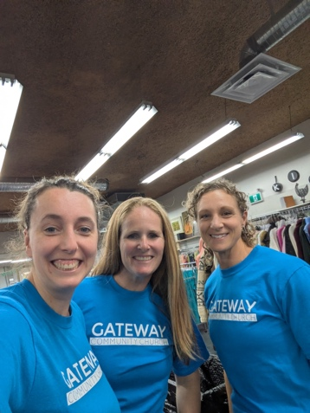
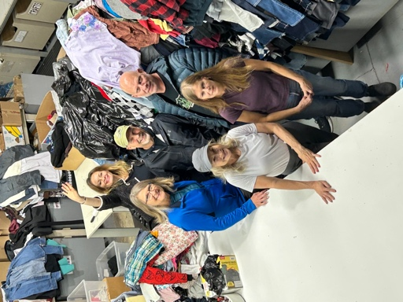
- As a heads up, next weeks, we’ll be preparing our feedback forms to send out to all our group members, as a way to hear about how the season went for your group! It’s very helpful tool for us to plan for the coming seasons, to gauge the spiritual health and activity of our church family, and to assess our leadership needs going into the next season.
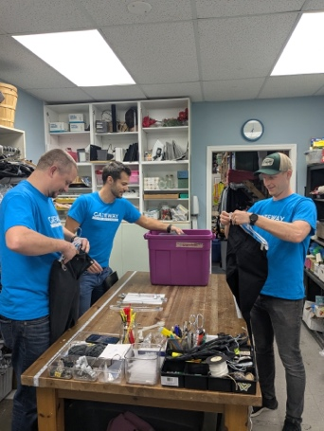
- When those come out, if you all would encourage your members to complete them, that would be super helpful!

- PICTURES AT SERVE SITES?
- A number of your groups have gone out into our city serving in fantastic ways – at the food bank, at the Life Recovery Store – did you snap some pictures? Email or text them to pastor Adam.
- Picture on the top right, is the UNRAU group, and the bottom two are the GORTER/LUYMES group – both serving at Life Recovery Thrift Store.
- All this empty white space below here is reserved for more of your groups in action!! Let’s fill the whole space!!

GETTING TO KNOW YOU

LEADER NOTE: These are the lowest risk questions and are great ways to get everyone in your group talking – from those who love sharing stories, to those who feel a little uncomfortable in this new space. Low risk questions have their way of breaking the ice and getting everyone a little more comfortable sharing. It also gives a chance for everyone to share in an easy, approachable way.

- What was the easiest (big) decision you’ve made?

LEADER NOTE: As we’re talking about making wise decisions, let’s start our group conversations with that theme, and with the easy angle talking about the easiest decisions your members have made. This is a question where going “around the room” will be helpful to keep conversation flowing.

- What was the hardest decision you’ve had to make?

LEADER NOTE: Still on the theme of decision making, this question will head the opposite direction, and leaders, as always, you know your group the best and will know if there’s enough safety and familiarity in your group to proceed, as this could be a fairly difficult for some. Tread lightly, and don’t force anything. Simply invite people to share what they are willing to share.

What we hope will transpire in this moment, is that those who are confident and strong in their faith will share a perspective of hard ship, but that they felt the Lord’s guiding hand nearby. Lead with your own events to get conversation going – if necessary. As well, if you do find yourselves in some hard moments where some members share some significant, and uncared for wounds and hurts – stop and pray!! Ask for the Lord’s comfort, and a continuation of His guiding hand. As we heard on Sunday, the Lord can turn these hardships into moments of showing His glory.

QUICK REVIEW

LEADER NOTE: These following two questions aim to have your group reflect upon Sunday’s message. The first question will always be the same, and the second one is provided from our teaching pastor from the service.

1. Looking back at your notes from this week’s teaching, was there anything that particularly caught your attention, challenged, or confused you?

LEADER NOTE: Leaders, “lead by example” in your own use of these resources. Ahead of Sunday services, be sure to grab a guide in the lobby, fill it out during the message, scratch down extra thoughts and notes you might have, and bring it with you to your Life Group meetings.

2. This weekend, Pastor Adam talked about the twin pitfalls of human choice: “All life’s choices ride on me” and “Our choices are meaningless.” Which area do you tend to lean towards? How are those areas distractions and distortions of God’s Sovereignty?

LEADER NOTE: The pitfalls fall in the camps where we either think that we must choose all things in life correctly, and only we can do that, or on the other side, that none of our decisions matter, and we’re ok with life just coasting by, as it does. Both perspectives do not line up with the Christian faith, because we believe in a sovereign God who is in all things, knows all things, and claims all things to be His own! Thinking that we must decide everything pushes God out, and we place ourselves in that sovereign role. Whereas on the other side, when we let life go idly by, while that is us pushing God to the side, this is also us reducing ourselves to less than what God designed. He made us with the ability to make choices for ourselves, and to take ownership of our lives.

SCRIPTURE REVIEW

LEADER NOTE: Reading scripture together is one of the most important practices in our Life Groups, so never shirk away from reading the following passage, always making time to interact with the Word of God and its message for us. As leaders, you can read the passage yourselves, invite others to read the whole text, or go around the room from paragraph to paragraph. Over time, as you lead, you’ll see what works best. Always say “thank-you” to those who read out loud – it’s not everyone’s favourite thing to do.

These questions that follow, will be the same throughout the semester. And if you’re familiar with the “Triad Questions” from over the years, these are changed up a bit – simplified, and with slightly different emphases.

READ Proverbs 3:1-8
- How does this passage highlight God’s presence in our world?

- What does this passage say about our broken human condition?

- How does this passage call me to make change in my life?

Another option with these questions, is to even more simply ask, once you’ve read the passage together, as in a general way, “What strikes us about this passage?”

DIGGING DEEPER

LEADERS NOTE: These discussion questions generally start simple and gradually become deeper and more complex. This progression follows natural discussion patterns, but as leaders, you know your group best. Use this guide flexibly; it is not necessary to cover every question. Focus on ensuring everyone is heard and has the opportunity to contribute and ask their questions.

1. READ Proverbs 3:1-6. In past decisions, both big and small, how have you heard from the Lord, His direction for your life? How did that scenario play out?

LEADER NOTE: We’ve before about how the Lord speaks to us – and in this overarching conversation we’ve been talking about how the Lord will reveal Himself to us through prayer, through His word, and through conversations with others. This question leans into the specific moments that your members have found themselves needing to make decisions.

- READ Jeremiah 17:5-8. Thinking about that same decision, were you tempted to make your own choice outside of God’s leading? Why or why not?

LEADER NOTE: In our sinful and distracted nature, we easily forget to pursue God ahead of the things we do, and we press forward with decisions without considering wider ramifications of them. But hold off here on that part of the conversation, that’ll come next.

2. READ Proverbs 3:19-26. When it comes to making decisions in life, what dangers do you think arise when we trust our own understanding, but forget that God is ultimately in control?

LEADER NOTE: When we exclude God from our decision-making process, we inadvertently emphasize our sinful and selfish nature, where we think primarily of ourselves, and our own orbits. The danger here, is that humanly speaking we might see a very clear path forward with making a decision that we think is wise, but we can only see what we can see in the moment – the Lord, in His sovereignty – can see the past, the present, and the future of our paths in front of us, and can see how our decisions affect all of everything around us. His vision there isn’t just limited to our own path, but to everyone else’s!

The Lord sees from above this amazing web or tapestry of how all our lives our connected. So when we’re tempted, and we follow through with our own plans, we need to reconsider our selfish postures as we do that.

- READ Philippians 4:4-9. What rhythms or habits help you experience God’s guidance in your everyday decisions?

LEADER NOTE: Paul writes an encouraging letter to one of his favorite and supportive churches. It’s clear through this letter that the people in this church are ever aware of the Lord’s leading, which is seen in the very first chapter, where Paul talks about this church “partnering” with him in ministry, and where they are also “partakers with” Paul in receiving God’s grace. They supported him while he was in prison and continued to defend the gospel message to all who came their way. So then in chapter 4, Paul encourages them to keep up their patterns of seeking God’s guidance and wisdom. He writes to them here two things, (1) to present their requests to God, and (2) to seek the good things, or the right paths, in life. Paul is convinced that the Lord will honor those choices – and we can be filled with hope and assurance today, that as we align ourselves with the Lord similarly, He too, will honor us and our choices.

3. READ Proverbs 3:27-35. Observe how Solomon contrasts how we treat others (5 “do not” statements, vs. 27-31) to how God responds to such people (4 evil/good statements, vs. 32-35). What do you notice to be the difference?

LEADER NOTE: When we read those five “do not” statements, it becomes clear that Solomon knows the posture of the human heart. Like we explored on Sunday morning, from the text in Jeremiah 17:9, “The heart is deceitful above all things, and desperately sick.” We see in this Proverbs 3 text that we are prone to “withhold good,” to be deceitful with our neighbor, to “plan evil,” to argue with each other, and to be “envious” of what someone else has. But then as we engage in the next few statements about the Lord’s posture, we’ll see that He desires to bless those who are obedient to His words, and that curses will come upon those who are not.

- READ Proverbs 3:32-35. Look again at the positive statements in these verses. In the daily decisions we make, what do you see the Lord inviting us to consider? What patterns might you need to change, as you face tomorrow’s choices?

LEADER NOTE: The Lord is outlining a path for us today to discover the beauty and benefits of living a life that models His love and His compassion for all the others in our lives that He would have us connect with. He wants to hold us in places of honor, to bless our homes, to show us His favor. All things that we should be in pursuit of.

TAKING IT HOME

READ Genesis 50:20, Proverbs 16:9, Romans 8:28, Ephesians 1:11, & Philippians 2:12-13. God works through all things. How do these verses frame the way we ought to think about outcomes that do not go as planned? How does this affect our comfort and assurance of the Lord’s nearness and provision?

LEADER NOTE: Read these texts carefully, and slowly – don’t rush them. But also, should time allow, try to discover how each verse relates in the context they are in.

- Genesis 50:20 – is the conclusion of the whole story of Joseph, and how he was sold into slavery by his brothers, comes out as being instrumental in saving the coming nation from obliteration.
- Proverbs 16:9 – Solomon is continuing to speak to his son about the wisdom that he has gained through life as a gift of the Lord – consider looking at 16:7 here as well.
- Romans 8:28 – this verse is perhaps one of the verses that is most often taken out of its context, which we use to say that “life will work out.” Paul is emphasizing here a lot of what we’ve looked at already, which is the good work of the Lord, who is working in and through all things for His glory, and for the good of His people. It’s the Lord’s work, not ours.
- Ephesians 1:11 – Paul writes to the Ephesians, urging them to be united as followers of Jesus, and not just Jews and Gentiles.
- Philippians 2:12-13 – This isn’t Paul saying that his audience must choose the realities of salvation, but how they’re going to live it out – much like we’re doing in the context of Proverbs 3.

All in, these verses give us a very clear picture of the Lord’s guidance and preferred pathway for us to travel in this life. We should be left with greater comfort, and deeper assurances of that very reality. But also, we should be reminded overall, that in our lives – as followers of Jesus – we cannot just sit on our hands and let the world go by, thinking that the Lord will do what the Lord will do. But we need to consider that He invites us to participate with Him in the redemptive work that He is already doing. While we cannot change His plans, He certainly desires to use us and our orbits to influence others to say “yes” to being a part of His kingdom.

PERSONAL REFLECTION

LEADER NOTE: This following question is completely optional and is intended for the participants’ personal reflection. But do feel free to explore using the question within your groups meeting.

READ Proverbs 16:1-9. As Christians, we are to balance “planning carefully” with “trusting God’s sovereignty.” To this end, what insights are revealed in Proverbs 16?

