The Third Sunday in Lent
March 3, 2026
Divine Service, Setting 3
10:00 AM

Messiah Evangelical Lutheran Church
465 Pond Path ~ East Setauket, NY 11733
e-mail: info@messiahny.org
website: www.messiahny.org
(631) 751-1775

Rev. David Wackenhuth ~ Covering Pastor
Rev. Charles Bell ~ Pastor Emeritus
Mr. Thom Brownworth ~ Deacon
Mr. Chris Cuvier ~ Organist

WELCOME TO MESSIAH!
To all who carry a burden of sin and need a Savior; to all who wish to rejoice and give thanks; to all who are strangers and need a Church home; to all who are lonely and long for companionship; to all who worship the Lord, our Creator; to all who hunger for the Word; to all who are weary and need rest, the people of Messiah, in the Spirit and Name of Jesus, say WELCOME!

If you are a visitor, we ask you to please introduce yourself to our pastors (don't worry, they're friendly!) and please sign our Guest Register in the narthex or fill out the yellow card in your bulletin. This will help us to get to know you better!

If you would like us to pray for you (or with you), please see one of our pastors before the church service or write a prayer request on the back of the yellow card.

OUR STATEMENT OF PURPOSE
Messiah Evangelical Lutheran Church exists in order to lead people to faith in Christ Jesus and Fellowship in His family, to celebrate His presence in worship and the study of His Word, and to use all their God-given Time, Talents, and Treasures according to His Will in the ministry of His church and mission to the world.

PRIVATE PRAYERS FOR BEFORE, DURING, AND AFTER WORSHIP:

On entering a church
Lord, I love the habitation of Your house and the place where Your glory dwells. In the multitude of Your tender mercies prepare my heart that I may enter Your house to worship and confess Your holy name; through Jesus Christ, my God and Lord. Amen.

Before worship
O Lord, my creator, redeemer, and comforter, as I come to worship You in spirit and in truth, I humbly pray that You would open my heart to the preaching of Your Word so that I may repent of my sins, believe in Jesus Christ as my only Savior, and grow in grace and holiness. Hear me for His sake. Amen.

Before confession & absolution
Almighty, everlasting God, for my many sins I justly deserve eternal condemnation. In Your mercy You sent Your dear Son, my Lord Jesus Christ, who won for me forgiveness of sins and everlasting salvation. Grant me a true confession that, dead to sin, I may be raised up by Your life-giving absolution. Grant me Your Holy Spirit that I may be ever watchful and live a true and godly life in Your service; through Jesus Christ, my Lord. Amen.

Before communing
Dear Savior, at Your gracious invitation I come to Your table to eat and drink Your holy body and blood. Let me find favor in
Your eyes to receive this holy Sacrament in faith for the salvation of my soul and to the glory of Your holy name; for You live and reign with the Father and the Holy Spirit, one God, now and forever. Amen.

After communing
Almighty and everlasting God, I thank and praise You for feeding me the life-giving body and blood of Your beloved Son, Jesus Christ. Send me Your Holy Spirit that, having with my mouth received the holy Sacrament, I may by faith obtain and eternally enjoy Your divine grace, the forgiveness of sins, unity with Christ, and life eternal; through Jesus Christ, my Lord. Amen.

Prelude

Welcome
The order of service for today may be found in the Hymnal, page 184.

Stand

Opening Hymn: 905 Come, Thou Almighty King
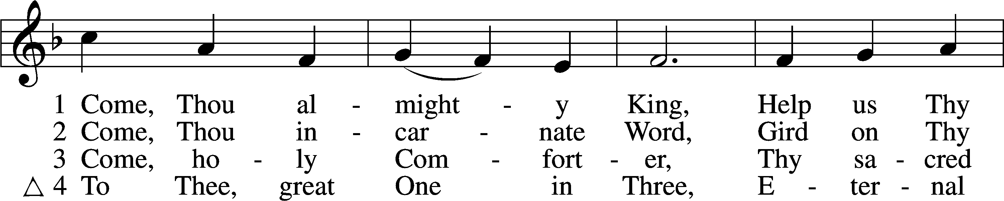
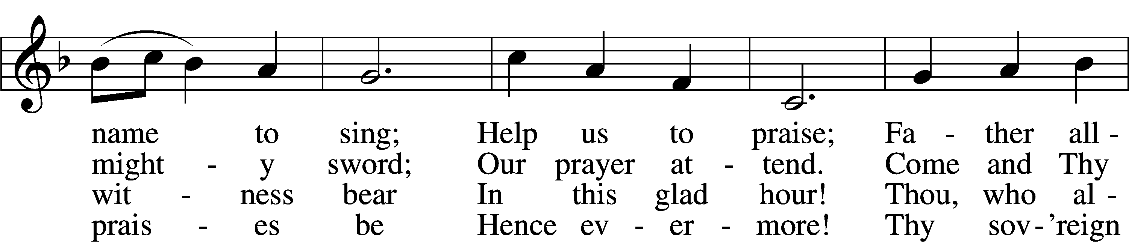
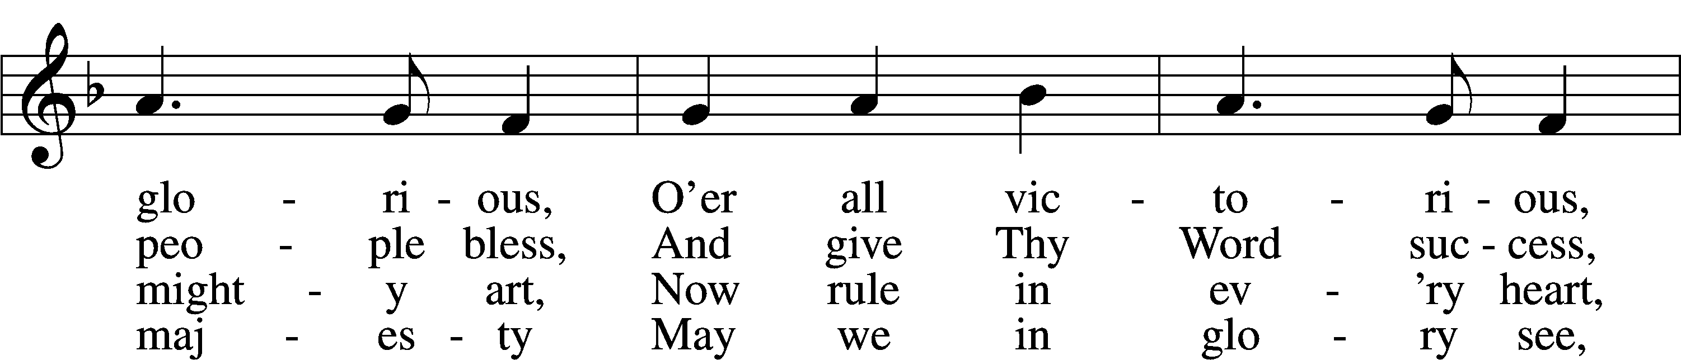
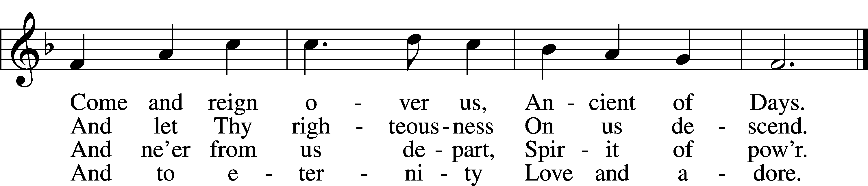
Text: English, before 1760, alt.
Tune: Felice de Giardini, 1716–96
Text and tune: Public domain

Confession and Absolution

The sign of the cross may be made by all in remembrance of their Baptism.

P In the name of the Father and of the T Son and of the Holy Spirit.
C Amen.

P Beloved in the Lord! Let us draw near with a true heart and confess our sins unto God our Father, beseeching Him in the name of our Lord Jesus Christ to grant us forgiveness.

P Our help is in the name of the Lord,
C who made heaven and earth.
P I said, I will confess my transgressions unto the Lord,
C and You forgave the iniquity of my sin.
Kneel/Stand

Silence for reflection on God’s Word and for self-examination.

P O almighty God, merciful Father,
C I, a poor, miserable sinner, confess unto You all my sins and iniquities with which I have ever offended You and justly deserved Your temporal and eternal punishment. But I am heartily sorry for them and sincerely repent of them, and I pray You of Your boundless mercy and for the sake of the holy, innocent, bitter sufferings and death of Your beloved Son, Jesus Christ, to be gracious and merciful to me, a poor, sinful being.

P Upon this your confession, I, by virtue of my office, as a called and ordained servant of the Word, announce the grace of God unto all of you, and in the stead and by the command of my Lord Jesus Christ I forgive you all your sins in the name of the Father and of the T Son and of the Holy Spirit.
C Amen.

Stand
Service of the Word
Introit Psalm 84:1–4; antiphon: v. 5
Blessèd are those whose strength is | in you,*
in whose heart are the highways to | Zion.
How lovely is your | dwelling place,*
O | Lord of hosts!
My soul longs, yes, faints for the courts | of the Lord;*
my heart and flesh sing for joy to the | living God.
Even the sparrow finds a home, and the swallow a nest for herself, where she may | lay her young,*
at your altars, O Lord of hosts, my King | and my God.
Blessèd are those who dwell | in your house,*
ever sing- | ing your praise!
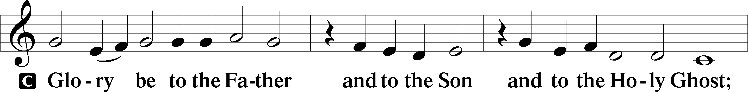
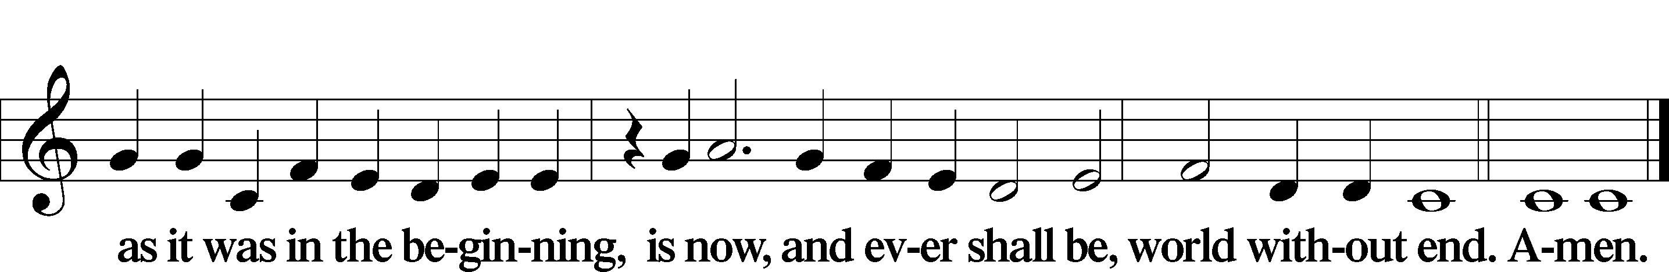
Blessèd are those whose strength is | in you,*
in whose heart are the highways to | Zion.

Kyrie LSB 186
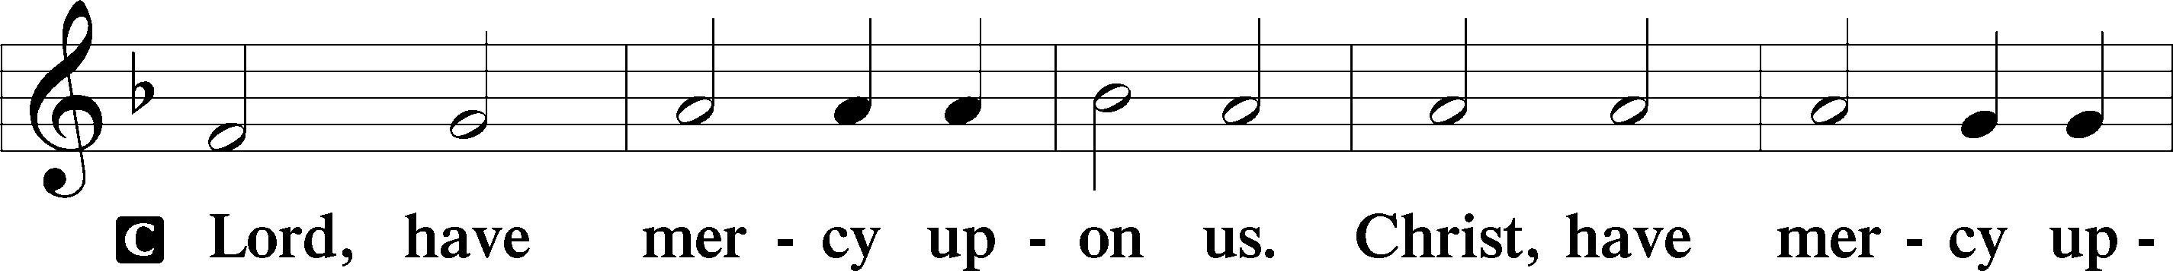
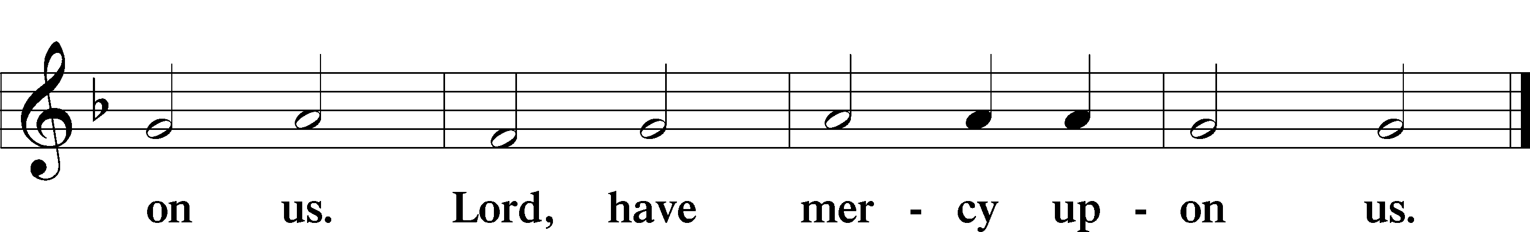

Salutation and Collect of the Day
P The Lord be with you.
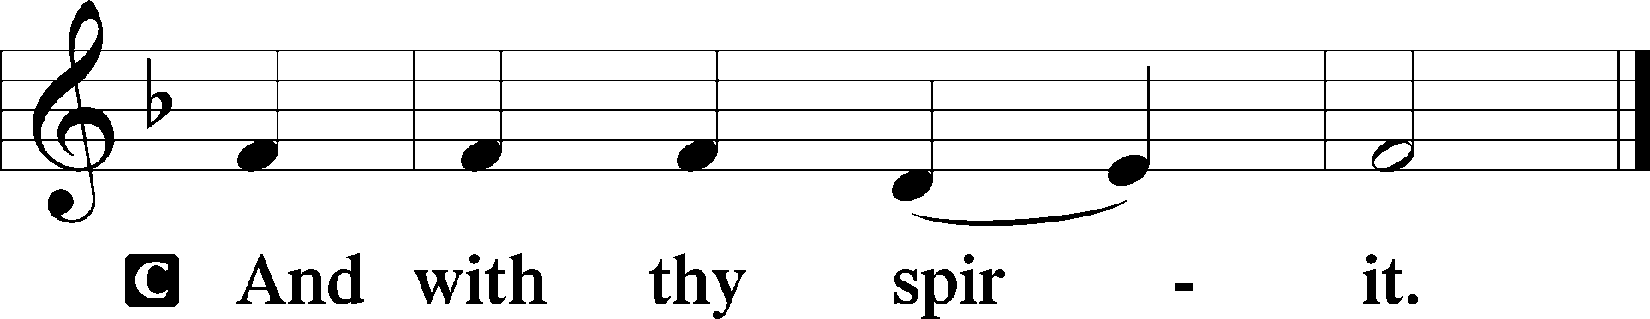

P Let us pray.
O God, whose glory it is always to have mercy, be gracious to all who have gone astray from Your ways and bring them again with penitent hearts and steadfast faith to embrace and hold fast the unchangeable truth of Your Word; through Jesus Christ, Your Son, our Lord, who lives and reigns with You and the Holy Spirit, one God, now and forever.

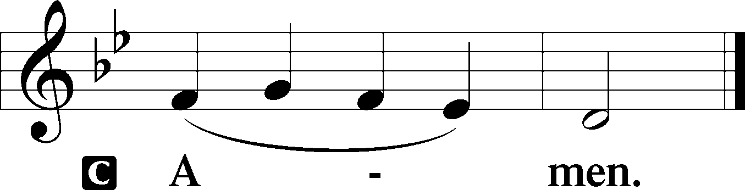

Sit

Children's Message
Any children present (and Mom and Dad, too!) are encouraged to come up to the chancel.

Lectionary Summary
We Worship the Father of Our Lord Jesus Christ in the Spirit and Truth of His Gospel
Though the Lord had brought them out of Egypt, “all the congregation of the people of Israel” grumbled against Him because “there was no water for the people to drink” (Ex. 17:1). Despite their quarreling, the Lord graciously provided for them. He did not strike the people for their sins, but by the hand of Moses He struck the rock instead and brought forth water for the people. In the same way, living water flows from the pierced side of Christ at “about the sixth hour” (John 4:6; 19:14), when He is lifted up on the cross for the sins of the world. He is “the gift of God” (John 4:10), the well from which the Holy Spirit is poured out and becomes in His people “a spring of water welling up to eternal life” (John 4:14). By this grace in which we stand, being at peace with God through our Lord Jesus Christ, we “worship the Father in spirit and truth” (John 4:23). “We rejoice in hope of the glory of God” because “God’s love has been poured into our hearts through the Holy Spirit who has been given to us” (Rom. 5:2, 5).

Old Testament Reading Exodus 17:1–7
1All the congregation of the people of Israel moved on from the wilderness of Sin by stages, according to the commandment of the Lord, and camped at Rephidim, but there was no water for the people to drink. 2Therefore the people quarreled with Moses and said, “Give us water to drink.” And Moses said to them, “Why do you quarrel with me? Why do you test the Lord?” 3But the people thirsted there for water, and the people grumbled against Moses and said, “Why did you bring us up out of Egypt, to kill us and our children and our livestock with thirst?” 4So Moses cried to the Lord, “What shall I do with this people? They are almost ready to stone me.” 5And the Lord said to Moses, “Pass on before the people, taking with you some of the elders of Israel, and take in your hand the staff with which you struck the Nile, and go. 6Behold, I will stand before you there on the rock at Horeb, and you shall strike the rock, and water shall come out of it, and the people will drink.” And Moses did so, in the sight of the elders of Israel. 7And he called the name of the place Massah and Meribah, because of the quarreling of the people of Israel, and because they tested the Lord by saying, “Is the Lord among us or not?”

A This is the Word of the Lord.
C Thanks be to God.

Gradual Hebrews 12:2
C [O come, let us fix our eyes on] | Jesus,*
the founder and perfecter | of our faith,
who for the joy that was set before him endured the cross, despis- | ing the shame,*
and is seated at the right hand of the | throne of God.

Epistle Romans 5:1–8
1Therefore, since we have been justified by faith, we have peace with God through our Lord Jesus Christ. 2Through him we have also obtained access by faith into this grace in which we stand, and we rejoice in hope of the glory of God. 3More than that, we rejoice in our sufferings, knowing that suffering produces endurance, 4and endurance produces character, and character produces hope, 5and hope does not put us to shame, because God’s love has been poured into our hearts through the Holy Spirit who has been given to us.
6For while we were still weak, at the right time Christ died for the ungodly. 7For one will scarcely die for a righteous person—though perhaps for a good person one would dare even to die— 8but God shows his love for us in that while we were still sinners, Christ died for us.

A This is the Word of the Lord.
C Thanks be to God.

Stand

Verse of the Day John 4:23a
The hour is coming, and is now here, when the true worshipers will worship the Father in spirit and truth.

Holy Gospel John 4:5–26
P The Holy Gospel according to St. John, the fourth chapter.

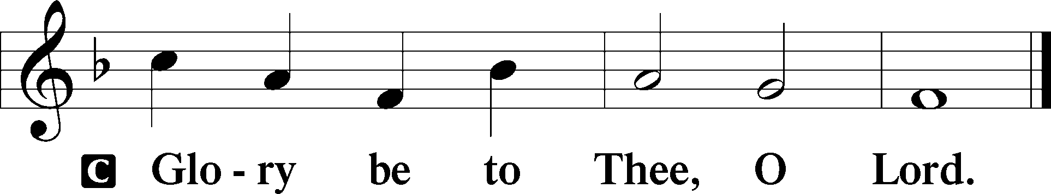

5[Jesus] came to a town of Samaria called Sychar, near the field that Jacob had given to his son Joseph. 6Jacob’s well was there; so Jesus, wearied as he was from his journey, was sitting beside the well. It was about the sixth hour.
7There came a woman of Samaria to draw water. Jesus said to her, “Give me a drink.” 8(For his disciples had gone away into the city to buy food.) 9The Samaritan woman said to him, “How is it that you, a Jew, ask for a drink from me, a woman of Samaria?” (For Jews have no dealings with Samaritans.) 10Jesus answered her, “If you knew the gift of God, and who it is that is saying to you, ‘Give me a drink,’ you would have asked him, and he would have given you living water.” 11The woman said to him, “Sir, you have nothing to draw water with, and the well is deep. Where do you get that living water? 12Are you greater than our father Jacob? He gave us the well and drank from it himself, as did his sons and his livestock.” 13Jesus said to her, “Everyone who drinks of this water will be thirsty again, 14but whoever drinks of the water that I will give him will never be thirsty forever. The water that I will give him will become in him a spring of water welling up to eternal life.” 15The woman said to him, “Sir, give me this water, so that I will not be thirsty or have to come here to draw water.”
16Jesus said to her, “Go, call your husband, and come here.” 17The woman answered him, “I have no husband.” Jesus said to her, “You are right in saying, ‘I have no husband’; 18for you have had five husbands, and the one you now have is not your husband. What you have said is true.” 19The woman said to him, “Sir, I perceive that you are a prophet. 20Our fathers worshiped on this mountain, but you say that in Jerusalem is the place where people ought to worship.” 21Jesus said to her, “Woman, believe me, the hour is coming when neither on this mountain nor in Jerusalem will you worship the Father. 22You worship what you do not know; we worship what we know, for salvation is from the Jews. 23But the hour is coming, and is now here, when the true worshipers will worship the Father in spirit and truth, for the Father is seeking such people to worship him. 24God is spirit, and those who worship him must worship in spirit and truth.” 25The woman said to him, “I know that Messiah is coming (he who is called Christ). When he comes, he will tell us all things.” 26Jesus said to her, “I who speak to you am he.”

P This is the Gospel of the Lord.

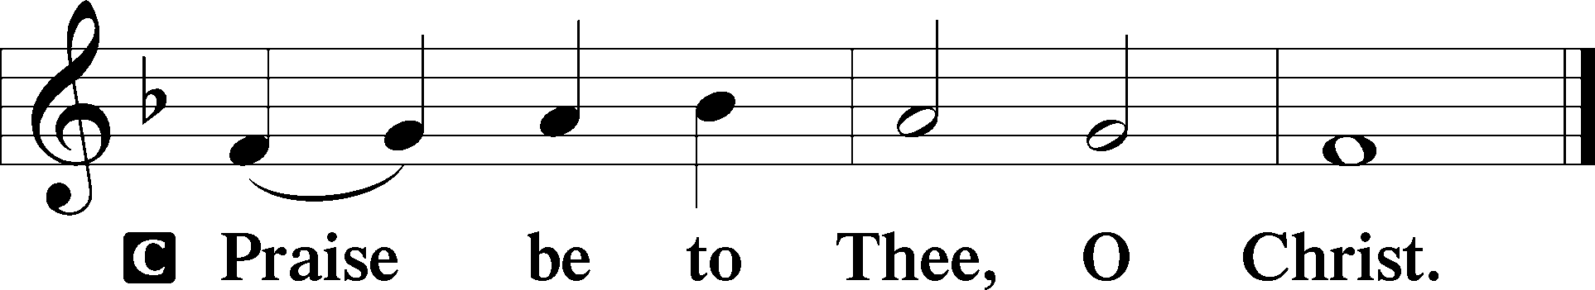

Apostles’ Creed
C I believe in God, the Father Almighty,
maker of heaven and earth.

And in Jesus Christ, His only Son, our Lord,
who was conceived by the Holy Spirit,
born of the virgin Mary,
suffered under Pontius Pilate,
was crucified, died and was buried.
He descended into hell.
The third day He rose again from the dead.
He ascended into heaven
and sits at the right hand of God the Father Almighty.
From thence He will come to judge the living and the dead.

I believe in the Holy Spirit,
the holy Christian Church,
the communion of saints,
the forgiveness of sins,
the resurrection of the body,
and the life T everlasting. Amen.

Sit

Song of the Day: You Who Are Thirsty
You who are thirsty,
Come to the well and drink from waters flowing.
You who are hungry,
Come to the bread and eat of His holiness.

You who are tired, find rest.
You who are weak, find strength.
You who are thirsty, come to the well and drink.

(repeat from beginning)

He will freely feed all of them who are weak.
He will quench the righteous thirst of all who humbly seek.

You who are thirsty,
Come to the well and drink from waters flowing.
You who are hungry,
Come to the bread and eat of His holiness.

You who are tired, find rest.
You who are weak, find strength.
You who are thirsty, come to the well and drink.

He will freely feed all of them who are weak.
He will quench the righteous thirst of all who humbly seek.
Text: Barbara Ross
Text: © 1992 BBR (Barbara Ross) Music, admin. BBR (Barbara Ross) Music; © 1992 BBR (Barbara Ross) Music. Used by permission: CCLI Copyright License no. 21243036

Sermon ~ “The Man at the Well”

P The peace of God, which passes all understanding, keep your hearts and minds in Christ Jesus.
C Amen.

Stand

Offertory LSB 192
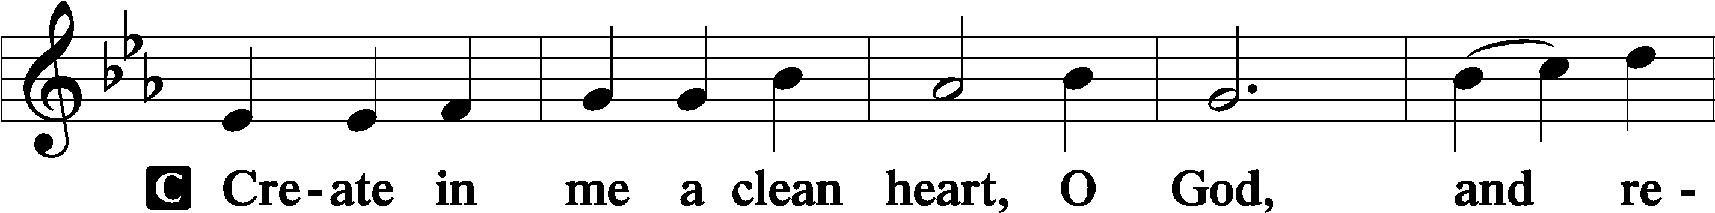
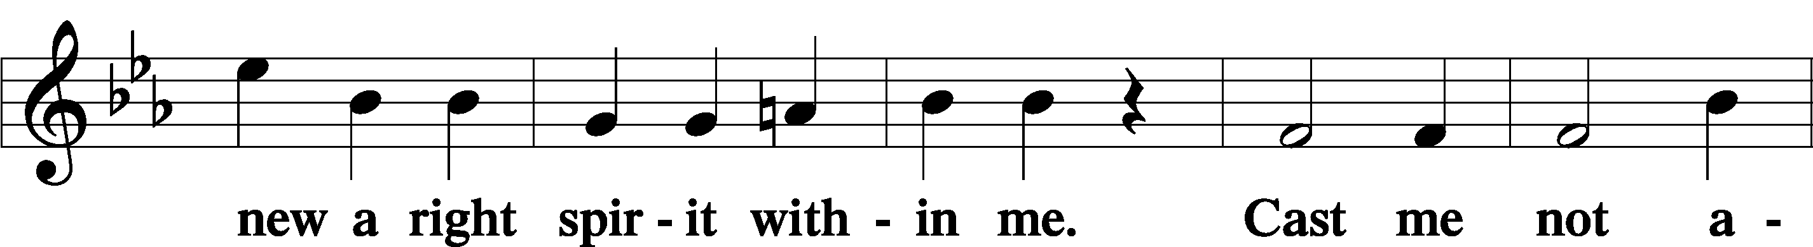
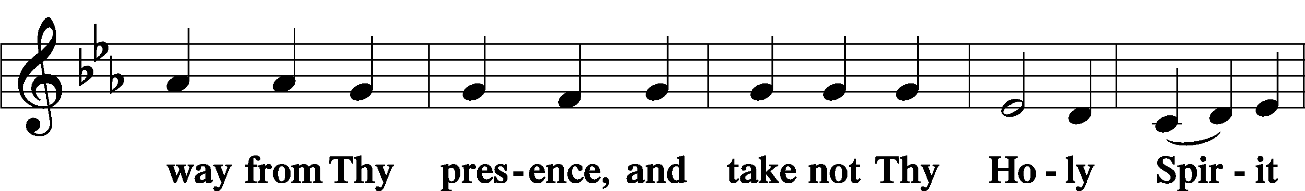
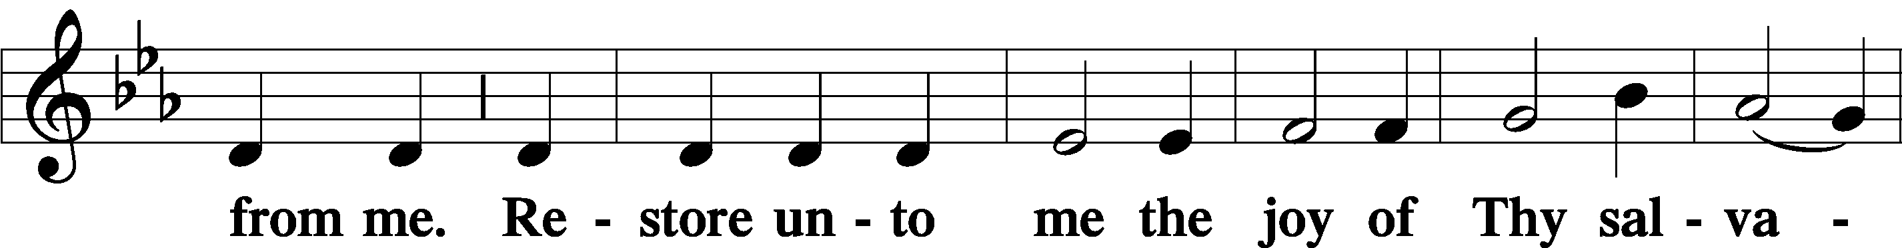
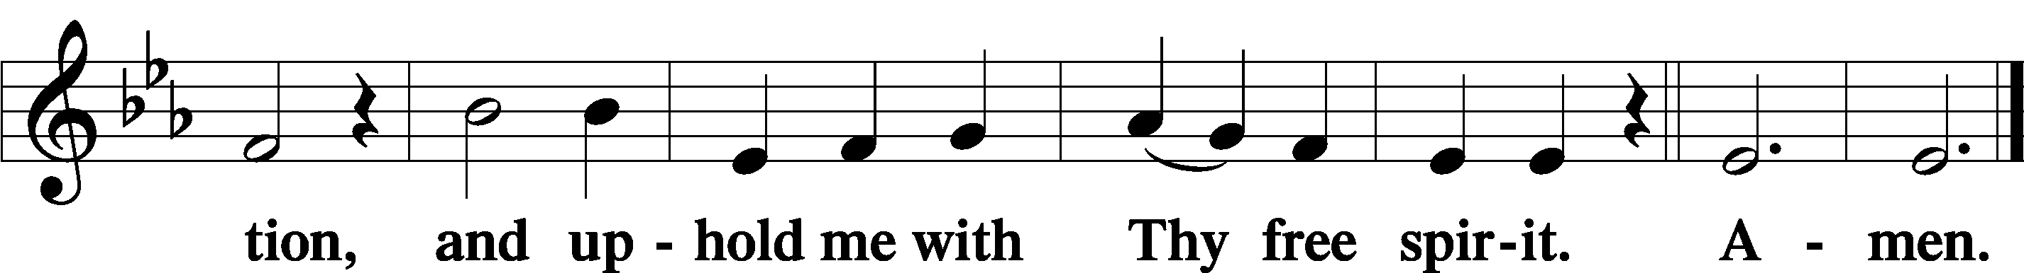

Sit

Offering

Stand

Prayer of the Church
The response for the prayers of the church is as follows:

P ... Lord, in Your mercy,
C hear our prayer.

The Sharing of the Peace
Following the prayers, the people may greet one another in the name of the Lord, saying, “Peace be with you,” as a sign of reconciliation and of the unity of the Spirit in the bond of peace (Matt. 5:22–24; Eph. 4:1–3). You are invited to greet one-another in whichever manner you are comfortable.

Service of the Sacrament
In Holy Communion, our Lord invites us to eat and drink His true Body and Blood for the forgiveness of sins and eternal life (Matthew 26:26-28). In preparation for this sacrament, each communicant should examine him or herself and come to the Lord’s Table seeking these things. As the Catechism teaches, “a person is truly worthy and well prepared who has faith in these words: ‘Given and shed for you for the forgiveness of sins.’” We likewise take seriously St. Paul's admonition in 1 Corinthians 11:27-30 regarding recognizing the Lord's Body and Blood in this sacrament and receiving it worthily. Therefore, we invite all baptized Christians who have been instructed in the Christian faith and who believe that Jesus offers here His true Body and Blood, in, with, and under the elements of bread and wine, for the strengthening of their bodies and souls, cleansing them of their old nature and giving them new life, to join us at His table. If you have any questions about this, please speak to our pastor. He will be happy to discuss it with you.
If you do not wish to commune or have not been baptized or instructed in the Christian faith, we invite you to come forward for a blessing. When you come forward toward the altar, please ask the pastor if he would bless you. If you would like to learn more about the Christian faith or wish to be baptized, please speak to our pastor!

Preface LSB 194
P The Lord be with you.
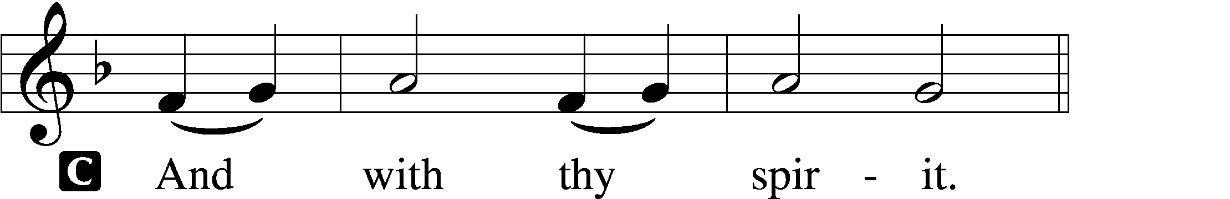

P Lift up your hearts.
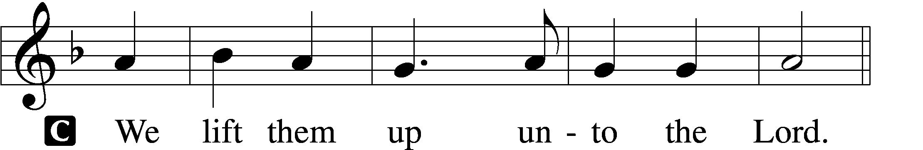

P Let us give thanks unto the Lord, our God.
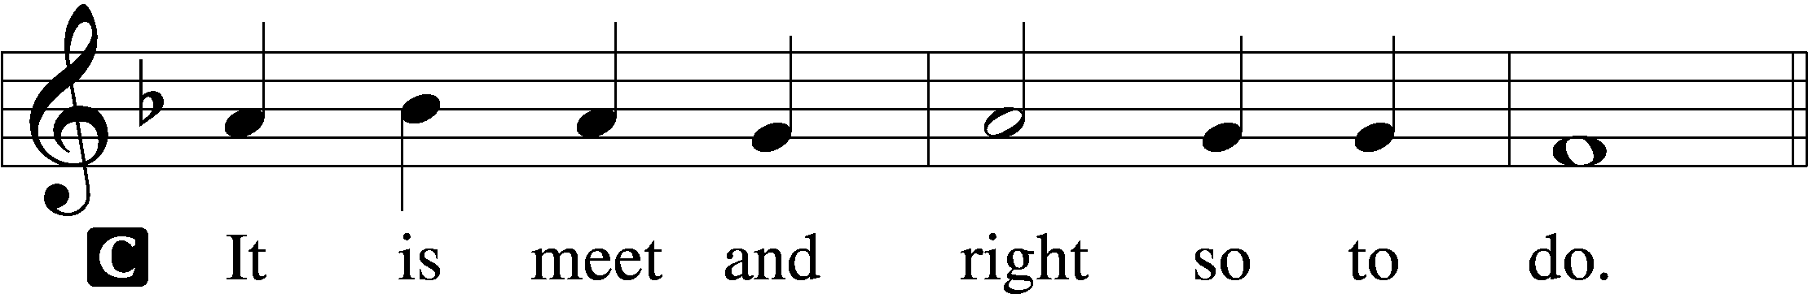

P It is truly meet, right, and salutary that we should at all times and in all places give thanks to You, holy Lord, almighty Father, everlasting God, through Jesus Christ, our Lord, who overcame the assaults of the devil and gave His life as a ransom for many that with cleansed hearts we might be prepared joyfully to celebrate the paschal feast in sincerity and truth. Therefore with angels and archangels and with all the company of heaven we laud and magnify Your glorious name, evermore praising You and saying:

Sanctus LSB 195
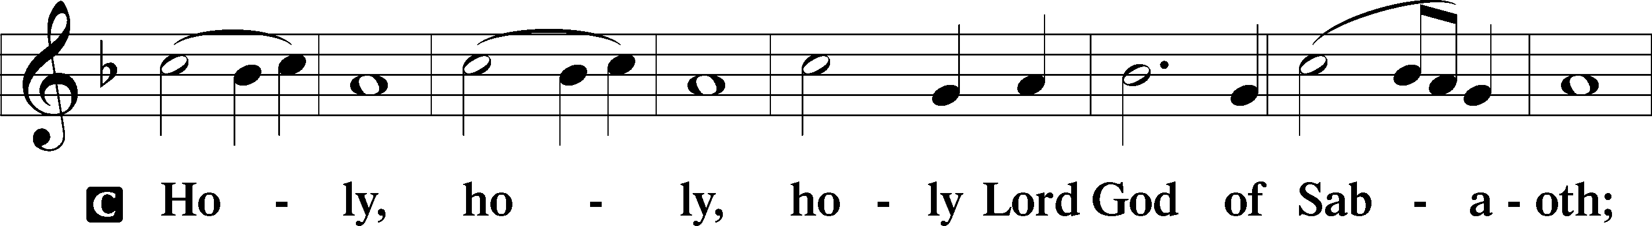
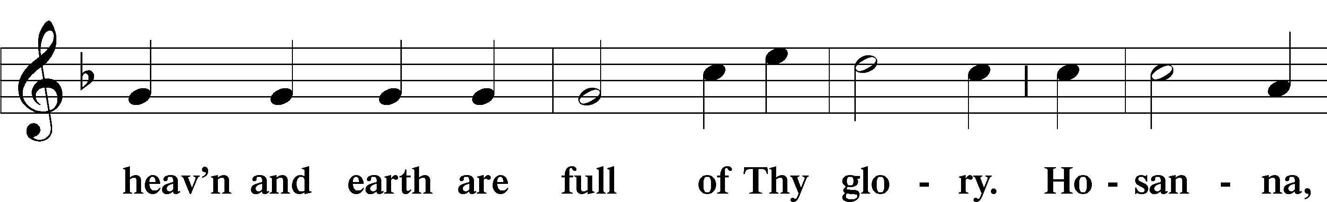
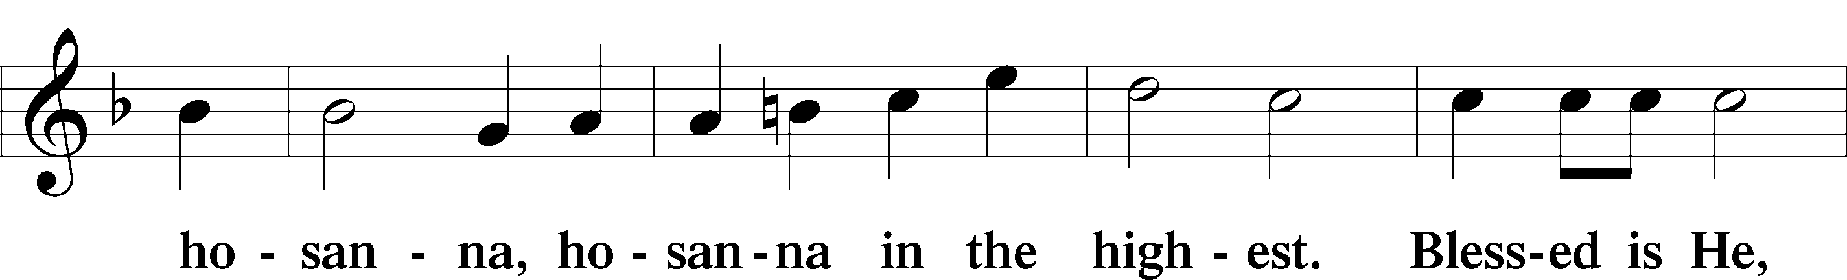
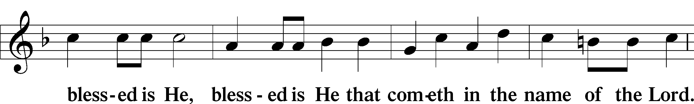
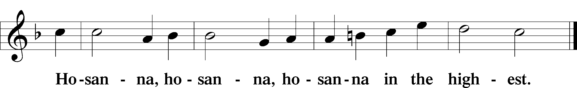

Lord’s Prayer LSB 179
P Lord, remember us in Your kingdom and teach us to pray:
C Our Father who art in heaven,
hallowed be Thy name,
Thy kingdom come,
Thy will be done on earth
as it is in heaven;
give us this day our daily bread;
and forgive us our trespasses
as we forgive those
who trespass against us;
and lead us not into temptation,
but deliver us from evil.
For Thine is the kingdom
and the power and the glory
forever and ever. Amen.

The Words of Our Lord LSB 197
P Our Lord Jesus Christ, on the night when He was betrayed, took bread, and when He had given thanks, He broke it and gave it to the disciples and said: “Take, eat; this is My T body, which is given for you. This do in remembrance of Me.”

In the same way also He took the cup after supper, and when He had given thanks, He gave it to them, saying: “Drink of it, all of you; this cup is the new testament in My T blood, which is shed for you for the forgiveness of sins. This do, as often as you drink it, in remembrance of Me.”

Pax Domini LSB 197
P The peace of the Lord be with you always.

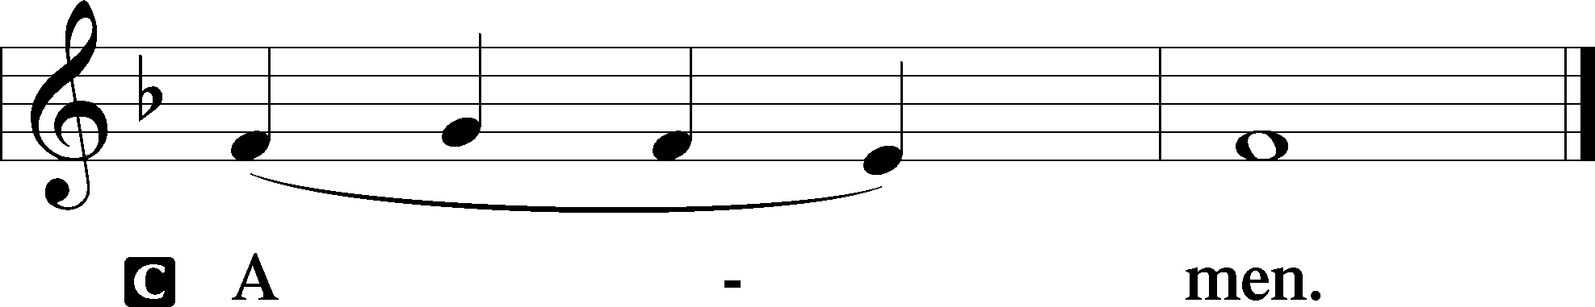

Agnus Dei LSB 198
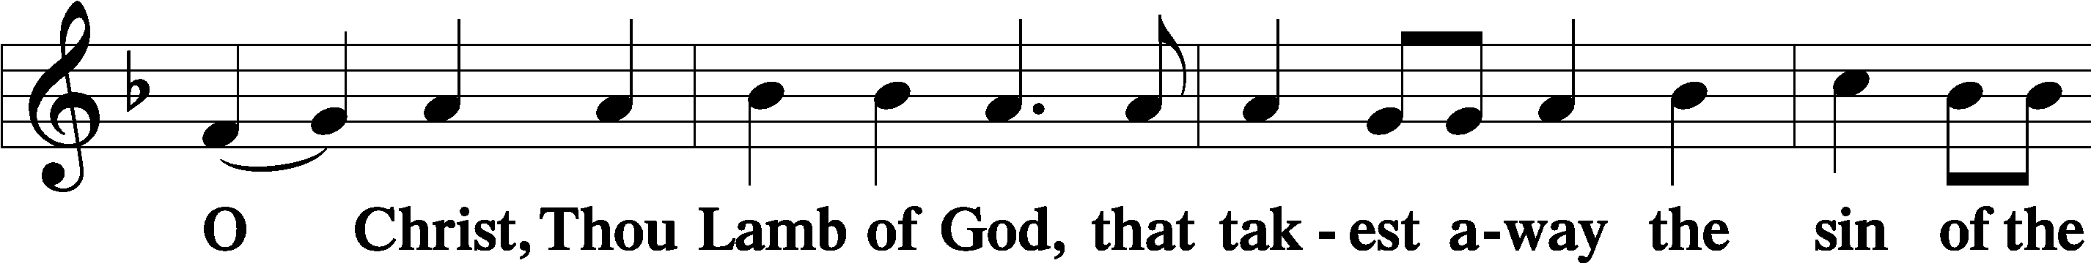
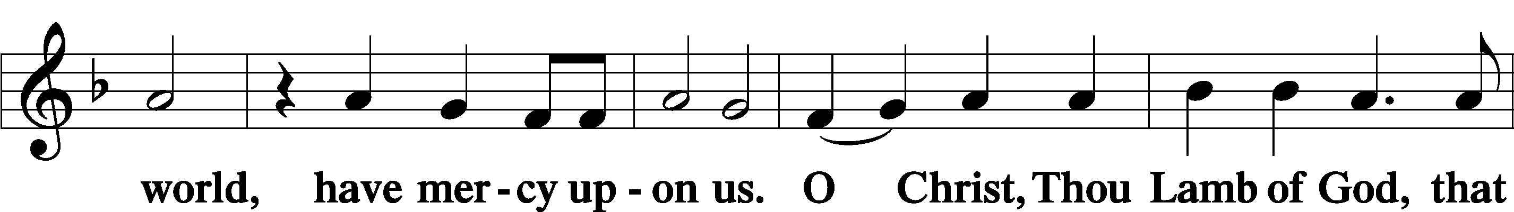
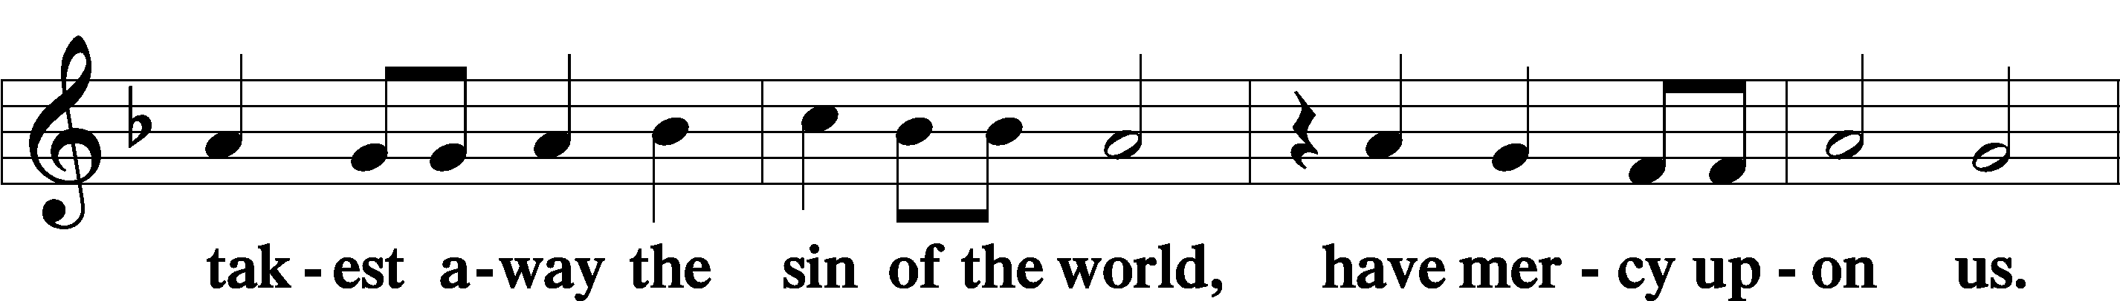
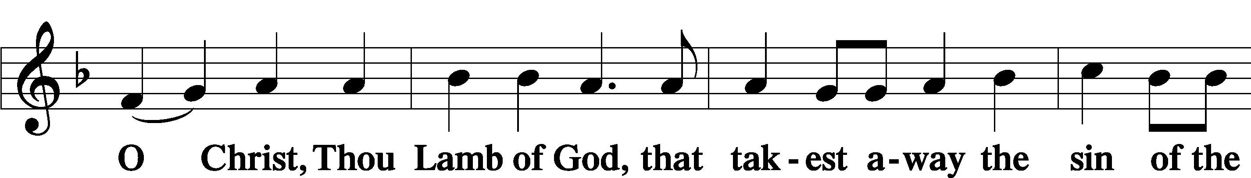
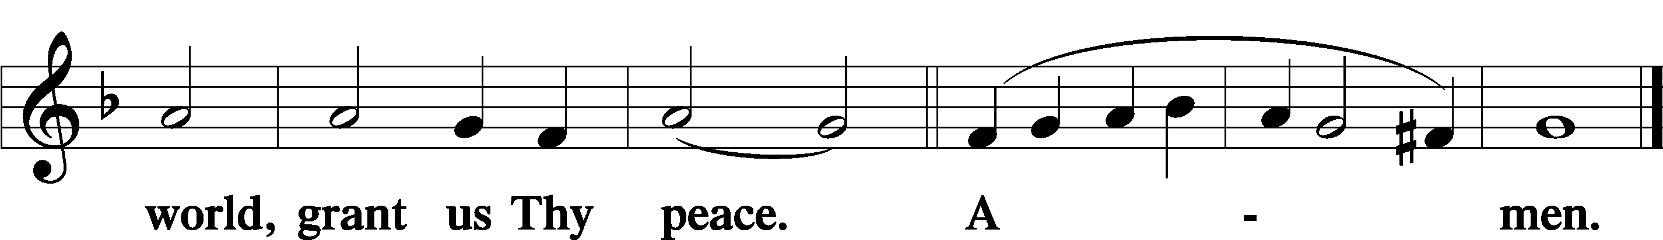

Sit

Distribution
Prior to the communion liturgy, we ask that all attendees fill out the yellow attendance card in the pew. When the usher dismisses your row to go to the altar, please hand your yellow card to the usher. Thank you!

Distribution Hymn: 763 When Peace, Like a River
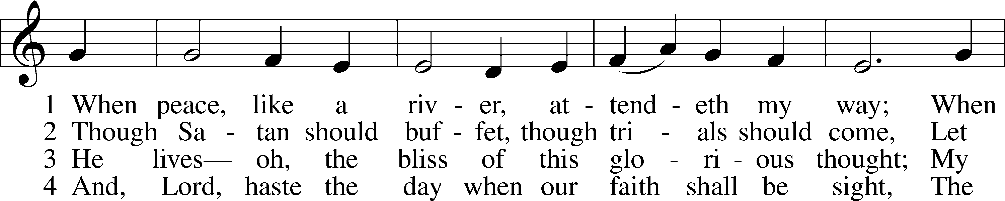
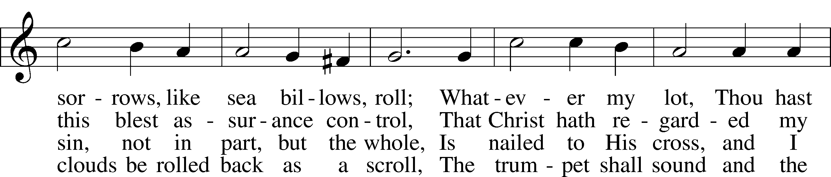
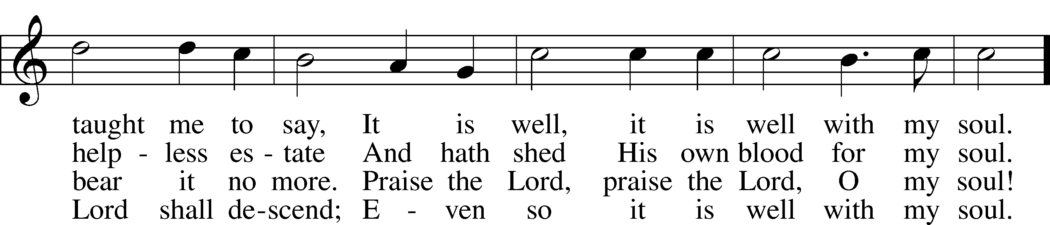
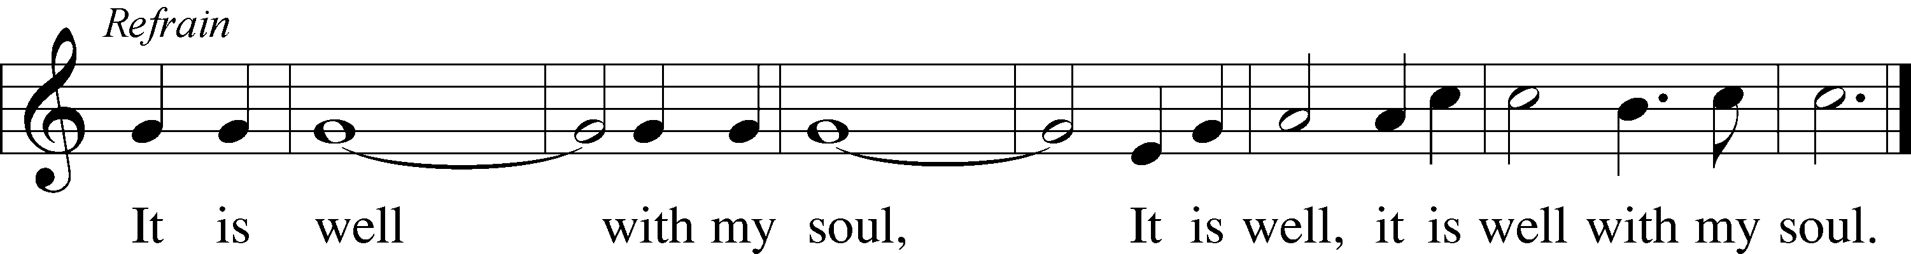
Text: Horatio G. Spafford, 1828–88, alt.
Tune: Philip P. Bliss, 1838–76
Text and tune: Public domain
The Dismissal:

P The body and blood of our Lord Jesus Christ strengthen and preserve you in body and soul to life everlasting. Depart T in peace.
C Amen.

Stand

Nunc Dimittis LSB 199
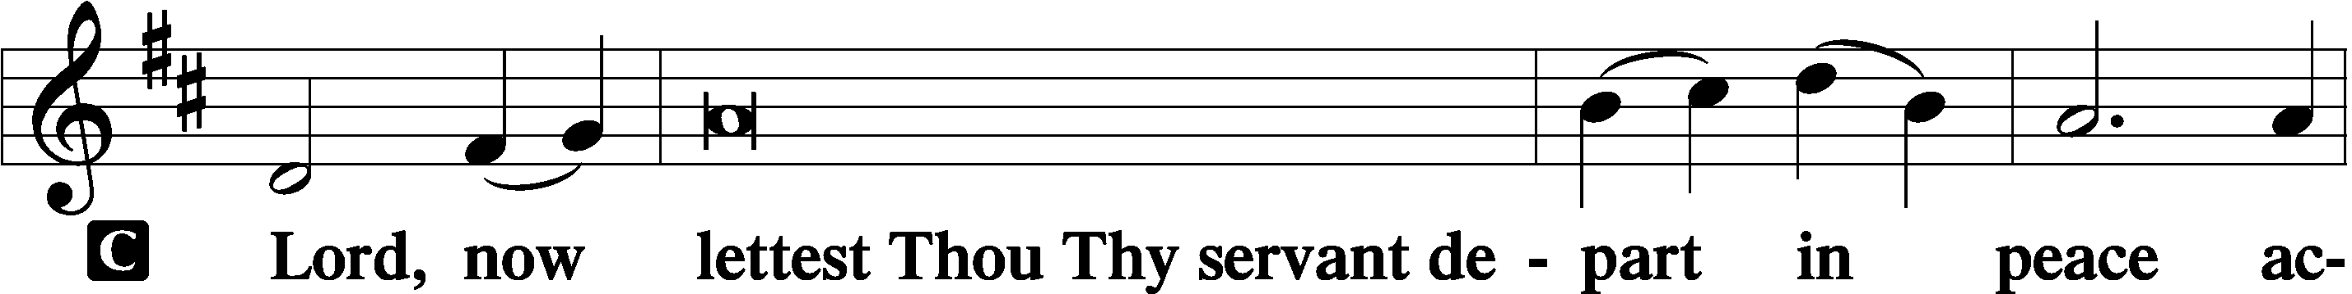
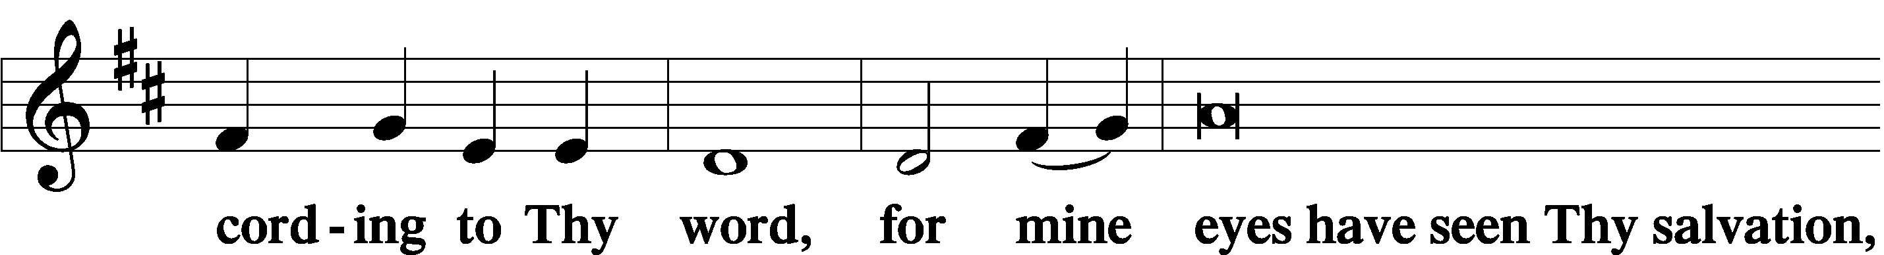
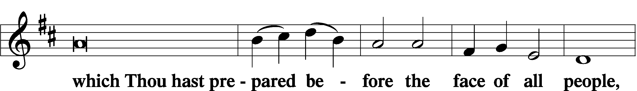
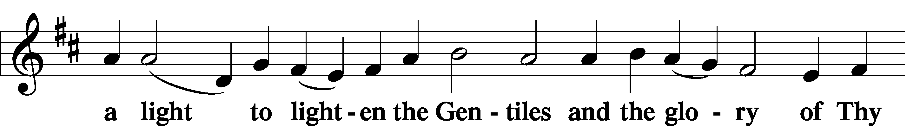
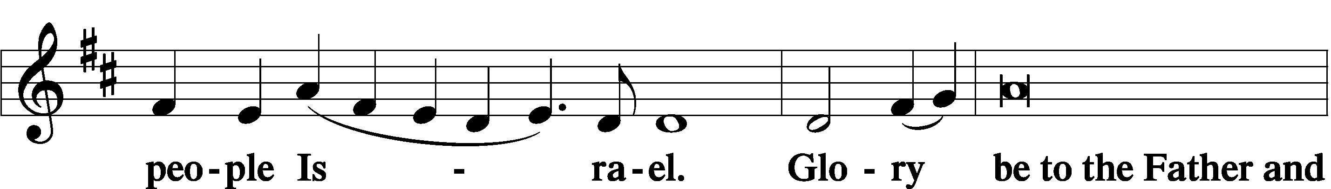
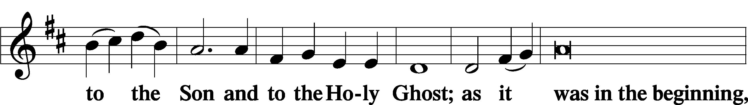
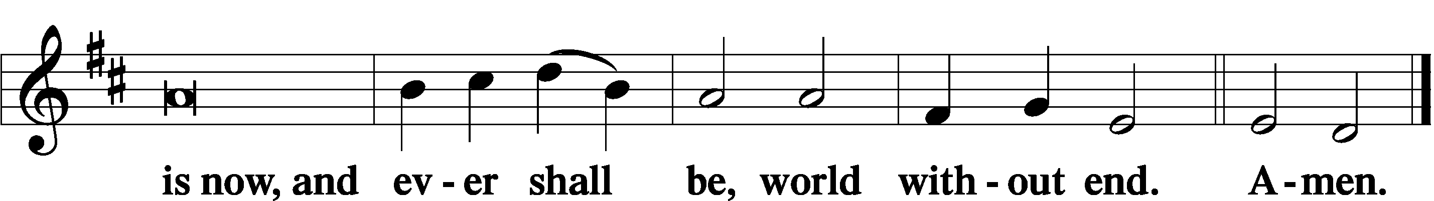

Thanksgiving LSB 200
A O give thanks unto the Lord, for He is good,

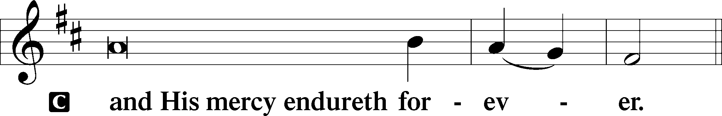

Post-Communion Collect
A Let us pray.
We give thanks to You, almighty God, that You have refreshed us through this salutary gift, and we implore You that of Your mercy You would strengthen us through the same in faith toward You and in fervent love toward one another; through Jesus Christ, Your Son, our Lord, who lives and reigns with You and the Holy Spirit, one God, now and forever.

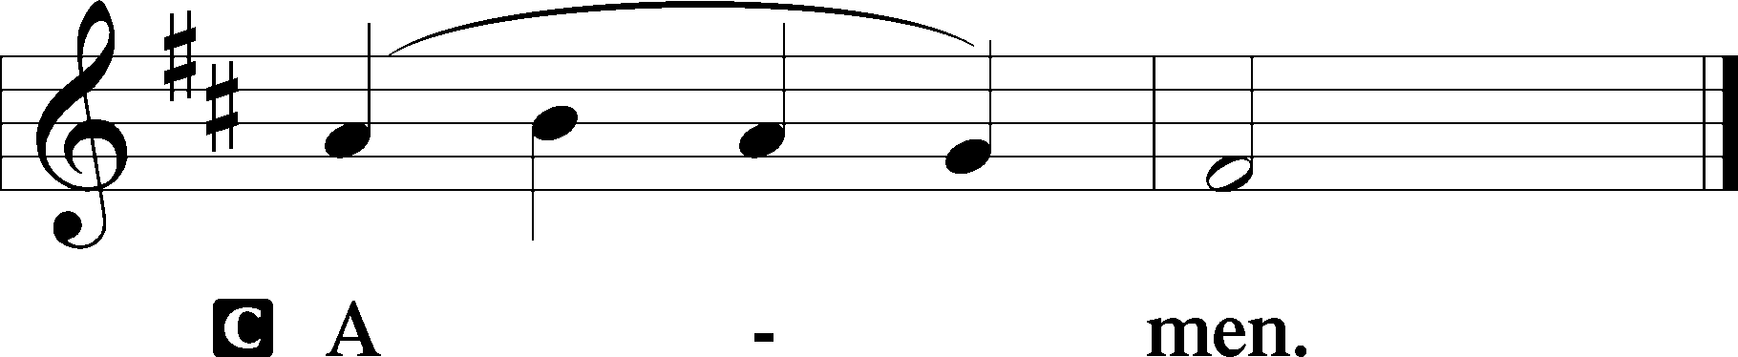

Salutation LSB 201
P The Lord be with you.

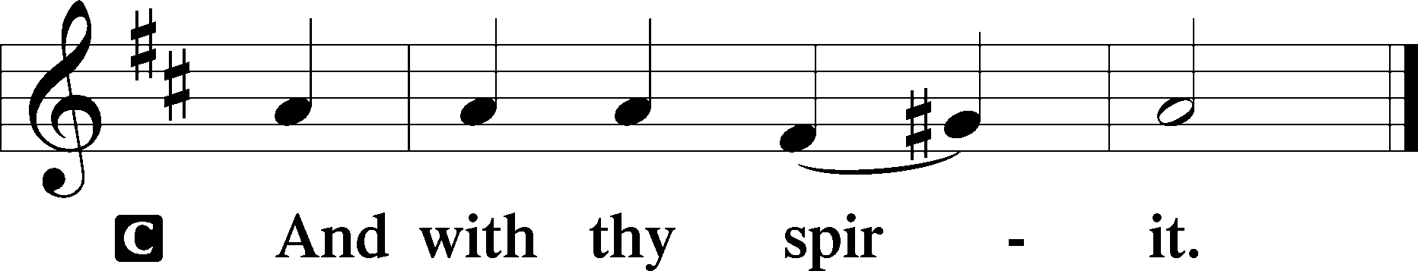

Benedicamus LSB 202
A Bless we the Lord.

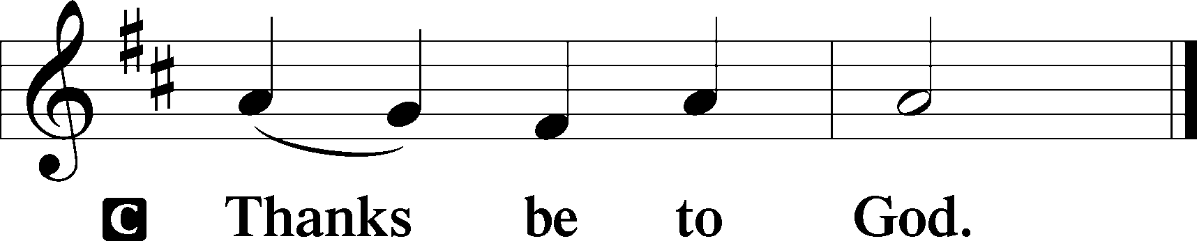

Benediction LSB 202
P The Lord bless you and keep you.
The Lord make His face shine upon you and be gracious unto you.
The Lord lift up His countenance upon you and T give you peace.
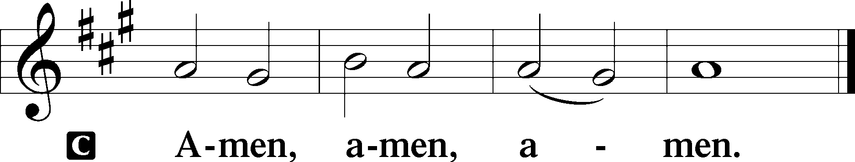

Sit

Matters of Importance

Stand

Closing Hymn: 700 Love Divine, All Loves Excelling
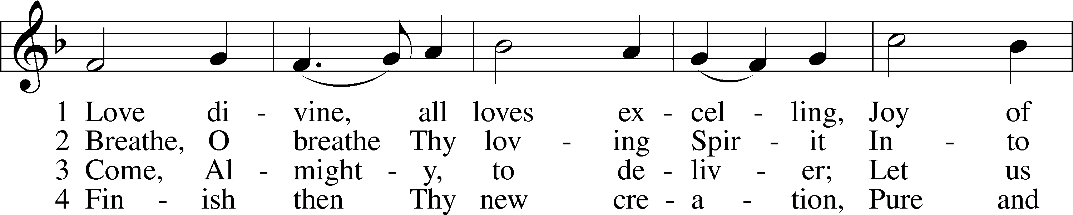
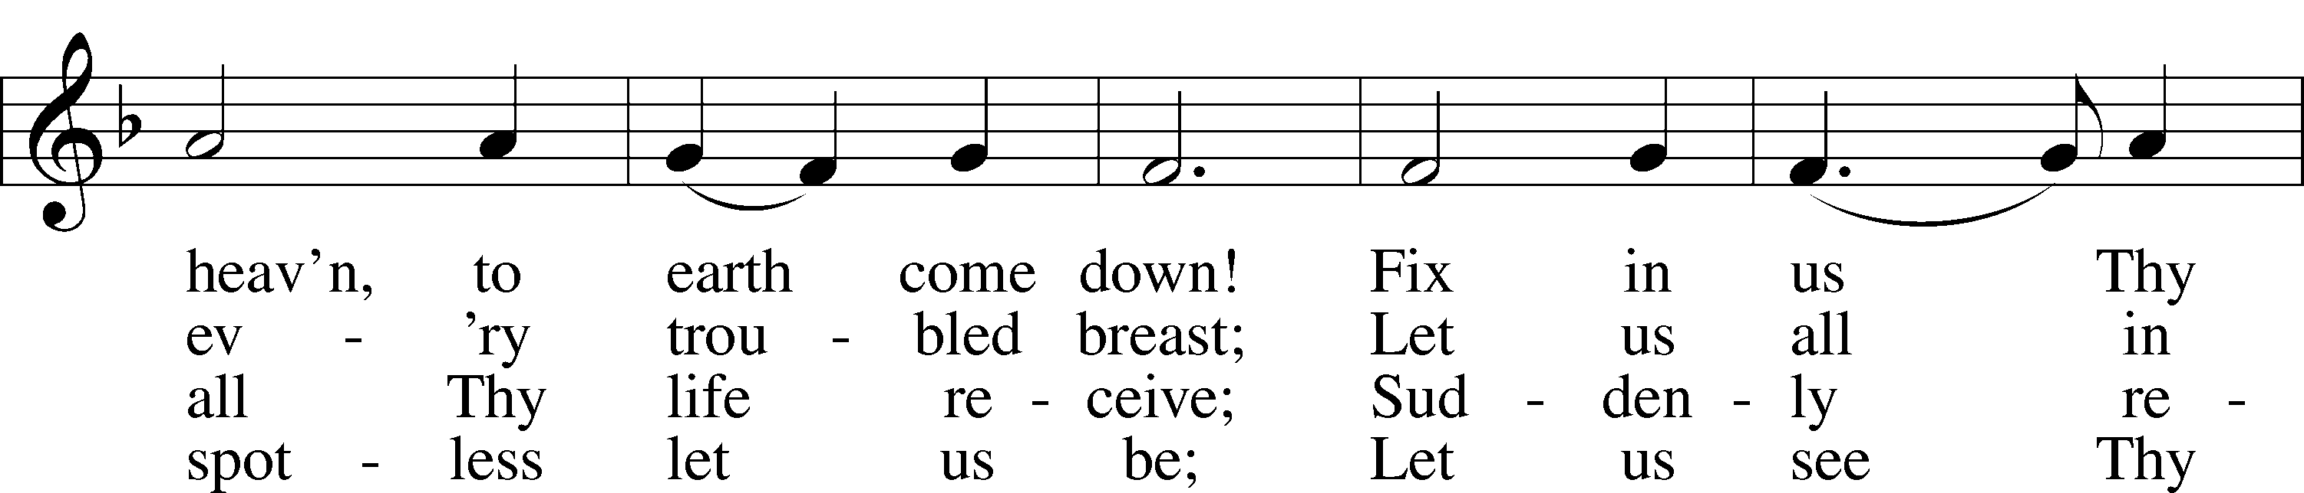
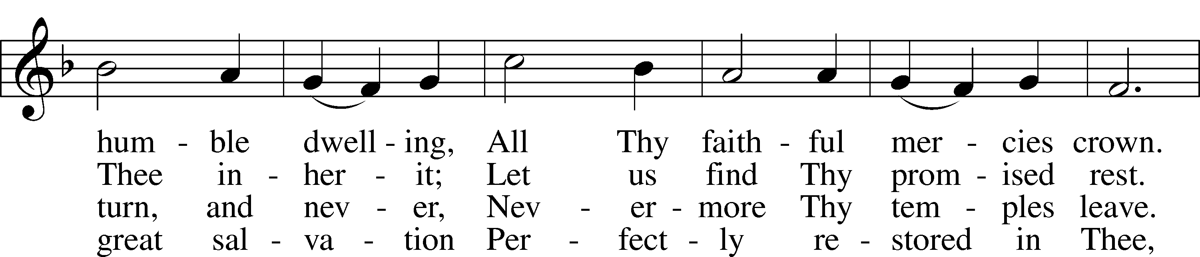
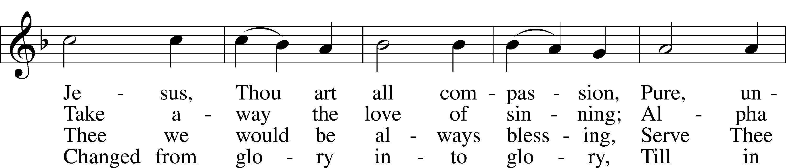
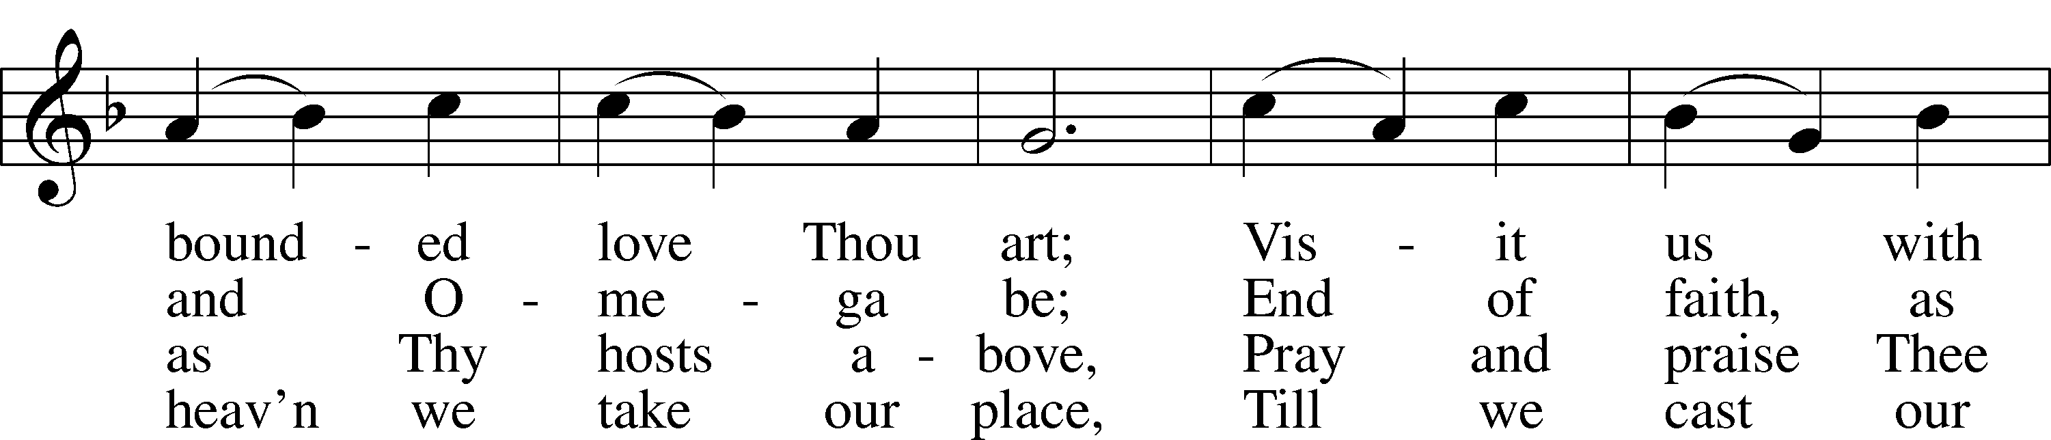
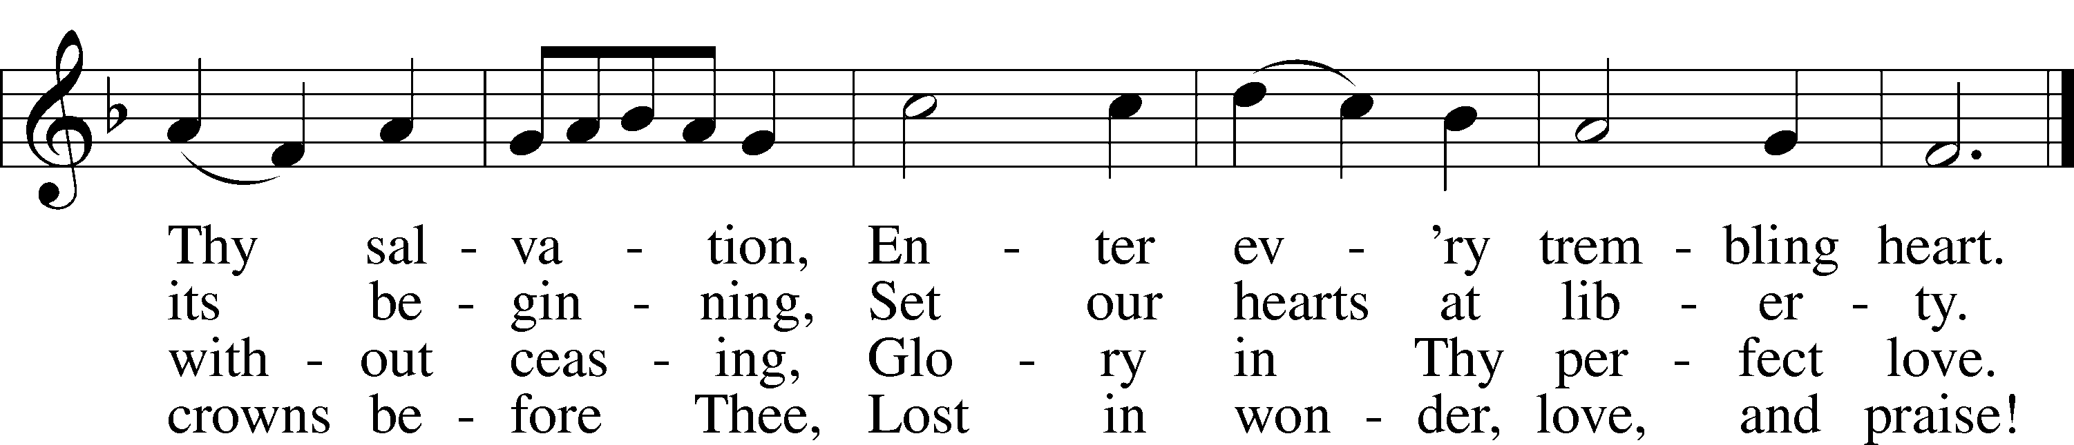
Text: Charles Wesley, 1707–88
Tune: Rowland H. Prichard, 1811–87
Text and tune: Public domain

Postlude

Acknowledgments
Divine Service, Setting Three from Lutheran Service Book
Unless otherwise indicated, Scripture quotations are from the ESV® Bible (The Holy Bible, English Standard Version®), copyright © 2001 by Crossway, a publishing ministry of Good News Publishers. Used by permission. All rights reserved.
Created by Lutheran Service Builder © 2026 Concordia Publishing House.

