

~~~TUESDAY NEWSDAY~~~
July 7, 2026
Help Support Cadence Fulfs - LCMS missionary to Belize
Cadence Fulfs, DCE intern from Concordia Seward, is preparing to serve the Lord as a missionary in Belize and St. John's would like to support her work. In Belize, Cadence will be assisting and supporting LCMS missionaries in their ongoing evangelism, education and outreach activities. She also will help local preschool teachers grow in God's Word and teach them how to disciple their students and families. Pray for Cadence as she serves in Belize for God to give her comfort, strength and guidance as she transitions to a new location, language and culture. Ask God to bless her time of learning as she serves and cares for God's people as a DCE intern and give thanks to God that Cadence is serving to spread the gospel to people in Latin America. If you would like more information and to support Cadence on her mission work financially, visit the following link: www.lcms.org/fulfs
~ Upcoming Events ~
SummerFest
Enjoy fun for all ages on Friday, July 10 from 5-7 PM at our annual SummerFest! We will have food, fellowship, inflatables and the always popular dunk tank. Enjoy some time outdoors with your St. John's family. Feel free to invite your friends and neighbors!
We could use some help for SummerFest to run smoothly!
Sign up to volunteer and donate here: https://stjohnsop.flocknote.com/signup/263918
Senior Day Trips
1. Frank Lloyd Wright's Graycliff - July 16
(Tour begins at 11:30 AM) To carpool meet at 10:45 AM.
2. Larkinville Food Trucks - Tuesday, July 21
To carpool meet at 4:30 PM. Bring a lawn chair.
Please sign up at Sign-Up Central.
Abby's Installation
On Sunday, July 19 we will be celebrating Abby's Installation as Director of Christian Education at all services. We will gather between services and would love if you could please bring treats to share. Thank you!
Save the Date
Country Night at St. John's will be on Friday, August 28.

~ Community Events ~
Eight Days of Hope - Buffalo - 2026
Come and join us to love and serve in Buffalo's South District this year from
July 18-25, alongside 1,800 other volunteers from 37 states and Canada. Gardening/ Landscaping, Painting, any construction skills or simply help us prepare food / laundry for all those workers. There is a place for everyone including Families with their children as long as you have the heart to serve. Please register to the event by clicking on "Volunteer" and "FAQ" on the following page for more information: EDOH - Buffalo 2026 - Eight Days of Hope. A minimum of 2 days is preferred. Any additional questions, contact Cecile Menard 716-430-1663.
~ Education & Ministry ~
YouVersion Bible App
Looking for a great resource to use when reading the Bible? Download the YouVersion Bible App today! https://www.youversion.com/bible-app
** ADULT EDUCATION & MINISTRY **
Gardening Angels
We will meet Tuesday evenings from 6:30 - 8:00 PM and Friday mornings from 9:00-10:30 AM. We garden for 1 hour and meet for a short devotion and fellowship time. Please contact Diane Hagelin 716-374-5219 if you are interested. We do not meet when it is raining, too hot or if there is no weeding to be done. I contact everyone through text or phone call to let you know if we cancel, so let me know if you are interested so I can contact you.
We welcome you to join in either Tuesdays or Fridays whenever you can!
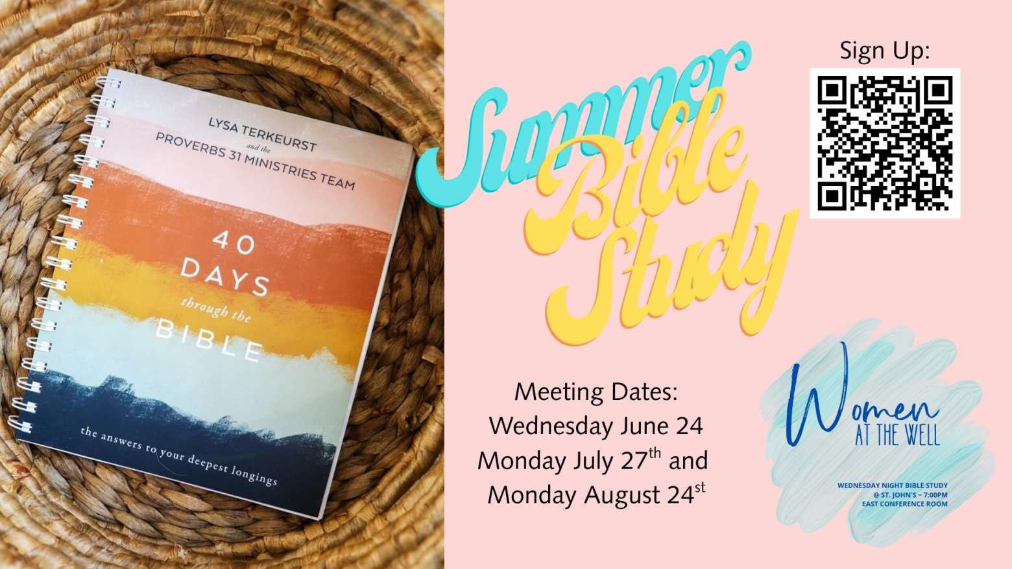
Tuesday Night Men’s Group
We will meet on July 7 & 21 at 7:00 PM.
Anyone who is interested in joining the group is more than welcome!
Questions? Please contact Sean Clifford at sean@stjohnsop.com
Women’s Bible Study
We will resume in September.
Questions? Contact Andrea Smith at 716-983-9169 or andrea@stjohnsop.com
Pastor Mike's Bible Class
We will resume in September.
Laurie's Knitting & Sewing Ministry.
We will resume on Tuesday, September 8 at 6:00 PM.
Women’s Discipleship Group
We will meet again on September 13 at 11:00 AM with a new study and continue to meet monthly on the first Sunday of the month.
We will be doing a study entitled RAHAB, Rediscovering the God Who saves me by Shadia Hrichi. The study books are available on Amazon.
If you have any questions or want me to order the book for you contact Diane Hagelin at 716-374-5219. All ladies are welcome to join us in September. This study will continue through March.
** HIGH SCHOOL & MIDDLE SCHOOL MINISTRY **


~ Prayer List ~
When filling out the prayer card please be sure to mark whether prayer request should be kept confidential OR included in the Tuesday Newsday & bulletin. If neither are marked then it will be kept confidential.
Our Church Family
June Meissner: awaiting hip surgery
Jane Roesser: rehab. following back surgery
Cyndie Smith: recovering from heart surgery
Our Family and Friends
Susan Schutte: recovering from surgery
Those with Health Concerns: Andrea Timmons
Those with Cancer: Kathleen Tuttle, Betsy M., Joanne, Chuck, Lori, Mary Beth, Kristi Krupp, Henry Fieldsa, Denise Crane, Pam, Joey, Bob,
Dennis Burgwardt, Pat Fournier, Danielle
Military: Aaron (Air Force pilot deployed to Middle East), Ethan, Benjamin Geblein, Alec Hoch, Tyler Vargo, Justin Snyder
*Prayer requests will remain on the list for three weeks unless otherwise noted in the prayer request.
*Please resubmit names to Dawn Sauda as needed if they have been removed.
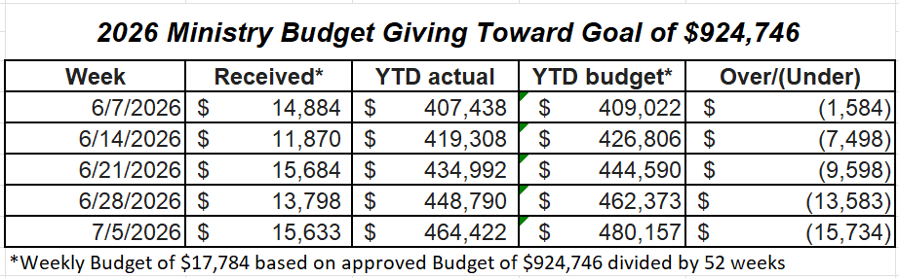

~~~~~~~~~~~~~~
Worship Attendance Report

July 4, 4:00 PM ~ 12 people

July 5, 8:00 AM ~ 40 people
July 5, 9:30 AM ~ 140 people
July 5, 11:00 AM ~ 93 people

~~~~~~~~~~~~~~

~On-Going Information~
Green Bins
Green Bin donations are paused until further notice. In the future, Mary Ellen Ferguson will be contacting other organizations to see if we can continue this out reach ministry. We will keep you posted.
Coupons
We will NOT be collecting coupons anymore. Please recycle at home. FYI - Please continue to leave new cards and calendars.
Flowers on the Altar
If you are interested in purchasing flowers for the altar in memory of a loved one, to celebrate an anniversary, etc. you can do so by signing up at Sign-up Central in the Lobby or emailing Dawn Sauda at dawn@stjohnsop.com. The cost is $15.00.
Praise Reports
If you have any praises that you would like to share with the church please feel free to send them to Dawn at dawn@stjohnsop.com
**Weddings, births, Dean's list, anything that brings joy and you'd like to share.
Shut-in/Unable to attend worship
If you are aware of anyone who is unable to attend worship and would appreciate a pastoral visit and at-home Holy Communion please contact Pastor Mike (mike@stjohnsop.com or 716-713-7305) or June Meissner (716-648-4062).
Please make sure we have up-to-date information on how to contact them.
House Blessing
Have you recently moved into a new home or simply desire to have your home blessed? Pastor Mike is happy to come to your house and bless each room with you or your family. Contact Pastor Mike at Mike@stjohnsop.com if you are interested or would like more information.
Need to talk to a Pastor?
If you would like to have a phone conversation and prayers with Pastor Mike about family illness, isolation, employment concerns, fear of the future or any other issues, send a message using the Pastoral Care Request link on the St. John's website. Please include the best phone number at which you can be reached and any days or times that are best for you.
Loved by Jesus. Sent to Others.

