

~~~TUESDAY NEWSDAY~~~
July 28, 2026
Help Support Cadence Fulfs - LCMS missionary to Belize
Cadence Fulfs, DCE intern from Concordia Seward, is preparing to serve the Lord as a missionary in Belize and St. John's would like to support her work. In Belize, Cadence will be assisting and supporting LCMS missionaries in their ongoing evangelism, education and outreach activities. She also will help local preschool teachers grow in God's Word and teach them how to disciple their students and families. Pray for Cadence as she serves in Belize for God to give her comfort, strength and guidance as she transitions to a new location, language and culture. Ask God to bless her time of learning as she serves and cares for God's people as a DCE intern and give thanks to God that Cadence is serving to spread the gospel to people in Latin America. If you would like more information and to support Cadence on her mission work financially, visit the following link: www.lcms.org/fulfs

Please feel free to order from the Amazon wish list or
choose from the items on the bulletin board in the Narthex.

~ Upcoming Events ~



Country Night
Join us Friday, August 28 for an evening of fellowship geared towards adults with live country music from local band Noah Lee & the Stetsons, BBQ, line dancing and fun! Tickets are $25 a person and include live entertainment, food and drinks.
This is a great event to gather and enjoy time with your St. John's family, but it is also a great way to invite friends and family to get introduced to the community at
St. John's and experience the love of Jesus. If you have guests who don't attend St. John's you'd like to attend with you, let us know and we can provide tickets at no charge. Purchase tickets between services or by signing up here: https://stjohnsop.com/events/large-event-tickets
** ADULT EDUCATION & MINISTRY **

Gardening Angels
We will meet Tuesday evenings from 6:30 - 8:00 PM and Friday mornings from 9:00-10:30 AM. We garden for 1 hour and meet for a short devotion and fellowship time. Please contact Diane Hagelin 716-374-5219 if you are interested. We do not meet when it is raining, too hot or if there is no weeding to be done. I contact everyone through text or phone call to let you know if we cancel, so let me know if you are interested so I can contact you.
We welcome you to join in either Tuesdays or Fridays whenever you can!

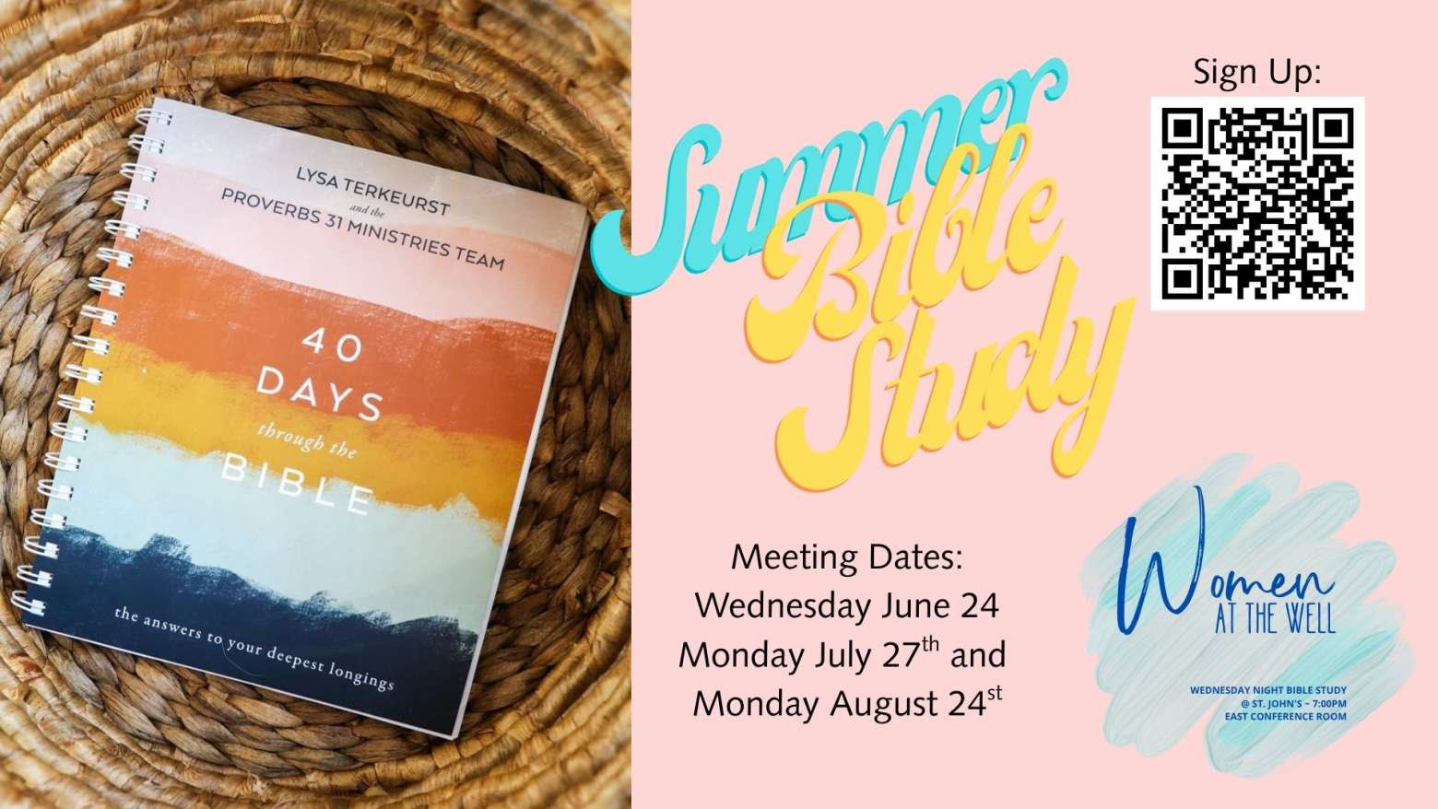
Tuesday Night Men’s Group
We will meet on August 5 & 19 at 7:00 PM.
Anyone who is interested in joining the group is more than welcome!
Questions? Please contact Sean Clifford at sean@stjohnsop.com
Gospel Moms
Join us for prayer, fellowship, and Gospel-focused discussion. Children welcome!
August 13 at 10:30 AM in the nursery.
Women’s Bible Study
We will resume in September.
Questions? Contact Andrea Smith at 716-983-9169 or andrea@stjohnsop.com
Pastor Mike's Bible Class
We will resume in September.
Laurie's Knitting & Sewing Ministry.
We will resume on Tuesday, September 8 at 6:00 PM.
Women’s Discipleship Group
We will meet again on September 13 at 11:00 AM with a new study and continue to meet monthly on the first Sunday of the month.
We will be doing a study entitled RAHAB, Rediscovering the God Who saves me by Shadia Hrichi. The study books are available on Amazon.
If you have any questions or want me to order the book for you contact Diane Hagelin at 716-374-5219. All ladies are welcome to join us in September. This study will continue through March.


~ Prayer List ~
When filling out the prayer card please be sure to mark whether prayer request should be kept confidential OR included in the Tuesday Newsday & bulletin. If neither are marked then it will be kept confidential.
Our Church Family
Leslee Hartwig & Family: prayers for peace & comfort following Ken's passing
Lynn Syprell: healing
Halsey VanLew: health issues
Our Family and Friends
Ray, Bob, & Terry: serious health concerns
The Bleecher Family: prayers for peace & comfort following Danielle's passing
Betsy Rahill Regan: new baby
Those with Health Concerns: Andrea Timmons
Those with Cancer: Kathleen Tuttle, Betsy M., Joanne, Chuck, Lori, Mary Beth, Kristi Krupp, Henry Fieldsa, Pam, Joey, Bob, Dennis Burgwardt,
Pat Fournier
Military: Aaron (Air Force pilot deployed to Middle East), Ethan, Benjamin Geblein, Alec Hoch, Tyler Vargo, Justin Snyder
*Prayer requests will remain on the list for three weeks unless otherwise noted in the prayer request.
*Please resubmit names to Dawn Sauda as needed if they have been removed.
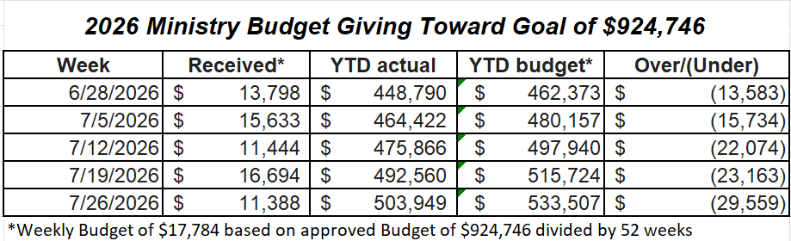

~On-Going Information~
Green Bins
Please consider helping FISH of East Aurora and Bread of Life. They would be extremely grateful for your donations.
FISH of East Aurora - 960 East Main, East Aurora, NY 14052. (716) 652-7272 Donation times: Tuesday & Thursday, 9am-noon and first Saturday of each month, 10am-noon. Note - They run a food pantry and give the clothing/household items away for free.
Bread Of Life Outreach Center - 8745 Supervisor Ave., Colden, NY 14033.
(716) 941-3550
Donation Times: Tuesday, 10am-4pm, Wednesday, 10am-4pm, Thursday, 2pm-7pm, Friday, 10am-4pm, Saturday, 9am-2pm. Gabe's on the Hill Thrift Shoppe.
Note - Bread of Life runs a food pantry along with their thrift shop which sells donations. This money is put back into the food pantry to buy food they run out of such as: pasta, peanut butter, cereal etc.
Cards & Calendars
Please continue to leave new cards and calendars in the baskets on the wall in the lobby.
Flowers on the Altar
If you are interested in purchasing flowers for the altar in memory of a loved one, to celebrate an anniversary, etc. you can do so by signing up at Sign-up Central in the Lobby or emailing Dawn Sauda at dawn@stjohnsop.com. Please sign up by the Sunday prior. The cost is $15.00.
Praise Reports
If you have any praises that you would like to share with the church please feel free to send them to Dawn at dawn@stjohnsop.com
**Weddings, births, Dean's list, anything that brings joy and you'd like to share.
Shut-in/Unable to attend worship
If you are aware of anyone who is unable to attend worship and would appreciate a pastoral visit and at-home Holy Communion please contact Pastor Mike (mike@stjohnsop.com or 716-713-7305) or June Meissner (716-648-4062).
Please make sure we have up-to-date information on how to contact them.
House Blessing
Have you recently moved into a new home or simply desire to have your home blessed? Pastor Mike is happy to come to your house and bless each room with you or your family. Contact Pastor Mike at Mike@stjohnsop.com if you are interested or would like more information.
Need to talk to a Pastor?
If you would like to have a phone conversation and prayers with Pastor Mike about family illness, isolation, employment concerns, fear of the future or any other issues, send a message using the Pastoral Care Request link on the St. John's website. Please include the best phone number at which you can be reached and any days or times that are best for you.
Loved by Jesus. Sent to Others.

