

~~~TUESDAY NEWSDAY~~~
June 2, 2026
Graduation Slide Show
Once again we will have a slide show celebrating our high school and college graduates. Please send your child's name, where they graduated from and what their future plans are, along with picture of when they were younger & a current one. Please send everything to Andrea Smith at andrea@stjohnsop.com by June 14.
Engagement with the Bible Form
Thank you to those of you who filled out the following form during church yesterday about your engagement with the Bible! If you haven't filled it out yet, please do so as soon as possible so that we can get more information for future planning regarding the Bible! https://forms.gle/ZqtvoXNLAa3MSLYj6
Monthly Birthday Lists
Moving forward please see the bulletin boards in the narthex and the lobby for a full listing of monthly birthdays.
YouVersion Bible App
Looking for a great resource to use when reading the Bible? Download the YouVersion Bible App today! https://www.youversion.com/bible-app
Summer Worship schedule
Our Saturday & Sunday worship times will remain the same for the summer months.

~Upcoming Events~
Voters Meeting
Join us on Sunday, June 7 following the 11:00 AM service for a quick Voters Meeting as we prepare to call Abby as our full time Director of Christian Education.
Hauan Dinner
Gather together on Wednesday, June 17 from 5:30-7:30 PM for an evening of fellowship and food as we host Eric Hauan (past St. John's Vicar) and high school students from his congregation who will be in the area on a service trip at Camp Pioneer. Sign up here to help us plan for headcount and to bring beverages, sides and desserts: https://stjohnsop.flocknote.com/signup/258729
Senior Potluck
Our last potluck lunch until September will be held on June 29.
Please sign up at Sign-Up Central.
Senior Day Trip **DATE CHANGE**
Frank Lloyd Wright's Graycliff
NEW DATE - July 16 (Tour begins at 11:30 AM)
RSVP - $25 due to Pastor Mike by June 28.
Please sign up at Sign-Up Central.

~ Community Events ~

Connor Cared – Walk with Purpose The Connor Cared Hike for Mental Wellness will take place at Chestnut Ridge Park on Sunday, June 14 from 10:00 AM – 2:00 PM. The low impact hike will have educational & reflection stops along the route, as well as opportunities for interaction with local mental health and wellness resources. There will be activities to promote wellness practices & coping strategies.
For more information or to register you can visit:
connorcared.com or contact wecaretoo@connorcared.com. Feel free to reach out to Pastor Nate at nate@stjohnsop.com with inquiries as well.

Eight Days of Hope - Buffalo - 2026
Come and join us to love and serve in Buffalo's South District this year from
July 18-25, alongside 1,800 other volunteers from 37 states and Canada. Gardening/ Landscaping, Painting, any construction skills or simply help us prepare food / laundry for all those workers. There is a place for everyone including Families with their children as long as you have the heart to serve. Please register to the event by clicking on "Volunteer" and "FAQ" on the following page for more information: EDOH - Buffalo 2026 - Eight Days of Hope. A minimum of 2 days is preferred. Any additional questions, contact Cecile Menard 716-430-1663.

~Education & Ministry~

** ADULT EDUCATION & MINISTRY **
Gardening Angels
We will meet Tuesday evenings from 6:30 - 8:00 PM and Friday mornings from 9:00-10:30 AM. We garden for 1 hour and meet for a short devotion and fellowship time. Please contact Diane Hagelin 716-374-5219 if you are interested. We do not meet when it is raining, too hot or if there is no weeding to be done. I contact everyone through text or phone call to let you know if we cancel, so let me know if you are interested so I can contact you.
We welcome you to join in either Tuesdays or Fridays whenever you can!
Women’s Bible Study
We will resume in September.
Questions? Contact Andrea Smith at 716-983-9169 or andrea@stjohnsop.com
Tuesday Night Men’s Group
We will meet on June 2 & 16 at 7:00 PM.
Anyone who is interested in joining the group is more than welcome! Questions? Please contact Sean Clifford at sean@stjohnsop.com
Gospel Moms
Join us for prayer, fellowship, and Gospel focused discussion. Children welcome!
June 4 and 18 at 10:30 AM, in the nursery.
Women’s Discipleship Group
We will have a devotion and salad luncheon on Sunday, June 7 from 11:00-12:30 PM. We will meet in the basement room. It will be our last get together until Fall on Sunday, September 13 at 1100 AM.
Laurie's Knitting & Sewing Ministry
We will meet on June 9 at 6:00 PM.
That will be the last meeting until Tuesday, September 8 at 6:00 PM.
Pastor Mike's Bible Class
Our last class until September will be June 15.
Women at the Well
April 8 - June 10 at 7:00 PM


** HIGH SCHOOL & MIDDLE SCHOOL MINISTRY **
2:42 Parent Evaluations
Please take a few minutes to fill out the anonymous evaluation of 2:42 & the youth events provided throughout the year.
Middle School Parents: https://forms.gle/L2o36rMNFeWehumQ8
High School Parents: https://forms.gle/wycyiyza3B4jirmD6

**Please contact Abby by Sunday, June 14 if your youth wants to participate.**


The signup deadline for this event at Trinity is June 18.
Contact Abby (abby@stjohnsop.com) for more details

** HIGH SCHOOL MINISTRY **
Young Life "Club"
Every Tuesday at 7:30 PM. This is a time of fellowship, games, and learning more about who Jesus is. Locations vary.
Please contact Young Life leader, Jack Rosen (716)-547-5078 for more information.
Young Life "Campaigners"
Every Friday at 6:21 AM. This is a time devoted to studying God's Word, engaging in discussions, and praying together, led by one of the Young Life leaders.
Please contact Young Life leader, Grace Shaw (276)-768-0849 for more information.
** MIDDLE SCHOOL MINISTRY **


**Dinner & dessert provided! Please just bring a towel.**

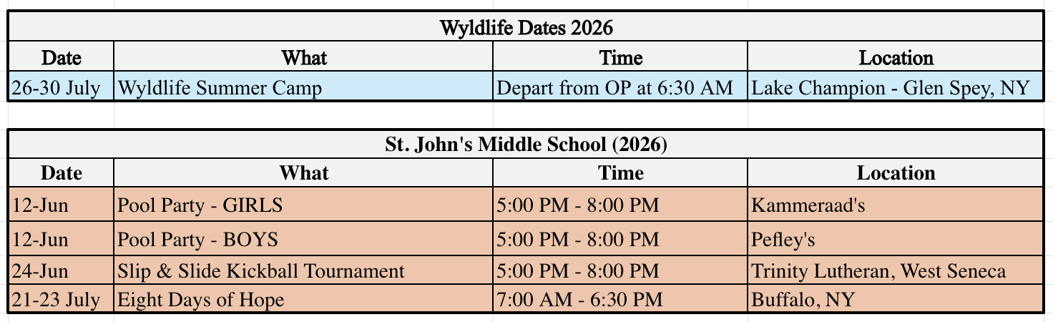
** YOUTH MINISTRY **



~Prayer List~
Our Church Family
Becky McKeon: continued healing
Our Family and Friends
Cartmill Family & Friends: sudden loss of husband, father, friend
Billy Yager: breathing issues Dave Witkowski: cancer
Those with Health Concerns: Andrea Timmons
Those with Cancer: Kathleen Tuttle, Betsy M., Joanne, Chuck, Lori, Mary Beth, Kristi Krupp, Henry Fieldsa, Denise Crane, Pam, Joey, Bob, Dennis Burgwardt,
Pat Fournier, Danielle
Military: Aaron (Air Force pilot deployed to Middle East), Ethan, Benjamin Geblein, Alec Hoch, Tyler Vargo, Justin Snyder
*Prayer requests will remain on the list for three weeks unless otherwise noted in the prayer request.
*Please resubmit names to Dawn Sauda as needed if they have been removed.
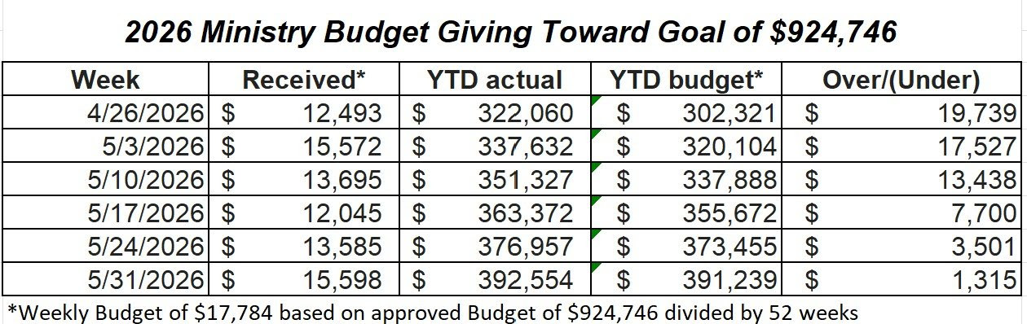

~~~~~~~~~~~~~~
Worship Attendance Report

May 30, 4:00 PM ~ 24 people

May 31, 8:00 AM ~ 57 people
May 31, 9:30 AM ~ 149 people
May 31, 11:00 AM ~ 121 people

~~~~~~~~~~~~~~

~On-Going Information~
Green Bins
Green Bin donations are paused until further notice. In the future, Mary Ellen Ferguson will be contacting other organizations to see if we can continue this out reach ministry. We will keep you posted.
Coupons
Please continue to bring in your coupons from the newspaper and BJ's booklets. Place them in the basket hanging on the wall near the coffee counter.
**I am unable to accept any expired coupons.**
Flowers on the Altar
If you are interested in purchasing flowers for the altar in memory of a loved one, to celebrate an anniversary, etc. you can do so by signing up at Sign-up Central in the Lobby or emailing Dawn Sauda at dawn@stjohnsop.com. The cost is $15.00.
Praise Reports
If you have any praises that you would like to share with the church please feel free to send them to Dawn at dawn@stjohnsop.com
**Weddings, births, Dean's list, anything that brings joy and you'd like to share.
Shut-in/Unable to attend worship
If you are aware of anyone who is unable to attend worship and would appreciate a pastoral visit and at-home Holy Communion please contact Pastor Mike (mike@stjohnsop.com or 716-713-7305) or June Meissner (716-648-4062).
Please make sure we have up-to-date information on how to contact them.
House Blessing
Have you recently moved into a new home or simply desire to have your home blessed? Pastor Mike is happy to come to your house and bless each room with you or your family. Contact Pastor Mike at Mike@stjohnsop.com if you are interested or would like more information.
Need to talk to a Pastor?
If you would like to have a phone conversation and prayers with Pastor Mike about family illness, isolation, employment concerns, fear of the future or any other issues, send a message using the Pastoral Care Request link on the St. John's website. Please include the best phone number at which you can be reached and any days or times that are best for you.
Loved by Jesus. Sent to Others.

