Monthly Publication Volume 7, Issue 5 December, 2019
Our Mission: Love God, Love & Serve Others, Make Disciples of Jesus Christ

THE ANNOUNCER is a publication of Christ Church United Methodist, 5109 Washington Ave., Racine, WI 53406
Christ Church United Methodist - Phone 262-632-1607, Fax 262-632-1609

www.christchurchracine.com, E-Mail address: christcumc@gmail.com

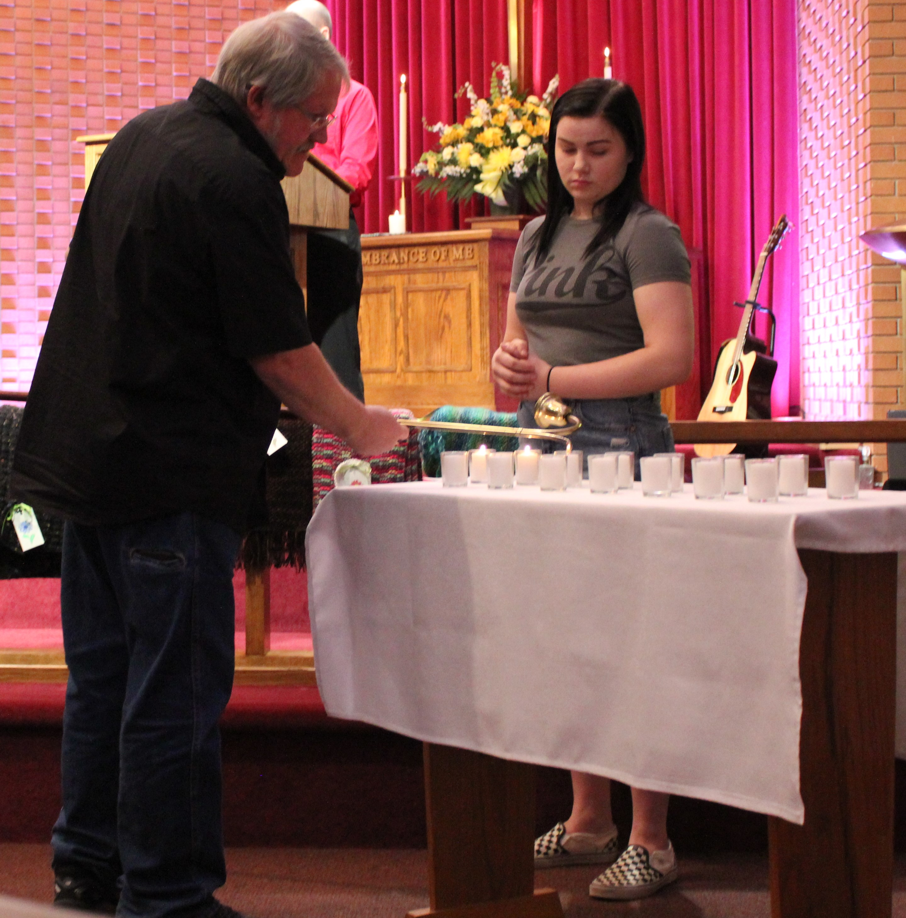

On Nov.10 we remembered those who died in this past year and lit candles for them as we gave God thanks for their lives.

Christmas Caroling December 18th at 6:00 p.m.
We will meet at church and travel to a local care facility.

Christmas Eve Services December 24
10:30 a.m. (Scripture & songs)
4:00-5:15 p.m. (Scripture & songs, kid’s nativity & candlelight).

Worship Services
Typically, two styles of worship, Traditional at 9:00 a.m. and Contemporary at 10:30 a.m.
Communion is typically offered on the first Sunday each month. Professional childcare is offered during each worship time. Plan to stay or come early for refreshments and fellowship between services.

Praise Reports

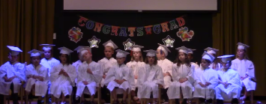
Our faith formation classes help kids turn Bible information into life transformation!
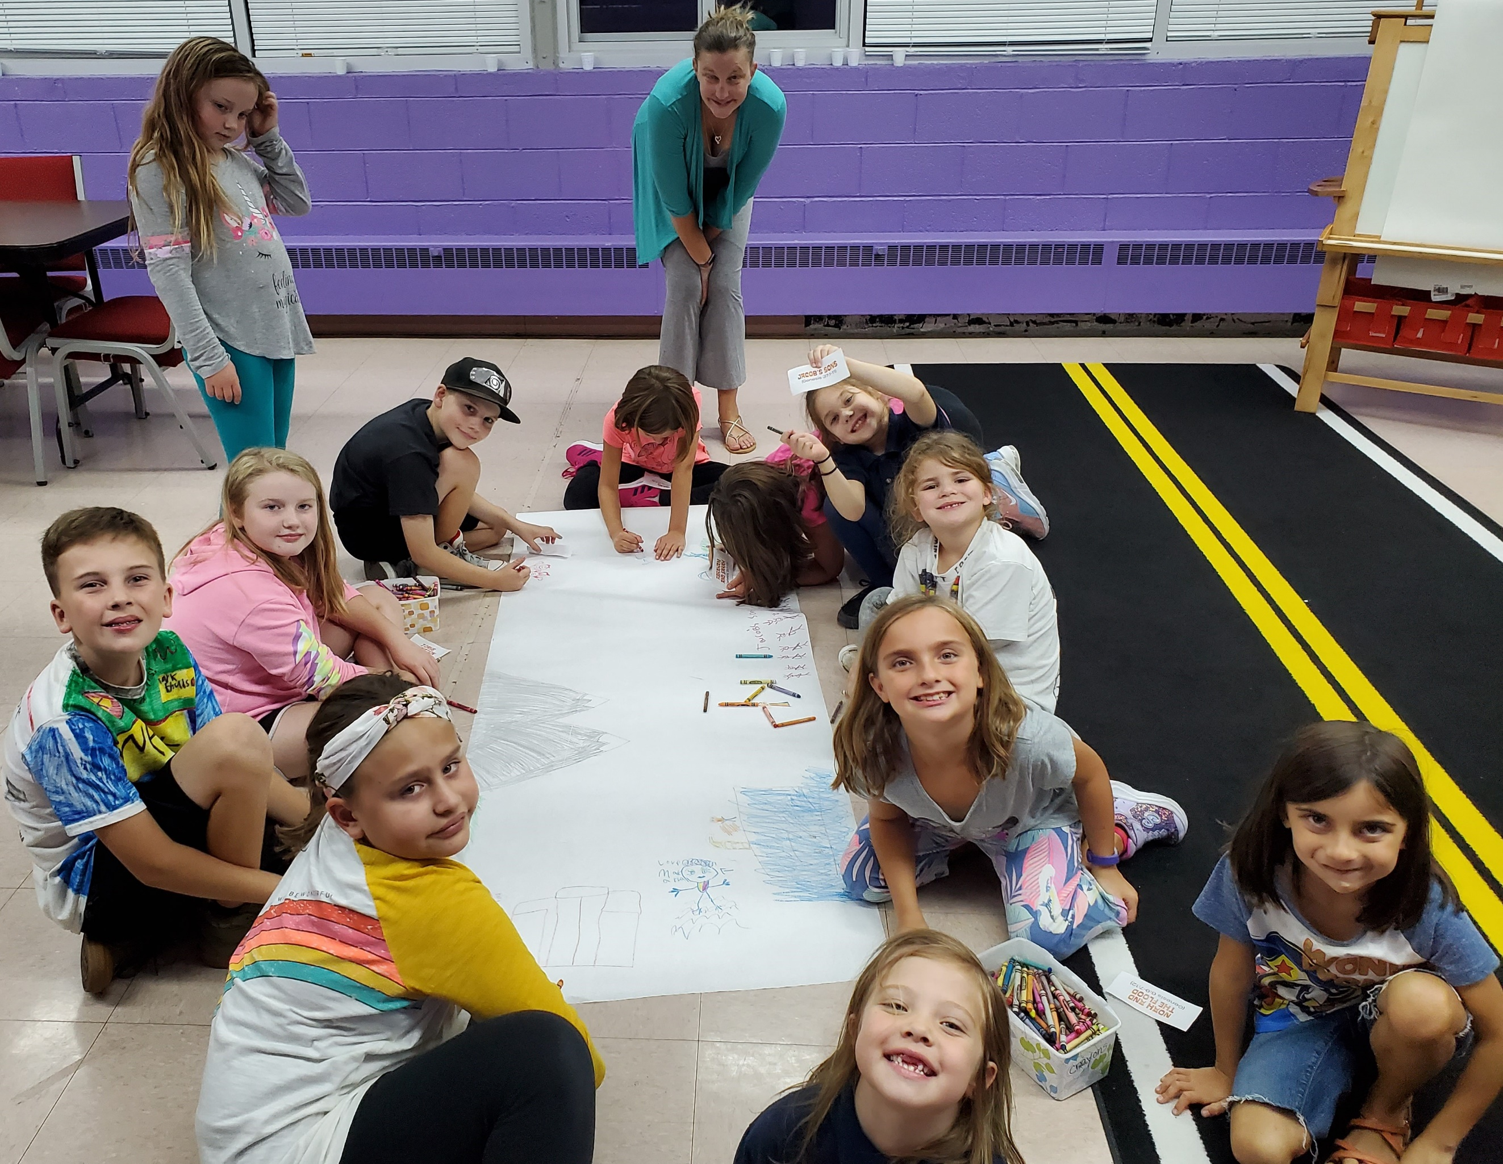
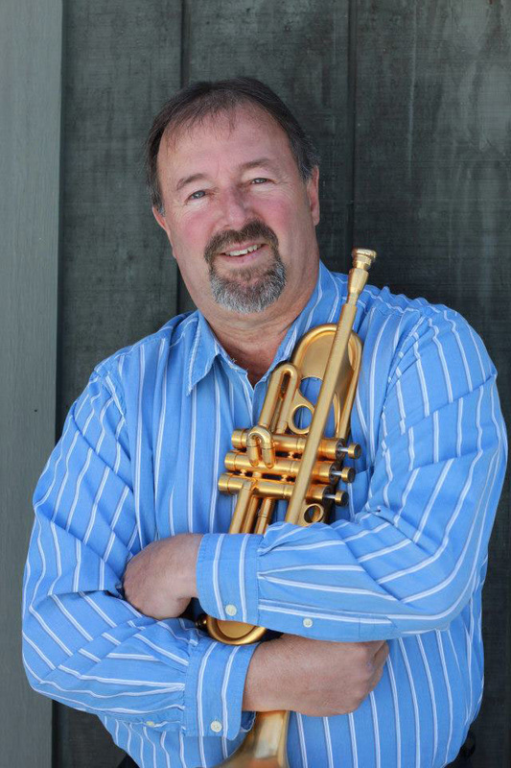

On Nov. 24 Don Shire, one of four missionaries we support, shared in worship stories of ministry with orphans and widows in India. He also led us in praise of God with his trumpet.
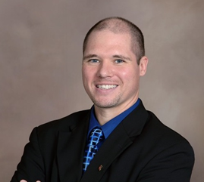
From the Pastor’s Desk

With the coming of winter is the coming of the Advent season as well. Advent starts four weeks before Christmas day, and marks the start of the “Church year,” which begins with our preparation to celebrate the coming of Christ through the birth in the manger. As we prepare to celebrate Christmas many will be busy decorating, baking, buying gifts, and making plans to gather with family and friends, all while still keeping up with all the regular weekly activities. This can cause some stress and distract us from what Christmas is really about. My hope is that among all the busyness, we take time to welcome once again the coming of our Lord, to remember the “reason for the season.”
Christmas is an awesome event as we remember that over 2000 years ago God Almighty humbled Himself into the form of a baby, Jesus gave up the glory of heaven to dwell among us, Jesus comes to be Emmanuel: God with us! How amazing is that, God comes to us in a personal way, to teach us, to heal us, to love us, to die and rise for us, and then sends the Spirit to transform and empower us. The joy of Christmas is that it points to the love revealed on the cross and the hope discovered in the empty tomb. The Christmas event reveals just how much God has given to the world. As we celebrate this great gift of Jesus I challenge us to think about what we will do in response.
It is like a present under the Christmas tree with your name on it, the gift inside has been picked with you in mind, the price has been paid and it’s offered to you freely. The giving is only a part of the process though, the gift does not do us any good if it is not received, opened, and claimed. God has sent us the gift of Jesus; Jesus comes to share God’s love and forgiveness with you and me, with the world. Will we accept it? How will we respond to it? When I get a gift I want to show my thanks. We can show our thanks to God by accepting the love God offers and by reciprocating it through worship and service, by getting to know God more every day through prayer and Scripture reading, by offering ourselves to God as God offers Himself to us. We are called to be disciples, giving our lives to Jesus to be molded and taught by Him and to be transformed and used by Him to bless others.
So this Christmas take time to remember and celebrate the real reason for the season, God’s great gift to us, Jesus the Christ! God Bless you all, have a great Christmas this year.
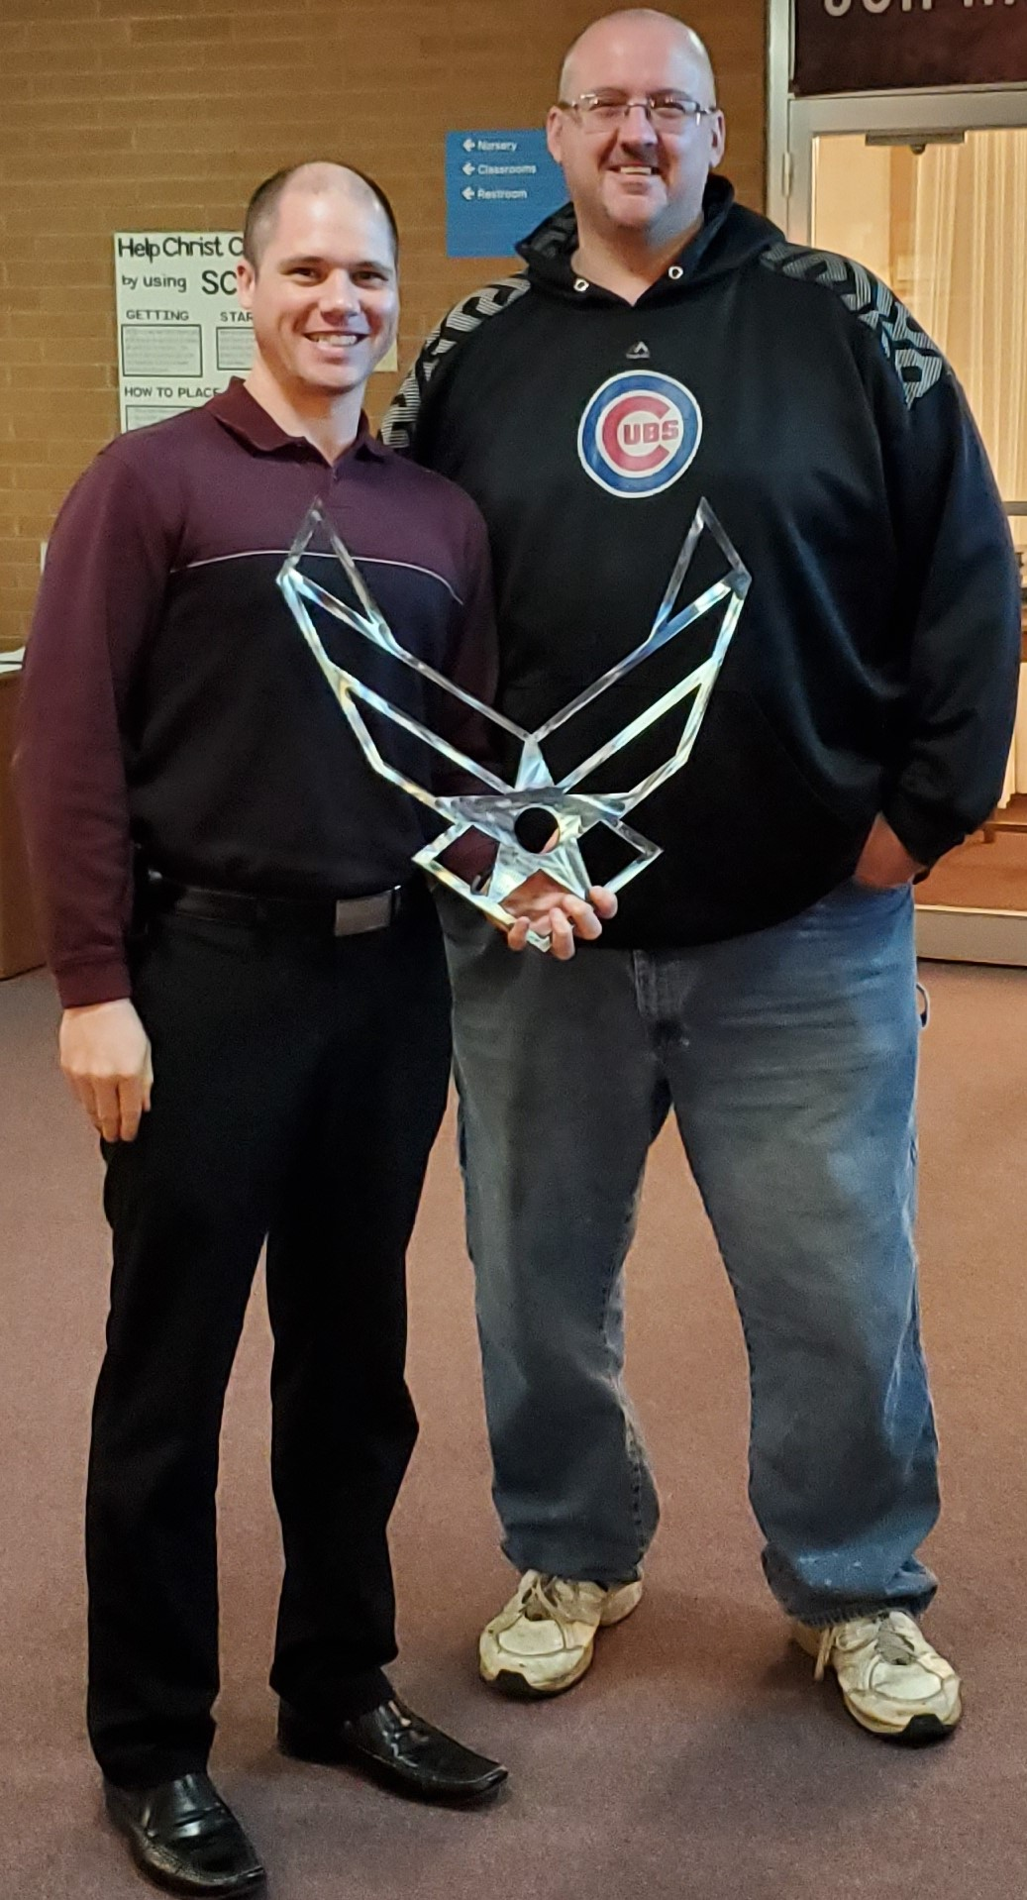
God Bless,
P.S. Thanks to Tom for the metal Air Force symbol he made for me. The congregation’s support of my chaplain work and ministry to military families is a blessing.
Pastor George J. Kafer

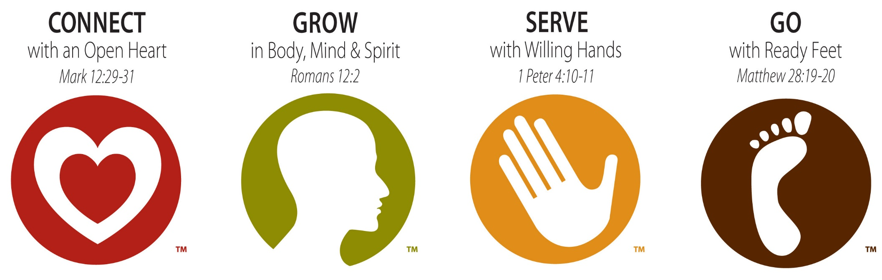
r

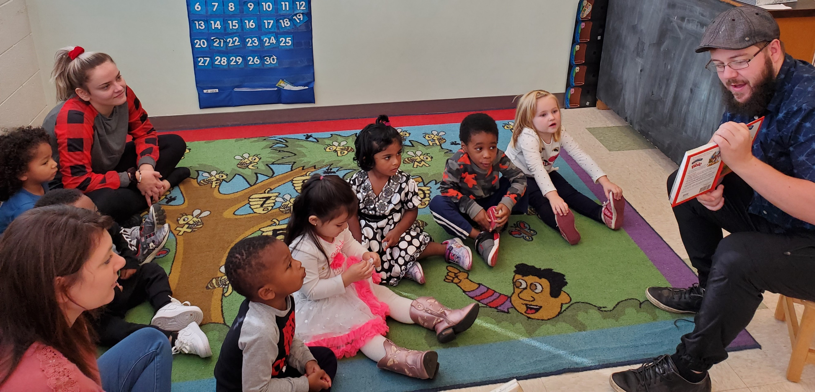
Josh teaching at a weekly childcare chapel class.

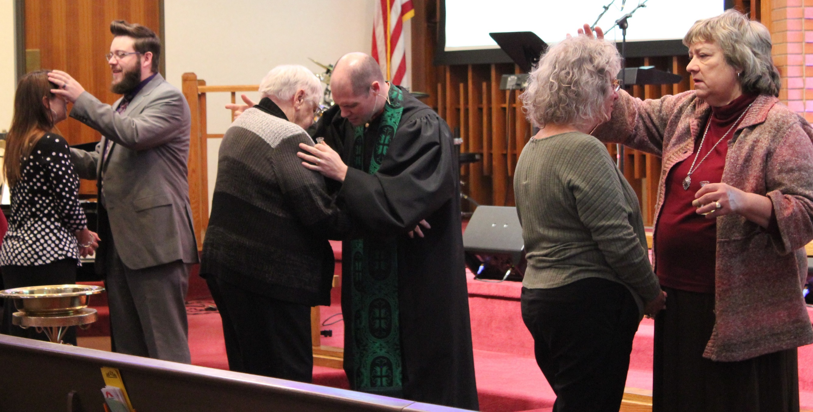
Nov. 17 anointing & prayer healing service.

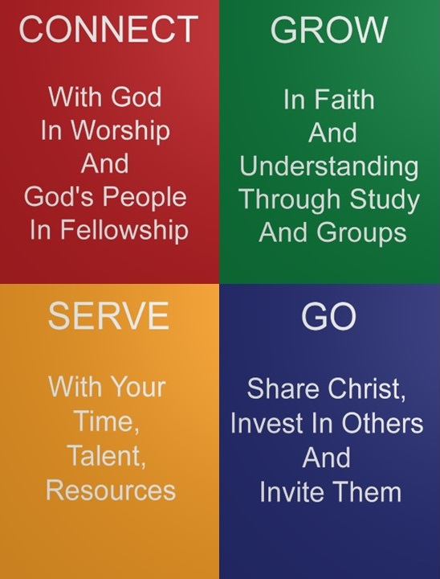
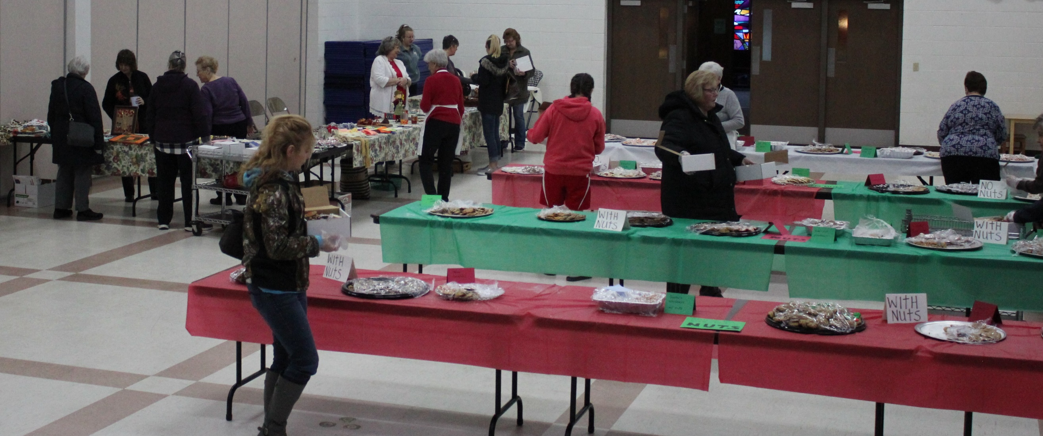
Thank You!
The United Methodist Women thank everyone who made this year's Cookie Walk/Harvest Bazaar a success. A big thanks to all who made cookies and/or donations along with the items for our Bazaar table, those who helped set up and work the event, and those who ordered nuts and candies. All proceeds will help support missions here in Racine and around the world.

Share your “Time & Talent” and further God’s work!

If interested in ministry areas contact the church office.
-Help watch and play with kids on the first Friday of each month from 6:00-8:30 p.m. to enable Christ Church to offer free child care so parents can have some time out. Contact church office.

-Audio/Visual Ministry, be trained to run the system during worship services. Contact Pastor.

-Sunday Door Opener or Greeter. People are needed to commit to opening the doors and greeting people one Sunday each month before worship.

-Driver: Help pick people up for worship using the church van.

SCRIP is a gift card where a portion of the value of the card comes back to Christ Church. Need a gift card for a gift? Have a home improvement project? Planning a trip? Use a SCRIP gift card, your purchases meets your needs and helps Christ Church. Pick up a SCRIP order form, to see how SCRIP can help with your plans. SCRIP cards can be purchased or ordered on Sundays here at church; or online at www.shopwithscrip.com and picked up as soon as Wednesday afternoon. When enrolling online, use code 91LDB747375L9. All orders must be paid for before placing an order.

Staff Emails

Liz Martin (Office)
christcumc@gmail.com

Pastor George Kafer
revkafer@outlook.com

Josh Levenhagen (Family)
christchurchracinefamily@gmail.com

Merry Kris Demske (Adm.)
mkdemske@gmail.com

Cassandra Kafer (Media)
christchurchmediaministry@gmail.com

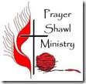
Join us in making shawls for those going through tough times. The shawls serve as a reminder of God’s love and the prayers of God’s people. We gather at
1:00 p.m. on the second Friday of each month in the Friendship Room at Christ Church.

Reminder: If you know someone who could benefit from receiving a Loving Arms Prayer Shawl; please contact the church office at 632-1607.

God Is Good
God is working good in the lives of people through the ministries of Christ Church. If you have a story of how your life or someone else’s has been blessed by God or affected by a ministry at Christ Church please share it with Pastor George so God can be glorified.
Your Giving Makes a Difference!

Here are just a few highlights: We served dinner to an average of 100 working poor every other month and gave out 275 sack lunches to the poor downtown. We collected food for a local Food Pantry and middle school. We sent teams to the Appalachian Service Project as well as donated to four Missionaries. We have given to UMCOR, our Prayer Shawl Ministry, Feed My Starving Children, the Food Pantry, VBS and other charities.

Thank you to those who offer support for vital, life changing ministry.

To give online go to www.christchurchracine.com and click “give” or text “give” to 1-262-631-3012

December Birthdays

Meaning,

Purpose,

Hope

Learn how to find them at Christ Church!

Katherine Kremis 12 1
Alex Picciurro 12 4
Brian Esser 12 6
Kelson Meredith 12 6
Clyde Green 12 7
Tyler Bosch 12 9
Beth Snyder 12 11
Linda Bixler 12 14
Tony Zegarra 12 18
Harry Wallace 12 20
Judy Piekarski 12 21
Carl Kiefer 12 24
Ray Rorek 12 25
Liz Martin 12 28
Cesar Tenuta 12 29

Thank you to all who helped provide Christmas Gifts for foster children!

Please turn in your 2020 pledge cards and time and talent forms to the church office.

NEW ADDRESS
Bill Wilms has a new address – he so enjoys hearing from his church family!
1201 Village Centre Dr. Room 103,
Kenosha, WI 53144.
His phone number is
262-854-9915.

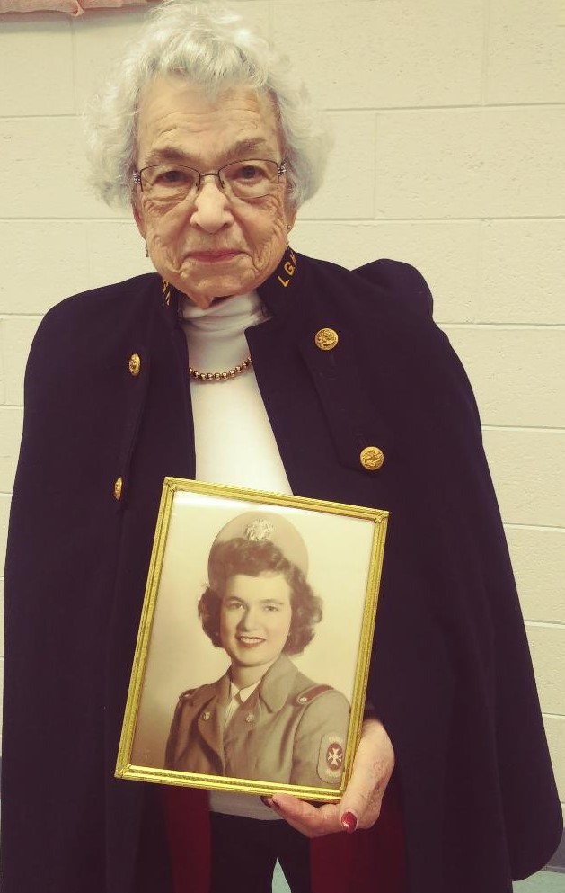
Bernice Kissinger shared with the evening UMW circle about being a Nurse Cadet during World War 2.

Christ Church Men’s Bible Study
Wednesdays at 6:00 pm in the
Conference Room
Bring your Bible. Contact Brian Crowe for the current chapter being studied. Then read in advance of coming to class. Bring a friend with you. Let’s GROW!

The Evening Dinner Circle meets on Monday Dec 2nd at 6:00 p.m. for dinner and a mission program.

The Marge Circle meets on Thursday Dec 19th at 1:00 p.m. in Room 16.

NEWS FROM ZIMBABWE
Larry and Jane Kies, our missionaries at Africa University (AU) in Zimbabwe, are busy raising food for their growing student population as well as training future farmers in farming techniques. They are deeply grateful for our help in providing money for scholarships which have given Larry his largest first-year class ever! Other important undertakings on the farm have been the acquisition of a fertilizer spreader and lining the fish ponds so that tilapia can be raised. They are also planning for the expansion of the poultry production to beyond 1000 birds a week! Zimbabwe is continuing to struggle with hyperinflation but AU is able to mitigate the situation due to their own production of many staple food items. 2020 will bring Larry and Jane home for visits to supporting churches. We look forward to their visit sometime between July and September! They have asked us to pray for guidance in making big decisions for the next year, for a good raining season, and for wisdom for farmers in dealing with the hyperinflation. Tammy Hayward, Outreach/Witness Chair

Sunday

Adult Sunday School 10:30 – 11:30 a.m. Led by: Linda Wallace in Room 16
Discussion that will follow Sunday’s sermon on Dec. 1 & 29 and the James Study (see below) on Dec. 8,15, 22.

Wednesday

“The Book of James” Study at 11:00 a.m. & 6:00 p.m. Led by: Pastor in the Friendship Rm.
Dec. 4 & 11. This Study uses narrative accounts by Bible personalities of different subjects discussed in James, such as Barnabas speaking of wisdom or King Solomon discussing foolishness. Together, the videos and study guides provide an in-depth view of the main subjects in the book of James.

Men’s Bible Study at 6:00-7:00 p.m. Led by: Brian Crowe in the Conference Rm.
Verse by Verse, Chapter by Chapter Bible Study. Come to learn and share insights and application.

Thursday

Adult Coloring Group
6:00-8:00 p.m. Meets on the Fourth Thursday - Will be meeting on Dec 12th due to the holidays

Friday

“The Book of James” Study (see Wed. above) at 9:30 a.m. Led by: Marci Tenuta in the Friendship Room

Prayer Shawl Ministry
Meets at church every 2nd Friday of the month at 1:00 p.m. in the Friendship Room

Community Connections

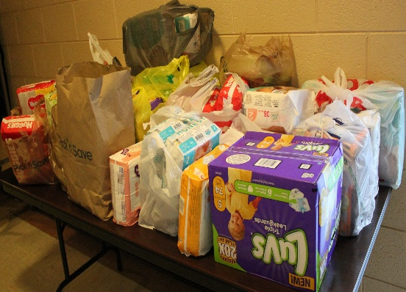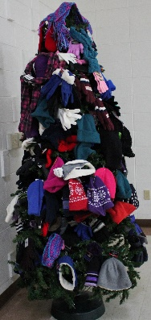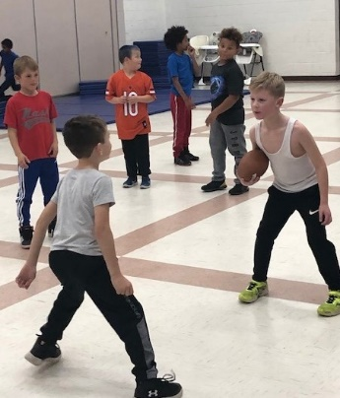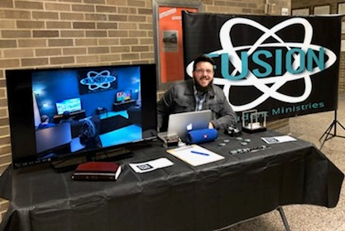

In November we collected diapers for distribution at the food pantry, provided hats and mittens for school children in need, provided space for a local youth football team to practice when the weather got cold, and had a table at Starbuck School’s parent teacher conferences to share the family ministries we offer.

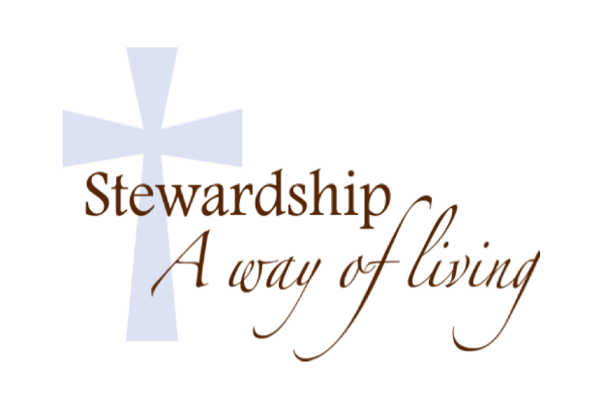

Coming up December 14 from 10:30 a.m.-12:00 p.m. we will be holding a Gingerbread House Building Contest. This is an opportunity for you to bring your family together and get ready for the Christmas season! We will be decorating the houses for about an hour and then have our official judges come up and determine the top three winners! The 1st, 2nd, & 3rd place winners will receive a $100, $75, & $50 Walmart Gift Cards respectively! Talk about some extra Christmas spending money! So, come out and have a great time with your friends and family. Will see you then!

---------------------------------------------------------------------------------

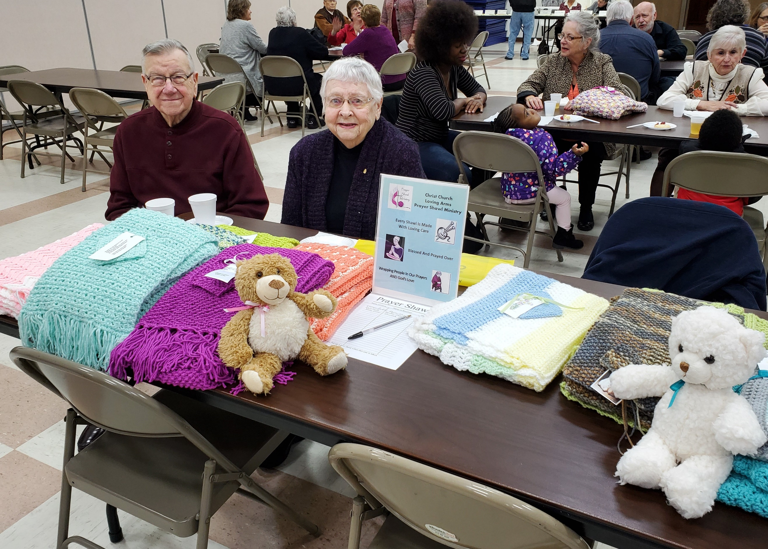

If you have a story, letter, or card showing appreciation for the prayer shawl ministry please bring it to the office for use in a display highlighting shawl impact. Thanks!
What Will Your Legacy Be?
Have you considered your legacy; how about continuing to let God use you to transform lives by adding a line to your Will that gives 10% of your estate to Christ Church. Estate funds have helped us with much needed building repairs or improvements so that our building continues to support vital ministry.
Friendship Luncheon
Wed., Dec. 11th at 12:30 p.m. Make your reservations: Call Billie Stilley at 554-8801.
Open to all and friends of our community.

Apportionment Giving
Christ Church has a history of 100% apportionment giving, allowing us to help transform lives by God’s love. Apportionments provide for ministries that directly help over 50,000 people in Wisconsin and many more beyond. In 2019 our apportionment is $43,728, if we each give faithfully to the general fund and if able a special gift for apportionments, $254 a year per member, we can continue to support connectional ministries and free up more of our general funds to increase outreach and ministry in our local area.

Stewardship Makes a Difference!
Thank you for all the ways you support ministry. This newsletter has examples of how our church is making a difference in people’s lives through your giving! It is good to see people trusting in God and answering His call to give. People are offering themselves to serve and their financial giving (several tithing 10% of income, or working toward tithing)! Check the connection table for Electronic Fund Transfer forms and ways to give of your time and talent as well. As you respond to God’s call in the giving of your time, talent, and resources remember if you have a need contact Pastor George.

Music Ministry
at Christ Church

Praise Team
Provides/leads praise and worship songs at our Sunday Contemporary worship. Practices year round, currently on Sundays following the 10:30 service.

Chancel Choir
Provides special music and leads hymns at our Sunday Traditional worship. Sept.-mid June. Practices on Wednesdays at 7:00 p.m. Sept.-mid June.

Special Music
Please contact Alan Biehn

Message System

Text “connect” to 262-631-3012

Follow the instructions once you receive a reply back. This communication system will allow us to send special messages (meeting cancelations…) or reminders to you. Sign up today.

Christ Church’s Vision

A church that seeks, welcomes, and forms in Christian faith all people with a special focus at this time on reaching out more to families and children, increasing our connection with and ministry in the community, and forming more small groups to grow people in relationship with Jesus and one another.

Membership Expectations
By taking the vows of membership members of Christ Church agree to help carry out our mission and to be: regular in worship; active in spiritual growth (personal devotions/growth groups); active in an area of service in the church and/or
community; to give in proportion to your income, and to be a witness to the faith. These vows help us grow in faith and live it out in the world as followers of Jesus.
Need a Visit?

Gifted lay people along with the Pastor extend the Church’s presence to the homebound and others through visits. If you have moved, are ill, having surgery, or need a visit for any reason please call the church office to keep the Pastor and lay visiting team informed. If we do not know we cannot go!

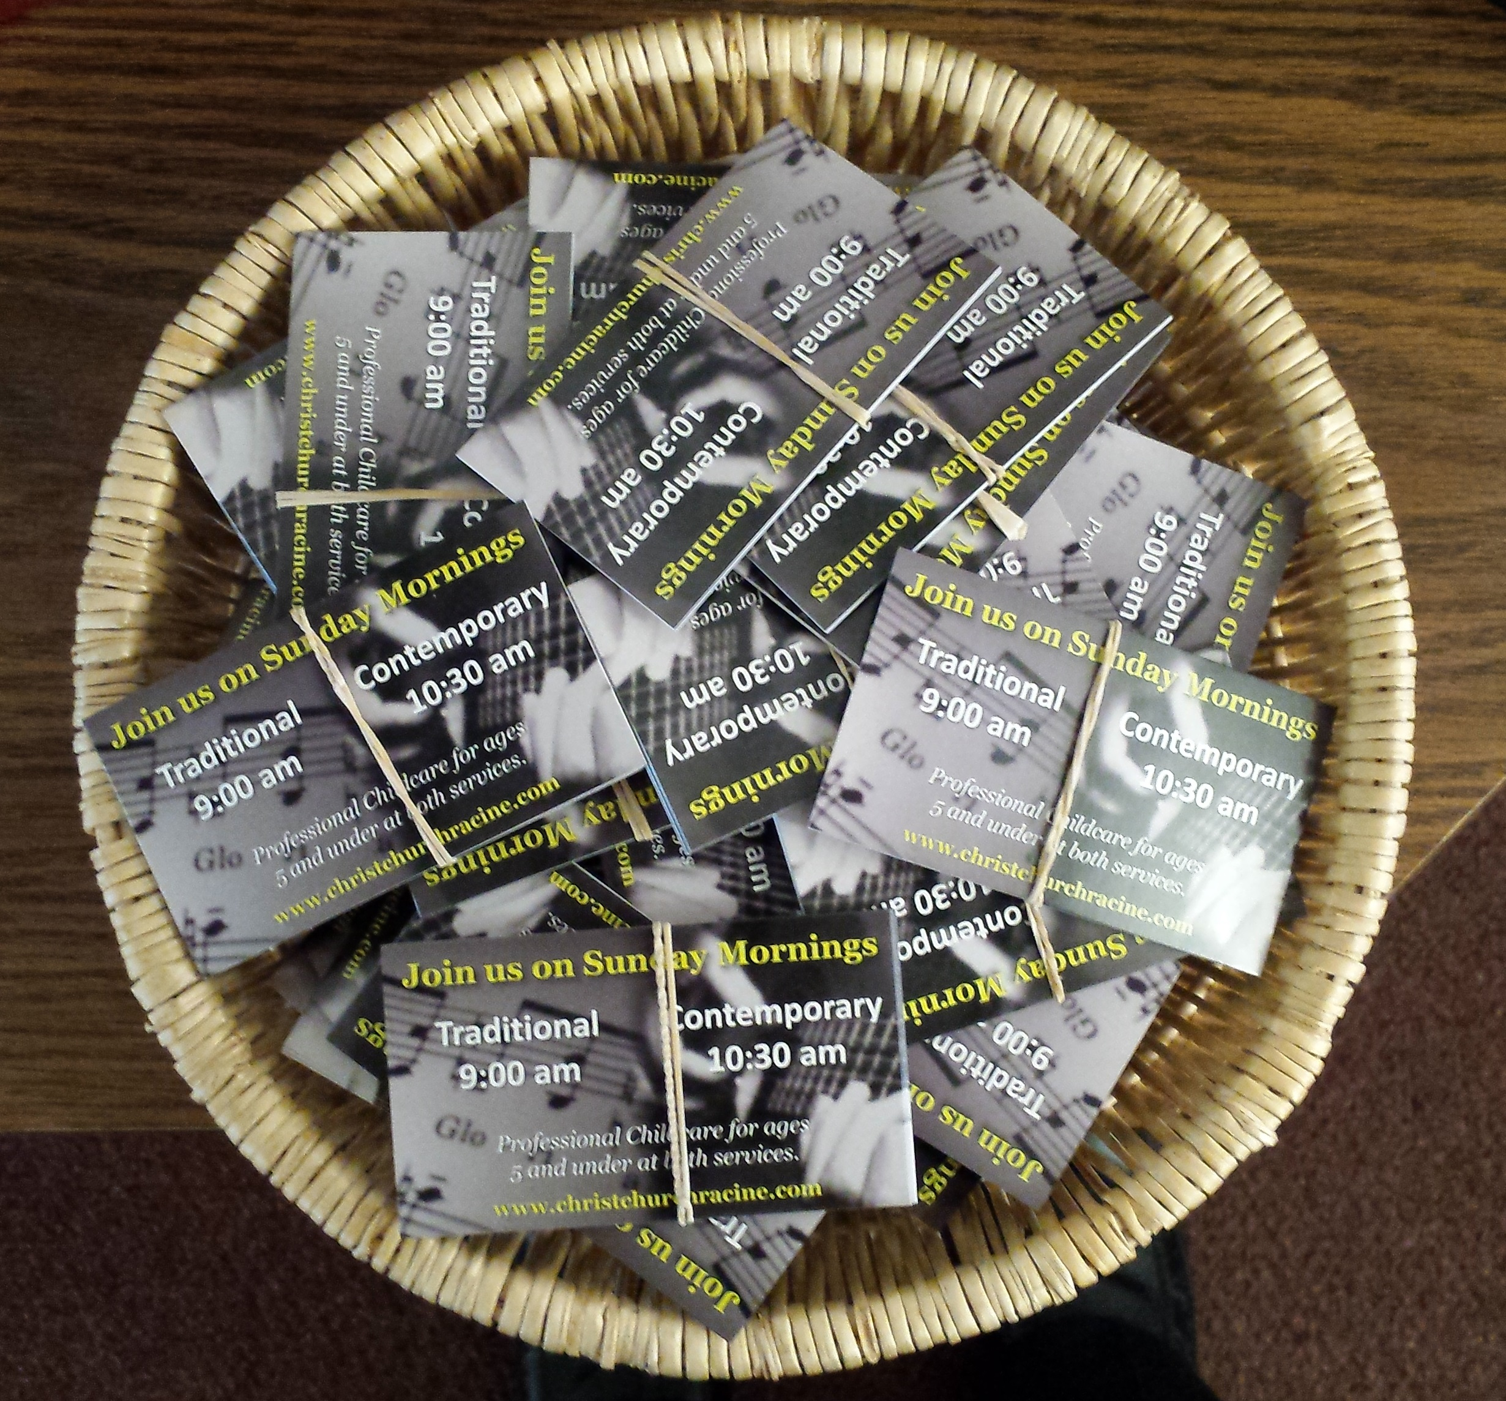
We have bundles of worship invite cards in the entryways to take and give out:
- Put a stack at your office, store or place of work.
- Ask if you can set a stack out in a business that you frequent.
- Give them to neighbors, friends and co-workers.
- Leave them on tables at restaurants to invite your server (leave a tip, too).
- Give them out in drive thru lanes.
- Ask God to give you an opportunity to give them out.
- Keep a few in your wallet, purse or car.

Consider This
If you desire to give to specific ministries beyond your general offering here are some areas: Apportionments,
Building Fund
(repairs, special projects…),
Compassionate fund, Sign Fund,
Roof Fund, Youth Ministry,
Audio/Visual Fund,
Camp Scholarships
($100 per camper).

Christian Education, Children’s, Youth & Family Ministry

Sunday School: September - May For Kids Age 4 - 5th Grade

Preschool-K – Room 14 led by Angela Furuglyas & Beth Green

1st – 5th Grade Room 17 led by Samantha Wallenta & Shannon Knudson
3
Middle & High School (6th-12th Grade) are invited to attend worship.

Wednesday Kid’s Club (September - May)
A gathering for K–5th graders in Room 18 from 6 p.m.-7:15 p.m. where kids learn Biblical teachings through songs, videos, drama, crafts, stories, games, and mission projects. Classes are after a free meal (5:15 p.m.)
On the 3rd Sunday October-May Kid’s Club kids sing at 10:30 a.m. worship.

Youth Group
Wednesday night gatherings from 6:00-7:15 p.m. Youth hang out, worship, and learn about God’s word.

Family Ministry
-Child Care for 4yrs. and under offered in the nursery on Wednesdays during the classes, 5:45-7:15 p.m.
-“Parent’s Night Out” First Friday of the month - Free Child Care from 6:00-8:30 pm
-Gingerbread House Contest December 14 at 10:30 a.m.

Options for Kids During Worship
Worship Clipboards are located in the south entryway for children Preschool - 3rd grade.
A nursery room for 5-year old’s and under is staffed with professional child care.

Other Youth Opportunities
Scouts: Meets at Christ Church on Mondays from 6:30-8:00 p.m.
Girl Scouts: Meets at Christ Church every other Sunday from 1:00-3:00 p.m.

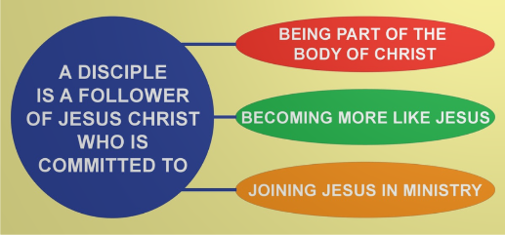

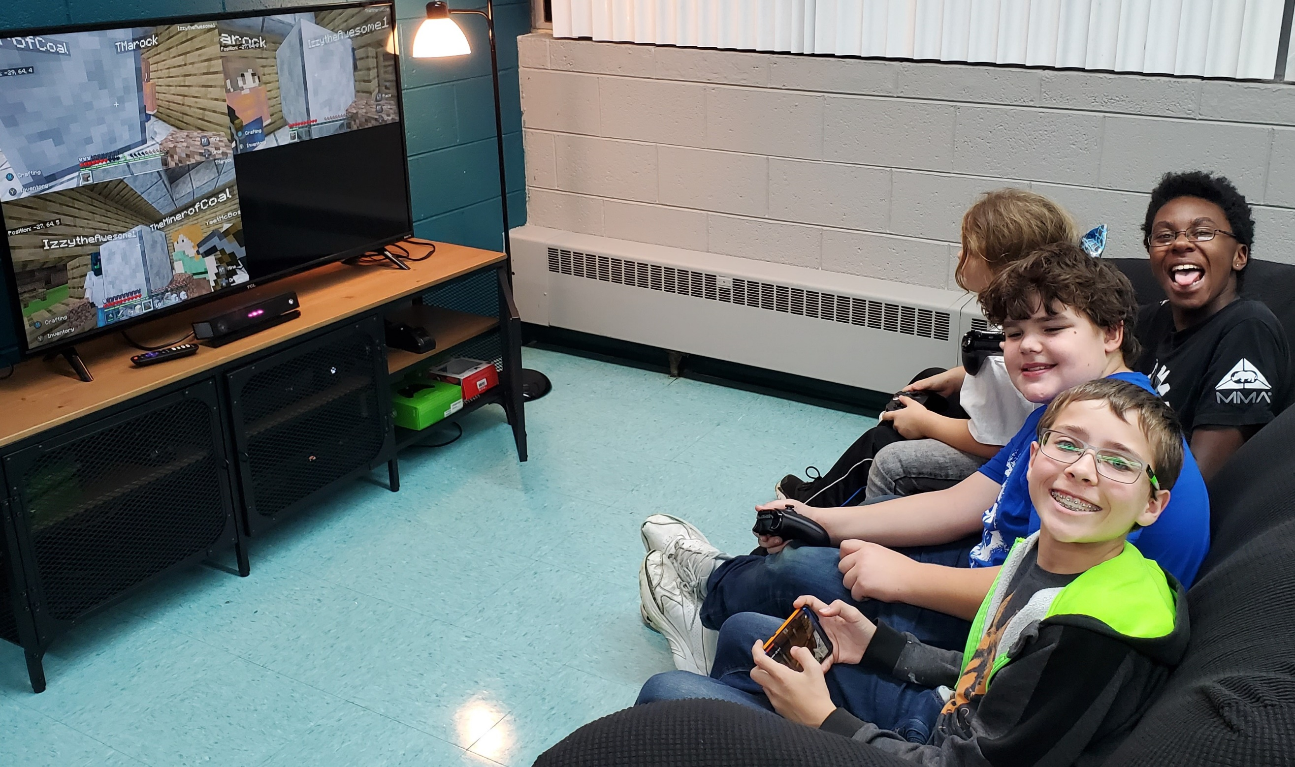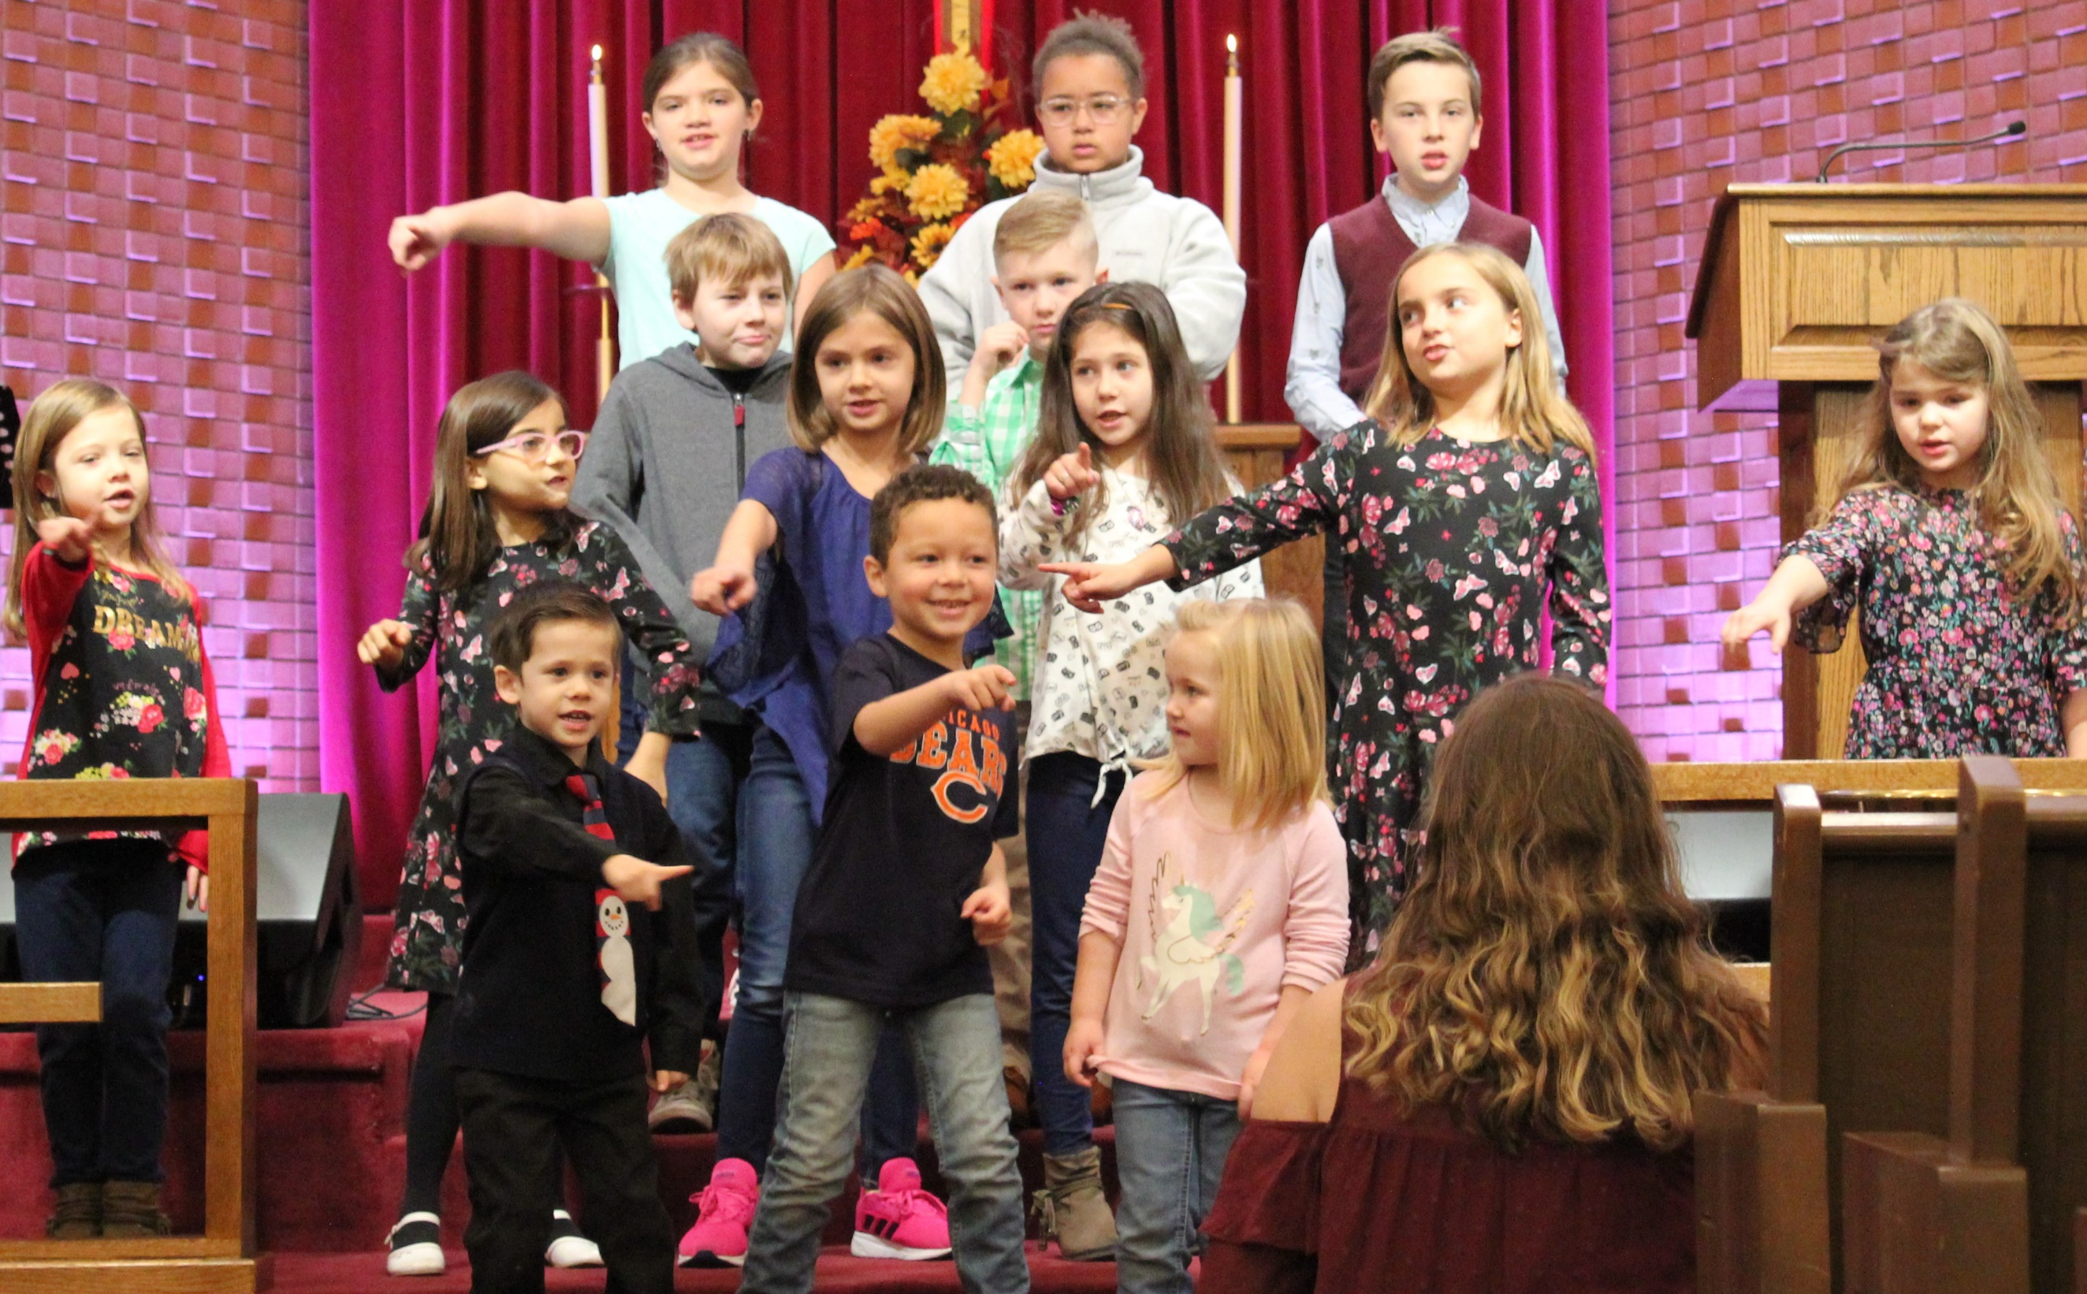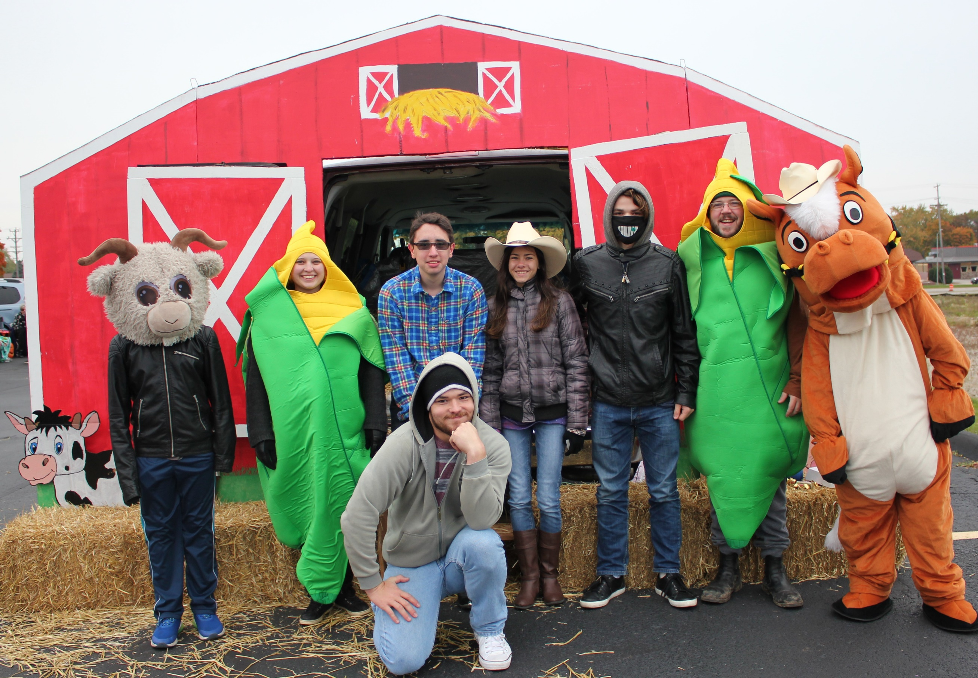
Some youth enjoying Kids singing a song Trunk or Treat
their new space. during worship. family event

December 6

On the first Friday of the month, parents are invited to drop off their kids (3 months-5th grade) at Christ Church for free child care from 6:00-8:30 p.m. where games, activities, and snacks will be provided.
This is a way to support families in our congregation and community by allowing parents to have time for themselves and their relationships.
Please sign up children at the connection table or call the church office at 632-1607. Those wishing to help may sign up at the connection table as well. Chris Bahr, PNO Director

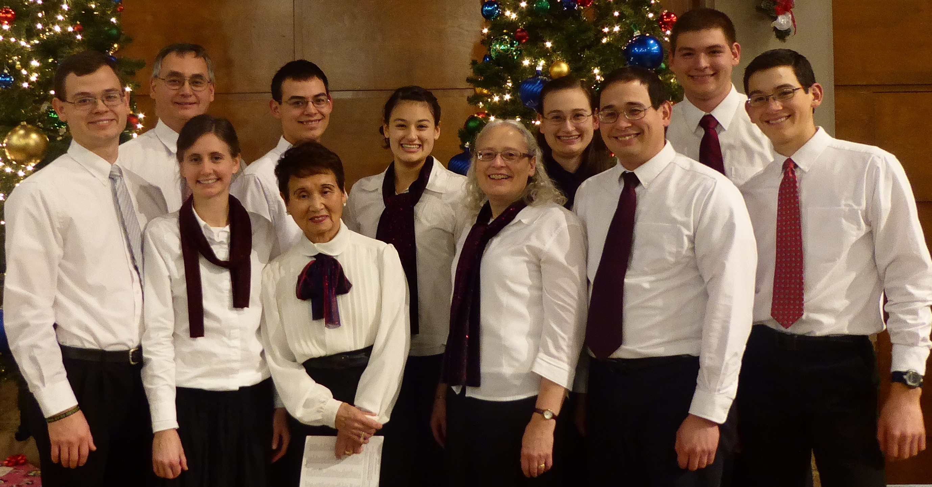

Christmas Concert
December 8, 6:00-8:00 p.m.
Includes 30-minute intermission with refreshments.

Invite a friend and plan to get into the Christmas spirit with traditional sacred and secular songs of the season performed by the Rocke Family.

Charge Conference
On December 9 at 6:00 p.m.

A time to celebrate ministry, remove members who have not lived out their vows, elect those gifted to serve in ministry positions, and adopt a ministry budget to support our mission.

We collected food and money to provide Thanksgiving meal baskets to families from the food pantry and Starbuck School.
Thank You!

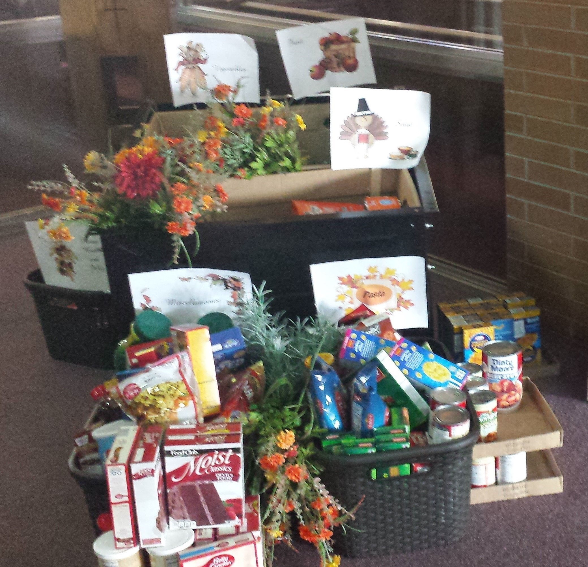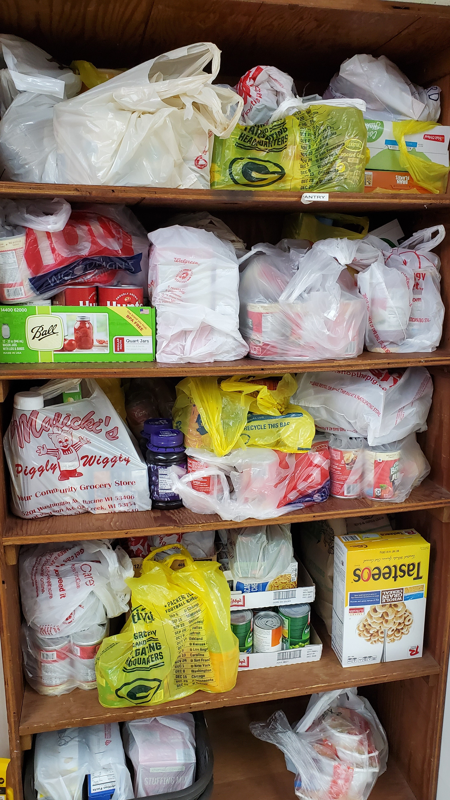

---------------------------------------------------------------

Change for Change in December is going to support “Feather-a-Nest” to help provide furniture to families in need.
The next Community Meal is January 14th, look for a sign up in the south entryway to help donate food or to serve at the meal.

Sunday | Monday | Tuesday | Wednesday | Thursday | Friday | Saturday
1  9 am – Traditional Worship  10:30 am -Contemporary  Worship & Sunday School | 2  9 am Racine Garden Group- 16  6 pm Evening Dinner Circle  6:30 pm -Scouts | 3  4 pm  Delta Kappa Gamma Craft & Bake Sale - FH | 4 11am  Sm Group-FR  5:15 pm Meal  6:00 pm Kid’s Club  6 pm Fusion  6 pm Sm Group-FR  6 pm MIM  7 pm Choir | 5  12:30 pm UMW Bd Mtg- CR  6 pm Cub Scouts – Room 14 | 6  9:30 am Small Group  6 pm –  Parent’s Night Out | 7
8 9 am Traditional Worship  10:30 am Contemporary  Worship & Sunday School  1 pm Girl Scouts- FH  6 pm  Rocke Family Christmas Concert | 9  6 pm Charge Conference – Room 16  6:30 pm -Scouts | 10 | 11  9:45am SSMT Christmas Program- Sanct/FH  11am Sm Group-FR  12:30 pm Friendship Lunch  5:15 pm Meal  6:00 pm Kid’s Club  6 pm Fusion  Sm Group-FR; MIM  7 pm Choir | 12  6 pm Coloring Group - CR  6 pm Christian Life- Library  6:30 pm Family Ministry - 16 | 13  9:30 am Small Group- FR  1 pm Prayer Shawl Ministry- FR | 14  9 am Witness  10:30 am  Gingerbread House Contest - FH
15  9 am Traditional Worship  10:30 am Contemporary  Worship & SS | 16  6:30 pm -Scouts  FH – Court of Honor | 17  6 pm Trustees | 18  11am Sm Group-FR  5:15 pm Meal  6 pm All Church Christmas Caroling (includes Kid’s Club & Fusion)  7 pm Choir | 19  1 pm – Marge UMW Circle- 16 | 20  9:30 am Small Group- FR | 21  10:30 am Sack Lunch - 1st UMC
22  9 am Traditional Worship  10:30 am Contemporary  Worship & SS  1 pm Girl Scouts - FH | 23 | 24  10:30 am Christmas Eve Worship  4 pm  Christmas Eve Candlelight Worship | 25  Merry Christmas! | 26 | 27 | 28
29  9 am Traditional Worship  10:30 am Contemporary  Worship & SS | 30 | 31 |  | December

Christ Church United Methodist
5109 Washington Avenue
Non-Profit
Organization
U.S. Postage
PAID
Racine, WI
Permit No 24
Racine, WI 53406

CHANGE SERVICE REQUESTED

Our Worship Schedule December 2019

Sunday, December 1 9:00 a.m. Traditional & 10:30 a.m. Contemporary
Message by Josh Levenhagen

Sunday, December 8 9:00 a.m. Traditional & 10:30 a.m. Contemporary
“Hanging of the Greens”
Communion Offered

Sunday, December 15
Choral Cantata 9:00 a.m. Traditional
“John’s Advent Call” 10:30 a.m. Contemporary
& Child Care Kids Sing
Matthew 3:1-12

Sunday, December 22 9:00 a.m. Traditional & 10:30 a.m. Contemporary
“When Jesus Does Not Fit”
Matthew 11:2-11

Tuesday, December 24 10:30 a.m. & 4:00 p.m.
Christmas Eve Service

Sunday, December 29 9:00 a.m. Traditional & 10:30 a.m. Contemporary
Message by Josh Levenhagen

