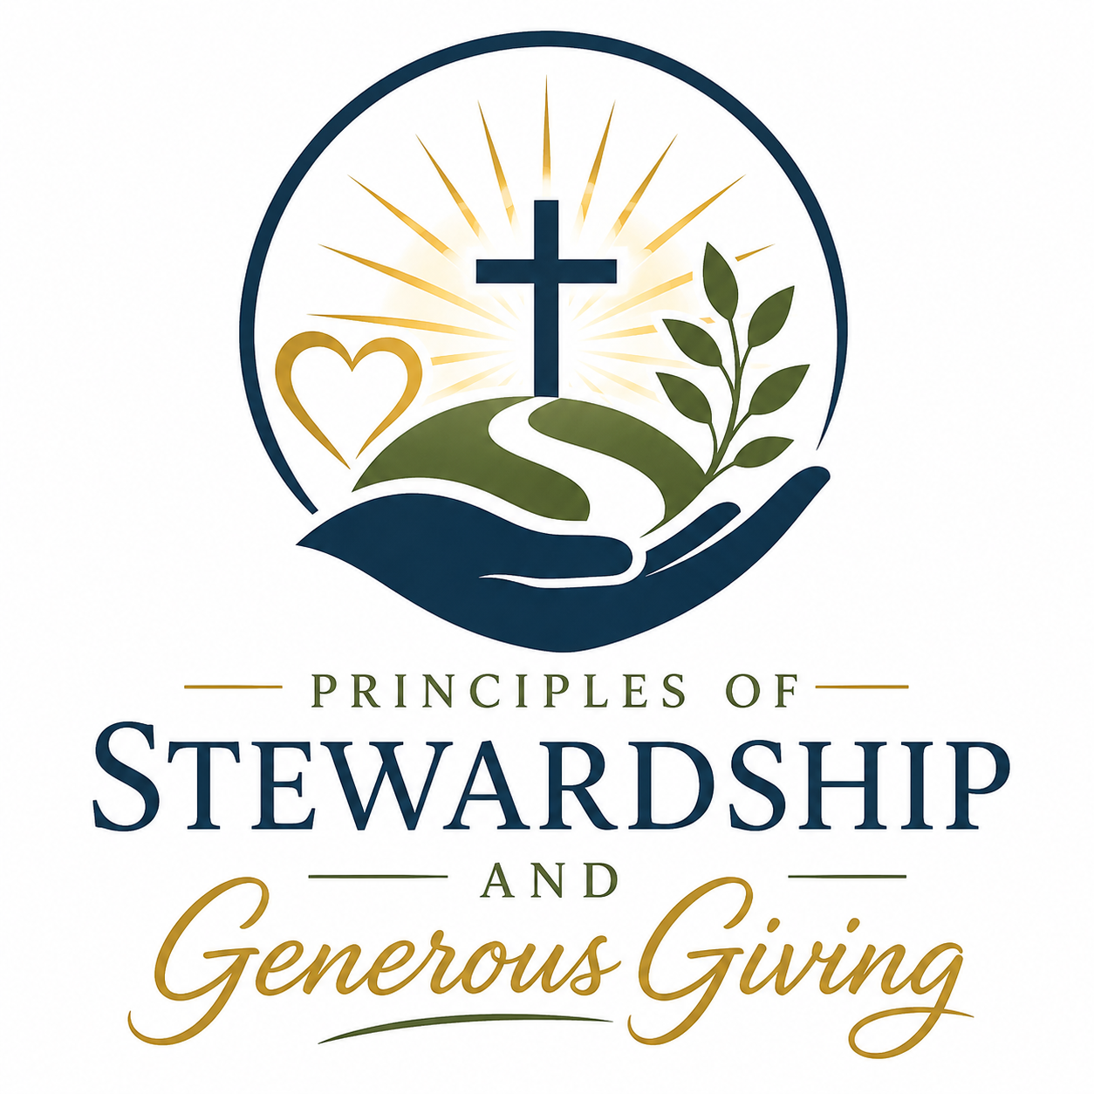
Guilford College United Methodist Church
1205 Fleming Road Greensboro, NC 27410
Phone 336-292-5833 www.guilfordcollegeumc.org _______________________________________________________________________
Rev. Jeremy Troxler, Lead Pastor - Rev. Susan Suárez Webster, Associate Pastor

“Think of us in this way: as servants of Christ and stewards of God’s mysteries.
Moreover, it is required of stewards that they be found trustworthy.”
-I Corinthians 4:1-2
October 6th, 2026
Dear Church,

Whenever another person trusts us with something that is precious to them, we feel a great sense of responsibility – and importance. Knowing that someone else is counting on us to deliver the message, or to complete the task, or to keep a confidence, or to check in on a loved one, or to take care of a treasured possession, humbles us – and gives us a sense of purpose.

This is even more true when the One who has entrusted us with such a sacred assignment is God.

We often talk in church about the amazing power of trusting in God. Just as amazing, however, is the realization that God trusts us. The Bible speaks of God’s people as “stewards” or “trustees” who have been entrusted with safe-guarding and sharing Christ’s belongings. The Scriptures remind us that every one of us has been entrusted with a holy calling of putting God’s gifts to work: “Like good stewards of the manifold grace of God, serve one another with whatever gift each of you has received.” (I Peter 4:10)

THANK YOU, Church, for being so faithful to that calling, and for so beautifully honoring the trust that God has placed in you: I continually marvel at how you so generously share the multi-faceted grace of God with each other, and with the world. Our Church is truly a place where grace overflows into thanksgiving.

GCUMC exists as living legacy of such amazing grace and such holy giving. Enclosed with this letter is a booklet which traces that remarkable history of sacrificial generosity. We hope you will enjoy thumbing through the photos of some of the ways we have served God, one another, and our neighbors with the gifts that God has given us.

Also enclosed with this letter you will find a Giving Commitment Card and a Gifts & Skills Offering sheet for 2027. And here is where, once again, we ask for your help.

As a spiritual discipline, and as an expression of your commitment to Christ, we ask that you please take some time to prayerfully complete both the Giving Commitment Card and the Gifts & Skills Offering sheet included in this mailing. Please return both the card and the sheet to the church by dropping them off at the Church Office, by mailing them to us, by placing them in the secure Dropbox outside the Office door, or by bringing them to worship on for before Commitment Sunday, October 25th.
If doing things online is a better option for you, you can find these materials on our Church website at www.guilfordcollegeumc.org , or via your REALM online database account.

Whenever and however you make these commitments, thank you for returning them to us no later than the end of October, which is when our leaders will be preparing our Ministry Budget for next year.

Like many of your households, our church household is also facing financial challenges in the year ahead. Though we continually look to find savings in our budget, costs for everything just continue to increase. Balancing next year’s budget is going to be hard. But we want to continue to do good ministry. We want to continue to have the good staff that we need to lead us. We want to continue to take good care of our building. So, we ask for your help.

We hope that those of you who have the means will even consider increasing your financial commitment in the year ahead, as much as you are able – but we thank you, and we thank God, for whatever you are able to offer.

Despite these challenges, we trust in God.
We trust in you.
And God trusts us.

Thank you for being faithful servants of Christ,
and the trustworthy stewards of God’s grace.

Grace and Peace,

Pastor Jeremy
(On behalf of your brothers and sisters at GCUMC)

