Our Mission:
To Build a Faith Family that is Crazy about People and Passionate about God!
(Matthew 22:37-39)

Leadership Team  Lead Pastor, John Czech  Music Director, Chris Ashwood  Chris@lvhudson.org  Director of Family Ministries  Elizabeth Handy  Elizabeth@lvhudson.org  Youth Ministry Assistant Director  Alison Czech  Alison@lvhudson.org | Elders  - Dave Berglund  - Ben Chirhart  - John Czech  - Matthew Girdeen  - Ken Zuber

Please complete a Connection Card if you would like to receive church notifications and special event updates as they occur. You can drop the card in the blessing box at the back of the auditorium or drop it off at the Connection Desk in the Community room and receive a gift bag!

Two Ways of Financial Giving to Living Vine
Online@https://lvhudson.org/give,org
Blessing Box at the back of the auditorium

CHECK OUT the Lending Library in the Community Center. Books for all ages to borrow.

Hearing assistance devices are available at the sound booth.

Wi-Fi: Living Vine Guest, Password: LivingVine1
Visit us on the web at www.lvhudson.org
309 Vine St, Hudson, WI 54016

Church Office Hours
Mondays and Fridays 9am – noon
Email: office@lvhudson.org
Phone: (715) 386-9589

FAMILY MINISTRY PROGRAMS

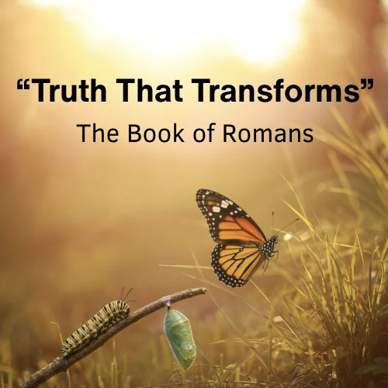

Living Vine Church
October 4, 2026
10:00 AM

Today’s Message
“How True is My Worship?”
Message Series: “Truth that Transforms”
Guest Speaker: Kelly Czech

[Grab your reader’s attention with a great quote from the document or use this space to emphasize a key point. To place this text box anywhere on the page, just drag it.]

[Grab your reader’s attention with a great quote from the document or use this space to emphasize a key point. To place this text box anywhere on the page, just drag it.]

WELCOME GUESTS!
We’re so glad you are here.
Please join us after the gathering for
refreshments & treats in the Community Center.

FAMILY MINISTRY PROGRAMS
FAMILY LIFE MINISTRY MISSION:
To assist parents in discipling their children.
Lil’ SPROUTS (Infant — Kindergarten)
Provided with a safe and loving environment where they can explore and feed their natural curiosity, our babies & toddlers get to play while listening to music, hear a Bible story, and make friends. Volunteers are ready for check-in at the Nursery counter on the main level at 9:45am.

VINE KIDS (1st — 5th grade)
Vine Kids remain in the auditorium with their parents and are dismissed as a group for class, after announcements. In Vine Kids, children engage in "hands on" interactive Bible lessons and games/crafts. They also participate in energetic, age-appropriate worship through song. After the service is done, parents will pick up their children upstairs.
IVY LEAGUE (6TH — 12TH GRADE)
Check the website for the schedule @ https://lvhudson.org/connect/youth-group. Meets most Wednesday nights from 6:30pm to 8:00pm upstairs in the Family Life Center with special events at various times.
UPCOMING EVENTS
EVENTS THIS WEEK

For a listing of all events and the church calendar, see our website at https://lvhudson.org/whats-happening. Scroll down to bottom to view our full calendar
SMALL GROUP SIGN-UPS are available at the Connection Desk.
Please check out the different small groups that are available.
SPOOKTACULAR VOLUNTEER SIGN-UP at the Connection Desk.
Volunteers are needed for setup/takedown and to bring candy! Thank you!
Saturday, October 31, 5-7pm

Tuesday, October 6, 6-8:30pm: Grow 201 – Maturity

Wednesday, October 7: Ivy League, 6:30-8pm
Adult Sunday School: 9-9:50am in the Family Life Center. We are studying the Pauline Prison Epistles.

For All Grow Classes Sign-up at the Connection desk or on-line at https://lvhudson.org/grow
Tuesday, October 13, 6-8:30pm: Grow 301 – Ministry - Finding Your Purpose
Take the gift test before the class @ https://www.gifttest.org/survey/
Bring your results to class.

Tuesday, November 3, 6-8:30pm: Grow 401A – Mission for the World
Tuesday, November 10, 6-8:30pm: Grow 401B – Mission and Me (formerly
Extending your Reach)

Meets every Saturday, 8-9:30am: Ironmen's Life Group, first Saturday is breakfast!
Meets every second Saturday, 2-4pm: Prayer Shawl Group
Meets every third Saturday, 10-12pm: Oasis Women’s Group

