Our Mission:
To Build a Faith Family that is Crazy about People and Passionate about God!
(Matthew 22:37-39)

Leadership Team  Lead Pastor, John Czech  Music Director, Chris Ashwood  Chris@lvhudson.org  Director of Family Ministries  Elizabeth Handy  Elizabeth@lvhudson.org  Youth Ministry Assistant Director  Alison Czech  Alison@lvhudson.org | Elders  - Dave Berglund  - Ben Chirhart  - John Czech  - Matthew Girdeen  - Ken Zuber

Please complete a Connection Card if you would like to receive church notifications and special event updates as they occur. You can drop the card in the blessing box at the back of the auditorium or drop it off at the Connection Desk in the Community room and receive a gift bag!

Two Ways of Financial Giving to Living Vine
Online@https://lvhudson.org/give,org
Blessing Box at the back of the auditorium

CHECK OUT the Lending Library in the Community Center. Books for all ages to borrow.

Hearing assistance devices are available at the sound booth.

Wi-Fi: Living Vine Guest, Password: LivingVine1
Visit us on the web at www.lvhudson.org
309 Vine St, Hudson, WI 54016

Church Office Hours
Mondays and Fridays 9am – noon
Email: office@lvhudson.org
Phone: (715) 386-9589

FAMILY MINISTRY PROGRAMS

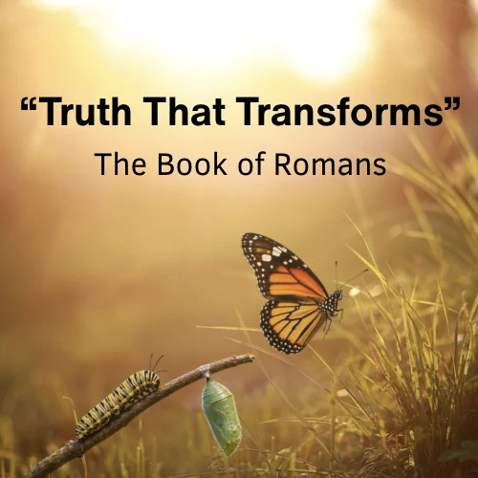

Living Vine Church
October 25, 2026
10:00 AM

Today’s Message
“How to Live the Rest of Your Life”
Message Series: “Truth that Transforms”
Speaker: John Czech

[Grab your reader’s attention with a great quote from the document or use this space to emphasize a key point. To place this text box anywhere on the page, just drag it.]

[Grab your reader’s attention with a great quote from the document or use this space to emphasize a key point. To place this text box anywhere on the page, just drag it.]

WELCOME GUESTS!
We’re so glad you are here.
Please join us after the gathering for
refreshments & treats in the Community Center.

FAMILY MINISTRY PROGRAMS

FAMILY LIFE MINISTRY MISSION:
To assist parents in discipling their children.
Lil’ SPROUTS (Infant — Kindergarten)
Provided with a safe and loving environment where they can explore and feed their natural curiosity, our babies & toddlers get to play while listening to music, hear a Bible story, and make friends. Volunteers are ready for check-in at the Nursery counter on the main level at 9:45am.

VINE KIDS (1st — 5th grade)
Vine Kids remain in the auditorium with their parents and are dismissed as a group for class, after announcements. In Vine Kids, children engage in "hands on" interactive Bible lessons and games/crafts. They also participate in energetic, age-appropriate worship through song. After the service is done, parents will pick up their children upstairs.
IVY LEAGUE (6TH — 12TH GRADE)
Check the website for the schedule @ https://lvhudson.org/connect/youth-group. Meets most Wednesday nights from 6:30pm to 8:00pm upstairs in the Family Life
Center with special events at various times.

For a listing of all events and the church calendar, see our website at https://lvhudson.org/whats-happening. Scroll down to bottom to view our full calendar

UPCOMING EVENTS
EVENTS THIS WEEK

REMEMBER TO SET YOUR CLOCKS BACK ONE HOUR ON SATURDAY, OCTOBER 31st, For Daylight Savings Time.

SMALL GROUP SIGN-UPS are available at the Connection Desk.
Please check out the different small groups that are available.
Wednesday, October 28: Ivy League, 6:30-8pm

Saturday, October 31, 5-7pm: SPOOKTACULAR
Volunteers are still needed and more candy too! Thank you!
Adult Sunday School: 9-9:50am in the Family Life Center
We are studying the Pauline Prison Epistles.
Enneagram in the Bible: 12:15-1:30 in the Family Life Center-WILL NOT MEET TODAY. Come and discover God’s love for individuality and His own consistent character.

For All Grow Classes Sign-up at the Connection desk or on-line at https://lvhudson.org/grow
Please Note: If childcare is needed for any class, a 2-week advance notice is required to ensure that we can have the nursery adequately staffed with 2 vetted volunteers. Thank you!
Tuesday, November 3, 6-8:30pm: Grow 401A – Mission for the World

Tuesdays, November 3 and 17th: 6-8pm: “This side of the shoebox” for GOOD WORKS! Join us at the Chirhart house, 118 113th St. in Hudson. Everyone is invited to reach out to others to join in the fun of working together!
Tuesday, November 10, 6-8:30pm: Grow 401B – Mission and Me
Meets every Saturday, 8-9:30am: Ironmen's Life Group, first Saturday is breakfast!
Meets every second Saturday, 2-4pm: Prayer Shawl Group
Meets every third Saturday, 10-12pm: Oasis Women’s Group

