God has blessed us abundantly during this year as he has demonstrated again and again his faithfulness. It is truly a blessing to be a part of God’s family here at Manchester First Methodist.
Hebrews 11 records these words: “. . . without faith it is impossible to please God, because anyone who comes to him must believe that he exists and that he rewards those who earnestly seek him.”
Faith is simply taking God at his Word. Faith is not believing that God can, but that God will. As one author wrote, “Faith sees the invisible, believes the incredible, and receives the impossible.”
When we take God at his Word, whether it be as an individual, as a family or in our church, we move forward by faith. We step out in obedience as God directs. Nowhere is that more evident than in our giving. Even when from a human perspective, it doesn’t make sense. Even when from an accounting perspective, the numbers do not add up.
As one person said it so well, “God does not ask for our endorsement of his plan, just our obedience to it.”
And that takes faith. It takes being willing to take the first step when we cannot see the second step clearly or at all. It takes “moving forward by faith” one step at a time. It takes trusting God to keep his promises to provide all that is needed as we put him to the test through our giving.
Do you believe God exists? Do you believe that God is a rewarder of those who earnestly seek him? Do you believe that God will keep his promises to you?
If so, will you be a part of those who are “moving forward by faith”? Will you covenant with God, by faith, to give in 2025 as he provides, even if you do not know where the funds will come from?
Please take a few moments to read the remainder of this brochure. Then ask God to give you specific direction concerning what you should give in 2025. Finally, please complete the Pledge Card, which is included with this brochure and bring it with you to the worship service on January 26, 2025.
Remember that your Pledge is a commitment you make not to the church or the staff or any committee. It is to God. As you complete the Pledge Card, what you are saying, in effect, is this: “Lord, as you provide, by faith, this is how I intend to give in the future.”
As you covenant with God concerning your giving in the coming year, please keep in mind our key verse from this year’s stewardship emphasis:
“. . . without faith it is impossible to please God, because anyone who comes to him must believe that he exists and that he rewards those who earnestly seek him” (Hebrews 11:6).
Thank you, in the name of the Lord Jesus Christ, for your faithful financial support in the past. Thank you as well for “moving forward by faith” here at Manchester First Methodist.
And thank you for following the Lord’s leading concerning what you should give in the coming year and for bringing your Pledge Card with you on January 26, 2025.

Manchester First Methodist 105 Church St.
Manchester, TN 37355
(931) 728-4624

Moving Forward
by
Faith

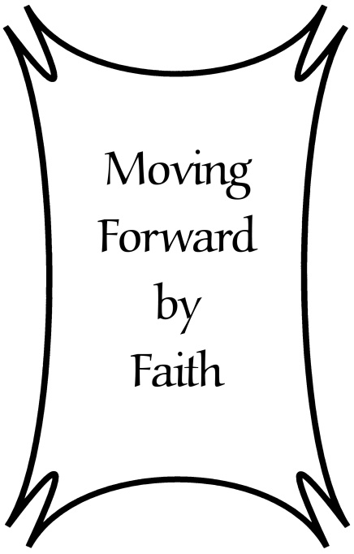

““. . . without faith it is impossible to please God, because anyone who comes to him must believe that he exists and that he rewards those who earnestly seek him.”
Hebrews 11: 6

